AccessMap VN — WF-01 Technical / Design Specification
Workflow: Contributor Data Submission & Multi-modal Ingestion
Status: Design baseline for mentor review and implementation
Technology baseline: React Native; ReactJS admin; ASP.NET Core gateway and Hangfire AI worker; Python FastAPI AI service (YOLOv8/OpenCV); PostgreSQL + PostGIS; EF Core/Npgsql/NetTopologySuite; private MinIO (local) / Cloudflare R2 (production); Firebase Cloud Messaging.
Document authority. This is the complete business and technical specification of WF-01. Part A describes the workflow and decisions. Part B defines the implementation rules, schema, configuration, APIs, algorithms and acceptance tests. Any implementation contract is derived from this document.
Values stated as defaults require calibration before production use; they are defined here to make the capstone implementation testable.

Contents
- Part A — System and workflow design: §§A.1–A.18. Start here to understand WF-01, its people, decisions and diagrams.
- Part B — Detailed normative specification: §§B.0–B.25. Look up exact columns, DTOs, formulas, validation and test conditions when needed.

Reading path for a mentor or new team member
- What happens to a contribution? Read A.1, the visual overview in A.1.2.1 and the actor boundaries in A.2.
- Where do the parts run? See the architecture in A.3, place resolution in A.5 and evidence flow in A.6.
- How is information stored? Start with the core entity map in A.8.1.1, then inspect the full ERD and focused relationship diagrams in A.8.2; B.3 is the lookup for complete column types and constraints.
- How does a claim become visible on the map? Follow the end-to-end sequences in A.15, then confidence and routing in A.10–A.13.
The diagrams describe ownership and decision paths. They are not a replacement for the typed schema and implementation rules in Part B. The separate Coding-Agent Contract condenses rules for implementation; this document explains the workflow and retains their full technical reference.

Part A — System and workflow design

A.1 Purpose, scope and terminology

A.1.1 Purpose
WF-01 turns contributor observations about a physical place into traceable, verified accessibility information. A submission is evidence; it is not automatically public truth. Only the controlled publication operation updates the public feature record.

A.1.2 Included flow
Search/select or propose a place; request camera permission and optional device-location permission; capture photos/videos in app or select gallery photos taken within the last 30 days (strictly less than 30×24 hours); retain source and time provenance, compare an available capture-time device fix with the selected place using a provisional 30 m radius; upload using owned signed intents; run bounded media pre-scan; review contributor claims and explicitly confirm Submit; atomically persist Submission and domain AI job; after commit Hangfire calls Python for full verification; combine AI signals with eligible historical claims when available; apply integrity rules and confidence routing; publish accepted facts and record EXP/history/notifications.

A.1.2.1 WF-01 at a glance
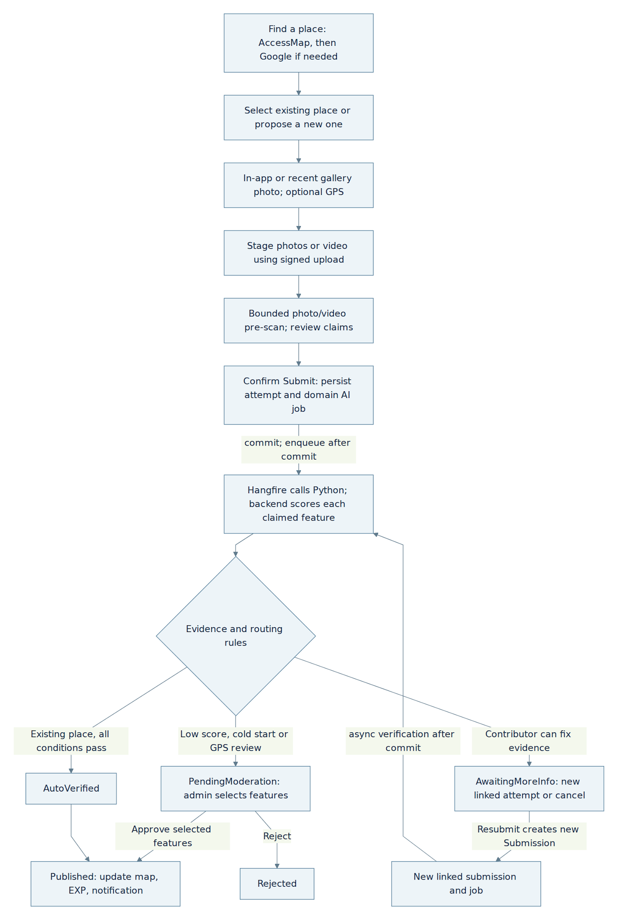
flowchart TB
Search["Find a place: AccessMap, then Google if needed"] --> Select["Select existing place or propose a new one"]
Select --> Capture["In-app or recent gallery photo; optional GPS"]
Capture --> Upload["Stage photos or video using signed upload"]
Upload --> Check["Bounded photo/video pre-scan; review claims"]
Check --> Submit["Confirm Submit: persist attempt and domain AI job"]
Submit -->|"commit; enqueue after commit"| AI["Hangfire calls Python; backend scores each claimed feature"]
AI --> Decision{"Evidence and routing rules"}
Decision -->|"Contributor can fix evidence"| More["AwaitingMoreInfo: new linked attempt or cancel"]
Decision -->|"Low score, cold start or GPS review"| Review["PendingModeration: admin selects features"]
Decision -->|"Existing place, all conditions pass"| Auto["AutoVerified"]
Review -->|"Approve selected features"| Published["Published: update map, EXP, notification"]
Review -->|"Reject"| Rejected["Rejected"]
Auto --> Published
More -->|"Resubmit creates new Submission"| Retry["New linked submission and job"]
Retry -->|"async verification after commit"| AI
Searching Google does not create a Location. A new place is created as Provisional when the contribution is submitted and becomes Active only after publication. The pre-scan helps the contributor improve media before submission; Python's later verification and the backend's community and integrity rules decide the route. AutoVerified is followed by a separate publication transaction; a new Location always waits for admin review when its media is usable.

A.1.3 Exclusions
Road accessibility, route contributions, navigation correctness, travel speed and route reporting belong to other workflows. WF-01 does not calculate a building-wide accessibility score. A map provider supplies place identity and context, never the truth of a ramp, elevator or other accessibility feature.

A.1.4 Vocabulary
Term | Meaning
Location | AccessMap's identity for one physical place; its canonical coordinate is Position.
External place | Third-party search result without an AccessMap record until contribution creation.
Claim | One contributor's asserted state of one accessibility feature.
Evidence | Uploaded photo/video and derived analysis supporting or questioning claims.
AI suggestion | Optional assistance before submission, which a contributor reviews.
Pre-submit pre-scan | Synchronous, non-authoritative image-quality feedback before the contributor presses Submit; no Submission or AIProcessingJob exists.
AI verification | Asynchronous post-submit evidence analysis; the backend applies business rules.
LocationFeature | Current published state for one feature at one Location.
Resubmission | A new immutable attempt linked to a previous submission.

A.1.5 Invariants
Search never writes a Location. A selected third-party place becomes a Provisional Location only during contribution creation after duplicate resolution. User, Location, auth, repository, storage and notification components already in a project must be reused. A published or rejected attempt is terminal; cancelling a correction request is terminal too. No external calls run inside a database transaction.

A.2 Actors, responsibilities and trust

A.2.1 Human actors
Actor | Authorized action | Boundary
User — contributing (Contributor use case) | Search, capture, review, submit, view own status, resubmit corrected evidence, cancel own AwaitingMoreInfo attempt. | Cannot choose verification outcome, assign points, moderate or write published features.
User — seeking information (Seeker use case) | Read published accessibility features and their supported public summary. | Does not see private evidence, raw GPS, internal model output or draft submissions.
Admin | Review queued cases, inspect authorized evidence, approve, reject, request clarification and recover failed AI jobs. | Every decision is authorized, reasoned, audited and concurrency checked.

A.2.2 System actors
The ASP.NET Core backend owns identities, transitions, publication and all authoritative validation. PostgreSQL/PostGIS holds relational history and spatial state. Object storage keeps private binaries. Google Places only helps discover and identify places. The AI provider returns suggestions and evidence signals; its output is not a publication command. FCM transports notifications but cannot reverse a committed decision.

A.2.3 Authorization rules
The only account roles are User and Admin. The existing User/auth record holds one authoritative Role value (User or Admin); default registration creates User. Contributor and Seeker name two use-case actions of the same signed-in User, not separate roles, accounts or account states. Reuse existing authentication and role storage; do not add a custom UserRole join table for these personas. If the existing auth framework already stores the equivalent role, map it as the authoritative User role instead of persisting a conflicting copy. Admin may sign in to the React Native mobile app for ordinary User functions and to the ReactJS Admin Portal for management at the same time. These are separate server-issued sessions/tokens with distinct server-validated session identifiers (or the existing auth system's equivalent token family): the mobile session cannot call Admin APIs, while the portal session must carry a validated portal scope and the current authoritative Admin role plus the action policy (for example Wf01.Moderate) for every management request. Reuse the existing auth session/revocation infrastructure to check session identity and revocation on protected requests; a stateless role claim or client-provided session label alone cannot establish either permission or logout. Signing out revokes only the selected session identifier, including its outstanding tokens, without automatically signing out the other; global account revocation invalidates both, and removal of Admin access immediately blocks portal management even if a formerly elevated token has not expired. No separate User or UserRole entity is introduced. Concurrent sign-in does not create another role or User record. The mobile client may receive the role for display, but a client-supplied role, client identifier, Origin header or hidden/visible UI control never grants access. Role assignment or change is restricted to trusted account provisioning with audit; ordinary registration/profile APIs cannot set Role. Recheck authorization and invalidate or expire stale elevated sessions when Admin access is removed. All place search, discovery and detail reads require a signed-in account. A signed-in User or Admin may create a submission and view only their own private submissions. Ownership checks apply to status, resubmission and cancellation. Storage is private; the server grants short-lived access to authorized media views. No provider secret or raw device GPS appears in a public response.
Shared registration rule: a User supplies one email and one phone number; each is unique across accounts. The User selects Email or Sms to receive the registration OTP. One successful verification completes registration; only the selected destination is confirmed. Email OTP does not confirm the phone number, and SMS OTP does not confirm the email. OTP is required for registration only, not every normal login. Search and discovery require a signed-in User; registration is required before using the app's place features. Reuse the existing User/auth component; no separate Contributor/Seeker account or additional identity-verification workflow.

A.3 System architecture and deployment

A.3.1 Logical architecture
This view names the main running components and external services and shows how they exchange requests, work and media. Its boxes are deployment or application components, not database entities. For the data entities and their relationships, use A.8.
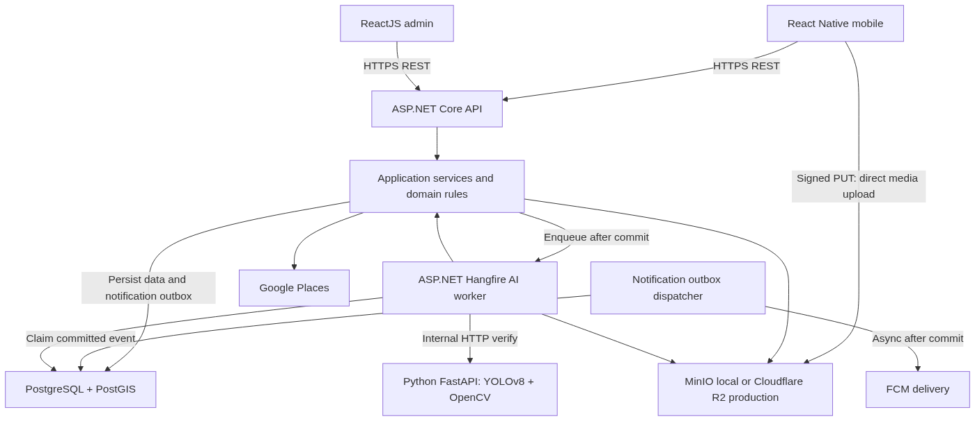
flowchart TB
Mobile["React Native mobile"] -->|"HTTPS REST"| API["ASP.NET Core API"]
Admin["ReactJS admin"] -->|"HTTPS REST"| API
API --> App["Application services and domain rules"]
App -->|"Enqueue after commit"| Worker
App -->|"Persist data and notification outbox"| DB["PostgreSQL + PostGIS"]
Mobile -->|"Signed PUT: direct media upload"| Store["MinIO local or Cloudflare R2 production"]
App --> Store
App --> Google["Google Places"]
Notifier["Notification outbox dispatcher"] -->|"Claim committed event"| DB
Notifier -->|"Async after commit"| FCM["FCM delivery"]
Worker["ASP.NET Hangfire AI worker"] --> DB
Worker --> Store
Worker -->|"Internal HTTP verify"| AI["Python FastAPI: YOLOv8 + OpenCV"]
Worker --> App

A.3.1.1 System Architecture
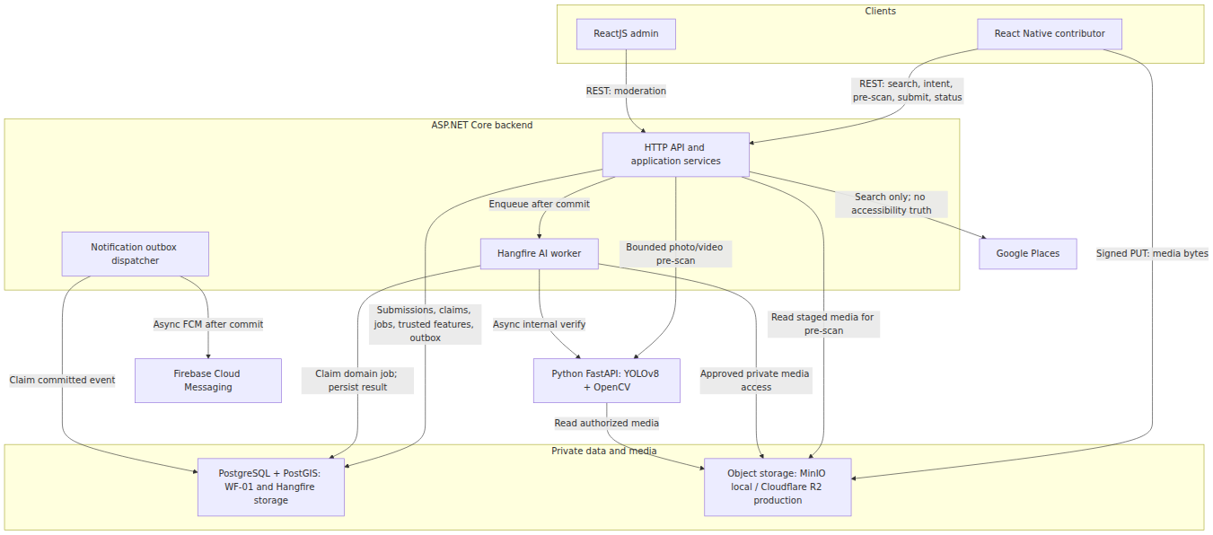
flowchart TB
subgraph Clients["Clients"]
Mobile["React Native contributor"]
Admin["ReactJS admin"]
end
subgraph Backend["ASP.NET Core backend"]
API["HTTP API and application services"]
Worker["Hangfire AI worker"]
Notifier["Notification outbox dispatcher"]
end
subgraph Data["Private data and media"]
DB["PostgreSQL + PostGIS: WF-01 and Hangfire storage"]
Store["Object storage: MinIO local / Cloudflare R2 production"]
end
Mobile -->|"REST: search, intent, pre-scan, submit, status"| API
Admin -->|"REST: moderation"| API
Mobile -->|"Signed PUT: media bytes"| Store
API -->|"Submissions, claims, jobs, trusted features, outbox"| DB
API -->|"Enqueue after commit"| Worker
Worker -->|"Claim domain job; persist result"| DB
API -->|"Read staged media for pre-scan"| Store
Worker -->|"Approved private media access"| Store
API -->|"Search only; no accessibility truth"| Google["Google Places"]
API -->|"Bounded photo/video pre-scan"| AI["Python FastAPI: YOLOv8 + OpenCV"]
Worker -->|"Async internal verify"| AI
AI -->|"Read authorized media"| Store
Notifier -->|"Claim committed event"| DB
Notifier -->|"Async FCM after commit"| FCM["Firebase Cloud Messaging"]
The arrows distinguish control calls from media bytes. A mobile upload goes straight to private object storage using a backend-issued signed PUT URL; the client subsequently submits an opaque mediaId. Python returns inference results, while .NET applies community evidence, hard rules and publication. PostgreSQL contains both the WF-01 domain schema and persistent Hangfire storage; their commits are not one transaction. The field-level DB schema and indexes are specified in B.3.

A.3.2 Application layering
Controllers authenticate, validate transport shape, invoke application services and map results to DTO/HTTP responses. Application services coordinate the use case and transaction boundaries. Domain services resolve state changes, confidence, integrity, publication and reputation policy. Infrastructure adapters implement EF Core queries, provider HTTP calls, object storage and FCM. No controller directly updates an EF entity to bypass a business rule.

A.3.3 Component responsibilities
Component | Input | Durable output / side effect
PlaceSearchService | Search text and optional coordinate | Read-only local results plus fallback identity results.
LocationResolutionService | Existing ID, external ID or proposed identity | Existing Location or one new Provisional Location.
MediaValidationService | Server-approved staged mediaIds and object bytes | Accepted media metadata/hash or actionable validation errors.
SubmissionService | Place context, media and claims | Submission, claims, status history, job and idempotent response.
Wf01AiWorker | Claimed durable job | AI results, feature evidence and a routing decision.
SubmissionStateService | Current state, actor and reason | Authorized state plus append-only history.
PublicationService | Verified or moderated decision | LocationFeature version/history, reputation event and Published status.
NotificationService | Committed workflow event | Best-effort delivery with independent retry and deduplication.

A.3.4 Deployment model
The ASP.NET Core API serves client/admin REST and uses Hangfire Server with persistent PostgreSQL-backed Hangfire storage to run durable AI verification jobs. A separately deployed Python FastAPI service owns video frame extraction and YOLOv8/OpenCV inference. The Hangfire job calls its internal POST /api/v1/ai/verify asynchronously; the HTTP wait consumes a bounded worker slot and connection but does not execute YOLO on a .NET request thread. Python spends CPU/GPU on decoding/inference. .NET owns scoring, state, moderation, EXP and publication. No mobile request waits for full verification. BackgroundService may perform lightweight best-effort in-memory work, but never owns AI verification, recovery or the only trigger for a durable job. WF-01 keeps AIProcessingJob as its domain status/attempt/audit record; Hangfire provides persistent execution and scheduling. Pre-submit pre-scan is a bounded synchronous API request to Python without a durable job. MinIO is the local storage provider and Cloudflare R2 the production provider. Mobile can reach only backend-issued signed PUT URLs, never provider credentials or Docker-only hostnames.

A.3.5 Data and security boundaries
The mobile and admin clients are untrusted callers; backend authorization and content validation apply even if a client hides an action. Mobile uploads to a backend-assigned private staging key using a short-lived signed PUT URL; the server subsequently checks object existence, ownership and actual bytes before binding a mediaId to a Submission. The PostgreSQL transaction covers only local database changes. Place-provider lookup, media validation and any final object copy happen before commit; AI verification and FCM happen after commit. Sensitive evidence is stored privately; signed URLs are short lived and never used as submit references.

A.4 Workflow preconditions, outcomes and product actions

A.4.1 Preconditions
The contributor is authenticated and allowed to submit. Exactly one of locationId, externalPlaceId, or a valid free-form place proposal is provided. locationId and all database IDs are UUID v4; human-readable place/submission codes are separate strings. Coordinates are valid and represent the device location; the place coordinate is resolved separately. There is at least one typed feature claim and at least one verified photo/video mediaId in private staging owned by this contributor. Header Idempotency-Key identifies the operation. No prior identical evidence by the same contributor at the same place for the same feature may violate the duplicate rule.

A.4.2 Successful postconditions
The backend has durably created a Submission, its claims, validated media references, status history, an AIProcessingJob and an IdempotencyRecord in one database transaction and returns 202 Accepted with Status=Submitted. Staged media intents are atomically marked Attached in the same transaction. A newly created place remains Provisional. Later publication updates eligible LocationFeatures, writes history when replacing them, creates the single idempotent EXP event for the flow and schedules notifications.

A.4.3 Product action mapping
Product wording | Backend action
Update Place | New Submission targeting an existing Location.
Update local draft | Client-side edit before a server Submission exists.
Update Submission / provide corrected evidence | New resubmission attempt linked to the AwaitingMoreInfo predecessor; the old evidence is immutable.
Correct rejected or published information | New Submission for the same Location, with lineage if applicable; never reopen the terminal attempt.
Cancel correction | AwaitingMoreInfo → Cancelled by its owner; no points or publication.

A.4.4 Correction visibility
Only the latest actionable attempt in a lineage should show a resubmit action. A previous AwaitingMoreInfo row may retain that historical status after a child is created; the UI derives SupersededByNewAttempt from the lineage and must not present a second correction action for the same predecessor.

A.4.5 Business rules and validation outcomes
This quick reference summarizes decisions already specified in A.5–A.15 and B.8–B.15. Detailed rules and thresholds in those sections remain authoritative.

Situation / check | Validation outcome | Contributor or admin action | Details
Search or propose a place | Search is read-only; duplicate candidates require confirmation before creating a new provisional place. | Select an existing place or confirm an unambiguous new place. | A.5; B.5–B.6
Draft media or pre-scan warning | Advisory feedback only; no Submission or AI job exists. | Retake in app, retry location acquisition or correct the selected place, then review feedback and confirm Submit. Uncertain/outside-radius GPS is flagged for Admin; missing capture GPS is accepted for Admin review when other evidence is usable. | A.6.1; A.10.1; B.8.0
Upload, ownership, format or all media invalid | Submission is not created if upload/byte validation fails; an accepted attempt lacking usable evidence needs correction. | Fix upload or retake; for AwaitingMoreInfo resubmit a new linked attempt or cancel. | A.6.2–A.6.4; B.8; B.12
Valid new place or feature with no eligible community history | PendingModeration, even when cold-start FeatureConfidence is below .60; no retake solely for missing votes. | Wait for admin; provide evidence only if a separate actionable gap exists. | A.11.3–A.11.5; B.13.1
Usable evidence but capture GPS outside/uncertain within the 30 m radius, metadata mismatch or conflicting signals | PendingModeration; a mismatch alone is not a finding of dishonesty. | Admin examines media, coordinates and per-feature evidence. | A.6.4.1; B.12
Existing feature, history present, score < .60 | AwaitingMoreInfo only for a fixable evidence gap; otherwise PendingModeration for disagreement. | Provide a new angle if requested, or await review. | A.11.5; B.13.1
History present, score .60–<.80 or ≥.80 | <.80: PendingModeration. ≥.80: AutoVerified only when all minimum-evidence and integrity rules pass. | Await review or publication; score alone does not prove compliance. | B.11.11–B.14
AI unavailable or output invalid | Durable job retries; exhausted retries go to moderation, never an unsupported publication. | Wait for retry or admin; no forced retake for provider failure. | A.10.2; A.15.3; B.12; B.17
Admin approves / rejects; publication | Publish only evidence-backed selected features and one source event. WF4 applies eligible +50/+20 spendable and +5/+2 trust once under its uniqueness/anti-repeat rules; publication alone guarantees no credit. Rejected/Cancelled earn 0. | See outcome; corrected evidence creates a new linked submission. | A.12–A.13; B.14–B.15

A.5 Place search, identity and spatial resolution

A.5.1 Search order
WF-01 and WF-03 share GET /api/v1/locations/search for identity suggestions. q is a place name/address and works without GPS. Optional coordinates bias ranking; an unstated 2 km radius must not exclude text matches. Coordinate-only Find near me starts with the configured 2,000 m default; an explicit radius/area applies when chosen. WF3 sends source=accessmap, which returns local records only and skips provider fallback even when empty. WF1 may omit that selector and retain its existing AccessMap-first, separately tagged external place lookup for contribution selection. Identities never receive compatibility labels from this GET. A selected external candidate is resolved/deduplicated only at WF1 submission; search creates no Location, Submission or claim.

A.5.2 Resolution modes
- Existing AccessMap Location: load by ID, follow a valid MergedIntoLocationId and accept only an eligible active/provisional target.
- Selected external place: resolve provider ID outside the transaction; check unique external ID first, then nearby candidates using PostGIS distance plus normalized name/address; reuse confirmed match or create Provisional.
- New free-form proposal: require name and coordinate; run the same spatial/name duplicate screen; obtain explicit confirmation if candidates are ambiguous, then create Provisional.

A.5.3 Duplicate decision
Distance produces candidates, not proof of sameness. A provider ID match is strong identity evidence; a same-name nearby place may still be a different entrance or business. Return duplicate candidates and a next action where confirmation is needed. Two simultaneous external submissions are protected by a partial unique provider-ID constraint; free-form creation serializes a deterministic identity/spatial cell using a PostgreSQL advisory transaction lock, then repeats the check inside the transaction.

A.5.4 Spatial model
Location.Position is geography(Point,4326) with a GiST index; returned latitude/longitude are projections. Spatial checks use PostGIS geography distances in metres. Optional capture-time device GPS is distinct from EXIF/container GPS and canonical place coordinates. A manual pin or denied location permission does not block usable evidence; it prevents automatic verification and triggers Admin review. Missing embedded metadata alone does not imply fraud. B.10 defines the 30 m policy and accuracy-aware review. A Location may have separately verified entrance/building context; a pin or nearby GPS fix cannot establish the contributor's floor. Proposed address or pin corrections are Admin-resolved, audited metadata changes with old/new values, reason, evidence, actor, decision and effective version. Feature claims and published versions carry an explicit building/entrance/unit/floor or floor-range scope and supported access limit where applicable; an observation on one floor cannot overwrite another. Use the versioned AccessScope schema in B.3.1; migrate existing unscoped features as BuildingGeneral with CoverageUnknown, never as proof about every floor. Claims, publication, cross-check and UI use the same scope identity.

A.5.5 Lifecycle
Provisional means identity exists without trusted accessibility publication. Active follows successful publication or an explicitly established existing-location rule. Merged redirects to another Location; Hidden is not exposed in normal discovery. A failed/rejected submission cannot activate a new place by itself.

A.6 Evidence, media and storage

A.6.1 Capture and quick feedback
The contributor selects a place, grants camera permission for in-app photos/videos or selects a gallery photo (including correction attempts); optional device-location permission provides stronger on-site evidence. Acquire a current location fix at each photo capture and at video start/end, recording coordinates, horizontal accuracy, fix timestamp and capture time. If permission is denied, GPS is unavailable or the fix is stale, explain the lower assurance and offer retry; allow otherwise usable evidence to proceed to Admin review. Never substitute upload-time GPS as a capture fix. Show the 30 m proximity result against the selected place before submission. Outside/uncertain results prompt location reacquisition or place correction; usable evidence may still be submitted for Admin review. React Native checks type, dimensions, size and video length, creates an owned upload intent with capture metadata, and PUTs to private staging. The app runs bounded pre-scan for every selected photo/video in batches, displays quality feedback, then lets the contributor confirm claims and explicitly submit. Python samples only bounded frames during video pre-scan; full analysis runs after submission. A timeout falls back to basic checks and permits submission with a visible warning. No Submission, SubmissionClaim or AIProcessingJob exists during pre-scan; hints never overwrite contributor claims or promise approval. A bounded synthetic/edited-media suspicion check may run at pre-scan and again during full verification. It emits a reason and retake/additional-evidence advice, not a definitive AI-generated-image verdict. A suspicious or unavailable check on otherwise usable evidence prevents silent auto-publication and routes by configured policy to more information or Admin. Preserve original hashes, capture metadata, model/policy version and human decision; keep image quality separate from authenticity suspicion.

A.6.2 Authoritative validation
The backend loads only staged media referenced by owned mediaIds, checks actual content/MIME, integrity, size, dimensions, basic video container/codec/duration and limits, and computes SHA-256. The Python AI service owns compute-heavy frame extraction, OpenCV quality analysis and YOLOv8 inference after submission. A video that cannot yield a usable frame is not positive feature evidence. Exact limits and tools appear in B.4 and B.8.

A.6.3 Storage sequence
Mobile PUTs bytes directly to private MinIO (local) or Cloudflare R2 (production) using a short-lived upload URL for a server-generated staging key. PostgreSQL stores an UploadIntent keyed by UUID mediaId, owner, expected type/size, expiry and claim state. Before submission commit, .NET verifies the object exists, matches the intent, decodes/inspects the file and computes its SHA-256; it copies validated bytes to an immutable final key outside the transaction. Inside the transaction the intent is claimed exactly once and linked to SubmissionMedia. Cleanup expires unused staging media and compensates orphan final objects after a failed commit. Derived Python keyframes reference the parent media and have a retention rule; they are never silently treated as original uploads.

A.6.4 Integrity and content safety
EXIF location or capture time can help analysis but may be absent, stripped or altered. Missing EXIF alone cannot reject a submission. Content safety may be evaluated asynchronously; flagged evidence routes to AwaitingMoreInfo so the contributor can supply a new corrected attempt or cancel. Client quality preview is not a guarantee that later content safety or semantic verification passes.

A.6.4.1 Optional photo EXIF GPS cross-check
After original uploaded photo bytes pass validation, the backend may read embedded GPS. Compare each valid photo position with canonical Location.Position and, separately, device GPS. This adds location-integrity evidence; EXIF can be absent, removed or altered and cannot prove where a photo was taken. Missing EXIF does not reject the contribution. A material mismatch with usable evidence goes to manual moderation rather than an automatic dishonesty finding. Keep original coordinates private and never substitute them for public place coordinates.

A.6.5 Duplicate evidence rule
Block only the same media hash from the same contributor for the same Location and same FeatureType when a non-Rejected submission already exists. Different contributors, different claims, a new angle or a contradictory new observation remain eligible for evaluation. Give the contributor the existing submission reference rather than silently discard a request.

A.7 Accessibility claims and domain model

A.7.1 Feature types and states
Feature types: Ramp, Elevator, AccessibleRestroom, AccessibleParking, WideEntrance, TactileGuidance, StepFreeAccess. Claim states: Unknown, Available, Limited, NotAvailable. A Limited claim must describe the limitation; numeric measurements require units. The normative reference is Vietnamese technical regulation QCVN 10:2024/BXD, effective 01 February 2025. For each criterion the team elects to assess, persist its QCVN criterion reference, required measured values, evidence provenance, outcome (Observed, InsufficientEvidence, Reviewed) and review method; do not treat object-detection confidence as proof of dimensions or whole-place compliance. Suggested capability wording: “AI hỗ trợ phân tích ảnh và video về các hạng mục tiếp cận, đối chiếu bằng chứng với những tiêu chí liên quan của Vietnamese Technical Regulation 10:2024/BXD; các tiêu chí thiếu số đo hoặc bằng chứng được chuyển để bổ sung hoặc kiểm duyệt.” Show the comparison phrase only for implemented criterion mappings. After publishing an actually verified ramp feature, say: “Thông tin về ram dốc tại lối vào đã được xác minh và xuất bản trên AccessMap.” Never replace these with “địa điểm đạt chuẩn Vietnamese Technical Regulation” based only on images.

A.7.2 Independent feature claims
One Submission may assert several different features and selects one AccessScope and at most one claim per AccessibilityFeatureType. Unknown claims may be stored but are never published or used to increase confidence. A selected UI tag such as ramp maps through a defined frontend-to-enum mapping to FeatureType=Ramp and ClaimedStatus=Available; unknown free-form keys in accessibilityClaims are rejected. These are contributor assertions, not AISuggestion or AI verdicts. AI-generated suggestions, if used, require contributor confirmation before becoming claims. Pre-scan hints remain advisory; admin sees the worker's persisted verification evidence and confidence. A feature may be withheld even when another from the same submission is published. Each scope belongs to the canonical Location. A contribution for a different entrance/floor is a separate Submission with its own evidence; unknown coverage remains explicit.

A.7.3 Domain diagram
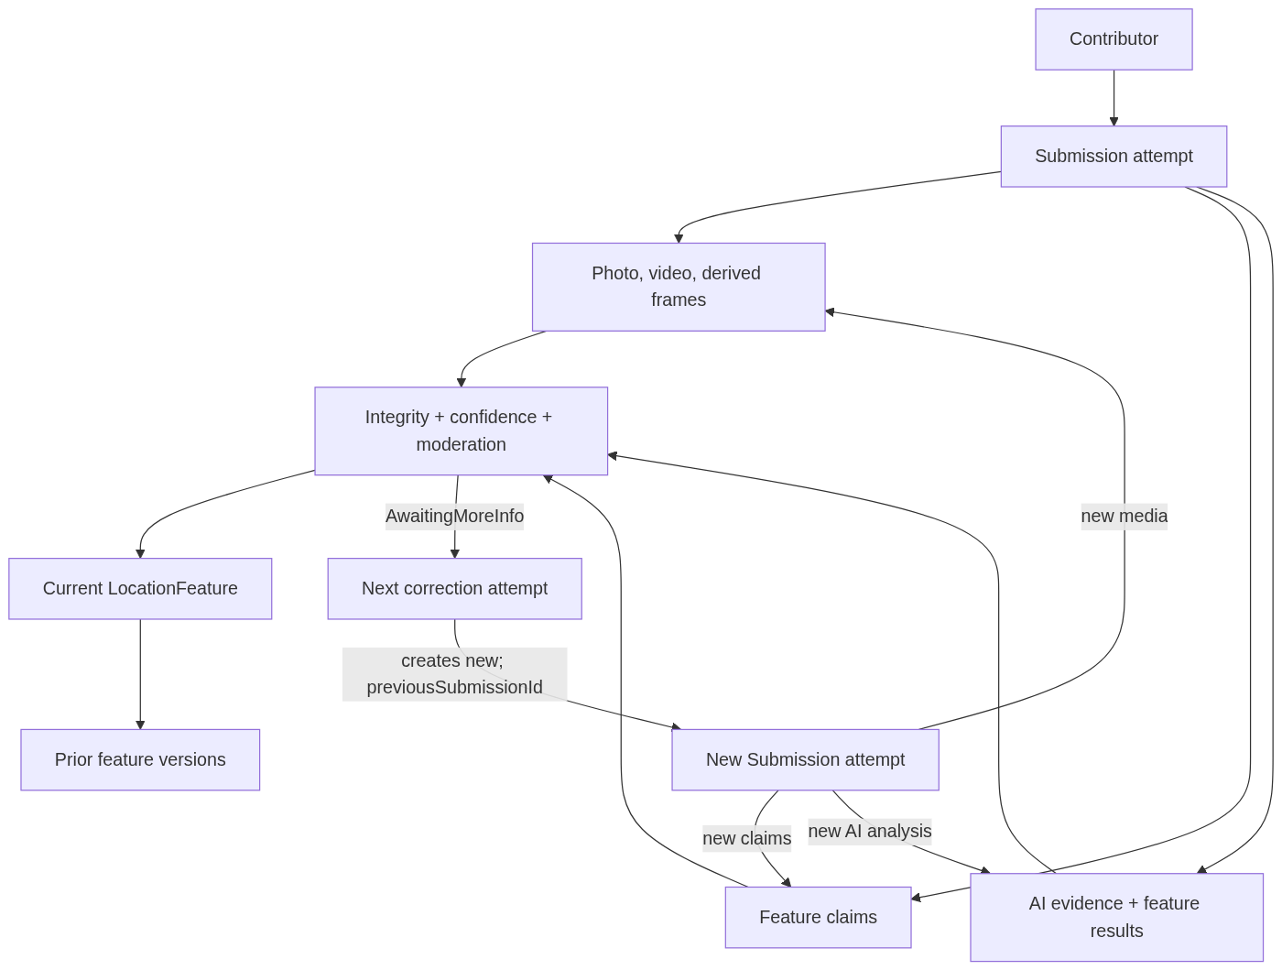
flowchart TB
Person["Contributor"] --> Submission["Submission attempt"]
Submission --> Evidence["Photo, video, derived frames"]
Submission --> Claims["Feature claims"]
Submission --> Verification["AI evidence + feature results"]
Claims --> Decision["Integrity + confidence + moderation"]
Evidence --> Decision
Verification --> Decision
Decision --> Truth["Current LocationFeature"]
Truth --> History["Prior feature versions"]
Decision -->|"AwaitingMoreInfo"| Next["Next correction attempt"]
Next -->|"creates new; previousSubmissionId"| NewSubmission["New Submission attempt"]
NewSubmission -->|"new media"| Evidence
NewSubmission -->|"new claims"| Claims
NewSubmission -->|"new AI analysis"| Verification

A.7.4 Aggregate boundaries
Submission owns its attempt's claims, media references, AI analyses and status history. Location owns stable place identity and current LocationFeature records. Publication connects them transactionally by recording each feature's source claim/submission. Resubmission creates a new Submission aggregate linked to prior/root attempts; it does not mutate its predecessor's evidence.

A.8 Database architecture and full relationship map

A.8.1 System of record
PostgreSQL holds identity, workflow, audit, AI results and current truth. PostGIS handles location points and nearby lookups. Object storage owns media bytes. The schema in B.3 is the authoritative column/type/index reference; the diagram below shows cardinality and ownership. Extend the project's existing USER and LOCATION tables; do not introduce duplicates.

A.8.1.1 Core entities at a glance
This is the quick reading map for a presentation: a contributor submits evidence about one Location; each Submission owns its media and feature claims; verification informs the decision, and publication updates the Location's current features. The boxes here show only the core persisted entities. Use A.8.2 for cardinality, foreign keys and supporting tables such as jobs, audits, moderation and idempotency.
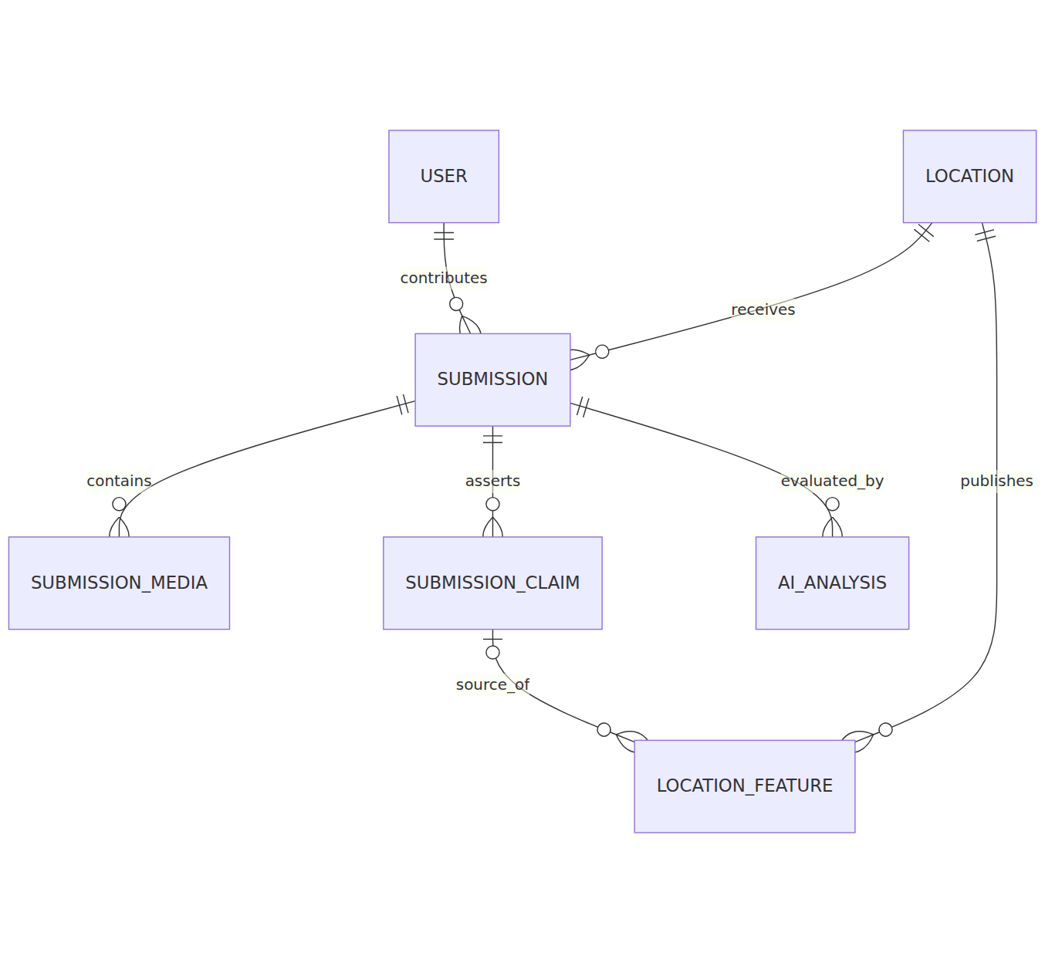
erDiagram
USER ||--o{ SUBMISSION : contributes
LOCATION ||--o{ SUBMISSION : receives
SUBMISSION ||--o{ SUBMISSION_MEDIA : contains
SUBMISSION ||--o{ SUBMISSION_CLAIM : asserts
SUBMISSION ||--o{ AI_ANALYSIS : evaluated_by
LOCATION ||--o{ LOCATION_FEATURE : publishes
SUBMISSION_CLAIM ||--o| LOCATION_FEATURE : source_of

A.8.2 Full WF-01 ERD
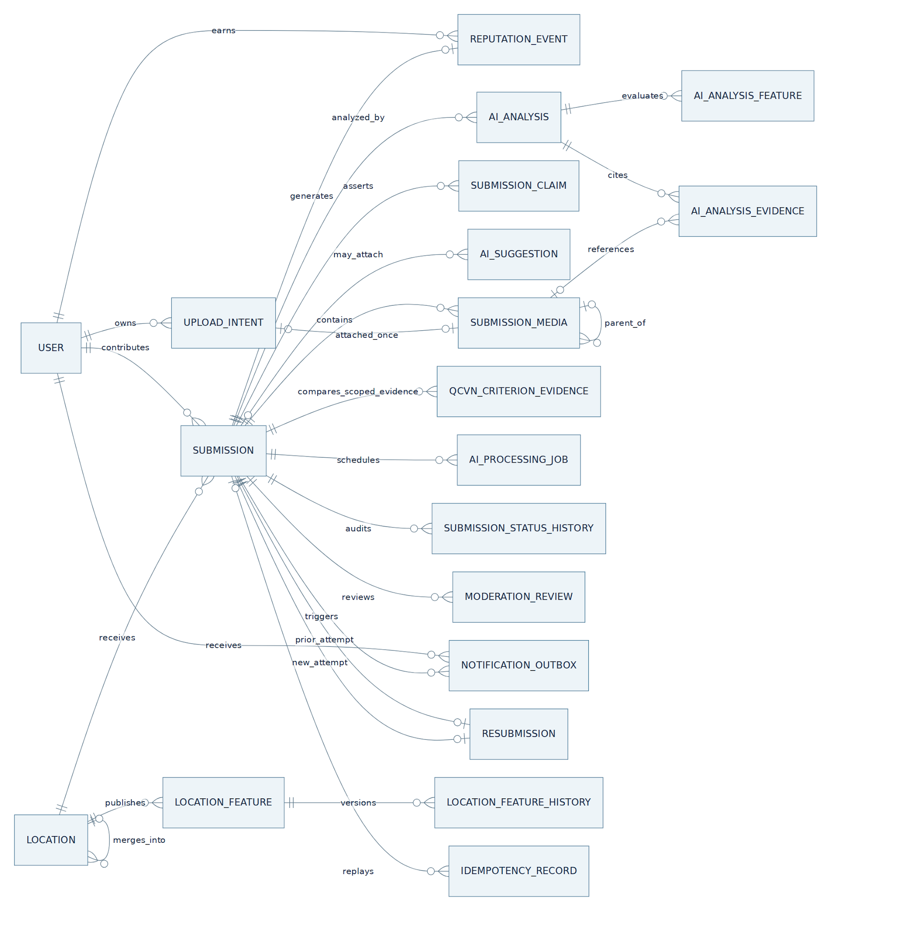
erDiagram
direction LR
USER ||--o{ SUBMISSION : contributes
USER ||--o{ UPLOAD_INTENT : owns
USER ||--o{ REPUTATION_EVENT : earns
LOCATION ||--o{ SUBMISSION : receives
LOCATION ||--o{ LOCATION_FEATURE : publishes
LOCATION o|--o{ LOCATION : merges_into
SUBMISSION ||--o{ SUBMISSION_MEDIA : contains
UPLOAD_INTENT o|--o| SUBMISSION_MEDIA : attached_once
SUBMISSION_MEDIA o|--o{ SUBMISSION_MEDIA : parent_of
SUBMISSION ||--o{ SUBMISSION_CLAIM : asserts
SUBMISSION o|--o{ AI_SUGGESTION : may_attach
SUBMISSION ||--o{ AI_ANALYSIS : analyzed_by
SUBMISSION ||--o{ QCVN_CRITERION_EVIDENCE : compares_scoped_evidence
AI_ANALYSIS ||--o{ AI_ANALYSIS_FEATURE : evaluates
AI_ANALYSIS ||--o{ AI_ANALYSIS_EVIDENCE : cites
SUBMISSION_MEDIA o|--o{ AI_ANALYSIS_EVIDENCE : references
SUBMISSION ||--o{ AI_PROCESSING_JOB : schedules
SUBMISSION ||--o{ SUBMISSION_STATUS_HISTORY : audits
SUBMISSION ||--o{ MODERATION_REVIEW : reviews
SUBMISSION ||--o| REPUTATION_EVENT : generates
USER ||--o{ NOTIFICATION_OUTBOX : receives
SUBMISSION ||--o{ NOTIFICATION_OUTBOX : triggers
SUBMISSION ||--o| RESUBMISSION : prior_attempt
SUBMISSION ||--o| RESUBMISSION : new_attempt
LOCATION_FEATURE ||--o{ LOCATION_FEATURE_HISTORY : versions
SUBMISSION o|--o{ IDEMPOTENCY_RECORD : replays

A.8.2.1 Place identity, uploads and contributor claims
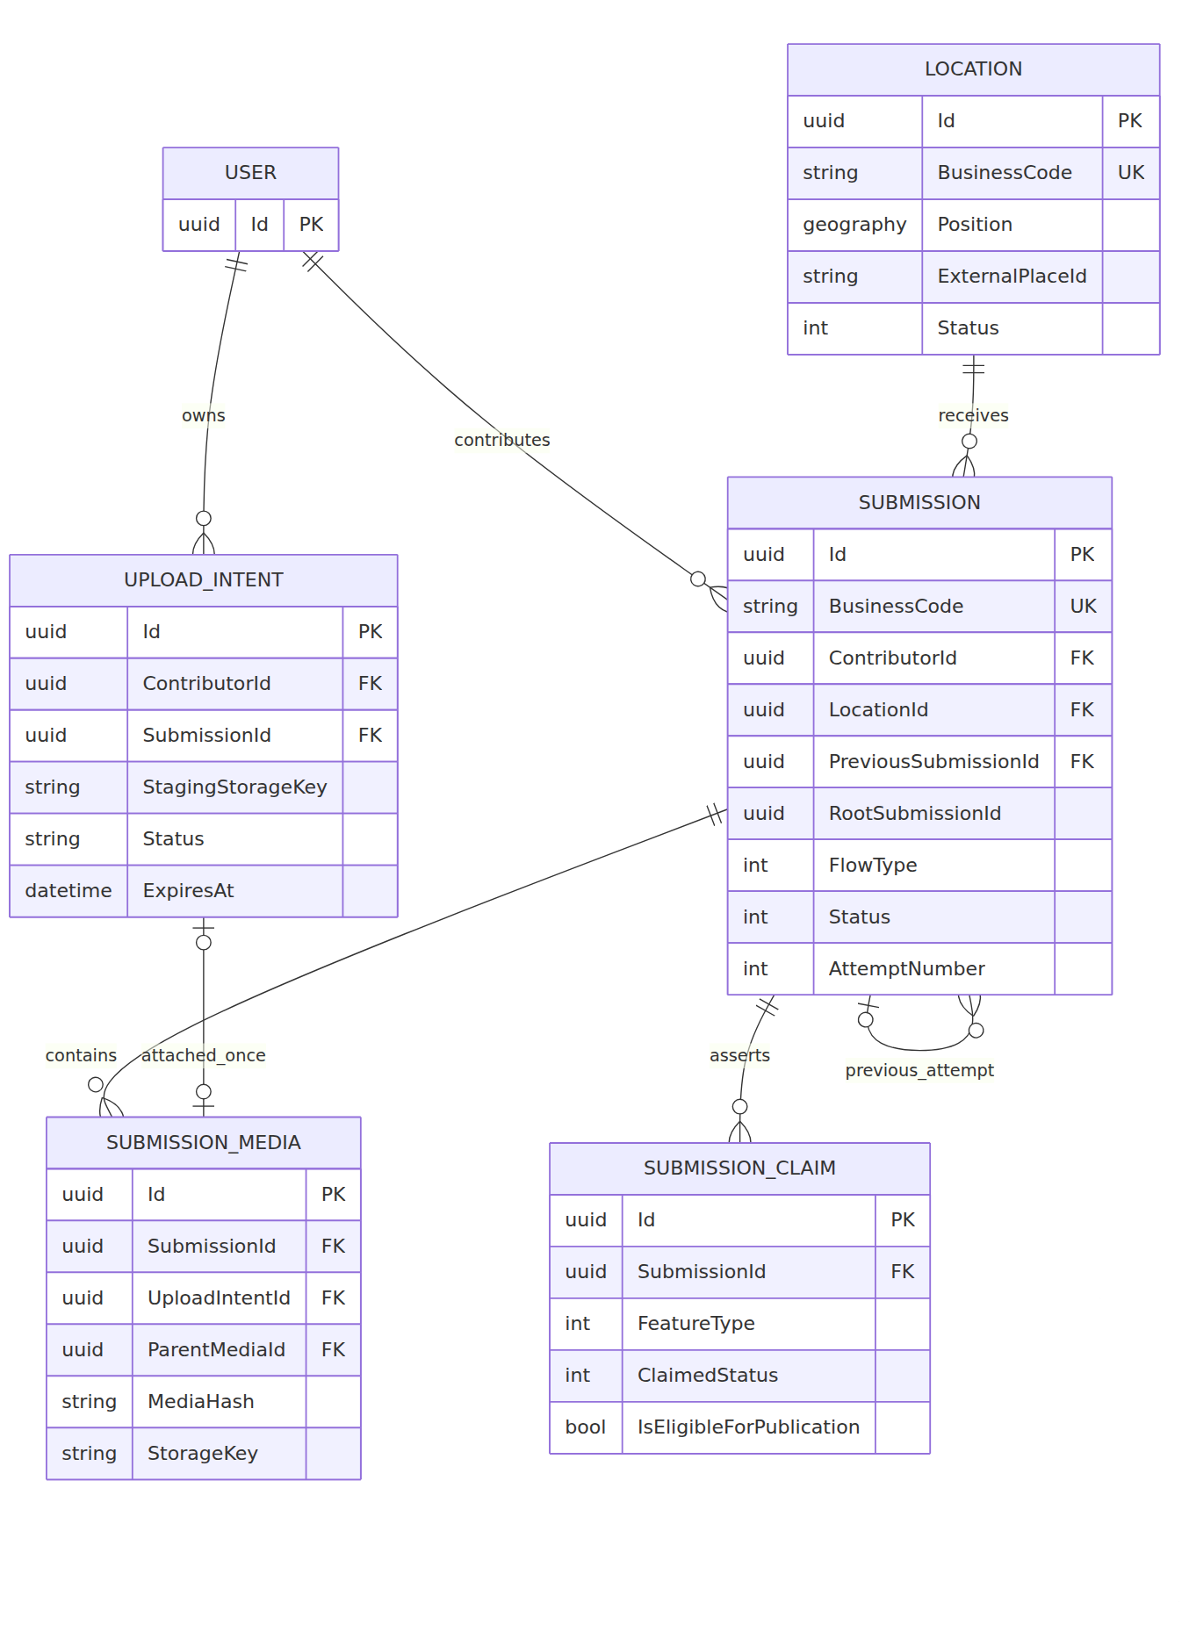
erDiagram
USER ||--o{ SUBMISSION : contributes
USER ||--o{ UPLOAD_INTENT : owns
LOCATION ||--o{ SUBMISSION : receives
SUBMISSION ||--o{ SUBMISSION_MEDIA : contains
UPLOAD_INTENT o|--o| SUBMISSION_MEDIA : attached_once
SUBMISSION ||--o{ SUBMISSION_CLAIM : asserts
SUBMISSION o|--o{ SUBMISSION : previous_attempt

USER {
uuid Id PK
}
LOCATION {
uuid Id PK
string BusinessCode UK
geography Position
string ExternalPlaceId
int Status
}
SUBMISSION {
uuid Id PK
string BusinessCode UK
uuid ContributorId FK
uuid LocationId FK
uuid PreviousSubmissionId FK
uuid RootSubmissionId
int FlowType
int Status
int AttemptNumber
}
UPLOAD_INTENT {
uuid Id PK
uuid ContributorId FK
uuid SubmissionId FK
string StagingStorageKey
string Status
datetime ExpiresAt
}
SUBMISSION_MEDIA {
uuid Id PK
uuid SubmissionId FK
uuid UploadIntentId FK
uuid ParentMediaId FK
string MediaHash
string StorageKey
}
SUBMISSION_CLAIM {
uuid Id PK
uuid SubmissionId FK
int FeatureType
int ClaimedStatus
bool IsEligibleForPublication
}
Location.Position is geography(Point,4326) with a GiST index. BusinessCode is a unique UI label, separate from the UUID key. Media bytes live in MinIO/R2: one owned staging UploadIntent can attach once to a validated immutable SubmissionMedia object. Resubmission creates a new Submission with PreviousSubmissionId; the prior evidence is never overwritten.

A.8.2.2 AI verification and criterion evidence
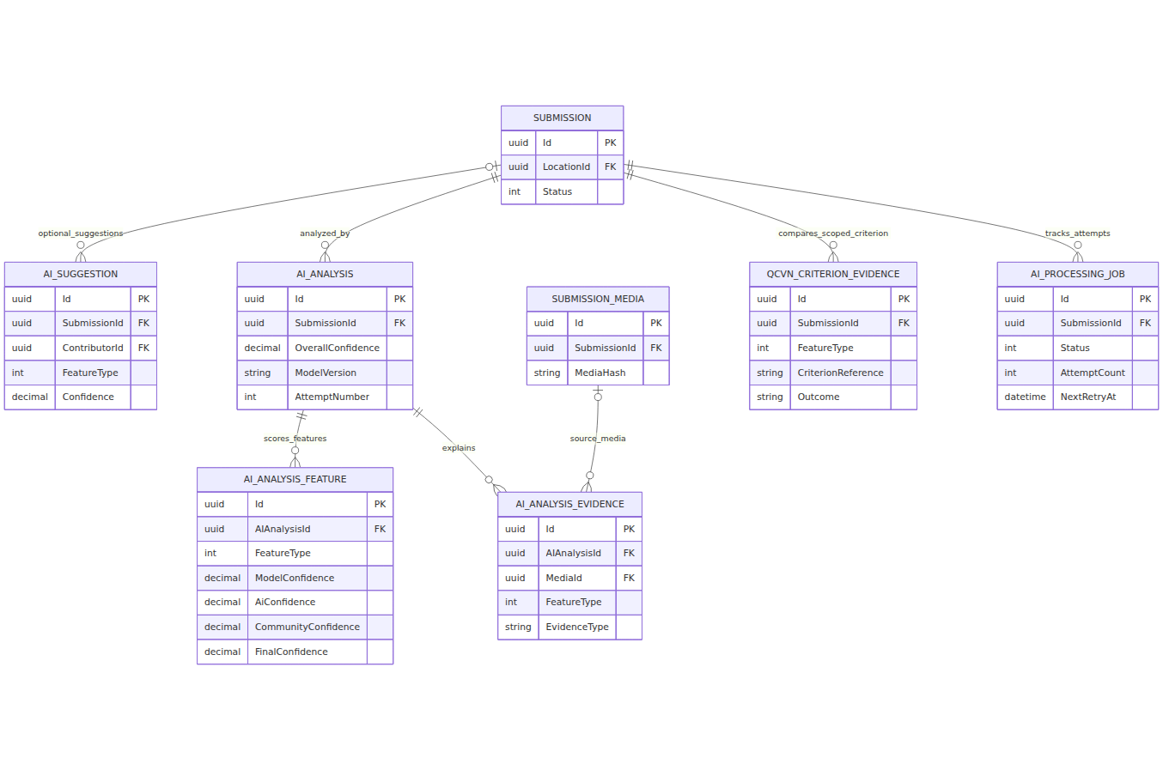
erDiagram
SUBMISSION o|--o{ AI_SUGGESTION : optional_suggestions
SUBMISSION ||--o{ AI_ANALYSIS : analyzed_by
AI_ANALYSIS ||--o{ AI_ANALYSIS_FEATURE : scores_features
AI_ANALYSIS ||--o{ AI_ANALYSIS_EVIDENCE : explains
SUBMISSION_MEDIA o|--o{ AI_ANALYSIS_EVIDENCE : source_media
SUBMISSION ||--o{ QCVN_CRITERION_EVIDENCE : compares_scoped_criterion
SUBMISSION ||--o{ AI_PROCESSING_JOB : tracks_attempts

SUBMISSION {
uuid Id PK
uuid LocationId FK
int Status
}
SUBMISSION_MEDIA {
uuid Id PK
uuid SubmissionId FK
string MediaHash
}
AI_SUGGESTION {
uuid Id PK
uuid SubmissionId FK
uuid ContributorId FK
int FeatureType
decimal Confidence
}
AI_ANALYSIS {
uuid Id PK
uuid SubmissionId FK
decimal OverallConfidence
string ModelVersion
int AttemptNumber
}
AI_ANALYSIS_FEATURE {
uuid Id PK
uuid AIAnalysisId FK
int FeatureType
decimal ModelConfidence
decimal AiConfidence
decimal CommunityConfidence
decimal FinalConfidence
}
AI_ANALYSIS_EVIDENCE {
uuid Id PK
uuid AIAnalysisId FK
uuid MediaId FK
int FeatureType
string EvidenceType
}
QCVN_CRITERION_EVIDENCE {
uuid Id PK
uuid SubmissionId FK
int FeatureType
string CriterionReference
string Outcome
}
AI_PROCESSING_JOB {
uuid Id PK
uuid SubmissionId FK
int Status
int AttemptCount
datetime NextRetryAt
}
AI_SUGGESTION.SubmissionId may be empty until a contributor submits. Python's feature confidence is kept separately from the .NET feature confidence and community consensus. A criterion row identifies one configured QCVN clause and its evidence; a generic object detection is not a whole-place compliance verdict. Hangfire schedules execution while AI_PROCESSING_JOB records the domain attempt and recovery state.

A.8.2.3 Moderation and published accessibility truth
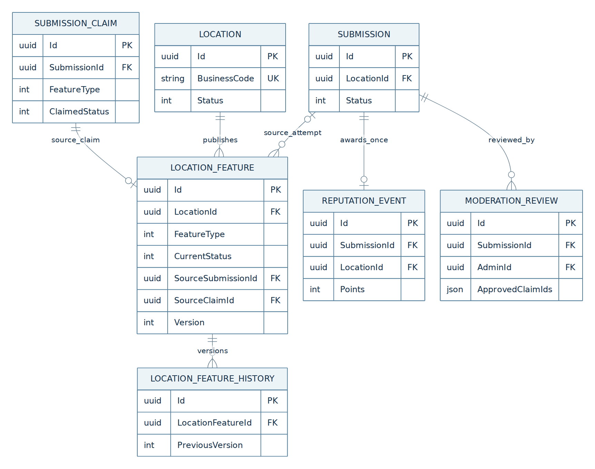
erDiagram
LOCATION ||--o{ LOCATION_FEATURE : publishes
LOCATION_FEATURE ||--o{ LOCATION_FEATURE_HISTORY : versions
SUBMISSION ||--o{ MODERATION_REVIEW : reviewed_by
SUBMISSION ||--o| REPUTATION_EVENT : awards_once
SUBMISSION o|--o{ LOCATION_FEATURE : source_attempt
SUBMISSION_CLAIM ||--o| LOCATION_FEATURE : source_claim

LOCATION {
uuid Id PK
string BusinessCode UK
int Status
}
SUBMISSION {
uuid Id PK
uuid LocationId FK
int Status
}
SUBMISSION_CLAIM {
uuid Id PK
uuid SubmissionId FK
int FeatureType
int ClaimedStatus
}
LOCATION_FEATURE {
uuid Id PK
uuid LocationId FK
int FeatureType
int CurrentStatus
uuid SourceSubmissionId FK
uuid SourceClaimId FK
int Version
}
LOCATION_FEATURE_HISTORY {
uuid Id PK
uuid LocationFeatureId FK
int PreviousVersion
}
MODERATION_REVIEW {
uuid Id PK
uuid SubmissionId FK
uuid AdminId FK
json ApprovedClaimIds
}
REPUTATION_EVENT {
uuid Id PK
uuid SubmissionId FK
uuid LocationId FK
int Points
}
Only published LOCATION_FEATURE rows represent trusted map data; contributor claims and AI suggestions stay separate. (LocationId, ScopeId, FeatureType) uniquely identifies a current scoped feature; prior values go to LOCATION_FEATURE_HISTORY. An Admin approves selected features rather than an entire Location; publication records exactly one EXP event per published Submission.

A.8.2.4 Status audit, request replay and notifications
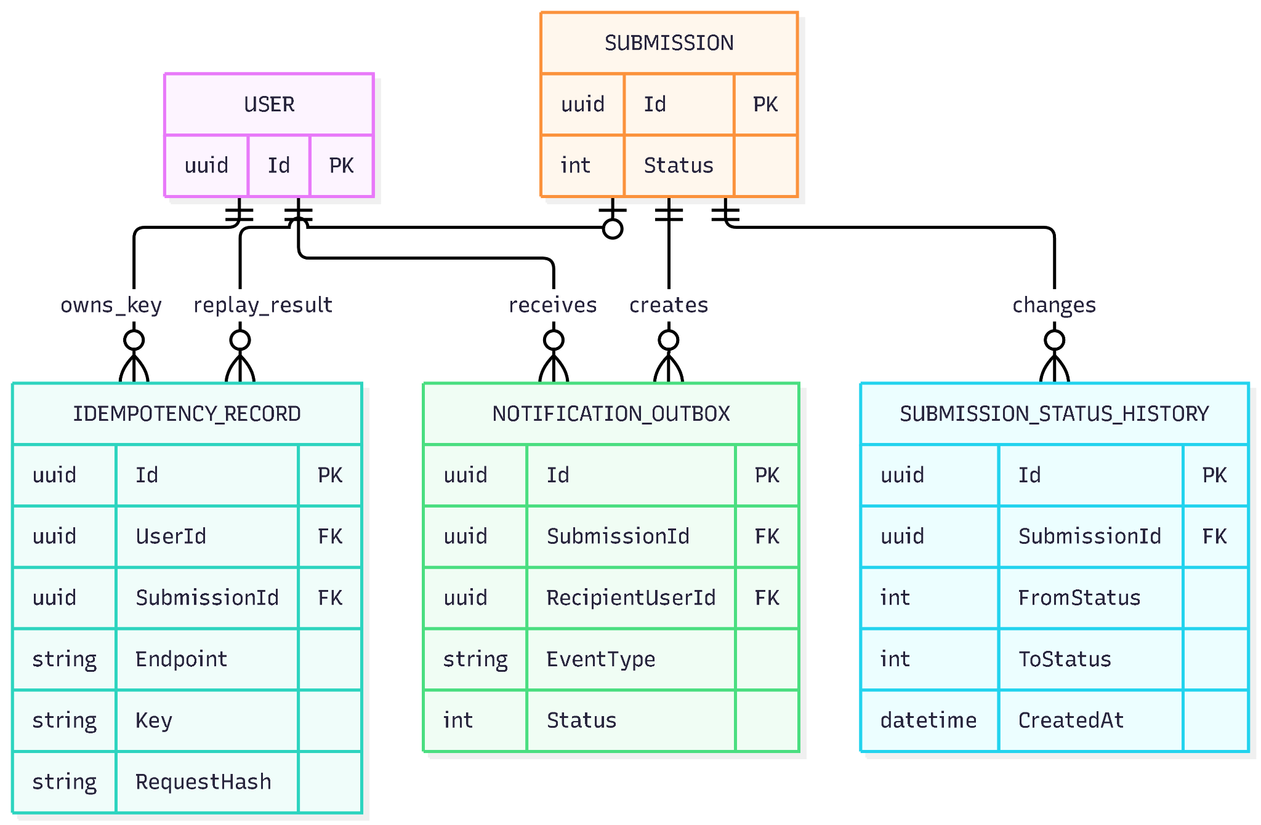
erDiagram
USER ||--o{ IDEMPOTENCY_RECORD : owns_key
SUBMISSION o|--o{ IDEMPOTENCY_RECORD : replay_result
SUBMISSION ||--o{ SUBMISSION_STATUS_HISTORY : changes
SUBMISSION ||--o{ NOTIFICATION_OUTBOX : creates
USER ||--o{ NOTIFICATION_OUTBOX : receives

USER {
uuid Id PK
}
SUBMISSION {
uuid Id PK
int Status
}
IDEMPOTENCY_RECORD {
uuid Id PK
uuid UserId FK
uuid SubmissionId FK
string Endpoint
string Key
string RequestHash
}
SUBMISSION_STATUS_HISTORY {
uuid Id PK
uuid SubmissionId FK
int FromStatus
int ToStatus
datetime CreatedAt
}
NOTIFICATION_OUTBOX {
uuid Id PK
uuid SubmissionId FK
uuid RecipientUserId FK
string EventType
int Status
}
The displayed fields are representative identifiers and decision fields, not a replacement for the complete typed tables in B.3. PK marks the primary key, FK a reference and UK a unique display code. The full ERD above shows the remaining relationships, including RESUBMISSION and SUBMISSION_MEDIA.ParentMediaId.

A.8.3 ERD interpretation
UPLOAD_INTENT exists before submission; its ID is the mediaId used by clients, and an original SUBMISSION_MEDIA row binds it exactly once. AI_SUGGESTION.SubmissionId is nullable because suggestions can precede submission. IDEMPOTENCY_RECORD.SubmissionId is nullable, though successful create/resubmit references a Submission. Both RESUBMISSION sides point to Submission. The Location self-reference applies only when merged. A media-to-evidence link is optional for text or metadata evidence.

A.8.4 Table families
Family | Tables | Why persisted
Identity and truth | USER, LOCATION, LOCATION_FEATURE, LOCATION_FEATURE_HISTORY | Stable place identity and public feature versions.
Contribution | UPLOAD_INTENT, SUBMISSION, SUBMISSION_MEDIA, SUBMISSION_CLAIM, RESUBMISSION, SUBMISSION_STATUS_HISTORY | Owned direct upload, immutable evidence attempts and actor history.
AI and criterion evidence | AI_SUGGESTION, AI_ANALYSIS, AI_ANALYSIS_FEATURE, AI_ANALYSIS_EVIDENCE, QCVN_CRITERION_EVIDENCE, AI_PROCESSING_JOB | Explainable feature results, scoped QCVN evidence and durable processing.
Decision and reliability | MODERATION_REVIEW, REPUTATION_EVENT, IDEMPOTENCY_RECORD, NOTIFICATION_OUTBOX | Audited decisions, one-time credit, request replay and durable notifications.

A.8.5 Index and constraint intent
Unique (LocationId, ScopeId, FeatureType) identifies the current feature; unique (SubmissionId, FeatureType) prevents repeated claims within one attempt. A partial unique job index prevents multiple active jobs for one Submission. Unique (UserId, Endpoint, Key) prevents a repeated HTTP operation from creating a second attempt. GiST on Location.Position makes nearby search practical. Other indexes support contributor history, moderation queues, job dispatch and feature history. Publication, cross-check and community references use the matching scope. Submission.ScopeId binds all claims and AI evidence in the attempt to one scope.

A.9 API and client integration

A.9.1 Authenticated endpoint catalog
Endpoint | Caller | Outcome
GET /api/v1/locations/search | Authenticated user | Local results, external fallback if needed; read only.
POST /api/v1/submissions/pre-scan | Contributor | Synchronous, advisory photo-quality checks and optional visibility hints; no Submission/job.
POST /api/v1/ai/suggestions | Contributor | Optional suggestion list; can fail without blocking submission.
POST /api/v1/media/upload-intents | Contributor | Create one owned staging mediaId and short-lived signed PUT URL.
POST /api/v1/submissions | Contributor | JSON with verified mediaIds and enum claims; 202 Submitted.
GET /api/v1/submissions/{id}/status | Owner/admin | State, per-feature result, next permitted action.
GET /api/v1/submissions/mine | Contributor | Paginated own attempts.
POST /api/v1/submissions/{id}/resubmit | Owner | New attempt, new AI job; predecessor unchanged.
POST /api/v1/submissions/{id}/cancel | Owner | AwaitingMoreInfo → Cancelled.
/api/v1/admin/submissions/... | Admin | Queue, detail, approve, reject, request more information.
POST /api/v1/admin/ai-jobs/{jobId}/retry | Admin | Authorized controlled job retry.

A.9.2 Submission request
application/json contains exactly one location mode, optional captured device latitude/longitude with explicit source, one or more opaque mediaIds and one or more typed accessibilityClaims whose featureType/claimedStatus values belong to canonical enums. Idempotency-Key is required for creation and resubmission, but not for upload-intent creation or pre-scan. Server checks owned staged objects and their real bytes again regardless of pre-scan; arbitrary media URLs and human-readable business codes cannot substitute for UUID identifiers. Each mediaId must carry owned capture metadata from B.7.1.0; malformed supplied coordinates fail validation, while missing/stale capture GPS permits usable evidence for Admin review. Proximity uncertainty with valid GPS routes usable evidence to Admin. A Submission selects exactly one scopeId for an existing Location, or proposedScope {kind,label,floorNumber,parentScopeId} for Flow B; the server creates/resolves that scope atomically with Location before persisting claims. All claims/media in this attempt belong to that one scope; another scope requires a separate Submission.

A.9.3 Responses and errors
Creation returns 202 Accepted, SubmissionId, Status=Submitted, LocationId, LocationCreated and a message. Status DTO returns overall confidence, per-feature outcomes, counts and action text for the owner. Use 400/422 for malformed or business-invalid input, 401/403 for auth, 404 for inaccessible/not-found resources, 409 for duplicate/stale/idempotency conflicts, and 503 for an unavailable optional suggestion provider. Media pre-scan follows its specific fallback in B.7.1.1. B.7 and B.9 define the HTTP contracts.

A.9.4 No direct entity exposure
EF entities, private storage keys, signed URLs except an authorized temporary media endpoint, raw model JSON and device EXIF/GPS never appear in generic public DTOs. DTOs return only the information a user needs to understand the outcome.

A.10 AI assistance and verification

A.10.1 Pre-submit assistance
The app runs synchronous POST /api/v1/submissions/pre-scan on staged in-app photos/videos or accepted recent gallery photos before the contributor confirms Submit. The gateway validates owned media and Python performs bounded image checks or representative video-frame checks within the timeout and resource caps. Batch larger drafts within B.4 limits. Results are advisory and create no Submission or durable AI job; a provider timeout produces basic-check feedback and an explicit warning rather than an indefinite wait. The submit endpoint independently revalidates media and capture GPS, so pre-scan success is never an authorization token. Optional POST /api/v1/ai/suggestions remains separate: contributors accept/change/ignore AI-origin suggestions; confirmed contributor claims and AI output are stored separately.

A.10.2 Post-submit execution
After commit, a Hangfire AI job atomically claims its durable domain AIProcessingJob and asynchronously calls the internal Python POST /api/v1/ai/verify over authenticated service-to-service HTTP. Python runs YOLOv8/OpenCV over validated photos and sampled video frames. The production response must include model_version and traceable media/frame provenance in extra.evidence under B.18. Legacy signals without that provenance remain advisory and cannot satisfy AutoVerified evidence requirements. The .NET backend validates the response schema, combines verified GPS/media quality and existing AccessMap evidence, calculates scoring/routing and persists evidence only when provenance is available. Python never writes Submission state, LocationFeature or EXP and never directly sets Published.

A.10.3 Evidence provenance
Each AIAnalysisEvidence row identifies its feature when applicable, evidence type, explanation and optionally source media. The verification stores provider/model version and branch outputs, including unavailable signals. Retain enough evidence to explain why a claim was accepted, withheld, corrected or sent to an admin.

A.10.4 Missing and contradictory signals
Unavailable AI branches are excluded from the AI denominator. Missing optional EXIF/container GPS alone cannot reject usable evidence; an available device fix must pass freshness/coordinate validation; absent device GPS routes usable evidence to Admin. Valid but uncertain/outside-radius capture GPS requires Admin review. Absence of visual proof for a feature prevents automatic verification. Fresh disagreement against published data, CV/NLP contradiction and suspicious timestamps force manual review as specified in B.12. A low score cannot be rescued by an unrelated strong feature.

A.11 Confidence, integrity and routing

A.11.1 AI component
For available signals only, per-feature AIConfidence = Σ(weight × normalized_signal) / Σ(available_weight). Default signal weights are CV .40, NLP .15, GPS .15, quality .15, consistency .15. These are project calibration defaults, not measured accuracy. An unavailable branch contributes neither a zero nor its denominator weight. When no AI branch exists, AIConfidence is zero and auto-verification is forbidden. Python already returns both features[feature_key].confidence (a distinct recognition confidence for each detected/assessed feature) and overall_confidence_score (an aggregate AI score for the submission). Map the first to the appropriate per-feature visual/CV signal when its value supports that claimed state; use additional available B.11.1 signals to calculate per-feature AIConfidence. overall_confidence_score remains a diagnostic provider hint in this release; never substitute it directly for AIConfidence, including a single-claim submission. The backend computes AIConfidence from the available weighted signals under B.11.1.1, then combines it with community evidence and applies hard routing rules. A provider recognition confidence is an input signal, not a verification decision.

A.11.2 Community component
For each (LocationId, ScopeId, FeatureType), previously published eligible claims are deduplicated by contributor, weighted by the authoritative ReputationScore owned by WF-04 and recency 2^(-ageDays/halfLifeDays). ConsensusRatio = WeightedAgree/WeightedTotal for a candidate claim value; zero denominator means no community evidence. ContributorFactor = min(distinctContributorCount/targetContributorCount,1). CommunityConfidence = ConsensusRatio × ContributorFactor. Default half life is 180 days and target contributors is three. WF-01 records one publication source event carrying nominal +50/+20 spendable amounts; WF4 alone applies eligible +50/+20 spendable and +5/+2 trust under its guards. The current submission never uses the points it is about to earn as a vote for itself.

A.11.3 Final score
FeatureConfidence = 0.60 × AIConfidence + 0.40 × CommunityConfidence; with no eligible historical community claims for that feature, CommunityConfidence=0 and FeatureConfidence=0.60 × AIConfidence. For example, the backend computes per-feature AIConfidence=0.845 from the available weighted signals. With CommunityConfidence=0, FeatureConfidence=0.60×0.845=0.507. The 0.845 in this example is a backend-derived intermediate value, not Python overall_confidence_score. The submission's routing score is the minimum non-Unknown claim confidence. A usable Flow B submission or Flow A claim with no independent historical evidence goes to PendingModeration before numeric thresholds; missing community votes alone do not justify retaking media. Unusable/unsafe evidence and other correction rules still request more information. A score at least .80 may reach AutoVerified only with independent community evidence and minimum visual support. The single provider-wide score cannot be copied onto multiple claims as their individual AIConfidence values. In this document 'per-feature' means per (Submission.ScopeId, FeatureType) when a Location has more than one entrance/floor; community history and independent contributors are filtered to that same scoped identity.

A.11.4 First contribution at a place
A valid first contribution creating a new Location has no independent historical community evidence. For example, AIConfidence .92 produces FeatureConfidence .552 with HasCommunityEvidence=false. The cold-start rule routes it to PendingModeration after usable-media and hard-rule checks. It never automatically publishes, and low confidence caused only by absent community evidence does not demand a retake. If media is unusable or a correction rule applies, the contributor receives AwaitingMoreInfo.

A.11.5 Override precedence
Validate schema, then calculate each feature, then apply hard integrity rules, then threshold routing. Safety flags and unusable media request correction; outside/uncertain capture GPS within the 30 m policy or embedded GPS mismatch, fresh contradiction and CV/NLP disagreement force moderation. Provider/schema failure triggers retry, not publication. All-Unknown claims request more information. Automatic publication requires a concrete non-Unknown claim, a Supported AI result, independent historical community evidence, CV evidence and passing feature confidence. Moderated publication requires usable evidence and an explicit decision; no blocking safety/quality failure may be waived. Eligible high-reputation contributors may receive a prioritized Admin queue after the same checks. Expedited review still requires an explicit authorized Admin decision, reason and audit; reputation tier alone cannot publish.

A.12 State machine, correction and moderation

A.12.1 Submission states
Submitted, AIProcessing, AwaitingMoreInfo, PendingModeration, AutoVerified, Published, Rejected, Cancelled. Only ISubmissionStateService changes a state, checks caller/transition legality and writes append-only history in the same transaction. AutoVerified is transient: a separate publication transaction produces Published. AwaitingMoreInfo is the single status for contributor-actionable corrections, including unusable media quality and other fixable evidence or content issues; it is not limited to poor-quality photos. Low confidence without an actionable evidence gap routes to PendingModeration.

A.12.2 State diagram
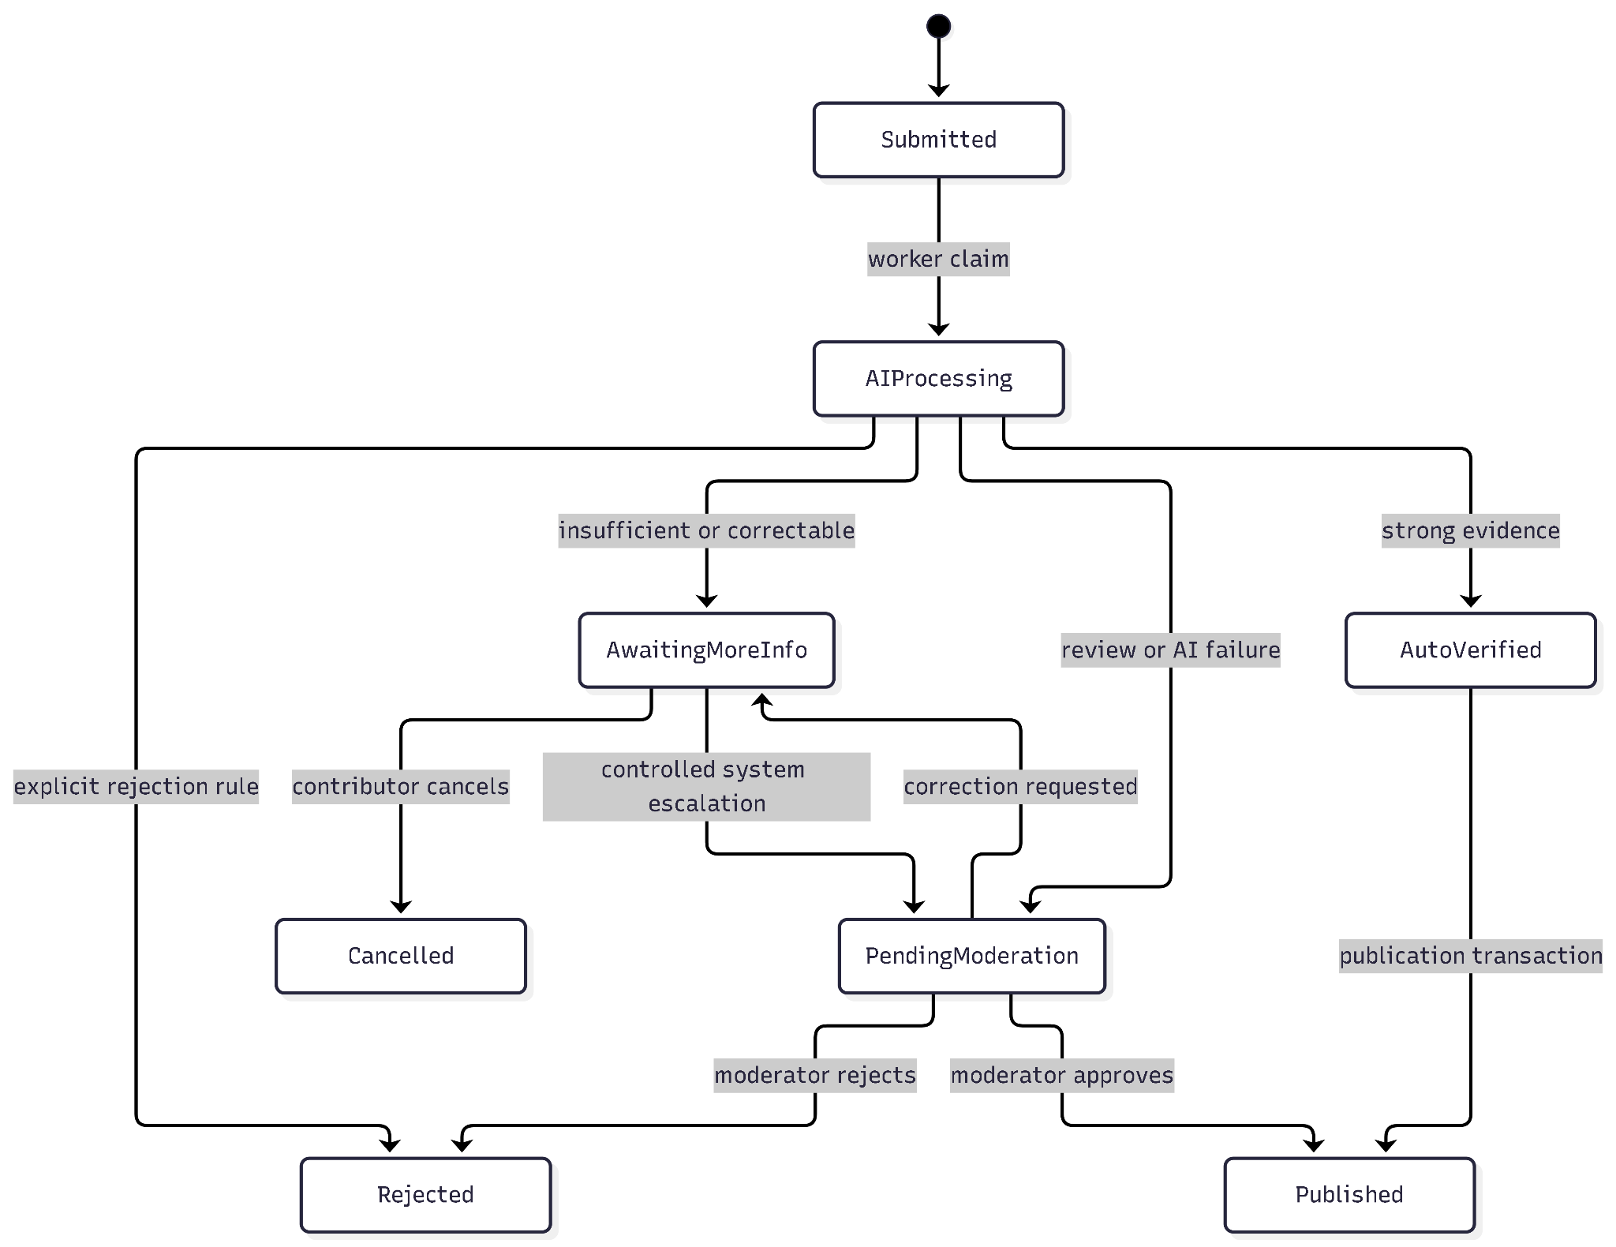
stateDiagram-v2
[*] --> Submitted
Submitted --> AIProcessing: worker claim
AIProcessing --> AwaitingMoreInfo: insufficient or correctable
AIProcessing --> PendingModeration: review or AI failure
AIProcessing --> AutoVerified: strong evidence
AIProcessing --> Rejected: explicit rejection rule
AutoVerified --> Published: publication transaction
PendingModeration --> Published: admin approves
PendingModeration --> Rejected: admin rejects
PendingModeration --> AwaitingMoreInfo: correction requested
AwaitingMoreInfo --> PendingModeration: controlled system escalation
AwaitingMoreInfo --> Cancelled: contributor cancels

A.12.3 Correction and terminal states
Published, Rejected and Cancelled are terminal and immutable. A contributor may edit only a local draft. A persisted AwaitingMoreInfo attempt retains its original claims/media; resubmission creates a child with PreviousSubmissionId, RootSubmissionId and incremented AttemptNumber. The cap is two child attempts by default. No POST or PATCH edits the original attempt in place.

A.12.4 Moderation
The admin sees each contributor-selected claim alongside the AI feature result, confidence, supporting media/evidence, quality/integrity warnings, current published feature, lineage and history. The admin UI must label the contributor's claim separately from the AI assessment; an initial contributor tag is not an AI recommendation. An Admin who contributed the submission cannot issue its moderation decision (approve, reject or request more information); another Admin must review it. This conflict-of-interest guard does not change the independent AutoVerified route when all WF-01 gates pass. If only one Admin exists, a self-originated case requiring manual moderation remains pending until another Admin is available; there is no self-approval exception. Approve publishes only eligible features transactionally; reject records a reason and preserves evidence; More Info requests a new corrected attempt. Race handling ensures an older worker cannot overwrite an admin's decision. Admin retry is only for a failed/recoverable AI job.

A.13 Publication, truth and downstream effects

A.13.1 Preconditions
The submission is AutoVerified or an authorized admin approves a pending case. Eligible claims must have concrete non-Unknown states, usable source evidence and no blocking integrity condition. When AI failed, an admin may assess that source evidence and document the decision; a moderation approval does not waive basic input/storage integrity requirements.

A.13.2 Atomic publication
Within one PostgreSQL transaction: check current state/concurrency; append old LocationFeature to history if replacing; create/update each eligible feature and version/source pointers; activate Provisional Location if this yields a published feature; create status history and idempotent ReputationEvent; set Published and commit. A duplicate or failed transaction cannot create duplicate points or partially updated truth.

A.13.3 Truth model
LocationFeature is the latest trusted statement at (LocationId, ScopeId, FeatureType) and references its source Submission and Claim. LocationFeatureHistory stores replaced versions. Earlier claims remain as evidence. A later contradictory observation starts a new Submission and follows verification/moderation; it never overwrites truth upon upload. A changed observation updates only its matching scope and feature.

A.13.4 Points and messages
On publication, record exactly one durable ReputationEvent: NewLocationPublished for Flow B or ExistingLocationEnriched for Flow A. The nominal spendable award is +50/+20 respectively; WF-04 alone checks source uniqueness and the approved rolling 30-day eligibility guard before applying actual spendable points and +5/+2 trust. Publication does not guarantee credit. Rejected, Cancelled and unpublished submissions receive no publication award. Reputation never bypasses integrity checks. Commit notification outbox work with the source transition; dispatch FCM after commit with independent retry.

A.14 Background work, retry, idempotency and concurrency

A.14.1 Durable job
Submission and domain AIProcessingJob are inserted atomically in PostgreSQL. After that commit, enqueue a Hangfire job containing only the domain job ID; a Hangfire recurring reconciliation job finds committed Queued/due RetryScheduled/expired-lease jobs when the enqueue call or process fails. Multiple Hangfire executions atomically claim the domain row by ID under a row lock, set a lease and increment attempts. An expired lease is reclaimable after crash, and a repeated computation must check the current Submission state before applying results. Hangfire persistence and the domain insert are separate commits: never claim that enqueueing after the transaction makes them atomic. BackgroundService is not a fallback dispatcher for this durable pipeline.

A.14.2 Retry policy
Default provider limit is 120 seconds and worker lease is 300 seconds. MaxRetries=3 means one initial domain execution plus at most three retries (four total executions); retry delays are 30, 120 and 600 seconds in that order. AttemptCount counts started domain executions, including the initial attempt. Schema-invalid output and transient provider failures persist RetryScheduled/NextRetryAt. Delayed Hangfire invocations wake due retries; recurring reconciliation initially runs once per minute to recover missed scheduling. Disable Hangfire automatic exception retries for this job. A crash is recovered after the domain lease expires. After four failed executions, mark the job Failed and the Submission PendingModeration with AI_VERIFICATION_FAILED; never auto-publish or strand the case.

A.14.3 Request idempotency
For create/resubmit, SHA-256 hashes the authenticated user, endpoint and canonical JSON including the ordered mediaIds; it does not require reading stored media bytes. Check (UserId,Endpoint,Key) before testing whether a mediaId is already Attached. A matching previously committed request returns its stored response even when its upload intents have expired or been attached; same key with changed JSON returns 409. For a new request, independently verify actual media bytes, compute media hashes for duplicate-evidence checks, and attach intents inside the same transaction as the response record. If two identical requests race, one transaction wins the unique key and the loser reloads that record and returns its saved response. Exactly-once notification delivery is not assumed; deduplicate by event identity.

A.14.4 Concurrency controls
Npgsql's PostgreSQL xmin protects mutable Submission and current feature updates. A admin/worker conflict reloads state and drops a stale decision. Concurrent Location creation rechecks identity under lock/unique constraint. Publication retries an optimistic conflict rather than silently overwriting a newer LocationFeature.

A.15 End-to-end flows

A.15.1 Contributor submission sequence
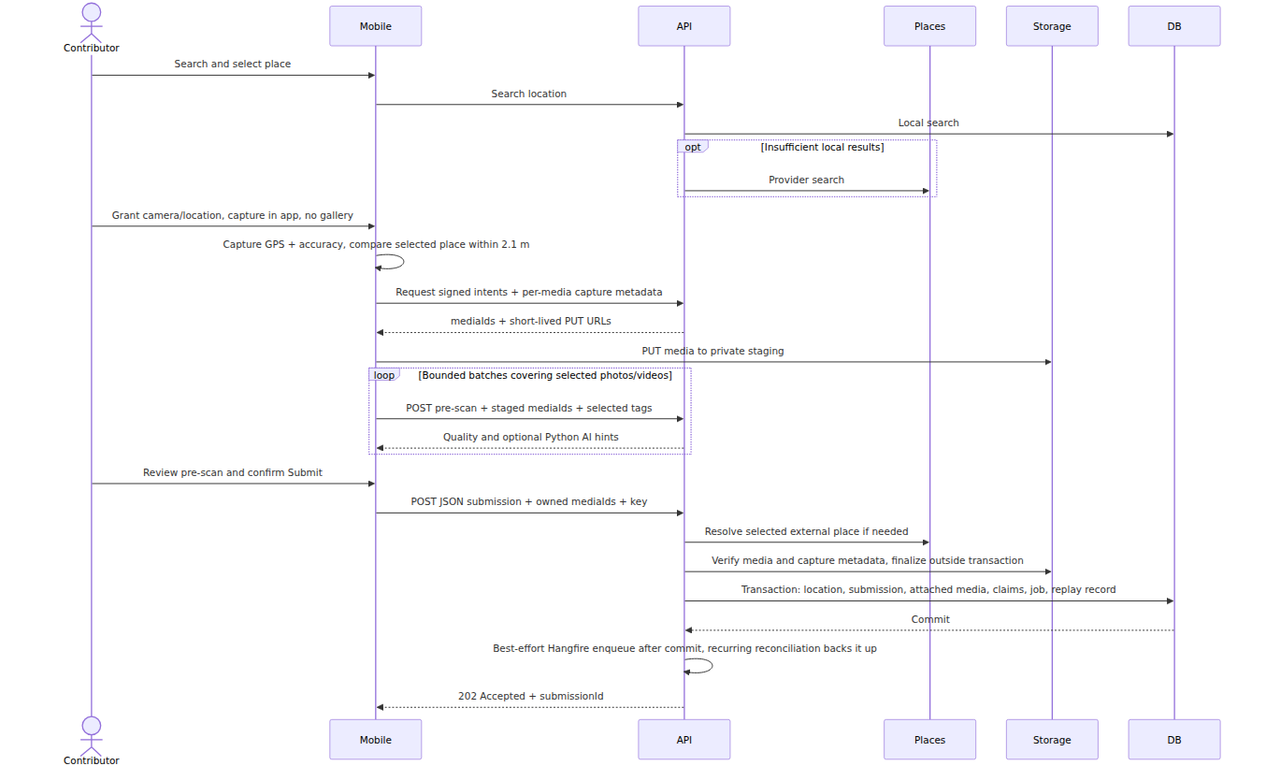
sequenceDiagram
actor Contributor
participant Mobile
participant API
participant Places
participant Storage
participant DB
Contributor->>Mobile: Search and select place
Mobile->>API: Search location
API->>DB: Local search
opt Insufficient local results
API->>Places: Provider search
end
Contributor->>Mobile: Capture in app or select recent gallery photo; location optional
Mobile->>Mobile: Capture GPS + accuracy, compare selected place within 30 m
Mobile->>API: Request signed intents + per-media capture metadata
API-->>Mobile: mediaIds + short-lived PUT URLs
Mobile->>Storage: PUT media to private staging
loop Bounded batches covering selected photos/videos
Mobile->>API: POST pre-scan + staged mediaIds + selected tags
API-->>Mobile: Quality and optional Python AI hints
end
Contributor->>Mobile: Review pre-scan and confirm Submit
Mobile->>API: POST JSON submission + owned mediaIds + key
API->>Places: Resolve selected external place if needed
API->>Storage: Verify media and capture metadata, finalize outside transaction
API->>DB: Transaction: location, submission, attached media, claims, job, replay record
DB-->>API: Commit
API->>API: Best-effort Hangfire enqueue after commit, recurring reconciliation backs it up
API-->>Mobile: 202 Accepted + submissionId

A.15.2 Verification and publication sequence
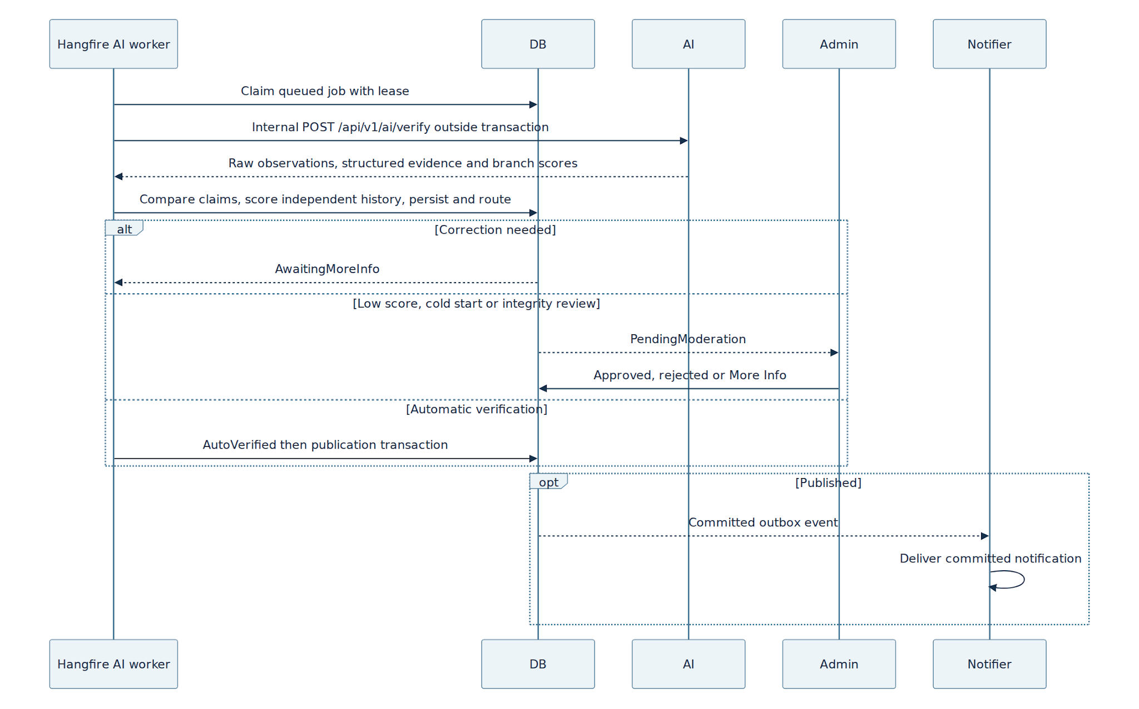
sequenceDiagram
participant Worker as Hangfire AI worker
participant DB
participant AI
participant Admin
participant Notifier
Worker->>DB: Claim queued job with lease
Worker->>AI: Internal POST /api/v1/ai/verify outside transaction
AI-->>Worker: Raw observations, structured evidence and branch scores
Worker->>DB: Compare claims, score independent history, persist and route
alt Correction needed
DB-->>Worker: AwaitingMoreInfo
else Low score, cold start or integrity review
DB-->>Admin: PendingModeration
Admin->>DB: Approved, rejected or More Info
else Automatic verification
Worker->>DB: AutoVerified then publication transaction
end
opt Published
DB-->>Notifier: Committed outbox event
Notifier->>Notifier: Deliver committed notification
end

A.15.3 Exception paths
Event | Durable outcome | User/admin action
External place lookup fails | No submission unless an already valid AccessMap identity is selected | Retry search or select an existing place.
Media validation/upload fails | No Submission/AI job; orphan storage cleanup if needed | Correct/retake and retry.
Duplicate evidence | No new attempt; existing ID returned | Open the existing attempt or supply distinct evidence.
Low confidence/unusable media/content safety | AwaitingMoreInfo | Resubmit corrected evidence or cancel.
Conflicting evidence/GPS mismatch | PendingModeration | Wait for admin decision.
AI provider exhausts retries | PendingModeration, failed job recorded | Admin reviews or retries a permitted job.
FCM fails | Published and outbox remain committed | Delivery retries independently.

A.16 Security, privacy and observability

A.16.1 Security controls
Use HTTPS, authenticated endpoints, owner- and role-based authorization, server-only secrets, private storage, short-lived media links and strict upload decoding/size checks. Ordinary mobile endpoints accept signed-in User or Admin accounts subject to the same ownership and business rules. Admin endpoints require a validated Admin role, portal-scoped session/token and the endpoint's action policy; hiding the control in React Native is not an authorization check. Never trust a role value submitted by the client or an unverified client identifier. Treat provider text, filenames, descriptions and model JSON as untrusted. Do not give a model or third-party service write access to published truth.

A.16.2 Sensitive data
Device GPS, EXIF GPS, raw media and moderation notes may be sensitive. Public place coordinates are derived from Location.Position; do not expose contributor capture coordinates as public place coordinates. Raw GPS retention must follow a declared project audit/retention policy. Logs omit JWTs, passwords, API keys, signed URLs and bytes.

A.16.3 Audit and metrics
Record SubmissionId, job/attempt, provider/model version, timing, transition actor/reason, rule codes, feature scores and publication source IDs. Track job queue age, retries, timeouts, moderation volume, correction rate and media failures. Metrics and audit entries must avoid exposing media bytes and secrets.

A.17 Verification, acceptance and traceability

A.17.1 Test levels
Domain tests cover status transitions, scoring, integrity and publication eligibility. Integration tests cover PostGIS identity resolution, transactional create/job, object-storage compensation, idempotent replay, worker lease/recovery, admin races and feature versioning. API tests cover payloads, authorization, errors and DTO secrecy. A full scenario verifies search → submit → worker → moderation/publication → public feature update.

A.17.2 Representative acceptance scenarios
Scenario | Expected result | Technical clause
Search Google result only | No Location row created | B.5
Two clients import same place at once | One Location; two valid submissions may share it | B.6.3
Same key/payload retried | Identical response, no second submission or points | B.16
Direct upload and attach | Mobile PUTs a backend-issued mediaId to private MinIO/R2; only the owner can attach verified bytes exactly once | B.3.3.1, B.7.1.0, B.8.3
Pre-scan returns blurry-photo feedback | User can retake; no Submission/job, public feature or points | B.7.1, B.8.0
Pre-scan vision AI times out | Basic quality feedback returns with ai_status=unavailable; user can still submit | B.8.0
Unknown feature or missing visual support | Feature not auto-published | B.11–B.13
New place with first valid submission | Confidence is 0.60 × AIConfidence; cold start routes PendingModeration even below .60. Publication emits the source event; WF4 applies eligible +50 spendable/+5 trust once. | B.11, B.13, B.15
Existing place enriched | Backend AutoVerified or Admin approval permits publication; WF4 credits eligible enrichment +20 spendable/+2 trust once after its checks. Ineligible repeats receive zero. | B.14–B.15
Worker crashes after claiming | Lease expires; job reclaimed safely | B.17
Published feature updated later | Version/history/source updated once | B.14
Content safety failure | AwaitingMoreInfo; new corrected attempt or cancellation | B.12, B.22

A.17.3 Requirement mapping
Requirement group | Design section | Detailed clause | Primary test group
Identity and search | A.5 | B.3, B.5–B.6 | B.21 Places/Location
Media and claims | A.6–A.7 | B.3, B.4, B.7.1, B.8 | B.21 Pre-scan/Submission
AI, scoring and routing | A.10–A.11 | B.10–B.13, B.18 | B.21 Confidence/routing
States and moderation | A.12 | B.6.6, B.7, B.22 | B.21 Moderation
Publication, points and notification | A.13 | B.3.17, B.14–B.15 | B.21 Publication
Worker and replay | A.14 | B.16–B.19 | B.21 Reliability
Security and deployment | A.3, A.16 | B.23–B.25 | API/integration security tests

A.17.4 Definition of Done
The endpoint behavior, all core tables/migrations, spatial index, private media storage, claim-by-claim analysis, correction lineage, worker retries, idempotency, moderation, feature history, points and privacy controls work against a clean PostgreSQL/PostGIS instance. The detailed acceptance list in B.25 is mandatory before declaring WF-01 complete.

A.18 Design decisions
Decision | Reason / consequence
PostgreSQL/PostGIS with canonical Location.Position | Spatial search and meter distances have one database source of truth.
AccessMap-first, Google fallback | Local truth and existing identities are reused before third-party discovery.
Provisional imported places | Discovery can precede publication without implying accessibility verification.
Feature-level truth | Independent claims, confidence and history remain explainable.
Private object storage | Database stores metadata and references, not large binaries.
Direct mobile upload | Backend issues owned staging media IDs and signed PUT URLs; submit binds validated IDs.
MinIO local and Cloudflare R2 production | Provider changes through the object-storage adapter.
Hangfire plus durable domain AIProcessingJob | API returns promptly; persistent execution and reconciliation recover missed dispatch and failures.
Python FastAPI inference service | Dedicated container performs YOLOv8/OpenCV image and video processing.
Immutable submission attempts | The exact evidence behind each decision remains auditable.
Backend-controlled state and publication | AI outputs and client input are evidence, not authority.

Part B — Detailed normative specification
The following clauses define enums, database columns and constraints, configuration defaults, request and response shapes, formulas, worker protocol, error behavior and test cases. A reference such as §11 within Part B means B.11.

B.0 Implementation governance and invariants

B.0.1 Non-negotiable architecture rules
# | Rule
R-01 | Inspect the existing solution first. Reuse existing User, Location, DbContext, authentication, authorization, storage, notification and repository/UoW patterns. Never create a duplicate User or Location entity.
R-02 | No business logic in controllers. Controllers map HTTP ↔ application services only.
R-03 | Never expose EF entities in API responses. Use the DTOs defined in §7.
R-04 | Frontend validation is never authoritative. Backend revalidates all inputs.
R-05 | AI verification never runs synchronously inside POST /submissions.
R-06 | Never call external services such as AI providers, Google Places, FCM or object storage inside a database transaction.
R-07 | Media binaries go to private object storage. PostgreSQL stores metadata only.
R-08 | No business threshold is hard-coded. Values in §4 must come from IOptions<T>.
R-09 | All Submission status changes go through ISubmissionStateService.
R-10 | AI failure never causes automatic publication.
R-11 | AI suggestions, contributor claims and AI verification results are stored separately.
R-12 | Never silently create a duplicate Location.
R-13 | Provider API keys and storage credentials never reach the client.
R-14 | Hangfire is the durable .NET AI job worker with persistent PostgreSQL storage; BackgroundService is limited to optional lightweight in-memory tasks. The dedicated Python FastAPI service performs YOLOv8/OpenCV inference and video frame extraction over internal HTTP.
R-15 | Published, Rejected and Cancelled submissions are terminal. Persisted evidence and claims remain immutable; correction/additional evidence creates a new linked Submission attempt only when the source state allows it.
R-16 | Third-party place data is place identity/context only. It is never treated as AccessMap accessibility truth.
R-17 | PostgreSQL + PostGIS is the system of record for AccessMap spatial data.
R-18 | Location.Position is the canonical geographic position. Latitude/longitude returned by the API are projections of this spatial value.
R-19 | Place search is read-only. Searching never creates a Location.
R-20 | A newly proposed/imported Location starts as Provisional and becomes Active only through successful publication or an explicit existing-location rule.
R-21 | All spatial calculations involving Location use PostGIS whenever a database query is required. Application-side Haversine may be used only for standalone validation where a database query is unnecessary.

B.0.1.1 Implementation priority
The implementation must classify work using the following priority:
Priority | Meaning | Rule
MUST | Required for WF-01 correctness | Implement before declaring WF-01 complete.
SHOULD | Required unless the existing architecture makes it unsafe or unnecessary | Document the exception if skipped.
OPTIONAL | Useful enhancement but not required for WF-01 acceptance | Do not implement unless explicitly requested.
All requirements in this specification are MUST unless explicitly marked SHOULD or OPTIONAL.

B.0.1.2 Implementation change budget
The implementation must make the smallest architectural change required to implement WF-01.
- Do not perform unrelated refactors.
- Do not rename existing public APIs, entities, roles, folders or services unless WF-01 requires it.
- Do not replace existing authentication, authorization, storage, notification, repository/UoW or exception-handling infrastructure when a compatible implementation already exists.
- Do not introduce a second persistence abstraction alongside an existing one.
- Do not upgrade framework/package versions unless required for PostgreSQL/PostGIS compatibility and explicitly justified.
- If an existing implementation conflicts with this specification, report the conflict and adapt the smallest possible surface.
- New abstractions must have a direct WF-01 responsibility.

B.0.1.3 Contract consistency check
Before writing code, the implementer must verify:
- Every section reference resolves to an existing section in this document.
- PostgreSQL + PostGIS is the only database design described by WF-01.
- The database provider, concurrency mapping and allowed state transitions agree across all sections.
- Resubmission semantics are consistent with immutable terminal submissions.
- Location creation is protected against concurrent duplicate creation.
- Configuration values referenced by business logic exist in §4.
- API DTOs do not expose EF entities or sensitive GPS/storage data.
If a contradiction is discovered in the existing solution, stop implementation of the affected phase and report the exact conflict before making a broad architectural change.

B.0.2 Execution protocol
Implement one phase at a time according to §20.
A phase is complete only when its acceptance criteria pass. Do not start phase N+1 before phase N builds and its tests are green.
The implementation must inspect the existing solution before creating or modifying entities.

B.1 Scope
WF-01 is the contribution and verification pipeline for accessibility information about a physical place.
It covers:
Search/select place
↓
In-app capture or <30-day gallery photo; optional device GPS
↓
30 m proximity check + bounded photo/video pre-scan
↓
Enter accessibility claims
↓
Review feedback and claims
↓
Confirm Submit
↓
Resolve/persist Location
↓
Persist Submission
↓
Background AI verification
↓
Confidence + integrity checks
↓
AwaitingMoreInfo / PendingModeration / AutoVerified
↓
Publication
↓
Trusted LocationFeature data
↓
Reputation + notification
WF-01 does not cover route/road accessibility.
WF-01 does not accept route/direction contributions and does not calculate travel patterns or travel speed. If a user reports an incorrect route, direction, map position or navigation result, that issue belongs to the separate Report/Moderation flow.
Accessibility is modelled per feature, not as one score for an entire building.

B.1.1 Glossary
Term | Meaning
Location | AccessMap's record for one physical place.
External place | A third-party place result, such as Google Places. It has no AccessMap Location until a submission is created against it.
Claim | A contributor's assertion about one accessibility feature in one submission.
LocationFeature | The current trusted published accessibility state of one feature at one Location.
AI suggestion | Pre-submission assistance. It never becomes a claim automatically.
AI verification | Post-submission asynchronous analysis. It provides evidence and confidence but does not independently publish data.
Provisional Location | A newly proposed/imported Location that has not yet produced trusted published accessibility data.
Active Location | A Location with published AccessMap data or an explicitly established existing record.

B.2 Canonical enums
These are the only definitions. Do not redefine them elsewhere.
public enum SubmissionStatus
{
Submitted = 0,
AIProcessing = 1,
AwaitingMoreInfo = 2,
PendingModeration = 3,
AutoVerified = 4,
Published = 5,
Rejected = 6,
Cancelled = 7
}
public enum AccessibilityFeatureType
{
Ramp = 1,
Elevator = 2,
AccessibleRestroom = 3,
AccessibleParking = 4,
WideEntrance = 5,
TactileGuidance = 6,
StepFreeAccess = 7
}
public enum FeatureClaimStatus
{
Unknown = 0,
Available = 1,
Limited = 2,
NotAvailable = 3
}
public enum AIFeatureResult
{
Unclear = 0,
Supported = 1,
NotSupported = 2
}
public enum AISuggestionState
{
NotDetected = 0,
Uncertain = 1,
Detected = 2
}
public enum MediaType
{
Photo = 1,
Video = 2,
VideoKeyFrame = 3
}
public enum AIAnalysisStatus
{
Queued = 0,
Processing = 1,
Completed = 2,
Failed = 3,
TimedOut = 4
}
public enum AIProcessingJobStatus
{
Queued = 0,
Processing = 1,
RetryScheduled = 2,
Succeeded = 3,
Failed = 4,
Cancelled = 5
}
public enum ModerationDecision
{
Approve = 1,
Reject = 2,
RequestMoreInfo = 3
}
public enum ContributionFlowType
{
ExistingEnrichment = 1,
NewLocation = 2
}
public enum ReputationEventType
{
NewLocationPublished = 1,
ExistingLocationEnriched = 2
}
public enum ReputationEventStatus
{
Pending = 0,
Credited = 1,
HeldForReview = 2,
Cancelled = 3
}
public enum LocationOrigin
{
Legacy = 0,
ContributorProposed = 1,
ExternalPlaceImport = 2,
Admin = 3
}
public enum LocationStatus
{
Provisional = 0,
Active = 1,
Merged = 2,
Hidden = 3
}
public enum PlaceResultSource
{
AccessMap = 1,
External = 2
}

B.2.1 Claim ↔ AI result agreement
AIFeatureResult is the backend's assessment of evidence against the specific SubmissionClaim, not Python's detected-object value. Supported=1 means the evidence supports the claimed status; NotSupported=2 means it contradicts or does not support that status; Unclear=0 is inconclusive. ClaimAgreement is in [0,1]. For NotAvailable, require explicit contextual evidence of absence or an unusable condition; failure to detect an object is not proof of absence.
Claim | Supported | Unclear | NotSupported
Available | 1.00 | 0.50 | 0.00
Limited | 1.00 | 0.50 | 0.00
NotAvailable | 1.00 | 0.50 | 0.00
Unknown | 0.00 | 0.00 | 0.00
A claim with Unknown:
- is never eligible for publication;
- never increases overall confidence.

B.3 PostgreSQL + PostGIS data model
The database engine is:
PostgreSQL
+
PostGIS
Required PostgreSQL extension:
CREATE EXTENSION IF NOT EXISTS postgis;
The project uses:
EF Core
Npgsql.EntityFrameworkCore.PostgreSQL
NetTopologySuite
for spatial mapping.
PostGIS SRID:
4326
Spatial type:
geography(Point, 4326)
geography is used because AccessMap works with real-world Earth coordinates and distance in meters.
Shared account constraints: reuse the existing User.Email/NormalizedEmail and User.PhoneNumber fields. Store phone numbers in one canonical E.164 form and enforce NOT NULL/UNIQUE on the stored phone value. Trim and normalize email through the existing auth normalizer and enforce NOT NULL/UNIQUE on the canonical email comparison; do not strip dots or plus-address suffixes. If the existing schema uses different equivalent names, map to it instead of adding duplicate columns/entities. Required registration contact fields cannot be blank. Preliminary duplicate checks are advisory; final User creation atomically rechecks both unique constraints after OTP success. Concurrent registrations sharing either canonical email or phone cannot both create accounts. Bind the OTP result to the exact pending registration and selected contact; an expired pending request does not permanently reserve either contact. Reuse existing per-channel confirmation fields (EmailConfirmed/PhoneNumberConfirmed or equivalent), setting only the successfully verified channel.

B.3.1 Location — extend existing table
Never recreate the existing Location entity.
Add only missing fields.
Column | PostgreSQL type | Null | Notes
ExternalPlaceId | varchar(200) | yes | Google place ID
BusinessCode | varchar(40) | no | Unique display code such as LOC-SGC-0102; never the primary key
ExternalPlaceProvider | varchar(50) | yes | GooglePlaces
ExternalPlaceFetchedAt | timestamptz | yes | When external data was copied
NormalizedName | varchar(300) | yes | Shared normalization
NormalizedAddress | varchar(500) | yes | Shared normalization
Position | geography(Point,4326) | no | Canonical spatial position
Origin | integer | no | LocationOrigin
Status | integer | no | LocationStatus
MergedIntoLocationId | uuid | yes | FK → Location.Id
OriginatingSubmissionId | uuid | yes | Root Submission that created a Flow B Location
Do not use separate database latitude/longitude columns as the spatial source of truth.
The API may expose:
{
"latitude": 10.7712,
"longitude": 106.7003
}
by reading the coordinates from Position.

Indexes
Create:
UX_Location_ExternalPlaceId
UNIQUE
WHERE ExternalPlaceId IS NOT NULL
UX_Location_BusinessCode UNIQUE
IX_Location_NormalizedName
IX_Location_NormalizedAddress
GIST index on Position
Example conceptual PostgreSQL index:
CREATE INDEX "IX_Location_Position"
ON "Locations"
USING GIST ("Position");
The GIST index is mandatory for efficient nearby/spatial searches. AccessScope (new table): Id uuid PK; LocationId uuid FK; ParentScopeId uuid nullable FK within same Location; Kind BuildingGeneral/Entrance/Floor/Unit; Label varchar(120); FloorNumber integer nullable; Position geography(Point,4326) nullable except approved Entrance anchors; PositionStatus Proposed/Approved/Retired; PositionVersion integer; CoverageStatus Known/Unknown; CreatedAt/UpdatedAt. Enforce one BuildingGeneral per Location, parent consistency and GiST on approved Entrance.Position. Only an Admin-approved entrance position/version is eligible for automatic GPS proximity. Changes append LocationMetadataHistory with old/new coordinate, actor, reason, evidence and effective version; old capture snapshots stay immutable. Location.MetadataVersion integer starts at 1 and increments only for approved metadata changes, guarded by expectedVersion or xmin; merge/rename and entrance changes preserve versioned audit. The history writer is the sole authorized path for changes to canonical address/position. LocationMetadataHistory has ChangeType=LocationMetadata/EntranceAnchor, nullable ScopeId for an Entrance, old/new values, source report/submission, actor, decision, reason, EffectiveAt and location/scope version as applicable. A change affecting an entrance records that scope's PositionVersion rather than pretending Location.Position moved.

B.3.2 Submission
Column | PostgreSQL type | Null | Notes
Id | uuid | no
BusinessCode | varchar(40) | no | Unique display code such as AMV-2026-08942; never an API UUID
FlowType | integer | no | Server-derived ExistingEnrichment (A) or NewLocation (B); inherited on resubmit
ContributorId | uuid | no
LocationId | uuid | no
Status | integer | no
TextDescription | text | yes
DeviceLatitude | double precision | yes
DeviceLongitude | double precision | yes
MediaGpsLatitude | double precision | yes
MediaGpsLongitude | double precision | yes
GpsDistanceMeters | double precision | yes
AiConfidence | numeric(5,4) | yes
PreviousSubmissionId | uuid | yes | Previous immutable Submission in the lineage
RootSubmissionId | uuid | yes | Root Submission for lineage; null only for legacy rows if not backfilled
AttemptNumber | integer | no | 0 for original submission; increments by 1 for each resubmission
CreatedAt | timestamptz | no
UpdatedAt | timestamptz | no
PublishedAt | timestamptz | yes
RejectedAt | timestamptz | yes
RejectionReason | text | yes
Concurrency uses PostgreSQL's system xmin through EF Core/Npgsql. No SQL Server-style rowversion is used.
Indexes:
IX_Submission_ContributorId
IX_Submission_LocationId
IX_Submission_Status
IX_Submission_CreatedAt
IX_Submission_LocationId_CreatedAt
UX_Submission_BusinessCode UNIQUE
Scope contract: Submission.ScopeId uuid FK → AccessScope.Id of its Location; all SubmissionClaim rows inherit it. Flow B creates Location plus one proposed scope in the same transaction; Flow A validates a selected existing scope. Existing Submission rows backfill to their Location's BuildingGeneral scope (CoverageUnknown). Preserve one scope across a resubmission lineage, or create a new independent Submission for another scope.
All entity primary/foreign keys, including Location.Id, Submission.Id, Submission.PreviousSubmissionId, UploadIntent.Id and SubmissionMedia.Id, are UUID v4. BusinessCode is a separate unique display string. Server generates a collision-safe value with a database sequence or equivalent unique allocation inside the relevant create transaction; migration backfills codes for existing Locations before making the column required. UI may display LOC-SGC-0102 / AMV-2026-08942, while routes and request UUID fields use real database IDs. A business code is never parsed as a UUID.

B.3.3 SubmissionMedia
Column | PostgreSQL type | Null | Notes
Id | uuid | no
SubmissionId | uuid | no
UploadIntentId | uuid | yes | Unique owned intent for original uploaded media; null for derived frames
ParentMediaId | uuid | yes
MediaType | integer | no
StorageKey | varchar(500) | no
FileName | varchar(260) | no
ContentType | varchar(100) | no
FileSizeBytes | bigint | no
Width | integer | yes
Height | integer | yes
DurationSeconds | double precision | yes
FrameTimestampSeconds | double precision | yes
Latitude | double precision | yes
Longitude | double precision | yes
CapturedAt | timestamptz | yes
BlurScore | numeric(10,4) | yes
PassedQualityCheck | boolean | no
MediaHash | char(64) | no
CreatedAt | timestamptz | no
PreScanAuthenticity | jsonb | yes | Immutable per-original copy from UploadIntent on Submit; NotAssessed/NoSignal/Suspected, media hash, reason codes, policy/model version and time.
EXIF GPS schema extension: SubmissionMedia.ExifGpsParseStatus varchar(12) NOT NULL is Missing, Parsed or Invalid for original photos (Missing for media without original EXIF GPS). SubmissionMedia.ExifGpsDistanceMeters double precision NULL stores the original photo-to-canonical-Location distance when a parsed photo and Location are available. Parsed requires valid Latitude and Longitude and a nonnegative distance after Location resolution; Missing and Invalid leave EXIF-specific coordinates/distance null. Optional EXIF parsing failure alone does not flip PassedQualityCheck. Enforce consistency in the EF model and migration.
Capture schema extension: UploadIntent.CaptureMetadata jsonb NOT NULL for new original uploads is immutable after issuance and is copied to SubmissionMedia.CaptureMetadata jsonb on attachment. Derived frames inherit their original via ParentMediaId and do not invent independent fixes; legacy/derived rows may have null metadata and are ineligible for automatic verification without adequate provenance. Required provenance fields: source=InAppCamera or GalleryPhoto; capturedAt (UTC) with capture-time evidence, immutable server receivedAt, and selected-place/ManualPin source. Device position {latitude,longitude,accuracyMeters,fixRecordedAt} is optional; an in-app video may provide endCapturedAt/endPosition when available. ManualPin coordinates never populate device-fix fields. GalleryPhoto requires age <30×24h and credible capture-time evidence; otherwise AwaitingMoreInfo or an explicit Admin historical-context exception. GalleryPhoto, missing device fix and manual-only position require Admin review for otherwise usable evidence. Bind an immutable target snapshot using existing locationId, externalPlaceId or a proposed place position. SubmissionMedia.CaptureGpsAssessment jsonb stores targetPosition, policy version/radius, per-fix distance, Within/Uncertain/Outside result and reason codes calculated by the server. Enforce finite ranges, nonnegative accuracy and timestamp consistency in DTO/EF validation; jsonb shape checks in migration must reject malformed new originals. Existing Latitude/Longitude and EXIF fields remain embedded metadata, not capture-device coordinates. CaptureGpsAssessment also records target anchor source (approved entrance or approximate place pin), approval/version, reported accuracy ceiling and proximity policy version. A place pin or proposed position without an approved entrance anchor is Uncertain for automatic proximity even when numerically nearby; retain the immutable original target snapshot. Submission.ScopeId identifies the single claimed area; selected EntranceScopeId and approved anchor PositionVersion are separately captured on UploadIntent/SubmissionMedia for GPS routing. They must resolve to the same Location. Changing the entrance after capture requires new evidence or Admin review, never silent reuse of Within. Authenticity persistence: UploadIntent.PreScanAuthenticity jsonb nullable stores the latest bounded assessment for this owned original with MediaHash, Assessment (NotAssessed/NoSignal/Suspected), ReasonCodes, PolicyVersion, ModelVersion nullable and AssessedAt; re-capture creates a new intent. On Submit, copy the exact assessment snapshot to SubmissionMedia.PreScanAuthenticity jsonb and retain the original hash. This is distinct from PassedQualityCheck and capture GPS. Absent or stale pre-scan is NotAssessed, never NoSignal.
Indexes:
IX_SubmissionMedia_SubmissionId
IX_SubmissionMedia_MediaHash
UX_SubmissionMedia_UploadIntentId UNIQUE WHERE UploadIntentId IS NOT NULL
IX_SubmissionMedia_ParentMediaId

B.3.3.1 UploadIntent — private staged media
Column | PostgreSQL type | Null | Purpose
Id (mediaId) | uuid | no | Server-generated UUID v4; never a URL.
ContributorId | uuid | no | Owner of this upload capability.
StagingStorageKey | varchar(500) | no | Random private key generated by backend.
FinalStorageKey | varchar(500) | yes | Immutable server-chosen destination if copied before commit.
MediaType | integer | no | Photo or Video.
DeclaredContentType | varchar(100) | no | Checked against real bytes on submission.
DeclaredSizeBytes | bigint | no | Request hint, not trusted as actual size.
ActualSizeBytes | bigint | yes | Populated by backend verification.
MediaHash | char(64) | yes | SHA-256 computed by backend from actual bytes.
Status | varchar(20) | no | Issued / Attached / Expired.
SubmissionId | uuid | yes | Set once on successful submission transaction.
ExpiresAt | timestamptz | no | Expiry for using an unattached intent.
CreatedAt | timestamptz | no | Audit/cleanup.
PreScanAuthenticity | jsonb | yes | Latest pre-scan assessment of owned original, bound to MediaHash; absent/stale means NotAssessed.
Index (ContributorId, Status, ExpiresAt) supports owner lookup and cleanup. Unique SubmissionId does not apply: one Submission may attach several media IDs. The attach operation checks owner, validity, storage key, verified object bytes and status under a row lock; after commit one intent belongs to exactly one Submission. Pre-scan may read Issued intents and does not attach them. Expired unreferenced objects are removed by a reconciler. CaptureMetadata is bound to the owned intent before upload and cannot be swapped at submit; changing media/target requires a new intent and pre-scan. A source label and client GPS are integrity signals, not cryptographic proof that a camera or location was genuine.

B.3.4 SubmissionClaim
Column | PostgreSQL type | Null
Id | uuid | no
SubmissionId | uuid | no
FeatureType | integer | no
ClaimedStatus | integer | no
Description | text | yes
MeasurementValue | numeric(8,2) | yes
MeasurementUnit | varchar(20) | yes
IsEligibleForPublication | boolean | no
VerificationResult | integer | yes
Confidence | numeric(5,4) | yes
CreatedAt | timestamptz | no
SubmissionClaim inherits required Submission.ScopeId; no duplicated claim scope column.
Unique:
(SubmissionId, FeatureType)

B.3.5 AISuggestion
Column | PostgreSQL type | Null
Id | uuid | no
SubmissionId | uuid | yes
ContributorId | uuid | no
CorrelationId | uuid | no
FeatureType | integer | no
SuggestedState | integer | no
Confidence | numeric(5,4) | no
Reason | varchar(500) | yes
ModelVersion | varchar(100) | yes
CreatedAt | timestamptz | no
Indexes:
IX_AISuggestion_CorrelationId
IX_AISuggestion_SubmissionId

B.3.6 AIAnalysis
Column | PostgreSQL type | Null
Id | uuid | no
SubmissionId | uuid | no
Status | integer | no
OverallConfidence | numeric(5,4) | yes
ModelVersion | varchar(100) | yes
ProviderName | varchar(100) | yes
RawResultJson | jsonb | yes
StartedAt | timestamptz | no
CompletedAt | timestamptz | yes
ErrorCode | varchar(50) | yes
ErrorMessage | text | yes
AttemptNumber | integer | no
FullScanAuthenticity | jsonb | yes
Indexes:
IX_AIAnalysis_SubmissionId
IX_AIAnalysis_Status AIAnalysis.FullScanAuthenticity jsonb stores one per-original mediaId/hash assessment with Assessment, ReasonCodes, PolicyVersion, ModelVersion nullable, AssessedAt and attempt number. AIAnalysis represents a post-submit full-scan attempt only; enforce UNIQUE (SubmissionId, AttemptNumber). Pre-scan remains an advisory assessment on UploadIntent/SubmissionMedia and creates no AIAnalysis. Preserve each AIAnalysis attempt; the backend routes using the successful current attempt plus the immutable pre-scan snapshot. Do not overwrite a previous attempt or infer NoSignal from null.

B.3.7 AIAnalysisFeature
Column | PostgreSQL type | Null | Notes
Id | uuid | no
AIAnalysisId | uuid | no
ComparedSubmissionClaimId | uuid | yes | FK to same-Submission claim with matching ScopeId/FeatureType; null for unclaimed AI observations.
FeatureType | integer | no
Result | integer | no
ModelConfidence | numeric(5,4) | no | Provider/model output confidence
CvScore | numeric(5,4) | yes
NlpScore | numeric(5,4) | yes
AiConfidence | numeric(5,4) | no | Normalized AI component after missing-signal handling
ConsensusRatio | numeric(5,4) | no | Reputation-weighted consensus for the evaluated claim value
CommunityConfidence | numeric(5,4) | no | Consensus ratio × contributor factor
HasCommunityEvidence | boolean | no | True only when eligible independent historical claims have positive total weight
ContributorFactor | numeric(5,4) | no | Independent-contributor diversity factor
DistinctContributorCount | integer | no
WeightedAgree | numeric(18,6) | no | Audit value
WeightedTotal | numeric(18,6) | no | Audit value
CommunityInputSnapshot | jsonb | yes | Internal snapshot of eligible historical claim IDs, contributor IDs, WF-04 score, recency/effective weight and evaluation time; no public DTO exposure
FinalConfidence | numeric(5,4) | no | AI + community confidence
Explanation | text | yes
CreatedAt | timestamptz | no
Unique:
(AIAnalysisId, FeatureType)

B.3.8 AIAnalysisEvidence
Column | PostgreSQL type | Null
Id | uuid | no
AIAnalysisId | uuid | no
AIAnalysisFeatureId | uuid | yes
FeatureType | integer | yes
EvidenceType | varchar(50) | no
Description | text | no
MediaId | uuid | yes
CreatedAt | timestamptz | no
Allowed EvidenceType:
Visual
Text
Ocr
Metadata
ExistingData

Evidence FK constraints: AIAnalysisEvidence.AIAnalysisId is required. Its optional AIAnalysisFeatureId must reference an observation of that same AIAnalysis; when FeatureType is present it must match. MediaId optionally references an original or derived SubmissionMedia from the same Submission. ComparedSubmissionClaimId is matched by the backend, not accepted as an unrestricted Python reference. A pre-scan creates no AIAnalysis; a Submission may have multiple immutable full-scan attempts, with exactly one selected successful attempt used for its decision.

B.3.8.1 QCVNCriterionEvidence — scoped evidence comparison
Populate this table only for a criterion the team maps to a named clause, required measurements and evidence. Generic YOLO detections never establish compliance.
Column | PostgreSQL type | Null | Purpose
Id | uuid | no | UUID v4 key.
SubmissionId | uuid | no | Source immutable Submission.
FeatureType | integer | no | Relevant feature enum.
StandardVersion | varchar(50) | no | Vietnamese technical regulation QCVN 10:2024/BXD.
CriterionReference | varchar(100) | no | Exact team-reviewed criterion.
RequiredEvidenceJson | jsonb | no | Required measurements and media.
ObservedEvidenceJson | jsonb | yes | Values, units, media and provenance.
Outcome | varchar(30) | no | Observed, InsufficientEvidence or Reviewed.
AssessedBy | uuid | yes | Reviewer, when applicable.
AssessedAt | timestamptz | no | Audit timestamp.
Unique (SubmissionId, FeatureType, StandardVersion, CriterionReference). An unmapped criterion has no assessment row. Missing measurements give InsufficientEvidence; never infer whole-place compliance from an object-detection score.

B.3.9 AIProcessingJob
Column | PostgreSQL type | Null
Id | uuid | no
SubmissionId | uuid | no
Status | integer | no
AttemptCount | integer | no
NextRetryAt | timestamptz | yes
LockedUntil | timestamptz | yes
LockedByWorkerId | varchar(100) | yes
ErrorCategory | varchar(50) | yes
ErrorMessage | text | yes
CreatedAt | timestamptz | no
StartedAt | timestamptz | yes
CompletedAt | timestamptz | yes
Create a partial unique index so only one active job exists:
CREATE UNIQUE INDEX "UX_AIProcessingJob_ActiveSubmission"
ON "AIProcessingJobs" ("SubmissionId")
WHERE "Status" IN (0, 1, 2);
Dispatcher index:
IX_AIProcessingJob_Status_NextRetryAt

B.3.10 SubmissionStatusHistory
Column | PostgreSQL type | Null
Id | uuid | no
SubmissionId | uuid | no
FromStatus | integer | yes
ToStatus | integer | no
ChangedByUserId | uuid | yes
Actor | varchar(20) | no
ReasonCode | varchar(200) | yes
Reason | text | yes
CreatedAt | timestamptz | no
Append-only.

B.3.11 Resubmission
Column | PostgreSQL type | Null | Notes
Id | uuid | no
PreviousSubmissionId | uuid | no | Submission that requested/triggered the correction
NewSubmissionId | uuid | no | Newly created immutable Submission
AttemptNumber | integer | no | 1-based resubmission attempt
RequestedReason | text | no | Why new evidence is requested
RequestedByUserId | uuid | yes | Admin/system requester
ContributorNote | text | yes | Contributor's new note
CreatedAt | timestamptz | no

B.3.12 ModerationReview
Column | PostgreSQL type | Null | Notes
Id | uuid | no
SubmissionId | uuid | no
AdminId | uuid | no
Decision | integer | no
Reason | text | yes
ApprovedClaimIds | jsonb | yes | JSON array of SubmissionClaim UUIDs belonging to this Submission when Decision = ModerationDecision.Approve; not feature-type names. Null otherwise. Each selected claim must pass non-waivable evidence/integrity gates.
CreatedAt | timestamptz | no

B.3.13 ReputationEvent
Column | PostgreSQL type | Null | Notes
Id | uuid | no
UserId | uuid | no
SubmissionId | uuid | no
LocationId | uuid | no | EXP publication target
Type | integer | no
Points | integer | no | Nominal spendable award (+50/+20); retain for source audit, not as proof of actual credit.
Status | integer | no | WF-04 outcome: Pending/HeldForReview is unresolved; Credited requires committed eligible credit; Cancelled includes ineligible repeats with Reason.
Reason | varchar(500) | yes
CreatedAt | timestamptz | no
CreditedAt | timestamptz | yes | Set only when WF-04 commits eligible credit; otherwise null.
Unique:
(SubmissionId)
Unique filtered (LocationId) WHERE Type = NewLocationPublished prevents duplicate +50 EXP for one place.

B.3.14 LocationFeature — trusted accessibility dataset
This is the destination of the WF-01 pipeline. Current status is unique per (LocationId, ScopeId, FeatureType); no floor or entrance inherits another scope's consensus.
Column | PostgreSQL type | Null
Id | uuid | no
LocationId | uuid | no
FeatureType | integer | no
CurrentStatus | integer | no
Confidence | numeric(5,4) | no
SourceSubmissionId | uuid | no
SourceClaimId | uuid | no
Version | integer | no
VerifiedAt | timestamptz | no
UpdatedAt | timestamptz | no
ScopeId uuid NOT NULL FK → AccessScope.Id.
Unique:
(LocationId, ScopeId, FeatureType)

Current-source cardinality: add UNIQUE (SourceClaimId) on LocationFeature. Each published current feature has exactly one SourceClaimId; a claim can source zero or one current feature. Historical replacements remain in LocationFeatureHistory; multiple independent supporting or contradicting claims are read by the scoped consensus query and captured in CommunityInputSnapshot. Do not create a generic Claim–Feature many-to-many table.

B.3.15 LocationFeatureHistory
The prior complete snapshot is appended in the same transaction that replaces a current LocationFeature. Its fields are: LocationFeatureHistory carries ScopeId and scope-version/effective-time snapshot; the public timeline does not infer an unrecorded floor.
Column | PostgreSQL type | Null | Meaning
Id | uuid | no | Primary key.
LocationFeatureId | uuid | no | FK to the continuing current-feature identity.
LocationId | uuid | no | Place for historic queries.
FeatureType | integer | no | Feature being replaced.
PreviousStatus | integer | no | Previously published status.
PreviousConfidence | numeric(5,4) | no | Previously published score.
PreviousSourceSubmissionId | uuid | no | Original published evidence.
PreviousSourceClaimId | uuid | no | Original claim.
PreviousVersion | integer | no | Version before the replacement.
PreviousVerifiedAt | timestamptz | no | Original verification time.
ReplacedAt | timestamptz | no | Replacement time.
UNIQUE(LocationFeatureId, PreviousVersion) prevents writing the same historic version twice. Index (LocationId, ScopeId, FeatureType, ReplacedAt DESC) supports scoped auditing. Rows are append-only. Historical FKs must use restrictive delete behavior so old evidence cannot be cascaded away accidentally.

B.3.16 IdempotencyRecord
Column | PostgreSQL type | Null
Id | uuid | no
UserId | uuid | no
Endpoint | varchar(200) | no
Key | varchar(100) | no
RequestHash | char(64) | no
ResponseStatusCode | integer | no
ResponseBodyJson | jsonb | no
SubmissionId | uuid | yes
CreatedAt | timestamptz | no
ExpiresAt | timestamptz | no
Unique:
(UserId, Endpoint, Key)

B.3.17 NotificationOutbox — durable post-commit delivery
Column | PostgreSQL type | Null | Meaning
Id | uuid | no | Event identity/primary key.
SubmissionId | uuid | yes | Submission source; required for WF-01 events, nullable for valid case/report-only WF-02 events.
RecipientUserId | uuid | no | Authorized User to notify.
EventType | varchar(50) | no | Existing submission/status, dispute/advisory/report, reward/restriction/redemption and export-ready event type; use the shared source contract below.
PayloadJson | jsonb | no | Server-created minimal notification payload, without private media/GPS.
Status | integer | no | Pending, Processing, Sent or Failed.
AttemptCount | integer | no | Delivery attempts.
NextAttemptAt | timestamptz | yes | Next retry time.
LockedUntil | timestamptz | yes | Expiring dispatcher lease.
LockedByWorkerId | varchar(100) | yes | Current dispatcher.
LastError | varchar(500) | yes | Redacted transport failure.
CreatedAt | timestamptz | no | Creation time.
SentAt | timestamptz | yes | Successful dispatch time.
Shared outbox source contract for WF1–WF4 and Portal: retain the existing nullable SubmissionId and RelatedCaseId (uuid FK → DisputeCase.Id, ON DELETE RESTRICT). WF1 events still require their real SubmissionId. Other events may have neither FK when their real source is a WF2 report/advisory, WF4 ledger/redemption/review audit or Portal export. PayloadJson carries server-created sourceType, sourceId and sourceEventId; these are JSON properties, not new columns/entities. Allow only Submission, DisputeCase, InaccurateInformationReport, TemporaryAccessAdvisory, ReputationLedgerEntry, UserVoucherRedemption, AccountRestrictionReviewCase, ManualAdjustmentAudit and CoverageExportRequest. A database check requires well-formed nonempty UUID sourceId/sourceEventId plus an allowed sourceType; replace the old submission/case/report-only source-presence check. The application validates source existence, committed outcome, recipient rights and the event/source pairing in the same source transaction. JSON references are application-validated, not falsely described as database FKs. Any supplied SubmissionId/RelatedCaseId/reportId must agree with that source and its Location/scope when applicable; account/export notifications do not require a fabricated Location, Submission or DisputeCase.
PayloadJson source mapping: Submission => sourceId=Submission.Id, sourceEventId=its committed SubmissionStatusHistory.Id; DisputeCase => sourceId=DisputeCase.Id; DisputeOpened uses sourceEventId=the committed case.Id once, while later decision notifications use their committed DisputeDecision.Id; InaccurateInformationReport => sourceId=Report.Id, reportId=Report.Id, sourceEventId=ReportStatusHistory.Id; TemporaryAccessAdvisory => sourceId/sourceEventId=advisory.Id with the actual lifecycle EventType. WF4 reward/tier credit uses sourceId/sourceEventId=ReputationLedgerEntry.Id; redemption uses UserVoucherRedemption.Id; hold/restriction uses AccountRestrictionReviewCase.Id; manual-adjustment notification uses ManualAdjustmentAudit.Id. Portal ExportReady uses sourceId=CoverageExportRequest.Id and sourceEventId=CoverageExportAudit.ExportRequestId, which is the same export UUID under the existing one-successful-audit key. Reusing an entity Id for sourceEventId is allowed only for its once-per-entity lifecycle EventType; repeated decisions use their immutable history/decision identity instead. Each writer commits the outbox with its actual outcome and reuses the same source identity on retry.
Require UNIQUE (RecipientUserId, EventType, (PayloadJson->>'sourceEventId')); a retry cannot enqueue another logical notification, while a later legitimate report decision has a distinct history identity. Index (Status,NextAttemptAt). Claim with an expiring lease, dispatch after commit and retry independently; clients deduplicate by outbox Id. Payloads contain only safe source/action metadata, no OTPs, voucher codes, private media or raw GPS. Backfill canonical source keys from real existing references and review unresolved legacy rows before replacing the old constraints/index; never invent linkage. Registration OTP delivery belongs to the existing auth challenge/sender before User creation, not this post-commit FCM/domain notification pipeline. Reuse the single existing domain outbox; delivery failure never rolls back business outcomes.

B.4 Configuration
All values are bound with IOptions<T>.
The implementation must ship these defaults exactly.

B.4.1 Media options
AllowedPhotoContentTypes = ["image/jpeg","image/png"]
MaxPhotoSizeBytes = 10485760
MinImageLongEdgePx = 1280
MinImageShortEdgePx = 720
AllowedVideoContentTypes = ["video/mp4"]
AllowedVideoCodecs = ["h264"]
MinVideoDurationSeconds = 5
MaxVideoDurationSeconds = 10
MaxVideoSizeBytes = 31457280
MinVideoLongEdgePx = 1280
MaxMediaFilesPerSubmission = 5
BlurVarianceThreshold = 100.0
MaxPreScanMedia = 3
MaxPreScanAggregateMediaBytes = 33554432
MaxPreScanVideoFrames = 3 // per video; sampled in Python
MaxCaptureGpsFixAgeSeconds = 10 // configurable acquisition default; validate against capture time
BlurVarianceThreshold is a project heuristic, not a universal image-quality truth. The implementation must keep it configurable and document/calibrate it against the project's test media.
KeyFrameIntervalSeconds = 1.0
MaxKeyFramesPerVideo = 10
MinUsableKeyFrames = 1
KeyFrameRetentionDays = 30

B.4.2 Location options
NearDuplicateSearchRadiusMeters = 20
NameSimilarityThreshold = 0.80
CaptureRadiusMeters = 30
MaxCaptureHorizontalAccuracyMeters = 15
// Radial distance around the selected, reliably mapped entrance, not ± degrees.
// Accuracy-aware classification in B.10; Outside/Uncertain prohibits auto-verification.
// Embedded GPS discrepancies use the same radius for review, never automatic fraud classification.
MinLocalResultsBeforeExternalSearch = 3
PlaceSearchDefaultRadiusMeters = 2000
PlaceSearchMaxResults = 20

B.4.3 AI options
MoreInfoConfidenceThreshold = 0.60
AutoVerifyConfidenceThreshold = 0.80
WeightCv = 0.40
WeightNlp = 0.15
WeightGps = 0.15
WeightQuality = 0.15
WeightConsistency = 0.15
MaxRetries = 3 // retries after the initial execution; maximum total executions = 4
RetryBackoffSeconds = [30,120,600]
ProviderExecutionLimitSeconds = 120
MaxConcurrentPythonVerifyCalls = 2
SuggestionTimeoutSeconds = 8
PreScanAiTimeoutSeconds = 8
WorkerLeaseSeconds = 300
HangfireReconciliationCron = "* * * * *" // recurring recovery check, once per minute
HangfireAiQueue = "wf01-ai"
HangfireAiWorkerCountPerServer = 2 // single-server default; enforce MaxConcurrentPythonVerifyCalls across all servers
Provider = PythonHttp (Fake only for automated tests and local offline fixtures) AuthenticityCheckEnabled, AuthenticityPolicyVersion and detector timeout are versioned configuration. When enabled, NotAssessed caused by provider failure is a review signal; when disabled by an approved rollout policy, do not claim synthetic-media screening occurred and disable automatic publication unless another approved integrity policy explicitly allows it.
Weights must sum to exactly 1.0.
Validate with IValidateOptions<T> at startup.

B.4.4 Community consensus options
HalfLifeDays = 180
TargetContributorCount = 3
AIWeight = 0.60
CommunityWeight = 0.40
AIWeight + CommunityWeight must equal exactly 1.0.
All community-consensus parameters are calibration parameters and MUST come from IOptions<T>.

B.4.5 Submission options
MaxResubmissions = 2
IdempotencyTtlHours = 24
GalleryMaxAgeDays = 30 // strict age < 30 × 24 hours at submit
ContradictionRecheckDays = 90

B.4.6 Reputation options
PointsNewLocationPublished = 50
PointsExistingLocationEnriched = 20
Exactly one event type per published Submission. The flow is derived on the server from Location identity resolved at submit: Flow B applies to the root lineage that created a new Provisional Location and publishes it following admin approval; Flow A applies to any contribution targeting an existing Location, including one discovered via Google and deduplicated to an existing AccessMap row. A resubmission inherits its root flow classification. Reject/cancel and unpublished states credit 0. A different publication cannot claim the Flow B reward again for the same Location; enforce uniqueness on the Location-level first-publication reward. At application, WF-04 enforces its 30-day same-user/location/scope/feature anti-repeat guard for both trust and spendable points. A source event is not a promise of a second award; an enrichment has one at-most +20 spendable/+2 trust award if any published feature is eligible.

B.4.7 Shared registration OTP options
Registration OTP configuration in the existing auth component: OtpLength=6, OtpLifetimeMinutes=5, OtpResendCooldownSeconds=60, OtpMaxFailedAttempts=5. These are configurable initial defaults, validated at startup. Generate unpredictable one-use codes bound to the pending registration, selected channel and canonical destination. Keep challenge/expiry/attempt state in the existing auth provider or short-lived auth store, not a new domain table. Resending or switching Email/Sms invalidates the preceding code and does not reset failed attempts/rate-limit counters for that registration. After five failures invalidate the challenge; further requests remain subject to configured per-destination and per-IP send/verify limits. Delivery failure or expiry does not complete registration or permanently claim a contact. Do not log plaintext codes, return them to the client or place them in FCM/domain notification payloads. Reuse the auth sender for Email/Sms; an SMS outage offers explicit channel switching, never silently changes which contact is verified. Verify with external providers outside database transactions, then consume the bound successful result once when the existing auth component finalizes User creation under both unique constraints. Replayed completion returns the same account outcome, not a second account or session for a different contact.

B.5 Place search and Location persistence

B.5.1 Principle
Read-through, write-on-submit.
Searching:
- reads AccessMap first;
- calls Google only as fallback;
- never creates a Location;
- never creates a cache row as a side effect.
A third-party place becomes an AccessMap Location only when a submission is created against it.

B.5.2 GET /api/v1/locations/search
Parameters:
q (optional place-name/address text)
lat and lng (optional complete pair)
radiusMeters (explicit geographic restriction, or nearby default when q is absent)
limit (bounded page size)
source=accessmap (optional local-only selector used by WF3)
cursor (optional local-page continuation for source=accessmap)
Defaults:
Coordinate-only Find near me: radiusMeters = PlaceSearchDefaultRadiusMeters (initially 2000).
Text q: no implicit radius filter; coordinates alone bias proximity.
limit = PlaceSearchMaxResults.
Omitted source retains WF1 contribution lookup; source=accessmap skips external fallback.
Algorithm:
- Validate that q is nonblank or both lat and lng are provided; reject incomplete coordinate pairs. Normalize q as place name/address text and search suggestions as it changes. Debounce calls in the client; apply bounded result limits and provider timeouts on the server.
- Search eligible local AccessMap identities with Status IN (Provisional, Active), subject to public visibility. Text q without an explicitly chosen radius is not cut off at 2 km; use coordinates as ranking context only. Coordinate-only nearby search or an explicit selected radius applies ST_DWithin. WF3 discovery uses Active destinations with current scoped published facts; this GET returns identities without compatibility labels. A permitted Provisional identity has no trusted accessibility label. Hidden records stay outside public results but remain relevant to authorized WF1 duplicate checks.
- Use PostGIS distance filtering only for coordinate-only nearby search or an explicitly selected radius; a coordinate bias on text q alone does not impose a radius.
Conceptually:
ST_DWithin(
Position,
ST_SetSRID(ST_MakePoint(@longitude, @latitude), 4326)::geography,
@radiusMeters
)
Order by:
with nonblank q: normalized name/address match relevance DESC, distance ASC if coordinates are supplied, then LocationId ASC;
without q: require coordinates and sort ST_Distance(Position, @origin) ASC, then LocationId ASC.
The same ordering applies to source=accessmap. Coordinates accompanying q supply proximity bias, not an implicit 2,000 m cutoff. Cursor binding and tests follow WF-03 B.4.
- If source=accessmap, return the bounded local page and cursor without calling an external provider, regardless of result count. Otherwise retain WF1's existing rule: enough local suggestions return locally; insufficient local suggestions may add separately tagged provider candidates.
- Only the WF1 lookup branch without source=accessmap may call IPlaceProvider.SearchAsync after local insufficiency.
- In that optional WF1 provider branch, provider failure preserves local results with providerAvailable=false. The local-only WF3 branch never invokes it.
- Deduplicate external results using:
  - ExternalPlaceId equality; or
  - distance <= NearDuplicateSearchRadiusMeters AND normalized-name similarity >= threshold.
- Return local results first.
- Never write to the database.
For local results:
hasAccessibilityData =
EXISTS(current published LocationFeature for Location)
source = accessmap; locationId is the UUID. External results use source = google_places and externalPlaceId; they have no local locationId or accessibility label.
A Provisional Location may appear as an identity suggestion, but hasAccessibilityData = false and label = null; it must not expose unpublished claims as trusted accessibility data. Only POST /api/v1/locations/discover/search may assess an Active Location from current published scoped LocationFeature rows. GET /api/v1/locations/search always returns label = null.

B.5.3 IPlaceProvider
public interface IPlaceProvider
{
Task<IReadOnlyList<ExternalPlaceDto>> SearchAsync(
string? query,
double? latitude,
double? longitude,
int radiusMeters,
int limit,
CancellationToken ct);
Task<ExternalPlaceDto?> GetByPlaceIdAsync(
string externalPlaceId,
CancellationToken ct);
}
public sealed record ExternalPlaceDto(
string ExternalPlaceId,
string Name,
string? FormattedAddress,
double Latitude,
double Longitude,
string? PrimaryType);
Implementations:
GooglePlacesProvider
FakePlaceProvider
The Google API key is server-side only.

B.6 Submission creation

B.6.1 POST /api/v1/submissions
Content type:
application/json
Header:
Idempotency-Key
Required fields:
locationId
OR
externalPlaceId
OR
placeName
latitude / longitude identify the selected place pin when supplied; a free-form place proposal requires both.
positionSource explicitly identifies the selected position source.
mediaIds are owned UUID v4 references; accessibilityClaims use typed enum values.
Optional capture device fixes are separate owned upload metadata; GPS permission is not a submission requirement.
Example request:
{
"locationId": "3fa85f64-5717-4562-b3fc-2c963f66afa6",
"latitude": 10.77382,
"longitude": 106.70114,
"positionSource": "ManualPin",
"mediaIds": ["7ba18a21-3c6f-4053-a140-0547376f2956"],
"scopeId": "<existing-access-scope-uuid>",
"accessibilityClaims": [
{
"featureType": "Ramp",
"claimedStatus": "Available",
"description": "Lối vào có ram dốc",
"measurementValue": null,
"measurementUnit": null
}
],
"textDescription": "Lối vào chính"
}
Location selection rules:
- locationId may be used to submit against an existing AccessMap Location.
- externalPlaceId may be used to resolve a third-party place.
- placeName is display/context data only and MUST NOT be sufficient by itself to create a Location. A free-form proposal requires valid contributor coordinates (latitude, longitude) and a place name.
- The server is authoritative for Location resolution; the client cannot force creation when a duplicate candidate is found.
latitude and longitude represent a selected place pin or device fix only according to an explicit source; store selectedPlacePosition and optional capture deviceFix separately. locationId and mediaIds must parse as UUID v4; display codes such as LOC-SGC-0102 or AMV-2026-08942 belong in businessCode response fields and cannot be substituted into UUID fields. featureType accepts only names from AccessibilityFeatureType and claimedStatus only names from FeatureClaimStatus (B.2); unknown free-form object keys and enum values are rejected. The server maps selected UI tags to these canonical values. Optional per-media device fixes are read only from the owned UploadIntent.CaptureMetadata, never inferred from manually selected submission-level place coordinates. Store the compared place coordinate snapshot; the backend rechecks against the resolved Location and flags a changed target for Admin. The request uses one scopeId for existing Location or proposedScope for Flow B; claims are unique by featureType within that scope; BuildingGeneral with CoverageUnknown does not establish floor accessibility.
At least one claim is required.
featureType must be unique within the submission.
Unknown claims are accepted but never published.

B.6.2 Ordered processing
- Authenticate
- Validate account
- Validate request
- Calculate canonical JSON request hash (including ordered mediaIds) and look up Idempotency-Key before checking UploadIntent status: matching stored response → return; different hash → 409
- Load the caller's unattached, unexpired UploadIntents named by mediaIds; verify actual objects, content, limits and SHA-256 hashes before commit
- Reject a nonexistent, foreign-owned, expired, overwritten or already attached mediaId; prepare immutable final storage references outside the transaction
- Resolve Location
- Check duplicate evidence
- Validate media provenance, optional device capture GPS and timestamps; recompute per-media 30 m accuracy-aware proximity against resolved Location; preserve review flags
- Verify hashes of immutable final objects outside the database transaction; the final key is never writable with the client signed PUT capability
- Begin database transaction
- Lock and recheck UploadIntents; create/update required records and attach each to this Submission exactly once
- Commit
- Attempt Hangfire enqueue with committed domain job ID; recurring reconciliation covers an enqueue failure
- Return 202
Transaction creates:
Submission
SubmissionClaim
SubmissionMedia
UploadIntent (transition Issued → Attached; one owner and one submission)
SubmissionStatusHistory
AIProcessingJob
IdempotencyRecord
AISuggestion records are attached to the Submission if suggestionCorrelationId is supplied.
External calls never occur inside the transaction.

B.6.3 Location resolution

Existing AccessMap Location
If locationId is supplied:
load Location
↓
must exist
↓
if Merged → follow MergedIntoLocationId
↓
use Location
Allowed source statuses:
Provisional
Active

External place
If externalPlaceId is supplied:
Find Location by ExternalPlaceId
If found:
use existing Location
Otherwise:
Google GetByPlaceId
↓
Nearby PostGIS search
↓
Name similarity
↓
Duplicate candidate?
If a duplicate candidate exists and the client has not confirmed:
{
"status": "DuplicateLocationCandidate",
"action": "NavigateToExistingLocation",
"candidates": []
}
If confirmed as a new place:
Create Location
Origin = ExternalPlaceImport
Status = Provisional

Free-form Location proposal
If neither locationId nor externalPlaceId exists:
PostGIS nearby search
↓
Name similarity
↓
Duplicate candidate?
If confirmed as a new place:
Create Location
Origin = ContributorProposed
Status = Provisional
The newly created Location does not become Active merely because a contributor created it.
It becomes Active after successful publication.

B.6.3.1 Concurrent Location creation
Location resolution MUST be safe under concurrent submissions.
For every create candidate:
- Perform the normal duplicate search before the transaction.
- Begin the database transaction only after external calls and media uploads are complete.
- Re-run the duplicate identity/spatial checks inside the transaction.
- For an external place, rely on the unique ExternalPlaceId constraint as the final identity guard. If a unique-constraint conflict occurs, reload and reuse the winning Location instead of returning a duplicate.
- For free-form proposals, acquire a PostgreSQL transaction advisory lock derived from the normalized place identity and a deterministic spatial cell key before the final duplicate check. The advisory lock is only a concurrency guard; the authoritative duplicate decision remains the PostGIS distance check plus normalized-name similarity check.
- Re-run the PostGIS distance + name-similarity check after acquiring the lock.
- Create the Location only if no duplicate exists.
- If a race is detected despite the lock/constraint, reload the existing Location and continue the submission against it.
The application must never solve this by loading all Locations into memory.

B.6.4 Duplicate evidence
Block only this exact case:
same MediaHash
AND same contributor
AND same Location
AND same FeatureType
AND existing submission is not Rejected
Return:
{
"status": "DuplicateEvidence",
"existingSubmissionId": "...",
"action": "ViewExistingSubmission"
}
Different contributor:
Accepted
Different feature:
Accepted
Different angle/new media:
Accepted
Contradicting observation:
Accepted

B.6.5 Response
202 Accepted
{
"submissionId": "3fa85f64-5717-4562-b3fc-2c963f66afa6",
"submissionCode": "AMV-2026-08942",
"previousSubmissionId": null,
"resubmissionCount": 0,
"status": "Submitted",
"locationId": "c724ad77-6689-4847-b9f8-00859e3ec2cb",
"locationCode": "LOC-SGC-0102",
"locationCreated": true,
"message": "Submission accepted for background verification."
}
The response follows six stages: (1) validate and resolve owner/media/location, (2) prepare private immutable media outside DB transaction, (3) begin transaction/recheck location and lock intents, (4) insert Location if required, Submission, claims, media references, status history, domain job and idempotency record and mark intents Attached, (5) commit, (6) best-effort Hangfire enqueue with the domain job ID, then return 202 Submitted. The first five stages persist the submission; stage six is a separate write to Hangfire storage and can fail without losing the committed submission because a recurring Hangfire reconciliation job later enqueues missed domain jobs. If the application commit fails, no durable domain job or credited EXP exists; staged/final orphan media are cleaned asynchronously. Only after a Hangfire job claims the committed domain job may it set AIProcessing.

B.6.6 Resubmission, correction and cancellation semantics
POST /api/v1/submissions/{id}/resubmit never reopens the original Submission. It creates a new Submission in Submitted state, copies only the necessary Location/context reference, stores corrected/new claims and media, and creates one Resubmission row linking the previous and new Submission.
Resubmit only the latest actionable attempt in the original root lineage, owned by the caller and in AwaitingMoreInfo. New evidence creates one immutable child Submission; the root has AttemptNumber=0, children increment by one and MaxResubmissions=2. Lock the root lineage and recheck the latest predecessor inside the transaction. Enforce UNIQUE(PreviousSubmissionId) and UNIQUE(RootSubmissionId,AttemptNumber), plus the existing unique NewSubmissionId, so concurrent requests cannot create sibling attempts. A parent has at most one child. Same idempotency key replays its child; a different key against an already-consumed predecessor conflicts. Preserve previous evidence/history; no new Superseded status.
This is the correction path when a submitted contribution reaches AwaitingMoreInfo, including a content-safety validation issue.
For the new Submission:
- PreviousSubmissionId points to the immediate previous attempt.
- RootSubmissionId points to the first Submission in the lineage.
- AttemptNumber is previous.AttemptNumber + 1.
- The original Submission has AttemptNumber = 0; the first resubmission has AttemptNumber = 1.
Before final submission, the client may freely edit its local draft. After a Submission has been persisted, server-side correction is performed through resubmission rather than mutation.
MaxResubmissions is counted from the immutable submission lineage using RootSubmissionId / PreviousSubmissionId and AttemptNumber. Terminal submissions are never reopened.

B.6.6.1 Contributor cancellation
POST /api/v1/submissions/{id}/cancel is allowed only when the current Submission is AwaitingMoreInfo and the authenticated contributor owns it.
Cancellation changes:
AwaitingMoreInfo → Cancelled
Cancelled is terminal and is not equivalent to Rejected.
Cancellation:
- does not publish any accessibility data;
- does not award reputation;
- does not reopen the Submission;
- does not mutate or delete the original evidence;
- records SubmissionStatusHistory with actor Contributor and a cancellation reason.
A contributor who wants to continue after a correction request must use resubmission, not cancellation followed by reopening.

B.7 API surface and DTOs

B.7.1 Contributor endpoints
GET /api/v1/locations/search
POST /api/v1/media/upload-intents
POST /api/v1/submissions
POST /api/v1/submissions/pre-scan
GET /api/v1/submissions/{id}/status
GET /api/v1/submissions/mine
POST /api/v1/submissions/{id}/resubmit
POST /api/v1/submissions/{id}/cancel
POST /api/v1/ai/suggestions

B.7.1.0 POST /api/v1/media/upload-intents
Authenticate the contributor; accept { "mediaType": "Photo", "contentType": "image/jpeg", "fileSizeBytes": 3481120, "captureMetadata": { "source": "InAppCamera", "capturedAt": "2026-09-24T11:50:00Z", "position": { "latitude": 10.77382, "longitude": 106.70114, "accuracyMeters": 4.2, "fixRecordedAt": "2026-09-24T11:49:59Z" }, "locationId": "3fa85f64-5717-4562-b3fc-2c963f66afa6" } }. Select exactly one target mode: locationId, externalPlaceId or proposedPlacePosition {latitude,longitude}; resolve/validate it on the server and retain a private snapshot. Video uses mediaType=Video, contentType=video/mp4 and additionally endCapturedAt/endPosition. Validate type, quota, capture provenance fields and current-at-capture GPS before issuing the intent. At a confirmed entrance target and zero centre distance, the 4.2 m accuracy example passes the provisional 30 m/15 m proximity gate. This alone is not proof of presence or sufficient for automatic publication. Return 201 Created: The backend resolves a selected entrance anchor to a server-approved coordinate and records its source/version in the immutable intent; a client-supplied coordinate cannot designate itself as approved. locationId, externalPlaceId or proposedPlacePosition still identifies the place. A place without an approved entrance anchor may submit usable evidence for Admin review but cannot pass the automatic proximity gate. The request accepts optional entranceScopeId for an existing Location and returns targetPositionSource, targetPositionVersion and proximityAssessment. A proposedPlacePosition cannot self-approve an entrance. The final Submission carries one scopeId for an existing Location or proposedScope for Flow B; reject scope/Location mismatches. Each attached media intent must match the selected place and scope.
{
"mediaId": "7ba18a21-3c6f-4053-a140-0547376f2956",
"uploadUrl": "https://storage.example.invalid/signed-put-placeholder",
"method": "PUT",
"headers": { "Content-Type": "image/jpeg" },
"expiresAt": "2026-09-24T12:05:00Z"
}
uploadUrl is a sample placeholder and a temporary bearer capability, never stored or logged as the submission reference. Mobile PUTs directly to the URL with the returned headers, then passes mediaId to pre-scan or submit. Production URLs point to Cloudflare R2's reachable S3 API endpoint; local MinIO must expose a mobile-reachable development URL, not http://minio:9000. Keep the bucket private and cap upload size through provider-supported signing/policy and server-side verification. Expired intents cannot be submitted; issue a new intent to retry upload. Cleanup removes unused objects.

B.7.1.1 POST /api/v1/submissions/pre-scan
Caller: authenticated mobile contributor. Content type: application/json. The app performs this bounded synchronous check before explicit Submit; it needs neither an Idempotency-Key nor an existing Submission. Pre-scan is advisory: a timeout/failure warning allows Submit with independent authoritative server checks. Each media result includes authenticity_assessment (NotAssessed/NoSignal/Suspected), authenticity_reason_codes and authenticity_policy_version. This bounded suspicion signal is advisory, not proof of an AI-generated image. Suspected prompts recapture/additional evidence and usable submitted evidence goes to Admin; NotAssessed due to detector unavailability also blocks silent auto-publication under versioned policy. Persist original hash and both pre-scan/full-scan assessments separately from blur quality.
JSON fields:
- mediaIds: 1–3 owned UUIDs for staged JPEG/PNG photos or accepted MP4/H.264 videos. Apply per-file B.4/B.8 limits and the 32 MiB aggregate limit to each batch; batch all selected draft media before confirmation. MaxMediaFilesPerSubmission remains 5. Originals retain InAppCamera or GalleryPhoto provenance and capture-time evidence; gallery photos must satisfy the 30-day policy.
- claimedFeatureTypes: zero or more values from AccessibilityFeatureType (optional), selected by the contributor; e.g., Ramp. These are proposed contributor tags, not AI suggestions.
- textDescription: optional contextual text. Latitude, longitude, is_new_location and submission IDs are unnecessary for media-quality feedback and are not accepted as a shortcut to submission validation.
Successful 200 OK example (the numbers and hints are illustrative, not validation thresholds):
{
"ai_status": "completed",
"media_results": [
{
"media_id": "7ba18a21-3c6f-4053-a140-0547376f2956",
"media_type": "Photo",
"frame_timestamp_seconds": null,
"laplacian_variance": 185.4,
"is_blur": false,
"quality_codes": [],
"action": "keep",
"authenticity_assessment": "NoSignal",
"authenticity_reason_codes": [],
"authenticity_policy_version": "v1"
}
],
"feature_hints": [
{
"feature_type": "Ramp",
"visibility": "possibly_visible",
"confidence": 0.82,
"message": "Chụp thêm góc thấy rõ toàn bộ lối dốc."
}
],
"processing_time_ms": 780
}
ai_status is completed, unavailable or skipped. If Python AI is unavailable or times out, return 200 with backend-verified basic per-media quality results, feature_hints: [] and ai_status: "unavailable"; the contributor can continue to Submit. If vision assessment is disabled, use skipped. Quality codes and actions (retake/keep) are advisory. Return 400 for malformed JSON, 413 for an oversized stored object, 422 for zero/too many IDs or unusable media, 401/403 for authentication/ownership, and 429 for rate limiting. Server validates each staged object's actual size/content and never returns storage keys, raw model output or private URLs. Video results identify the original media_id and sampled frame_timestamp_seconds; an unassessed video has a visible not_assessed code, not an invented blur score. Pre-scan does not set verification status.
This response contains no final suggested_tags, verification score, regulatory compliance verdict, reputation or publication status. The admin's confidence is derived from the post-submit worker. Post-submit media bytes and claims are validated again even if identical bytes passed pre-scan.

B.7.2 Admin endpoints
Policy:
Admin role + validated Admin Portal session/scope + Wf01.Moderate
Roles:
Admin
Endpoints:
GET /api/v1/admin/submissions/pending
GET /api/v1/admin/submissions/{id}
POST /api/v1/admin/submissions/{id}/approve
POST /api/v1/admin/submissions/{id}/reject
POST /api/v1/admin/submissions/{id}/request-more-info
POST /api/v1/admin/ai-jobs/{jobId}/retry
GET /api/v1/admin/media/{mediaId}/url
Admin approval request: POST /api/v1/admin/submissions/{id}/approve with { "approvedClaimIds": ["<claim-uuid>"], "reason": "Visible evidence reviewed." }. The array must be nonempty, unique and a subset of concrete scoped claims. Check usable evidence and blocking rules per (ScopeId, FeatureType); remaining claims stay unpublished. Store approved claim IDs and reason in ModerationReview in the same publication transaction. Before approve, reject or request-more-info, resolve the acting Admin ID from the validated portal session and reject when that ID equals Submission.ContributorId; on an allowed decision, persist the same identity in ModerationReview.AdminId. Another Admin must decide a self-originated submission. Reject or request more information through the state machine, with Admin authorization and audit. Admin scope-position contract: PATCH /api/v1/admin/access-scopes/{scopeId}/position accepts {position,expectedVersion,reason,evidenceSubmissionId} and requires Admin authorization. It verifies Location identity and evidence, locks the scope, increments PositionVersion, records old/new anchor plus actor and effective time in immutable LocationMetadataHistory, and commits once; stale expectedVersion returns 409. A proposed entrance can become Approved only by this transaction, never through a client flag or automatic GPS pass. A new Flow B Location/scope may be published after ordinary Admin review while its entrance anchor remains Proposed, making future proximity automatic verification unavailable until position approval.

B.7.3 Data transfer objects
public sealed record CreateSubmissionResponse(
Guid SubmissionId,
string SubmissionCode,
Guid? PreviousSubmissionId,
int ResubmissionCount,
SubmissionStatus Status,
Guid LocationId,
string LocationCode,
bool LocationCreated,
string Message);
public sealed record SubmissionStatusDto(
Guid SubmissionId,
string SubmissionCode,
Guid? PreviousSubmissionId,
SubmissionStatus Status,
string StatusText,
decimal? Confidence,
int ResubmissionCount,
int MaxResubmissions,
string? ActionRequired,
IReadOnlyList<FeatureOutcomeDto> Features,
int? PointsAwarded,
DateTimeOffset CreatedAt,
DateTimeOffset UpdatedAt);
PointsAwarded is actual spendable credit for this source, not ReputationEvent.Points: null while the publication award is Pending/HeldForReview, 0 after an ineligible/Cancelled outcome or a final non-awarded submission, and +50/+20 only after WF-04 commits eligible credit. A repeated read never triggers or retries the award.
public sealed record FeatureOutcomeDto(
Guid ScopeId,
AccessibilityFeatureType FeatureType,
FeatureClaimStatus ClaimedStatus,
AIFeatureResult? VerificationResult,
decimal? Confidence,
bool Published);
SubmissionStatusDto.ResubmissionCount is a derived value from the submission lineage; it is not a persisted mutable counter.
Admin DTOs must expose only DTOs and must never expose EF entities.

B.8 Media validation and processing
Pinned libraries:
Purpose | Library
Image | SixLabors.ImageSharp
EXIF | SixLabors.ImageSharp metadata
Video | FFMpegCore + ffmpeg/ffprobe
Hash | SHA256
The .NET gateway owns deterministic validation and request limits; Python OpenCV/YOLOv8 owns inference and video decoding. Lightweight ffprobe inspection may run before submission; bounded representative-frame decoding is allowed in Python pre-scan, while full keyframe analysis is performed by Python only after Hangfire dispatches the committed job.

B.8.0 Pre-submit media quality checks
The .NET gateway checks owner, capture metadata, expiry, actual object bytes and size for 1–3 staged photo/video mediaIds per bounded batch. Call internal POST /api/v1/ai/pre-scan with validated bytes and media-to-part mapping. Python returns image quality or at most MaxPreScanVideoFrames representative frames per video plus optional feature-visibility hints for selected enum tags. Enforce aggregate bytes, media duration, execution timeout and bounded Python decoding/concurrency; do not accept arbitrary client URLs. Vision hints are descriptive and never copied as final verification scores. Not seeing stairs does not prove their absence.
Use IPreScanVisionProvider with the Python HTTP adapter and a fake for tests. No durable AIProcessingJob, persisted AI verdict, Submission or claim is created. The app attempts pre-scan before confirmation; a timeout/error yields basic checks plus a visible warning and permits Submit. Server submission checks remain authoritative even if a modified client bypasses pre-scan. Persist final media hashes/provenance after submission, and rerun full analysis independently.
For video pre-scan, Python inspects accepted 5–10 second MP4/H.264 originals and samples at most 3 frames per video within the 8 second pre-scan execution budget. Frame sampling is a quick quality preview, not a full scan. Stop work when cancelled/timed out; enforce resource caps in the Python service as well as the HTTP adapter. If frames cannot be assessed in budget, return not_assessed/unavailable and basic container checks, then use Hangfire for the authoritative post-submit full scan. Limits are configurable project defaults, not guaranteed latency.
Criterion-level evidence comparisons refer to Vietnamese technical regulation QCVN 10:2024/BXD only when a specific clause, required measurements/evidence and a reviewer or validated decision rule are configured. Neither pre-scan nor generic recognition confidence makes a compliance determination; an image without scale may show a ramp while leaving its dimensions and slope as InsufficientEvidence.

B.8.1 Photo
Checks:
- Size limit.
- Magic-byte content sniffing.
- Decode.
- Resolution.
- Blur score.
- EXIF GPS.
- EXIF capture time.
Read GPS tags from validated original bytes, including N/S and E/W references, rather than frontend JSON or a resized/blurred derivative. Record Missing, Parsed or Invalid per original photo; malformed/out-of-range optional metadata is not a failed photo-quality check. Preserve original metadata privately for audit, remove geolocation from public derivatives, and do not infer a reliable UTC timestamp from EXIF capture time without a timezone.
A single bad photo does not reject the submission if another media item passes.
If no usable media remains:
EX-01

B.8.2 Video
Checks:
- Size.
- MP4 container.
- H264 codec.
- Duration (lightweight pre-submit metadata probe).
- Resolution (lightweight pre-submit metadata probe).
- Python post-submit keyframe extraction with OpenCV/ffmpeg.
- Python blur filtering and YOLOv8 analysis.
- At least MinUsableKeyFrames usable frames for positive feature evidence.
Keyframes are stored as SubmissionMedia:
MediaType = VideoKeyFrame
ParentMediaId = original video
FrameTimestampSeconds = extracted timestamp
If video inspection fails before commit, reject that media; if Python post-submit decode fails, route for corrected evidence or moderation according to the worker's retry policy. No feature is auto-published from an undecodable video.
Photo processing must continue to work independently.

Optional original-video location metadata check: after validating the uploaded video container, inspect location metadata in the original MP4 when a supported tag is present. A MOV file can be inspected under this rule only if MOV upload is enabled and passes its separate format checks; current MP4/H.264 acceptance is unchanged. Do not read location from derived keyframes as though it were independent GPS evidence. Missing/invalid tags do not fail an otherwise usable video; preserve valid coordinates and their source privately for the GPS-integrity review in B.10.0, and remove location tags from public derivatives.

B.8.3 Object storage
Media binaries are never stored in PostgreSQL.
Interface:
public interface IObjectStorage
{
Task<Uri> CreateSignedPutUrlAsync(
string stagingKey,
string contentType,
TimeSpan ttl,
CancellationToken ct);
Task<ObjectMetadata?> GetMetadataAsync(
string key,
CancellationToken ct);

Task<Stream> OpenReadAsync(
string key,
CancellationToken ct);

Task CopyAsync(
string stagingKey,
string immutableKey,
CancellationToken ct);

Task DeleteAsync(
string key,
CancellationToken ct);

Task<Uri> CreateSignedReadUrlAsync(
string key,
TimeSpan ttl,
CancellationToken ct);
}
Storage key:
staging/{contributorId}/{mediaId}
submissions/{submissionId}/{mediaId}{extension}
The server generates the key.
Never use the original filename to construct a storage path.
Storage is private: MinIO locally, Cloudflare R2 in production, both behind the same adapter. Signed PUT URLs expire quickly and authorize only the assigned object/method; never expose storage credentials. Mobile-accessible MinIO and R2 URLs must resolve from the device; http://minio:9000 is Docker-internal and cannot be used in mobile API responses. A signed PUT can be reused until expiry and can overwrite its assigned staging key: backend hashes and validates the actual staged bytes, copies them to an immutable server-owned key, then checks the copied object's bytes against that observed hash before attachment. If the staging bytes change during verification/copy, reject attachment and require a fresh upload intent. Backend never trusts a client-supplied media URL, Content-Type header or ETag as a SHA-256 hash. Unused staging keys and failed-commit copies are cleaned up. Python can read only server-approved private media through internal credentials or server-created short-lived read capabilities; it cannot access arbitrary URLs supplied by a contributor.

B.9 HTTP semantics
Situation | HTTP
Valid pre-scan, including AI timeout fallback | 200
Submission accepted | 202
Resubmission accepted | 202
Query | 200
Duplicate candidate | 200
Duplicate evidence | 200
Moderation decision | 200
Malformed request | 400
Semantic validation failure | 422
Request/photo exceeds configured size | 413
Pre-scan rate limited | 429
Unauthenticated | 401
Authenticated account blocked by existing auth status (for example, suspended) | 403
Unknown/unauthorized resource | 404
Idempotency conflict | 409
External provider unavailable with no fallback | 503
Domain statuses are not HTTP errors.

B.10 GPS validation
Signals:
Optional original capture device position, horizontal accuracy and fix time (photo; video start/end).
Optional original photo EXIF / video container position and credible capture time.
Resolved Location.Position or proposed-place position and immutable selected-target snapshot.
Media source distinguishes in-app capture and gallery; manual place selection is not a measured capture fix.
Coordinates must satisfy:
-90 <= latitude <= 90
-180 <= longitude <= 180
Otherwise:
EX-05
For database spatial calculations, use PostGIS.
Conceptually:
ST_Distance(
"Position",
ST_SetSRID(
ST_MakePoint(@longitude, @latitude),
4326
)::geography
)
ST_Distance(geography, geography) returns metres. For an available fresh capture fix, let d be distance to the reliably mapped selected entrance, a reported horizontal accuracy and r=CaptureRadiusMeters=30. Within requires a<=MaxCaptureHorizontalAccuracyMeters=15 and d+a<=r; Outside when max(0,d-a)>r; otherwise Uncertain. These provisional values require field trials and do not prove presence. All included originals must satisfy the automatic proximity policy; check video start/end separately. Missing, stale, uncertain or outside fixes, manual place coordinates, gallery media, a centroid instead of an entrance, a changed target or ambiguous building/entrance require PendingModeration when evidence is usable; none can AutoVerify. GPS permission denial does not block submission. Reject malformed supplied coordinates with 422; do not reject an omitted optional fix. Store selected place coordinates separately from device fixes, compare against resolved Location, preserve the target snapshot and never silently move Location.Position. GpsDistanceMeters is the maximum observed distance for audit, not the sole routing input.
Missing EXIF/container GPS is not an error. Available in-app device fixes must be captured within MaxCaptureGpsFixAgeSeconds of the relevant photo/video event; validate UTC timestamps, finite coordinates and accuracy >=0. Location permission is optional; stale cached/upload-time GPS cannot stand in for capture GPS. If no valid capture fix is present, allow otherwise usable evidence for Admin review and offer recapture to improve assurance. Device capture/GPS metadata can be manipulated and must not be described as verified physical presence.

B.10.0 Optional EXIF GPS verification for original photos
For each validated original JPEG/PNG, the backend optionally parses GPS from the original bytes before committing the submission. Missing or malformed optional EXIF GPS records Missing or Invalid and does not fail otherwise usable media. Parsed requires valid latitude/longitude; compute PostGIS geography distances for device-to-location, each photo-to-location and each photo-to-device, where both points are available. Keep per-photo coordinates and distance on SubmissionMedia. If several photos have GPS, submission-level media coordinates identify the photo farthest from the canonical Location; Submission.GpsDistanceMeters is the maximum comparable device/photo-to-location distance. Store a private, media-linked integrity reason when photo and device GPS differ beyond the CaptureRadiusMeters=30 m (review threshold, not a measurement-accuracy claim). A substantial discrepancy routes usable evidence to PendingModeration, not automatic rejection. EX-05 remains for invalid required client/place coordinates, not optional EXIF.

Optional video location metadata: For an accepted original MP4, the backend may inspect supported container location tags from validated original bytes. MOV can use the same optional parsing rule only if its upload format is separately enabled by configuration and validation; this paragraph does not expand the currently accepted MP4/H.264 media contract. Video metadata is not photo EXIF. If a finite, in-range position is available, compare it with canonical Location.Position and available device GPS using the same PostGIS geography distance method; persist the source and per-video observation as private, original-SubmissionMedia-linked integrity evidence. Include a comparable video-to-location distance in Submission.GpsDistanceMeters maximum and route a metadata distance over CaptureRadiusMeters=30 m or a capture/metadata discrepancy over that radius in otherwise usable evidence to PendingModeration. Missing, unsupported or malformed location tags mean no video GPS signal; they never reject otherwise usable video or override valid device GPS. Strip location metadata from public video derivatives. Never infer verified capture location solely from these editable tags.

B.10.1 GPS integrity
GpsIntegrity = 1.00 only when all available in-app capture fixes are Within and at least one valid fix exists and no embedded-location integrity flag exists.
GpsIntegrity = 0.00 when any available capture fix is Outside; usable evidence requires PendingModeration.
GpsIntegrity is unavailable when there is no valid capture fix or any available fix is Uncertain and none is Outside; exclude the GPS weight from the AI denominator and require PendingModeration.
An embedded-location mismatch is a separate HR-01 review flag; absent embedded metadata contributes neither a penalty nor evidence of absence.
No valid capture GPS: keep device fields null and route otherwise usable evidence to Admin; no AutoVerified. Invalid supplied coordinate values are rejected; legacy records with missing capture provenance remain ineligible for automatic verification.
The proximity gate cannot be overridden by high AI/community confidence. Apply HR-01 before threshold routing. The provisional 30 m entrance radius and 15 m reported-accuracy ceiling require field calibration; an approximate centroid or unconfirmed entrance is Uncertain and routes usable evidence to Admin. GPS alone cannot establish entry into a building or its floor.

B.11 Confidence
Confidence is calculated at the accessibility-feature level. A single global score must not replace feature-level confidence.
The WF-01 confidence model combines:
- AI verification of the current submission evidence.
- Reputation-weighted community consensus from historical contributor claims.
- Independent contributor diversity.
- Claim recency.
The final feature confidence is then subject to the hard integrity rules in §12 and the minimum-evidence policy in §11.11.

B.11.1 AI verification signals
The AI verification pipeline may produce the following normalized signals for each feature:
- CvScore
- NlpScore
- GpsIntegrity
- MediaQuality
- ClaimAgreement / AI result consistency
All produced signals are normalized to [0,1]. A detector confidence is not an accessibility truth verdict, and a Python recommendation field must be ignored or rejected by the new wire contract.
The AI provider's feature-level result MUST remain separate from contributor claims and community consensus.
If an AI branch is unavailable, its configured weight is excluded from the AI denominator rather than treated as zero.
Persist all scoring inputs in existing storage: AIAnalysis.RawResultJson retains providerResult unchanged plus backendEvaluation containing claim IDs, claim-relative results, component values/availability, effective weights/denominator, GPS/quality/integrity flags, thresholds, policy/model versions and evaluatedAt. Existing CommunityInputSnapshot stores the excluded current submitter, selected independent claim IDs, contributor reputation/recency weights and aggregates. No new table is required. Python supplies observations, confidence and provenance only; backend compares claims, computes scores, applies hard rules and owns routing.

B.11.1.1 AI confidence
For the currently available AI signals:
W_ai = sum(weight of available AI signals)

AIConfidence =
sum(weight_i × signal_i) / W_ai
If no AI signal is available, AIConfidence is 0 and the feature cannot satisfy the minimum-evidence policy for AutoVerified.
Configured AI signal weights:
WeightCv = 0.40
WeightNlp = 0.15
WeightGps = 0.15
WeightQuality = 0.15
WeightConsistency = 0.15
These weights apply to the AI-verification component, not directly to the community-consensus component.

B.11.2 Historical community claims
SubmissionClaim is append-only historical evidence. A new submission MUST NOT overwrite previous claims. Only claims belonging to a Published Submission and explicitly eligible for publication can influence automatic community consensus; Submitted, AIProcessing, PendingModeration, AwaitingMoreInfo, Rejected and Cancelled claims remain auditable but do not cast trusted historical votes. Use a consistent database snapshot when reading eligible claims and WF-04 reputation values for one verification decision.
Community consensus is calculated independently for each:
LocationId + ScopeId + FeatureType
Before selecting historical consensus, exclude the current Submission and every historical claim owned by its submitter. Within (LocationId, ScopeId, FeatureType), deduplicate all other contributors and select only their latest eligible published claim. The current contributor's history cannot verify their new claim or increase the independent-contributor count.
The contributor's most recent eligible claim within the same Location, Scope and Feature is used as that contributor's current representative claim. Multiple submissions from the same contributor MUST NOT increase the independent contributor count or create multiple independent votes.
AI suggestions and AI verification results MUST NOT be treated as community claims.

B.11.3 Eligible community claim values
The following claim states participate in community consensus:
Available
Limited
NotAvailable
Unknown claims MUST NOT contribute to:
weighted_agree
weighted_total
consensus_ratio
The implementation MUST distinguish:
no community evidence
from:
community evidence exists but consensus is low
They are not semantically equivalent.

B.11.4 Recency decay
Each effective contributor claim receives a recency weight:
recency_weight =
2 ^ (-age_days / half_life_days)
where:
age_days = current_time - claim.created_at
half_life_days = Wf01:CommunityConsensus:HalfLifeDays
Recommended initial value:
HalfLifeDays = 180
The half-life MUST be configurable through IOptions and MUST NOT be hard-coded in business logic.
Example:
Claim age | Approx. recency weight
0 days | 1.00
30 days | 0.89
90 days | 0.71
180 days | 0.50
360 days | 0.25

B.11.5 Reputation-weighted consensus
For each contributor's effective claim:
effective_weight =
reputation × recency_weight
reputation is the contributor's authoritative ReputationScore from WF-04 as observed at verification time, not the EXP value of a single ReputationEvent and not the current submission's prospective award. A missing WF-04 score must be resolved through the shared user/reputation contract or marked unavailable; it MUST NOT silently become a full-strength vote. A zero/nonpositive weight contributes neither to the weighted sums nor to distinct_contributor_count; negative weights are forbidden. Persist WeightedAgree, WeightedTotal, DistinctContributorCount and the contributor/claim/score/weight snapshot used for the decision in B.3.7; later WF-04 score changes must not rewrite a completed verification. WF-04's 3× multiplier refers to its community voting privilege; do not apply it a second time to WF-01's reputation-weighted historical claims unless the cross-workflow contract explicitly changes this formula.
For a candidate feature value V:
weighted_agree =
Σ effective_weight
for effective claims whose value = V

weighted_total =
Σ effective_weight
for effective claims whose value is
Available, Limited, or NotAvailable

consensus_ratio =
weighted_agree / weighted_total
If weighted_total = 0:
consensus_ratio = 0
has_community_evidence = false
The absence of contradictory claims MUST NOT be interpreted as positive community consensus.
For a candidate Available, claims for Limited and NotAvailable are opposing evidence and therefore remain in weighted_total. The same principle applies to whichever candidate value is being evaluated.

B.11.6 Independent contributor diversity
Community evidence must account for independent contributors rather than only reputation volume.
contributor_factor =
min(
distinct_contributor_count / target_contributor_count,
1.0
)
where:
distinct_contributor_count =
count of distinct eligible ContributorId values

target_contributor_count =
Wf01:CommunityConsensus:TargetContributorCount
Recommended initial value:
TargetContributorCount = 3
Example:
Independent contributors | Contributor factor
1 | 0.33
2 | 0.67
3+ | 1.00
This prevents one highly reputable contributor from being treated as equivalent to a genuinely corroborated community observation.

B.11.7 Community confidence
For each feature and candidate value:
community_confidence =
consensus_ratio × contributor_factor
If there is no historical community evidence:
community_confidence = 0
has_community_evidence = false
A new Location normally has no historical community evidence. Its first submission therefore does not constitute community consensus.

B.11.8 AI + community feature confidence
For every claimed feature, whether or not independent historical community evidence exists, the final confidence is:
feature_confidence =
AIWeight × AIConfidence
+ CommunityWeight × CommunityConfidence
Default configuration:
AIWeight = 0.60
CommunityWeight = 0.40
The weights MUST come from Wf01:CommunityConsensus options. They MUST sum to exactly 1.0 and MUST be validated at startup.
If WeightedTotal = 0, set HasCommunityEvidence = false and CommunityConfidence = 0; always calculate and persist FinalConfidence = AIWeight × AIConfidence + CommunityWeight × CommunityConfidence, so an AIConfidence of .845 yields .507. The current Submission does not count as independent historical evidence. A valid Flow B Submission always routes to PendingModeration after correction/safety rules, even when below MoreInfoConfidenceThreshold. The same missing-history override applies to a usable Flow A submission if any concrete claimed feature lacks independent historical community evidence: its missing votes cannot cause AwaitingMoreInfo, and it cannot auto-publish. Unusable media or a specific actionable evidence gap still requests more information. With historical community evidence, apply B.13's score thresholds after hard rules; a score below .60 without an actionable evidence gap goes to moderation, not an unsupported retake request.

B.11.9 Feature-level independence
Consensus and confidence MUST be calculated independently for every:
LocationId + ScopeId + FeatureType
A disagreement about one feature MUST NOT automatically invalidate another feature.
Example:
Ramp = 0.91
Elevator = 0.48
AccessibleRestroom = 0.88
These values remain independent.

B.11.10 Overall submission confidence
For submission-level routing, only features with:
ClaimedStatus != Unknown
participate.
OverallConfidence =
MIN(feature_confidence)
If all claims are Unknown:
OverallConfidence = 0
HR-09
AwaitingMoreInfo
The minimum is used so that one strong feature cannot hide another weak feature. Feature-level confidence values remain persisted and authoritative for feature-specific eligibility.

B.11.11 Minimum evidence policy
High confidence alone is not sufficient for automatic publication.
A feature is eligible for AutoVerified only when all of the following are true:
- ClaimedStatus != Unknown;
- feature_confidence >= AutoVerifyConfidenceThreshold;
- HasCommunityEvidence = true for the claimed feature;
- at least one usable media item exists for the submission;
- CV evidence identifies the claimed feature, source media/photo or video frame, and model version;
- the AI result for the contributor's claimed state is Supported;
- NotAvailable is backed by explicit visual/contextual evidence of the reported absence or limitation and is not inferred from an object simply not being detected;
- no hard integrity rule blocks publication;
- the feature has not been explicitly marked ineligible by routing rules.
This specification does not require a fixed number of photos/keyframes beyond the media-quality rules in §4 and §8.

B.11.12 No temporal corroboration bonus
The core consensus formula MUST NOT apply a special short time-window bonus merely because multiple contributors submit within a predefined number of hours.
Independent contributors submitting at different times still contribute through normal reputation and recency weighting.
If a future implementation introduces a temporal corroboration bonus, it MUST be added as an explicitly versioned and configurable scoring component rather than silently modifying this formula.

B.12 Hard integrity rules
Rules are evaluated after confidence and before threshold routing.
Code | Condition | Action
HR-01 | Missing, stale, Outside or Uncertain capture fix; manual pin or gallery media; changed/ambiguous target; embedded GPS conflicts with target/device. | PendingModeration
HR-02 | Content safety provider flags submitted media | AwaitingMoreInfo; contributor must correct the evidence or cancel
HR-03 | No media passes quality check | AwaitingMoreInfo
HR-04 | Claim lacks sufficient claim-specific visual evidence. | Missing/blurred/incomplete evidence → actionable AwaitingMoreInfo if no claim can proceed. Usable evidence but unsupported/unavailable model branch → PendingModeration, never AutoVerified.
HR-05 | Fresh contradiction | PendingModeration
HR-06 | CV and NLP disagree | PendingModeration
HR-07 | Gallery capture age is >=30×24h, capture time is missing/unreliable, or capture time is in the future. | AwaitingMoreInfo for fresh, credible evidence. Admin may retain older media as historical context only; it cannot satisfy fresh-evidence or AutoVerified gates.
HR-08 | Reserved / not used in WF-01 | No WF-01 route or travel-pattern processing
HR-09 | Every claim is Unknown | AwaitingMoreInfo
HR-10 | AI output schema invalid | Retry/fail job; never publish
HR-11 | AI feature lacks source media/frame or model version | PendingModeration; backend cannot auto-verify without traceable evidence
HR-12 | Any included original has Suspected at pre-scan or full scan | Pre-submit: offer re-capture. If submitted, actionable replacement gap → AwaitingMoreInfo; otherwise usable evidence → PendingModeration. Never AutoVerified.
HR-13 | Both checks NoSignal on every included original | Continue ordinary evidence, GPS, history and threshold rules; NoSignal alone does not AutoVerify.
HR-14 | Either required check NotAssessed or pre/full assessments mismatch | Usable evidence → PendingModeration; actionable replacement gap → AwaitingMoreInfo. Never AutoVerified until re-assessed.
HR-15 | New in-app replacement with a new mediaId/hash | Re-run both checks on new original; do not inherit prior suspicion. Only the currently included originals drive routing.
Hard rules always override confidence. Authenticity decision: NoSignal at both available checks is only absence of a warning and continues to ordinary evidence/score rules; Suspected at either check prompts recapture before Submit or Admin review for usable submitted evidence; detector-unavailable NotAssessed at either required check routes usable submitted evidence to Admin, while a specific fixable evidence gap uses AwaitingMoreInfo. A newly captured replacement has a new mediaId and is assessed independently. A pre/full mismatch routes to Admin. Never call any suspicion signal proof that media was generated by AI.

B.13 Routing algorithm
- Validate AI schema.
- Missing claimed feature → Unclear with no CV signal.
- Compute per-feature confidence.
- Compute overall confidence using minimum.
- Evaluate hard rules.
- Apply routing.
Routing order:
Reject rule
↓
Rejected
MoreInfo rule
↓
AwaitingMoreInfo
Moderation rule
↓
PendingModeration
Flow B: first valid Submission creating a new Location
↓
PendingModeration
Flow A: any concrete claimed feature has no eligible historical community evidence
↓
PendingModeration
confidence < MoreInfoThreshold
↓
AwaitingMoreInfo only when an actionable evidence gap is identified;
otherwise PendingModeration for other contributors' assessment
confidence < AutoVerifyThreshold
↓
PendingModeration
confidence >= AutoVerifyThreshold
↓
AutoVerified
Apply the Flow B cold-start override and per-feature missing-history Flow A override after hard MoreInfo and safety rules but before the numeric confidence < MoreInfoThreshold comparison. This placement prevents missing community evidence alone from requesting new photos. A valid Flow B resubmission inherits the same override while its Location remains Provisional; once published, later contributions to the Location follow Flow A. AwaitingMoreInfo requires an explicit contributor-actionable reason (such as unusable/insufficient media or a missing required view); low confidence caused only by historical disagreement or weak consensus routes to PendingModeration. If a multi-feature Flow A submission includes an uncorroborated concrete feature, the entire submission requires moderation, where eligible features may be selected independently (B.14). Provider failure continues through retry/fallback (B.17, B.19) and is not treated as a user-actionable evidence gap.

B.13.1 Cold-start and score routing decision table
Apply hard integrity rules in B.12 first. MoreInfoConfidenceThreshold = .60 and AutoVerifyConfidenceThreshold = .80 are configurable project defaults; they are routing thresholds, not measured AI accuracy or proof of compliance with the Vietnamese technical regulation.
Case | Result
Media is unusable and the claim lacks sufficient evidence that needs to be provided | AwaitingMoreInfo
New location, media is usable, and there is no historical data | PendingModeration, regardless of FeatureConfidence = 0.507
Existing location, but the feature has no community history, and the media is usable | PendingModeration; do not require the user to retake photos just because there is no historical data
Community history exists; score < 0.60 | AwaitingMoreInfo only if the user can provide evidence to resolve the issue; if the data is contradictory, move to PendingModeration
Community history exists; score 0.60–<0.80 | PendingModeration
Community history exists; score ≥0.80 | May be AutoVerified if the evidence and all other mandatory rules are satisfied
For multi-feature submissions, “ history exists” means every concrete claimed feature has eligible historical community evidence; a single uncorroborated claimed feature triggers the earlier missing-history row. The .507 value is the illustrative single-claim case below, not a fixed score for every new Location.
Example with a single claimed Ramp: Python may return features.exterior_ramp_present.confidence=0.92 as one visual-recognition signal. The backend combines supported CV, NLP, GPS, quality and consistency signals using the available-weight denominator in B.11.1.1. Suppose that backend calculation yields AIConfidence=0.845; with CommunityConfidence=0, FeatureConfidence=0.60×0.845=0.507. This illustrative intermediate value is not copied from Python overall_confidence_score. Usable Flow B evidence or Flow A evidence without independent scoped ramp history routes to PendingModeration, not AwaitingMoreInfo solely for absent community evidence. Every claim has its own backend calculation; neither 0.92 recognition confidence nor a provider-wide score is the final feature score.
Automatic publication requires every non-Unknown claim to satisfy B.11.11; no unclear/contradictory claim is auto-published. For moderated publication, the admin explicitly selects which claims have sufficient source evidence. The admin may approve a supported Ramp claim while withholding an unverified AccessibleRestroom claim, documenting the decision for each; a missing or low AI confidence is not a substitute for that documented evidence. At least one claim must qualify before the submission can become Published.

B.14 Publication
Publication is transactional. For AutoVerified, eligible features are the non-Unknown claims that all meet B.11.11; for PendingModeration, eligible features are the explicitly selected, evidence-backed ModerationReview.ApprovedClaimIds. At least one eligible feature is required. All unselected or ineligible claims remain evidence but do not become public LocationFeature rows. A admin can approve a feature whose AI score is below the automatic threshold after directly examining sufficient source evidence and recording the reason; no blocking safety or media-integrity condition can be waived.
BEGIN TRANSACTION
Transition submission:
AutoVerified → Published OR PendingModeration → Published
For every eligible claim:
existing LocationFeature?
↓
yes → append LocationFeatureHistory
update existing LocationFeature
increment Version

no → create LocationFeature Version = 1
If Location.Status == Provisional:
Location.Status = Active
Create ReputationEvent
Create SubmissionStatusHistory
Create NotificationOutbox event for post-commit delivery
COMMIT
Dispatch FCM only after commit. Notification failure must never roll back publication; the notification dispatcher retries pending outbox events.
A startup reconciler checks:
AutoVerified submissions older than 5 minutes
and retries publication.

B.15 Reputation
WF-01 owns publication and emits one durable ReputationEvent per actually Published Submission. WF-04 applies the source once to separate balances: +50/+20 spendable points and +5/+2 trust for eligible new-location/enrichment events respectively, subject to the approved uniqueness and 30-day anti-repeat guards. It never interprets +50/+20 as a ReputationScore delta. The current submitter and their historical claims are excluded from that submission's consensus.
WF-01 supplies | WF-04 supplies back | WF-01 use
One committed ReputationEvent identified by SubmissionId and type, carrying the nominal source award; actual credit is determined by WF-04 | Current authoritative ReputationScore for each historical contributor | Weight eligible published historical claims in B.11.5; record inputs/aggregates for audit
Published Flow B/Flow A outcome for WF-04 eligibility assessment | Tier and account privileges managed in WF-04 | A contributor whose account is already suspended or disabled by the existing authentication/account system cannot submit until that account system restores access; this is not the proposed WF-04 progressive contribution/vote soft lock, which remains disabled in the baseline. An UnderReview notice, low reputation or tier alone does not suspend WF-01 contribution. Tier never bypasses WF-01 media, Flow B moderation or other hard rules
WF-04 baseline ReputationScore=50 and VoteHoldThreshold=50. Trust uses the approved separate formula; voucher redemption debits spendable points only and never ReputationScore. High-tier auto-publication and extra tier multipliers remain disabled. Tier never bypasses WF-01 evidence, authenticity, GPS, cold-start or moderation gates.
Example: an eligible Flow B publication emits one NewLocationPublished source event for +50 spendable points; WF-04 applies +5 reputation, taking the baseline from 50 to 55. A distinct eligible enrichment later adds +20 spendable and +2 reputation. WF-01 reads authoritative decision-time reputation of other historical contributors only; a submission never uses its own prospective award. Redemption changes spendable points, not reputation. Existing publication uniqueness and rolling 30-day scope/feature anti-repeat guards prevent duplicate awards.
Reputation events are created inside the publication transaction. The amounts below are nominal spendable awards for eligible events, not unconditional credits. WF-04 B.2/B.5 owns effective credit and the rolling 30-day guard.
Flow and publication | ReputationEventType | Nominal points
Flow B: root attempt created this Location; admin approves its first publication | NewLocationPublished | +50
Flow A: enrich an existing Location; Python returns observations and source evidence; the backend compares claims and published history, computes confidence and may AutoVerify/publish only when all routing rules pass | ExistingLocationEnriched | +20
Flow A: enrich an existing Location; admin approves and publishes | ExistingLocationEnriched | +20
Determine FlowType on the server during Location resolution and persist it on Submission; a correction child inherits its root classification. Flow B cannot auto-publish. An imported provider place resolving to an existing AccessMap Location is Flow A. Publication records one ReputationEvent per Submission in the same transaction; unique SubmissionId and the filtered unique NewLocationPublished LocationId prevent duplicate source events. WF-04 then applies eligible awards once; a durable event is not proof of credit. A submission with zero published features earns zero.
Rejected, PendingModeration, AwaitingMoreInfo and Cancelled submissions receive no credited points.
Unique SubmissionId prevents duplicate publication source events. WF4 independently enforces once-only eligible application to its ledger/PointLot; the filtered NewLocationPublished LocationId uniqueness prevents repeated first-location awards.

B.16 Idempotency
Required for:
POST /submissions
POST /submissions/{id}/resubmit
Header:
Idempotency-Key
Maximum:
100 characters
RequestHash:
SHA256(
userId
+ endpoint
+ canonical JSON fields and enum values
+ ordered mediaIds
)
Behavior:
Key does not exist
→ process request
Same key + same hash
→ replay stored response immediately, including after its mediaIds became Attached or expired
Same key + different hash
→ 409 EX-15
Idempotency record is created inside the same database transaction as the Submission.
On a first request, validate actual object bytes and save their SHA-256 hashes on SubmissionMedia for duplicate-evidence checks; they are not part of the request hash. On concurrent reuse of the same key, reload the winning IdempotencyRecord after the unique-key conflict, compare hashes and replay or return 409; do not create a second Submission or award EXP twice. Retain the record at least as long as the documented client replay window.

B.17 Hangfire AI worker
Use Hangfire Server and persistent PostgreSQL-backed Hangfire storage for verification execution. Keep the application's AIProcessingJob row as the domain record of attempts, scheduling, lease, status and audit; Hangfire storage is an execution scheduler, not the Submission's system of record. Configure a dedicated wf01-ai queue and bound total live Python verification calls to MaxConcurrentPythonVerifyCalls; with multiple Hangfire Server instances, per-instance WorkerCount is not a cluster-wide limit, so set total worker capacity or add a distributed limit before scaling out. Never use BackgroundService, Channel<Guid> or in-memory tasks as the only AI job executor/recovery mechanism. Optional lightweight BackgroundService work cannot own verification or business state.
Create Submission and a Queued domain AIProcessingJob in one application transaction and commit before calling Hangfire. After commit, enqueue VerifySubmissionAsync(domainJobId) with a single GUID argument; never pass media URLs, secrets or raw images through Hangfire arguments. If enqueue fails, keep the domain row Queued and return the committed 202 submission; a Hangfire recurring reconciliation job will dispatch it. Register ReconcileAiJobsAsync() under a stable recurring identifier on HangfireReconciliationCron (default once per minute). It dispatches Queued, due RetryScheduled and expired-lease domain jobs, and may enqueue duplicates: claiming and state guards below make those duplicates harmless. Do not create a distributed transaction between the application commit and Hangfire storage.
Configure this AI job to use application-level retry attempts only (AutomaticRetry(Attempts = 0) for its Hangfire method). Catch expected provider failures, persist RetryScheduled/NextRetryAt, commit and schedule a delayed Hangfire invocation after commit. Hangfire reconciliation recovers a missed schedule. On an unexpected crash, Hangfire may mark an invocation failed; after the domain lease expires, reconciliation can enqueue a replacement. Hangfire and the domain layer must not independently count the same failure as two attempts.

B.17.1 PostgreSQL job claiming
Use PostgreSQL row locking with:
FOR UPDATE SKIP LOCKED
Conceptually:
WITH candidate AS (
SELECT "Id"
FROM "AIProcessingJobs"
WHERE "Id" = @domainJobId
AND
(
"Status" = 0
OR (
"Status" = 2
AND "NextRetryAt" <= NOW()
)
OR (
"Status" = 1
AND "LockedUntil" < NOW()
)
)
FOR UPDATE SKIP LOCKED
LIMIT 1
)
UPDATE "AIProcessingJobs" job
SET
"Status" = 1,
"LockedByWorkerId" = @workerId,
"LockedUntil" = NOW() + @lease,
"StartedAt" = COALESCE("StartedAt", NOW()),
"AttemptCount" = "AttemptCount" + 1
FROM candidate
WHERE job."Id" = candidate."Id"
RETURNING job."Id", job."SubmissionId";
The implementation may use an equivalent atomic EF Core/Npgsql command. A duplicate Hangfire invocation that cannot claim the row exits successfully; a Processing row with an unexpired lease cannot be claimed. Reconciliation selects candidates but does not itself transition Submission state or call Python. After a successful claim, check the current Submission state before setting AIProcessing; all status writes use ISubmissionStateService.
Never use:
SELECT job
UPDATE job
as two independent operations for claiming.

B.17.2 Worker flow
Hangfire executes VerifySubmissionAsync(domainJobId) after the application commit. The method loads all state by domain ID and calls Python outside a database transaction:
Queued
↓
AIProcessing
↓
Load Submission
↓
Load Claims
↓
Load Media
↓
Load LocationFeature
↓
Build AI request
↓
Call provider
↓
Persist AI result
↓
Calculate confidence
↓
Evaluate rules
↓
Route
↓
Publish if AutoVerified
Concurrency is controlled with the Submission concurrency token.
For PostgreSQL/Npgsql, map the existing Submission concurrency mechanism to PostgreSQL's xmin system column using the provider-supported EF Core concurrency-token mapping. Do not introduce a second Version column unless the existing architecture already requires one. If the existing solution already has an explicit concurrency-token abstraction, adapt that abstraction to xmin rather than exposing xmin in DTOs.
If a concurrency conflict occurs:
Reload submission
↓
Check current state
↓
If admin already changed it:
abandon worker routing
mark AI job Cancelled

B.18 Internal Python AI API and .NET adapter
The deployed AI process is a private Python FastAPI container with YOLOv8/OpenCV. .NET uses asynchronous internal HTTP from its durable worker. Python consumes CPU/GPU for inference and decoding; .NET occupies only a bounded worker slot while awaiting the response. MaxConcurrentPythonVerifyCalls, ProviderExecutionLimitSeconds, retry and worker lease control backpressure. The .NET gateway and admin portal do not run model inference. The FastAPI example below is the current wire shape supplied by the team; mapping and safe routing rules follow it. Only authenticated internal callers can reach these endpoints.

B.18.1 GET /health
A Docker liveness probe calls GET /health and receives 200 OK:
{ "status": "ok", "version": "1.0.0" }
The version is the service/API version, not proof of a YOLO model version or GPU readiness. Health never publishes a Submission.

B.18.2 POST /api/v1/ai/pre-scan
The authenticated .NET gateway validates 1–3 owned staged photo/video mediaIds and sends multipart/form-data to Python: media files (JPEG/PNG ≤10 MiB each or MP4/H.264 5–10 seconds ≤30 MiB), media_manifest JSON mapping each part to media_id/media_type, and optional text_description. Aggregate bytes ≤32 MiB per call. Python samples at most 3 frames per video under PreScanAiTimeoutSeconds=8; decoding/inference must obey cancellation and service resource caps. Mobile continues to upload directly to storage and sends only mediaIds to .NET. Return the feature hints below together with media_results entries {media_id,media_type,frame_timestamp_seconds,laplacian_variance,is_blur,quality_codes,action}; unsampled/unavailable results use null measurements and not_assessed. Results retain original-media/frame provenance, are advisory and create no durable job. This media multipart contract must be implemented in the Python adapter/service together; photo-only deployed implementations cannot silently claim video pre-scan support.
Example 200 OK:
{
"features": {
"exterior_ramp_present": {"value": true, "confidence": 0.88, "extra": {}},
"steps_present": {"value": false, "confidence": 0.75, "extra": {}, "step_count_estimate": null},
"elevator_present": {"value": "unknown", "confidence": 0.0, "extra": {}},
"door_width_ok": {"value": true, "confidence": 0.65, "extra": {}},
"accessible_restroom_sign": {"value": false, "confidence": 0.0, "extra": {}},
"tactile_paving_present": {"value": "unknown", "confidence": 0.0, "extra": {}}
},
"summary": "Phát hiện lối đi cho xe lăn (độ tin cậy: 88%)."
}
This response has no authoritative is_blur or Laplacian score: .NET calculates its own deterministic per-photo quality/blur feedback; the adapter converts recognized features to optional visibility hints without overwriting contributor tags. Missing/unknown features create no hint. AI timeout returns backend quality feedback with ai_status=unavailable as defined in B.7.1.1.

B.18.3 POST /api/v1/ai/verify
The .NET Hangfire verification job claims a committed domain AIProcessingJob, creates fresh server-authorized private read links, then calls Python with application/json:
{
"submission_id": "3fa85f64-5717-4562-b3fc-2c963f66afa6",
"location_id": "a3dfba33-4224-4365-acef-3a5b5859dfe4",
"media": [{"media_id": "7ba18a21-3c6f-4053-a140-0547376f2956", "read_url": "http://minio:9000/accessmap-media/contributions/sample.jpg", "media_type": "photo", "media_hash": "aaaaaaaaaaaaaaaaaaaaaaaaaaaaaaaaaaaaaaaaaaaaaaaaaaaaaaaaaaaaaaaa"}],
"text_description": "Lối vào có dốc thoải cho xe lăn và cửa rộng."
}
The sample minio:9000 address is valid only inside the Docker network, never in a mobile response. Production media[].read_url values are short-lived authorized private R2 read links or equivalent service references. Python reads only server-issued media IDs and URLs; .NET validates returned media ID and hash against the immutable original attached to this Submission. Never log URLs; refresh them on retries. Submission and Location IDs are distinct UUIDs.
Example 200 OK:
{
"submission_id": "3fa85f64-5717-4562-b3fc-2c963f66afa6",
"model_version": "vision-v2",
"features": {
"exterior_ramp_present": {
"value": true, "confidence": 0.92,
"extra": {"evidence": [{"mediaId": "7ba18a21-3c6f-4053-a140-0547376f2956", "mediaHash": "aaaaaaaaaaaaaaaaaaaaaaaaaaaaaaaaaaaaaaaaaaaaaaaaaaaaaaaaaaaaaaaa", "frameTimestampSeconds": null, "evidenceType": "visual_region", "region": {"x": 0.12, "y": 0.20, "width": 0.62, "height": 0.55}, "observation": "ramp visible at entrance"}]}
}
},
"media_authenticity": [{"mediaId": "7ba18a21-3c6f-4053-a140-0547376f2956", "mediaHash": "aaaaaaaaaaaaaaaaaaaaaaaaaaaaaaaaaaaaaaaaaaaaaaaaaaaaaaaaaaaaaaaa", "assessment": "NoSignal", "reasonCodes": [], "policyVersion": "auth-v1", "modelVersion": "auth-v1"}],
"overall_confidence_score": 0.92
}

Python returns observations, confidence and structured source evidence; it never compares contributor claims with history and never returns a trusted route or verification status. For this example, .NET maps exterior_ramp_present to a confirmed Ramp=Available claim, verifies the evidence media ID/hash, model version, normalized region and NoSignal authenticity assessment, then computes feature AI and community scores under B.11 and applies hard rules under B.12. A supplied overall_confidence_score is only a provider hint and must not be copied to each claim. The example has traceable visual evidence that can satisfy the provenance prerequisite, but AutoVerified also requires a credible approved GPS anchor, usable media, eligible same-scope historical evidence, no contradiction or other hard override, and a backend final score ≥0.80; cold start remains PendingModeration. False detection does not prove physical absence and unknown yields no support. A model hint about a wide door is not measured QCVN 10:2024/BXD compliance. Backend alone decides routing, publication and EXP. A missing or invalid media/authenticity assessment prevents AutoVerified; detector unavailability is NotAssessed. NoSignal means no warning, not proof of authenticity.
Python key | AccessMap interpretation
exterior_ramp_present | Ramp: possible visual evidence for an Available claim.
steps_present | Observation of visible steps; false never by itself proves StepFreeAccess or NotAvailable.
elevator_present | Elevator: visual hint only when a relevant image supports it.
door_width_ok | WideEntrance: visual hint; actual width needs a measurement with units.
accessible_restroom_sign | Signage hint for AccessibleRestroom; not whole-restroom verification.
tactile_paving_present | TactileGuidance: visual evidence if clear.
No corresponding key, including AccessibleParking | Unclear until separately verified.
Production Python responses MUST include a nonempty model_version and per-supported-feature extra.evidence referencing an original submission mediaId and its verified hash; video evidence additionally requires a decoded-frame timestamp within its duration. Regions use normalized [0,1] coordinates inside image bounds. .NET validates ownership, hash, model version, evidence type/region, timestamps and nonempty observation; invalid output is a retryable schema failure or Admin route under B.12, never fabricated provenance. This example fulfills only the source-evidence prerequisite for the Ramp claim, not every AutoVerified condition. Contract tests exercise the Python/.NET wire format and backend-only decision.

B.18.4 POST /api/v1/ai/blur
For an ingestion/privacy job, .NET sends one JPEG/PNG image to Python as multipart/form-data field image. Example response:
{
"faces_detected": 2,
"blurred_image_url": "http://minio:9000/accessmap-media/blurred/7ba18a21-3c6f-4053-a140-0547376f2956.jpg"
}
blurred_image_url is an internal result. .NET validates the returned object belongs to the expected private derived-media key and stores its key/reference; it never gives the internal MinIO address to mobile. Original submitted evidence remains private and immutable; authorized admins can inspect it. If the product exposes contributor media publicly, serve only the processed derived image; when required blurring fails, do not expose the unprocessed original. Derived images cannot increase independent evidence or EXP. The service's face count is not an accessibility feature.

B.18.5 Provider adapter rules
The .NET IAIAnalysisProvider and IPreScanVisionProvider translate this snake_case wire format into typed application signals; Python's value supports true, false and "unknown". Store unavailable branch scores as null in EF; if a legacy adapter uses -1 on the wire, convert it at the boundary and exclude that branch's configured weight from the AI denominator. No Python result directly mutates Submission/LocationFeature, and no HTTP/provider/storage call runs inside a PostgreSQL transaction. Retry timeouts, expired read links and 5xx with a new private read link; reject malformed provider schema for retry/fallback, never auto-publish.
public interface IAIAnalysisProvider { Task<AIAnalysisResult> VerifyAsync(AIAnalysisRequest request, CancellationToken ct); }
public sealed record AIAnalysisRequest(Guid SubmissionId, Guid LocationId, IReadOnlyList<AIMediaInput> Media, string? TextDescription);
public sealed record AIMediaInput(Guid MediaId, Uri ReadUrl, string MediaType, string MediaHash);
public sealed record AIAnalysisResult(Guid SubmissionId, decimal OverallConfidence, IReadOnlyList<AIFeatureOutput> Features, IReadOnlyList<AIMediaAuthenticity> MediaAuthenticity, IReadOnlyList<string> Warnings, string? ModelVersion);
public sealed record AIFeatureOutput(AccessibilityFeatureType FeatureType, System.Text.Json.JsonElement Value, decimal? CvConfidence, decimal? NlpConfidence, IReadOnlyList<AIEvidenceRef> Evidence, IReadOnlyList<string> Issues);
// Value is Python's raw true/false/"unknown" observation. The backend compares it and its evidence with a SubmissionClaim, then persists AIFeatureResult on AIAnalysisFeature; the provider does not return Supported/NotSupported or a verification decision.
public sealed record AIEvidenceRef(Guid MediaId, string MediaHash, decimal? FrameTimestampSeconds, string EvidenceType, NormalizedRegion? Region, string Observation);
public sealed record NormalizedRegion(decimal X, decimal Y, decimal Width, decimal Height);
public enum AIMediaAuthenticityAssessment { NotAssessed, NoSignal, Suspected }
public sealed record AIMediaAuthenticity(Guid MediaId, string MediaHash, AIMediaAuthenticityAssessment Assessment, IReadOnlyList<string> ReasonCodes, string PolicyVersion, string? ModelVersion);
The provider adapter translates snake_case observations and structured evidence into typed signals. Claims and prior published features are loaded by .NET after the scan and compared there; they are not inputs to Python verification. Legacy -1 confidence is converted to null at the boundary and excluded from the AI denominator. OverallConfidence is a diagnostic provider hint, never the final application score. A missing model version or traceable media/frame evidence invokes HR-11. Ignore or reject any legacy Python recommendation or verification status; only backend rules may produce AutoVerified.

B.18.6 AI suggestion API contract
AI suggestions are optional pre-submission assistance. They never create claims, never create LocationFeature rows and never change Submission status.
POST /api/v1/ai/suggestions MUST:
- Authenticate the contributor.
- Validate media/text using the same backend media constraints where applicable.
- Accept an optional correlationId supplied by the client or generate one server-side.
- Call IAISuggestionProvider outside any database transaction.
- Persist the suggestion result only after the provider returns successfully.
- Return suggestions with feature type, suggested state, confidence, reason and model version.
- Never persist the suggestion as a contributor claim automatically.
- Never call the verification provider synchronously as part of this endpoint.
Suggested response shape:
{
"correlationId": "...",
"suggestions": [
{
"featureType": "Ramp",
"suggestedState": "Detected",
"confidence": 0.87,
"reason": "Visual evidence appears consistent with a ramp.",
"modelVersion": "..."
}
]
}
If the provider times out or fails, return a controlled provider-unavailable response. The contributor can continue without AI suggestions.
Interface:
public interface IAISuggestionProvider
{
Task<IReadOnlyList<AISuggestionOutput>> SuggestAsync(
AISuggestionRequest request,
CancellationToken ct);
}

B.18.7 Implementations

Fake
FakeAIAnalysisProvider
Used for:
- unit tests;
- integration tests;
- local development.
Results are deterministic.

HTTP provider
HttpAIAnalysisProvider
Used when:
Wf01:Ai = PythonHttp
Internal Python service credentials live in server configuration/secrets.
Transient HTTP failures may be retried.
AI provider failure never directly publishes a submission.

B.19 Failure handling
Failure | Job | Submission | Recovery
Provider timeout/network/5xx | RetryScheduled | AIProcessing | Automatic retry
Schema-invalid output | RetryScheduled | AIProcessing | Retry
Retries exhausted | Failed | PendingModeration | Admin can decide from existing evidence
Worker crash | Lease expires | unchanged | Another worker reclaims
Hangfire enqueue/schedule lost after application commit | Queued / RetryScheduled | Submitted / AIProcessing | Hangfire recurring reconciliation dispatches committed due jobs
Storage upload fails | none | no submission | Contributor retries
Notification fails | unchanged | Published remains Published | Outbox delivery retry
Important:
AI failure
≠
automatic rejection
AI failure
≠
automatic publication
After all AI retries are exhausted, the submission becomes:
PendingModeration
with reason code:
AI_VERIFICATION_FAILED
This ensures failed AI cases do not remain permanently stuck in AIProcessing.

B.20 Implementation phases

B.20.1 Survey
No code.
Inventory:
User
Location
DbContext
Authentication
Authorization
Role names
Object storage
Notifications
Repository/UoW
Exception middleware
Options
Test project
PostgreSQL provider
PostGIS configuration
Every §3 table must be marked:
New
Extend
Reuse

B.20.2 Data model
Implement:
- PostgreSQL/Npgsql configuration
- PostGIS
- NetTopologySuite
- entities
- EF configurations
- indexes
- GIST spatial index
- partial unique indexes
- PostgreSQL concurrency configuration
- options validation
- migration
Acceptance:
Migration applies to empty PostgreSQL database.
Location.Position round-trips correctly.
ST_Distance/ST_DWithin queries work.
Location
→ Submission
→ Claim
→ Media
→ AIJob
can be inserted and read back.

B.20.3 Places and creation
Implement:
PlaceTextNormalizer
IPlaceProvider
FakePlaceProvider
GooglePlacesProvider
GET /api/v1/locations/search
IMediaValidationService
Keyframe extraction
MediaHash
IGpsValidationService
ILocationResolutionService
INearDuplicateService
ISubmissionService
POST /media/upload-intents
Direct PUT to MinIO/R2; verify owned staged mediaIds and attach once
POST /submissions (application/json)
Idempotency
Acceptance:
T-01 → T-20
all pass.
Search must perform zero database writes.

B.20.4 AI pipeline
Implement:
POST /submissions/pre-scan
Bounded staged-photo/video check and capture GPS validation and IPreScanVisionProvider calling internal Python FastAPI
Pre-scan fallback on vision timeout, without creating Submission/AIProcessingJob
IAISuggestionProvider
POST /ai/suggestions
IAIAnalysisProvider
Fake provider
AI worker
Python FastAPI YOLOv8/OpenCV container with /health, /api/v1/ai/pre-scan and /api/v1/ai/verify
Hangfire PostgreSQL-backed queue, recurring reconciliation and PostgreSQL SKIP LOCKED domain-job claiming
AIAnalysis persistence
Schema validation
Confidence calculation
Hard rules
Routing
Acceptance:
T-21 → T-38
pass.

B.20.5 Moderation and resubmission
Implement:
ISubmissionStateService
Admin endpoints
Resubmission
MaxResubmissions
AI job retry
Authorization
Error middleware
Audit logging
Acceptance:
T-39 → T-50
pass.

B.20.6 Publication
Implement:
LocationFeature
LocationFeatureHistory
Publication transaction
Reputation
Notifications
AutoVerified reconciler
Acceptance:
T-51 → T-58
pass.

B.20.7 Hardening
Implement:
Swagger
Structured logging
Full test matrix
End-to-end testing
PostgreSQL Testcontainers
Production configuration validation

B.21 Test matrix
Integration tests use:
WebApplicationFactory
Testcontainers PostgreSQL + PostGIS
FakePlaceProvider
FakeAIAnalysisProvider
FakePreScanVisionProvider
Do not use an alternative relational test database. Integration tests must use PostgreSQL + PostGIS.
Shared auth acceptance: both Email and Sms registration paths; email/phone canonical duplicates and concurrent creation; wrong/expired/reused code; five failed attempts; 60-second resend cooldown; old-code rejection after resend/channel switch; no failure-counter reset; configured destination/IP limits; provider failure; no account before verification; only selected channel confirmed; Unauthenticated search, discovery and place-detail requests return 401; ordinary login does not require another OTP. Registration always assigns User; a client-supplied Admin role or profile update cannot elevate it. Admin accounts can perform ordinary mobile User actions with owner checks. A User cannot sign in to Admin Portal or call admin APIs. An Admin mobile session cannot call admin APIs; a valid portal-scoped Admin session plus the endpoint action policy is required. Verify simultaneous mobile and portal sessions for the same Admin using distinct server-validated session identifiers: each keeps its own permissions, sign-out of either rejects subsequent use of that session's outstanding tokens while the other still works, global account revocation rejects both, and removal of Admin access immediately rejects portal management even with a previously valid token. A client-forged session identifier or stale role claim must not restore access. An Admin's own pending Submission cannot be manually approved, rejected or sent to AwaitingMoreInfo by that Admin; compare the authenticated Admin ID with Submission.ContributorId and store allowed decisions as ModerationReview.AdminId. Another Admin can decide, while independently eligible AutoVerified still works. With only one Admin, the self-originated manual case stays pending. A modified role response/token, spoofed client identifier or Origin, and an expired/revoked elevated session do not bypass server authorization. Existing auth tests cover challenge handling without sending real messages.

B.21.0 Pre-submit pre-scan
- One valid owned staged JPEG/PNG mediaId returns per-media blur/quality and optional Python AI visibility hints tied to contributor-selected tags, without creating Submission, AIProcessingJob, SubmissionClaim or points.
- Three owned media IDs within aggregate limits pass; zero/four IDs, foreign IDs, corrupt bytes and oversized objects return documented validation errors. Batch a five-item draft and rerun pre-scan after replacement.
- AI timeout returns 200, ai_status=unavailable, basic quality results and empty feature_hints; subsequent submission still runs independent authoritative checks.
- Low model visibility confidence or a missing visible feature never silently changes a contributor claim or assigns the post-submit confidence/status.
- Accepted video pre-scan returns at most 3 source-linked sampled-frame results per video; timeout cancels decoding and reports not_assessed without inventing a passing result. Full post-submit analysis runs independently through Hangfire. Gallery photos are permitted in initial and correction flows subject to the strict <30-day/time-evidence rule. Denied GPS permission and missing/stale fixes permit usable evidence for Admin review; invalid coordinate values are rejected, while an absent device fix remains nullable. Test radius boundaries with reported accuracy: a<=15 and d+a=30 is Within; d-a>30 is Outside; overlap or a>15 is Uncertain; a=4.2 m at d=0 is Within only for a confirmed entrance target. Outside/Uncertain usable evidence requires Admin even at score ≥.80. Missing EXIF alone remains accepted. Test a=15,d=15 at a confirmed entrance as Within; a=16,d=0 as Uncertain; d=46,a=15 as Outside; and a centroid or unapproved entrance at d=0 as Uncertain. Repeat field measurements at several building entrances/devices before promoting provisional values. Add tests: two floors with opposite Ramp statuses retain separate versions; BuildingGeneral legacy migration yields CoverageUnknown; entrance anchor version changes do not alter earlier GPS assessments. Test Suspected, NotAssessed timeout, recapture, Admin decision and no definitive accusation in the user response. Authenticity tests: NoSignal at both stages plus complete evidence follows normal backend score/routing; pre-scan Suspected prompts recapture but a submitted usable original goes PendingModeration; full-scan Suspected goes PendingModeration; NotAssessed due to detector outage cannot AutoVerified; an actionable missing view goes AwaitingMoreInfo; conflicting pre/full results go PendingModeration. Verify mediaId/hash binding, persisted reason/model/policy/attempt, old recapture excluded and no Python-issued verification status accepted. Boundary fixtures: gallery age just below 30×24h is eligible for Admin review, exactly 30×24h or missing/unreliable/future capture time yields AwaitingMoreInfo. Missing optional GPS is accepted for Admin review, malformed supplied coordinates return 422, and neither gallery nor manual-only location can AutoVerify. For Available, Limited and NotAvailable, Supported/Unclear/NotSupported map to 1/.5/0; Unknown maps to zero and never publishes. Nondetection alone cannot support NotAvailable. Unsupported model with usable media goes to Admin; insufficient/blurred evidence requests more information. Concurrent resubmissions against one predecessor create at most one child; historical claims by the current submitter add no independent consensus weight.

B.21.1 Places and Location
T-01 → T-10:
- local-only results when >= 3 matches;
- external provider called when fewer than 3;
- provider failure degrades to local results;
- external result deduped by ExternalPlaceId;
- external result deduped by distance + name;
- distant place is not deduped;
- search performs no writes;
- external submission creates exactly one Location;
- second external submission reuses Location;
- concurrent submissions create one Location.

B.21.2 Submission
T-11 → T-20:
- valid photo;
- valid video;
- photo below minimum resolution;
- fake extension with invalid content;
- invalid video duration;
- oversized video;
- invalid coordinates;
- empty claims;
- account already suspended by the existing auth system returns 403; WF-04 UnderReview or a deferred contribution/vote soft lock proposal alone does not block submission;
- repeated idempotency key;
- same idempotency key and payload replays the stored response after upload intents are attached or expired; a changed payload with the same key returns 409 before inspecting those intents; concurrent identical requests produce one submission;
- idempotency conflict;
- duplicate evidence;
- same media hash from another contributor is accepted.
- one upload intent attaches to one Submission only; expired/nonexistent/foreign mediaId and staging overwrite attempts never publish;
- reusable presigned PUT overwrites staged bytes during attachment: changed bytes cannot become published immutable evidence;
- blur failure keeps originals private; Python's Docker-internal blurred URL is never returned to mobile;
- numeric API UUIDs reject LOC-... and AMV-... display business codes without JSON parse failures;
- submit 202 starts Submitted and worker claim alone changes it to AIProcessing; resubmit response links the prior UUID and derives count up to 2.
EXIF GPS acceptance cases:
• Photo with valid EXIF GPS near the canonical Location: persist per-photo coordinates and distance; continue normal routing, without treating metadata as proof of physical presence.
• Photo without GPS tags or with malformed optional GPS: persist Missing or Invalid; usable media remains eligible and valid device GPS still applies.
• EXIF GPS materially disagrees with Location or device position: retain the original evidence and route a usable submission to PendingModeration; do not auto-reject or label fraud.
• Multiple original photos with GPS: retain each observation, select the largest photo-to-location distance for submission-level aggregation, and verify that private audit evidence identifies the original media.

Optional video metadata acceptance cases:

• Accepted MP4 with valid embedded location: compare with Location.Position and device GPS, and retain a private media-linked integrity result.

• MP4 without location or with malformed metadata: leave the location signal unavailable; otherwise valid video remains eligible.

• Valid embedded location that materially conflicts with the place/device position: retain the video and send usable evidence to PendingModeration, without automatically alleging fraud.

• MOV container remains subject to the existing allowed-format rule; optional metadata reading does not make MOV a supported upload.

B.21.3 Confidence and routing
T-21 → T-38:
The numeric threshold fixtures below target Flow A with configured historical evidence and no hard overrides; Flow B uses its explicit cold-start branch.
0.59 → AwaitingMoreInfo only with an identified actionable evidence gap; otherwise PendingModeration
0.60 → PendingModeration
0.79 → PendingModeration
0.80 → AutoVerified (fixture includes enough community evidence and satisfies minimum evidence) Test two entrances/floors at one Location with opposite feature values: historical claims, deduplication, score and publication are isolated by ScopeId. A score ≥.80 with provenance and every rule satisfied can AutoVerified through .NET; the identical Python output with missing source evidence cannot. Python never sends a trusted verification status. Test the authenticity matrix: NoSignal/NoSignal follows ordinary backend routing; Suspected at either scan blocks AutoVerified; detector outage or pre/full mismatch routes usable evidence to Admin; fixable missing evidence uses AwaitingMoreInfo; re-capture creates a fresh mediaId/hash; stale or foreign media IDs, invalid region and out-of-range video frame timestamps fail provenance. Assert decision, persisted pre/full snapshots and Admin audit, not merely response text. Verify both single-claim and multi-claim cases: changing only provider overall_confidence_score cannot replace the backend weighted per-feature calculation; observed feature confidences remain CV inputs. AIConfidence=0.845 in the cold-start example is a backend-derived fixture, yielding FinalConfidence=0.507.
Also test:
- minimum across multiple claims;
- missing NLP renormalization;
- missing CV;
- Python detection confidence alone with missing media/frame provenance or model version routes PendingModeration;
- provider feature value=false describes a detected absence only when evidence supports it; value="unknown" cannot be used as proof of absence;
- Capture GPS Outside/Uncertain at the 30 m/15 m provisional policy + confidence 0.95 → PendingModeration;
- fresh contradiction;
- CV/NLP disagreement;
- all claims Unknown;
- malformed AI JSON;
- unknown AI feature type;
- per-feature publication eligibility;
- same contributor submitting multiple times counts once;
- reputation-weighted agreement;
- only published eligible historical claims contribute to consensus; pending/rejected/cancelled and current submission claims do not;
- WF-04's authoritative score weights historical claims; a committed WF-01 publication event is assessed by WF4 and credits separate spendable/trust balances once only if eligible and cannot increase its own submission's consensus;
- a zero/missing WF-04 reputation is not silently treated as a full vote; a later score change does not alter a persisted verification snapshot;
- a high-tier 3× voting privilege does not multiply WF-01 claim weights again or bypass new-location moderation;
- old claims receive recency decay;
- distinct contributor factor;
- no historical community evidence gives CommunityConfidence=0, HasCommunityEvidence=false and FinalConfidence=0.60 × AIConfidence;
- one supported claim with backend-computed per-feature AIConfidence=.845 from the available weighted signals and no historical community evidence yields FeatureConfidence=.507; usable Flow B and Flow A without feature history both route PendingModeration before the .60 threshold;
- Flow A with usable media, existing consensus and OverallConfidence .59 but no contributor-actionable evidence gap routes PendingModeration; an identified missing required view routes AwaitingMoreInfo with that reason;
- mixed Flow A claims, one with eligible community history and one without, route PendingModeration and cannot auto-publish the whole submission;
- Python already supplies distinct features.exterior_ramp_present.confidence=.92 and features.elevator_present.confidence=.85 plus global overall_confidence_score=.845; map each supported feature confidence to its own CV input and never copy global .845 to both feature AIConfidence values;
- features.steps_present.value=false with confidence .81 and features.tactile_paving_present.value="unknown" with confidence .0 cannot be used as automatic proof of a contributor's claimed absence or tactile guidance;
- first new-Location contribution with AIConfidence 0.92 and usable evidence scores 0.552 yet routes PendingModeration by cold-start override;
- NotSupported AI result never auto-publishes a contradictory contributor claim;
- admin can publish an explicitly approved feature with adequate reviewed evidence when confidence is below the automatic threshold;
- high AI confidence without minimum evidence does not auto-publish;
- high community consensus with weak AI evidence does not bypass hard rules;
- feature-level consensus remains independent;
- community weights must sum to 1.0;
- no special 24-hour corroboration bonus;
- no route/travel-pattern scoring or reputation hold exists in WF-01;
- content-safety correction does not automatically reject the Submission.

B.21.4 Moderation
T-39 → T-50:
- approve publishes without another AI pass;
- admin approval with an empty/unknown approvedClaimIds array is rejected without publication or points;
- admin approval of one evidence-backed feature records the selected feature and reason, with another unselected claim remaining unpublished;
- reject is terminal;
- request-more-info;
- original attempt 0 → child attempt 1 allowed;
- child attempt 1 → child attempt 2 allowed;
- child attempt 2 → child attempt 3 rejected with EX-04;
- Published cannot be resubmitted;
- unauthorized submission returns 404;
- illegal state transition returns EX-14;
- content-safety violation enters AwaitingMoreInfo rather than Rejected;
- contributor can resubmit corrected evidence as a new Submission;
- contributor can cancel an AwaitingMoreInfo Submission;
- Cancelled is terminal and cannot be resubmitted;
- permanently failed AI job enters PendingModeration.

B.21.5 Publication and reliability
T-51 → T-58:
- LocationFeature v1;
- second publication creates history and v2;
- old Submission remains readable;
- reputation credited once;
- Eligible Flow B first-publication fixture credits +50 spendable/+5 trust once through WF4; eligible Flow A enrichment credits +20/+2 once. A Published source rejected by WF4 eligibility credits zero; Pending/HeldForReview has no final award yet. Rejected/Cancelled submissions earn zero;
- FCM failure does not roll back publication;
- AutoVerified crash recovered by reconciler;
- duplicate Hangfire invocations cannot process one domain job simultaneously;
- application commit followed by failed Hangfire enqueue is recovered by recurring reconciliation;
- expected provider failure consumes one domain attempt despite Hangfire retry configuration; crash is recovered after domain lease expiry;
- worker abandons routing after admin changes the Submission.

B.22 State transition table
ISubmissionStateService is the only writer of Submission.Status.
TransitionAsync(
submissionId,
toStatus,
actor,
reasonCode,
reason)
Allowed transitions:
From | To | Actor
Submitted | AIProcessing | System
AIProcessing | AwaitingMoreInfo | System
AIProcessing | PendingModeration | System
AIProcessing | AutoVerified | System
AIProcessing | Rejected | System
AutoVerified | Published | System
PendingModeration | Published | Admin
PendingModeration | Rejected | Admin
PendingModeration | AwaitingMoreInfo | Admin
AwaitingMoreInfo | PendingModeration | System
AwaitingMoreInfo | Cancelled | Contributor
Published | — | Terminal
Rejected | — | Terminal
Cancelled | — | Terminal
AwaitingMoreInfo is not reopened into AIProcessing. A contributor who supplies corrected/additional evidence uses the resubmission endpoint, which creates a new Submission in Submitted. A contributor who does not want to continue may use the cancellation endpoint, which changes the current Submission to terminal Cancelled. Neither action mutates the original evidence or reopens the old attempt.
When AI permanently fails:
AIProcessing
↓
PendingModeration
with:
ReasonCode = AI_VERIFICATION_FAILED
Every transition writes one SubmissionStatusHistory record in the same transaction.

B.23 Security, privacy and logging
Log:
SubmissionId
UserId
LocationId
status transitions
AIProcessingJobId
attempt number
confidence
routing decision
triggered rules
provider latency
Never log:
JWT
password
provider API key
storage credentials
signed URLs
raw media bytes
Contributor GPS is personal data.
It may be stored for verification but must not be exposed through public/unauthenticated endpoints.
Raw contributor/device GPS SHOULD be retained only for the minimum period required by the project's verification/audit policy and must not be treated as public place coordinates.
Uploaded filenames are display metadata only.
Signed URLs expire after 15 minutes.

B.23.1 PostgreSQL concurrency-token requirement
For entities that require optimistic concurrency, use PostgreSQL xmin through Npgsql's supported EF Core mapping.
Rules:
- The concurrency token is configured in the EF model; it is not exposed in API DTOs.
- Do not use a SQL Server-style rowversion property.
- Do not manually increment xmin. PostgreSQL owns it.
- On DbUpdateConcurrencyException, reload the entity and apply the workflow-specific conflict policy.
- For Submission AI routing, if an admin has changed the status, the worker must abandon its stale routing decision and cancel the active AI job as described in §17.
- For LocationFeature publication, a concurrency conflict must cause the publication transaction to retry/reload according to the existing repository/UoW policy; it must never silently overwrite a newer trusted state.

B.24 PostgreSQL-specific implementation requirements
The implementation must configure:
Npgsql.EntityFrameworkCore.PostgreSQL
NetTopologySuite
PostGIS
Example DbContext configuration:
options.UseNpgsql(
connectionString,
npgsql =>
npgsql.UseNetTopologySuite());
Location spatial property:
public Point Position { get; set; }
EF configuration must map it to:
geography(Point, 4326)
PostGIS index:
GIST(Position)
Spatial queries must use the database rather than loading all locations into memory.
The application must never calculate distance by iterating through every Location in C#.

B.25 Definition of Done
WF-01 is complete when:
- All tests in §21 pass.
- PostgreSQL + PostGIS is used as the database.
- WF-01 has no database dependency other than PostgreSQL + PostGIS.
- All thresholds come from configuration.
- Location.Position is the canonical spatial value.
- A GIST index exists for Location.Position.
- Place search performs no database writes.
- External place submission creates exactly one Location.
- Concurrent submissions cannot create duplicate Locations.
- AI failure never automatically publishes a submission.
- Permanently failed AI jobs reach PendingModeration.
- Published and Rejected submissions are immutable.
- Submission status is written only through ISubmissionStateService.
- Media binaries are stored in private object storage.
- PostgreSQL stores media metadata only.
- No provider API key reaches the client.
- LocationFeature contains the trusted accessibility state.
- LocationFeatureHistory preserves previous states.
- Reputation credit is idempotent.
- Notifications cannot roll back publication.
- PostGIS is used for nearby/radius/distance database queries.
- No literal business thresholds such as 0.60, 0.80, 1280, 720 or 30 are embedded in business logic.
- The project can run against a clean PostgreSQL + PostGIS instance using one migration.
- The implementation follows the existing project's architecture instead of creating parallel User, Location, authentication, storage or repository systems.
- Route/direction/travel-pattern logic is absent from WF-01.
- Content-safety violations request correction through AwaitingMoreInfo; contributors can resubmit corrected evidence or cancel.
- Cancelled is implemented as a terminal Submission state and is never used as a synonym for Rejected.
- Pre-submit photo/video pre-scan returns bounded actionable feedback before explicit confirmation, creates no Submission/job or verification verdict, and visibly falls back to basic checks on AI timeout. In-app/gallery provenance and optional per-media device GPS are validated independently; provisional 30 m/15 m proximity uncertainty prohibits auto-verification.
- Media upload uses server-issued signed PUT capabilities to private MinIO (local) or Cloudflare R2 (production); submit accepts only owned UUID mediaIds, not storage URLs or raw binaries.
- New database IDs are UUID v4; unique human-readable Location/Submission business codes are string display fields, not UUID replacements.
- Python FastAPI YOLOv8/OpenCV performs image/video inference in its own container; a PostgreSQL-backed Hangfire job invokes /api/v1/ai/verify; .NET alone owns score, state, publication and EXP. No BackgroundService is the durable AI executor.
- Flow B's first valid contribution and a usable Flow A contribution with missing historical evidence for any concrete claimed feature route PendingModeration despite a cold-start score of 0.60 × AIConfidence; missing votes alone never require retaking usable media. Publication emits one idempotent source event. Actual +50 spendable/+5 trust for new-location publication or +20 spendable/+2 trust for enrichment is applied only when WF-04 eligibility and anti-repeat rules pass, regardless of backend AutoVerified or Admin approval. An ineligible repeat earns zero; Rejected/Cancelled earn zero.
- Any Vietnamese technical regulation QCVN 10:2024/BXD criterion comparison identifies a configured clause, required measurements, evidence and reviewer/decision method; insufficient evidence does not produce a compliance claim.

AccessMap VN — WF-02 Technical / Design Specification

Workflow: Community Validation & Information Freshness
Status: Design baseline for team and mentor review; proposed policy values are configuration defaults, not measured production thresholds.
Technology baseline: React Native; ReactJS admin; ASP.NET Core and persistent Hangfire jobs; PostgreSQL + PostGIS; existing private media storage (MinIO local / Cloudflare R2 production); reuse WF-01 publication and WF-04 reputation contracts.
Document authority. Part A explains the WF-02 journey, boundaries and diagrams to readers. Part B specifies the schema, API, algorithms, transitions, transactions and acceptance criteria. This document derives the WF-02 behavior from the supplied community-validation workflow while aligning identity, claims, media, publication and confidence with the existing WF-01 technical specification. Any policy marked team decision needs explicit sign-off before production; it is not evidence of an implemented feature.

Contents and reading path
- See the workflow: A.1 and A.4 describe who votes, when a conflict opens and what appears on the map.
- See the architecture: A.3 shows only the main system components; A.7 distinguishes votes, submissions and published truth.
- See the data model: A.8 starts with core entities and then shows the full WF-02 ERD; B.3 defines field types, keys and constraints.
- See what changes automatically: A.9–A.13 explain consensus, freshness, moderation and the WF-01 handoff.
- Implement and test: B.0–B.23 contain endpoint contracts, deterministic policies, retries, authorization and verification scenarios.

Part A — System and workflow design

A.1 Purpose, scope and source interpretation

A.1.1 Purpose
WF-02 lets people reconfirm or question a published accessibility feature at a known AccessMap Location. It tracks independent observations over time, alerts admins to credible changes, and labels information needing recheck. A vote is an observation, not an automatic change to published accessibility truth.

A.1.2 WF-02 at a glance
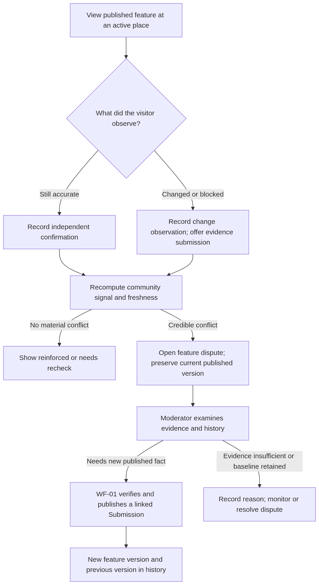
flowchart TB
View["View published feature at an active place"] --> Vote{"What did the visitor observe?"}
Vote -->|"Still accurate"| Confirm["Record independent confirmation"]
Vote -->|"Changed or blocked"| Change["Record change observation; offer evidence submission"]
Confirm --> Evaluate["Recompute community signal and freshness"]
Change --> Evaluate
Evaluate -->|"No material conflict"| Reinforce["Show reinforced or needs recheck"]
Evaluate -->|"Credible conflict"| Dispute["Open feature dispute; preserve current published version"]
Dispute --> Admin["Admin examines evidence and history"]
Admin -->|"Needs new published fact"| Wf01["WF-01 verifies and publishes a linked Submission"]
Admin -->|"Evidence insufficient or baseline retained"| Review["Record reason; monitor or resolve dispute"]
Wf01 --> Updated["New feature version and previous version in history"]
WF-02 owns both feature-specific CommunityVote and detailed inaccurate-information Report. They are separate records and actions: a Report can describe an incorrect, missing or outdated place/feature fact, while only an eligible CommunityVote participates in vote weighting. A Report never silently becomes a vote; an approved correction to published truth still passes through WF-01 publication.

A.1.3 In scope and out of scope
In scope: authenticated feature-specific CommunityVotes and separately persisted detailed Reports about incorrect, missing or outdated place/feature information; private optional evidence; reputation-weighted vote assessment; report/dispute moderation; freshness and temporary advisories; authenticated read-only status; audited WF-01 correction handoff and optional reviewed WF-04 events. Reports do not contribute vote weight. Out of scope: creating a Location, directly changing a published LocationFeature from a vote or report, redefining WF-04 tiers, or claiming technical-regulation compliance from an image. A new feature observation or publication correction starts WF-01.

A.1.4 Terms
Term | Meaning
LocationFeature | WF-01's authoritative current published value per (LocationId, ScopeId, FeatureType); stays visible, with caveats, during a dispute.
CommunityVote | An append-only user's observation about one existing published feature version. A replacement observation creates a new row and supersedes the prior one for counting.
DisputeCase | A review case for contradictory observations about one feature; never a new Submission status.
FeatureCommunityState | Materialized public-safe WF-02 assessment, separate from the published feature and WF-01's verification result.
FreshnessFactor | Bounded indicator derived from last trusted reconfirmation; not WF-01 FeatureConfidence.
TemporaryAccessAdvisory | Time-bounded, feature-specific notice approved by an admin; not a permanent feature value.

A.2 Actors and trust boundaries
Actor | Actions | Restrictions
User | A signed-in User views feature status, reconfirms or notes a change, and attaches owned media through the existing upload path. | Cannot set weight, public truth, closure or a dispute verdict.
Admin | Inspect feature history, accepted/rejected observations and authorized media; resolve cases or request a WF-01 correction; issue an advisory. | Must provide reason; cannot overwrite a feature without a WF-01 publication source.
ASP.NET Core backend | Validate, deduplicate, weight, create disputes, expose safe read models, invoke publication handoff. | Is the sole authority for write decisions.
Hangfire | Run persistent freshness and reconciliation jobs on a configured schedule. | Has leases, idempotent work and retry/recovery; never relies on an in-memory timer alone.
Python AI service | Optionally analyzes a new WF-01 evidence submission through WF-01's worker. | A simple WF-02 vote does not call YOLO or take an AI recommendation as a verdict.
WF-04 reputation service | Supplies authoritative score and tier snapshot, and processes approved reputation events. | WF-02 does not invent a tier table or apply a penalty just because a report conflicts.

A.3 Architecture and deployment
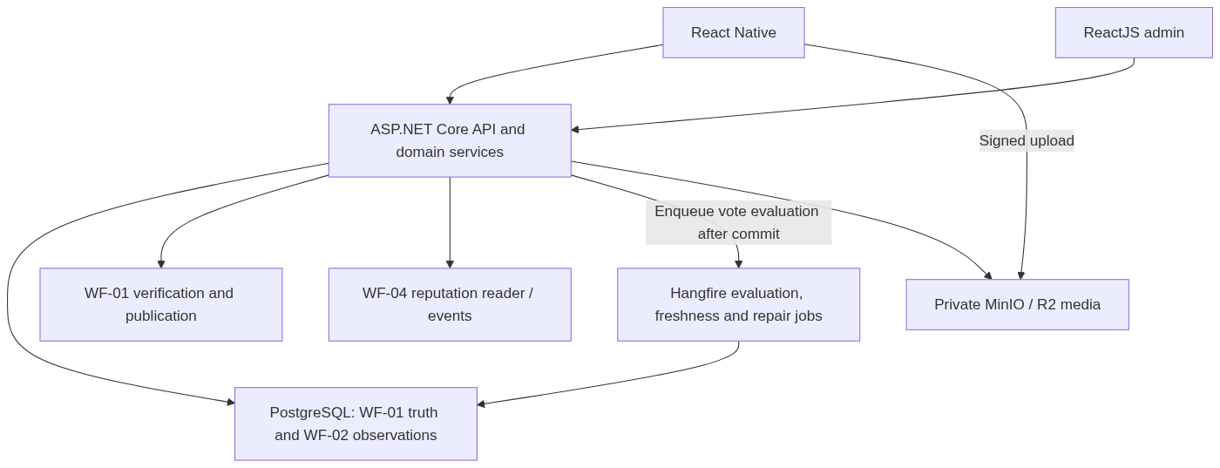
flowchart TB
Mobile["React Native"] --> API["ASP.NET Core API and domain services"]
Admin["ReactJS admin"] --> API
API --> DB["PostgreSQL: WF-01 truth and WF-02 observations"]
API --> WF01["WF-01 verification and publication"]
API --> WF04["WF-04 reputation reader / events"]
API -->|"Enqueue vote evaluation after commit"| Worker
Worker["Hangfire evaluation, freshness and repair jobs"] --> DB
API --> Storage["Private MinIO / R2 media"]
Mobile -->|"Signed upload"| Storage
This is a component view. The schema and FK cardinalities are in A.8. WF-02 reuses the project's existing User, Location, LocationFeature, Submission, upload-intent and notification infrastructure; it does not add a second location database. Its background scan is a separate persistent Hangfire recurring job sharing the configured PostgreSQL-backed scheduler. .NET performs vote aggregation; no Python inference is needed for a text-only vote.

A.4 Preconditions, actions and outcomes
Event | Preconditions | Durable result | User-facing result
Reconfirm current feature | Signed-in voter, Active Location and published concrete feature | CommunityVote(StillAccurate) and evaluation snapshot | Thank-you and current feature status; credit remains pending until WF-04 policy allows.
Report changed / blocked | Same baseline; concrete alternative state or comment; media optional | CommunityVote(Changed); potential DisputeCase | Change recorded, published value labelled as under review if a credible conflict opens.
Detailed inaccurate report | Authenticated reporter; valid canonical Location and reason; feature/version optional | InaccurateInformationReport and ReportStatusHistory; optional feature and dispute links, no CommunityVote | Open the WF-02 report form; create a Report, never an implicit CommunityVote.
New accessibility feature | No LocationFeature exists for selected type | No WF-02 vote | Start WF-01 Submission instead.
Scheduled freshness check | Published feature has a WF-02 state | Recomputed state/snapshot when changed | Feature gets NeedsRecheck label, not a falsified accessibility value.
Admin resolves dispute | Open case, authorized decision, concurrency matches | Immutable DisputeDecision, transition audit; optional linked WF-01 Submission | Clear outcome and reason; truth changes only after WF-01 publication.

A.4.1 Observation versus publication
A vote can reinforce confidence that a place has not changed, but it does not create a SubmissionClaim: that WF-01 table requires an immutable SubmissionId and belongs to submission evidence. WF-02 persists separate votes. A conflicting photo/video that could change the published value is attached to a new WF-01 Submission using the existing private upload and AI/Hangfire process; the vote and case link to its ID. An admin correction likewise needs an auditable WF-01-supported submission/publication path.

A.4.2 Business rules and validation outcomes
This quick reference summarizes existing WF-02 decisions in A.9–A.17 and B.5–B.16. Detailed eligibility and moderation rules in those sections remain authoritative.

Situation / check | Validation outcome | Contributor or admin action | Details
No active place or published feature | Quick vote is unavailable; no vote or SubmissionClaim is created. | Use WF-01 to contribute a new feature or resolve the place first. | A.4; B.16
Valid StillAccurate vote on current version | 201 Recorded; evaluation is queued. Published value and VerifiedAt stay unchanged. | See acknowledgment; community status updates after validation. | A.4.1; B.5.2; B.10
Changed vote lacks a meaningful alternative/description | 422 INVALID_OBSERVATION; no vote is saved. | Describe a concrete change or supply a different proposed status. | B.5.2; B.16
Client observed an older feature version | 409 FEATURE_VERSION_CHANGED with safe current summary; no stale vote is applied. | Reload the feature and decide again. | B.5.2; B.6; B.16
Repeat vote or idempotent retry | Same key/body replays original response; later distinct vote supersedes earlier effective vote while retaining audit. | Do not count multiple votes from the same person. | A.9.1; B.6; B.8; B.16
Authoritative reputation unavailable or score below the vote-hold threshold | Vote is recorded PendingValidation with zero effective weight; no fabricated confidence. | Await validation; no public confirmation until eligible. | A.9.2; B.8.3; B.16
Credible conflicting observation | Feature-specific DisputeCase may open; published value stays until WF-01 publishes a correction. | Admin reviews independent votes and authorized evidence; user can submit WF-01 evidence. | A.11–A.12; B.12
Feature ages beyond 90 days or short-lived blockage | NeedsRecheck is a freshness label; an approved temporary advisory expires and is reconciled. | Show dated warning; continue accepting new observations. | A.10; B.10; B.13
Evidence insufficient, admin decides or evaluation fails | RequestEvidence keeps case open; RetainBaseline records reason; correction needs WF-01 publication; failed job changes no truth. | Supply linked evidence, await decision or retry; disagreement alone earns no penalty. | A.12; B.12; B.14; B.16

A.5 Product action mapping

Product wording | Backend action
Reconfirm published accessibility information | Create a CommunityVote(StillAccurate) targeting the published source SubmissionClaim of one current LocationFeature version; evaluate eligibility asynchronously without changing published truth.
Report a changed or temporarily blocked feature | Create a CommunityVote(Changed) targeting the published source SubmissionClaim, evaluate a feature-specific conflict and, when warranted, open or reuse a DisputeCase; keep the current published value until reviewed.
Provide photo/video evidence for a lasting correction | Start a separate WF-01 Submission with owned media; link its ID to the vote or dispute. Only WF-01 publication can change LocationFeature.
Report detailed inaccurate information | Create a WF-02 Report with LocationId and optional FeatureType/version context; do not convert it into a CommunityVote. The admin can link it to a dispute or WF-01 correction.
Recheck information that may be outdated | Calculate freshness from publication or latest eligible independent reconfirmation; display NeedsRecheck without rewriting the feature value or WF-01 confidence.
Resolve a community dispute | Admin records an audited decision: retain baseline, request evidence, link WF-01 correction or create a bounded temporary advisory; close as updated only after WF-01 publication.
Signed-in Users see category labels, approximate corroboration age, approved metadata/feature history and separately moderated public CommunityComments. Private CommunityVote comments, voter IDs, individual reputation, raw GPS, pending/rejected reports, Admin deliberation and signed evidence links remain private.

A.6 Workflow sequences

A.6.1 Reconfirmation and change detection
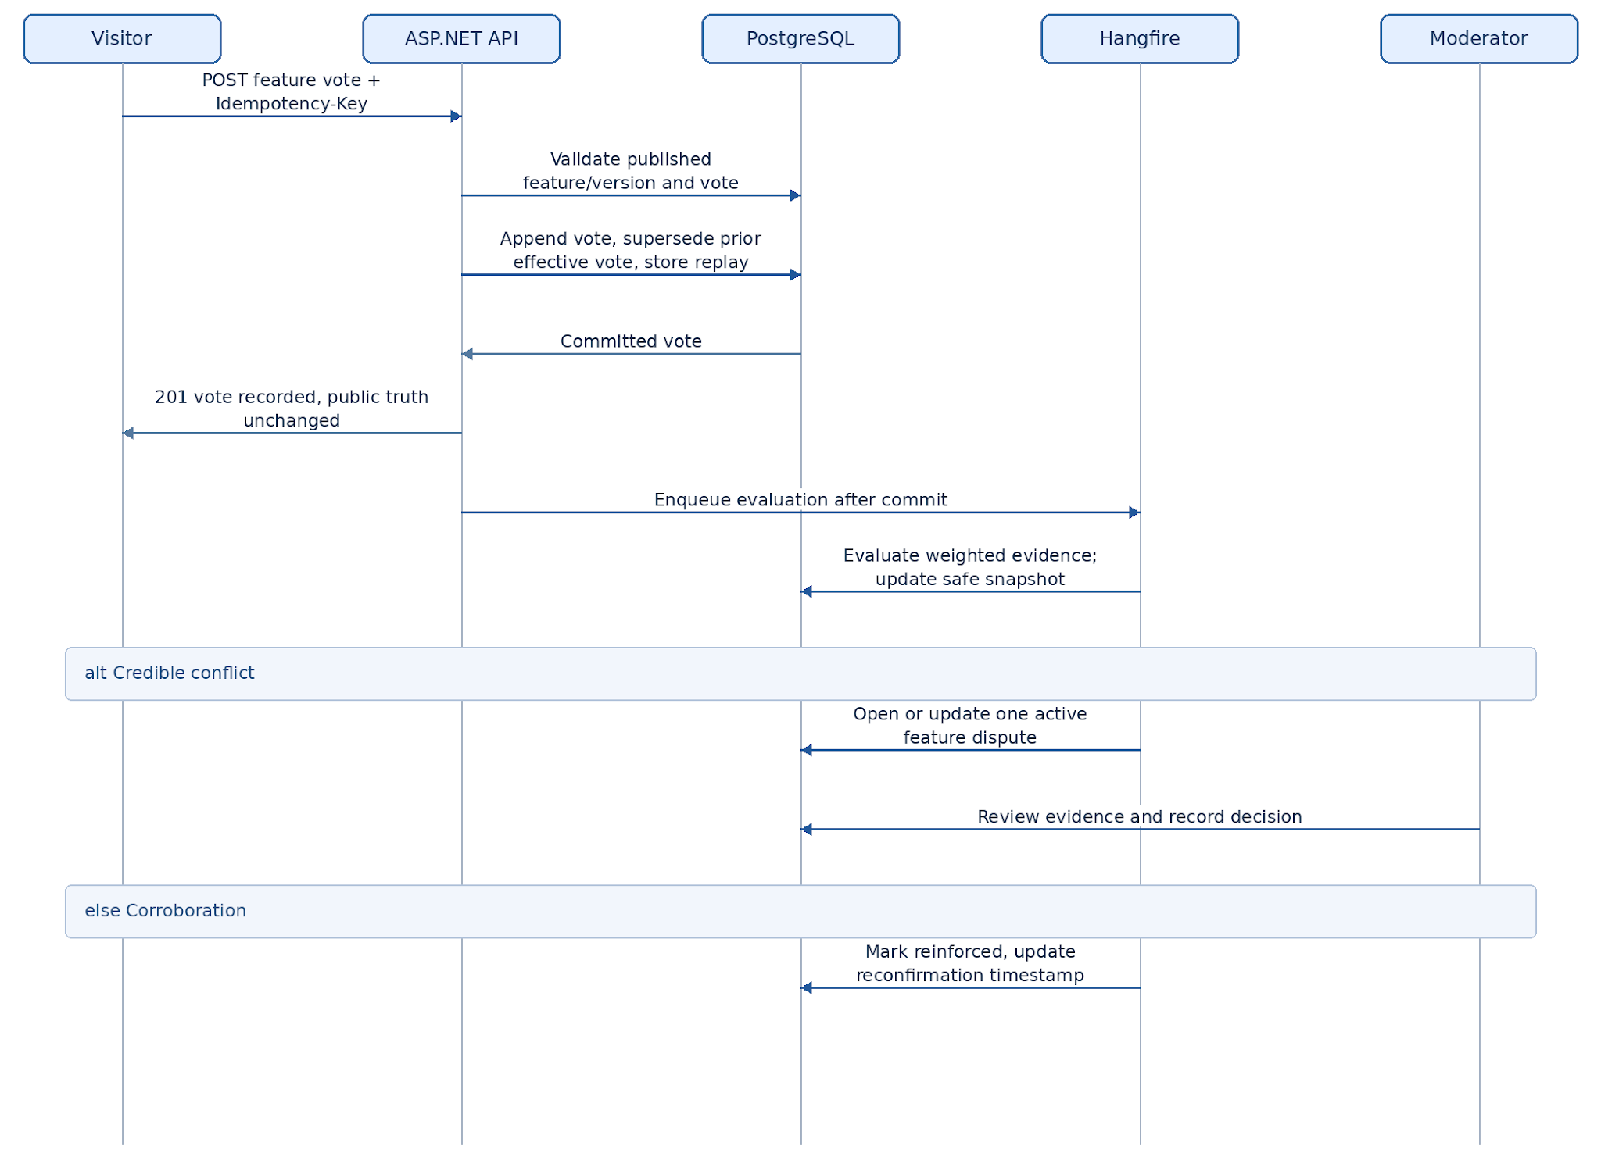
sequenceDiagram
actor V as Visitor
participant API as ASP.NET API
participant DB as PostgreSQL
participant J as Hangfire
participant M as Admin
V->>API: POST feature vote + Idempotency-Key
API->>DB: Validate published feature/version and vote ownership
API->>DB: Append vote, supersede prior effective vote, store replay response
DB-->>API: Committed vote
API-->>V: 201 vote recorded, public truth unchanged
API->>J: Enqueue evaluation after commit
J->>DB: Evaluate weighted evidence; update safe snapshot
alt Credible conflict
J->>DB: Open or update one active feature dispute
M->>DB: Review evidence and record decision
else Corroboration
J->>DB: Mark reinforced, update reconfirmation timestamp
end
The API may evaluate a small bounded vote set synchronously after commit to return a status hint, but final materialized status is produced by the durable evaluation job. A vote response cannot claim a final verdict that has not been persisted. A missed enqueue is recovered by Hangfire reconciliation.

A.6.2 Later change of published truth
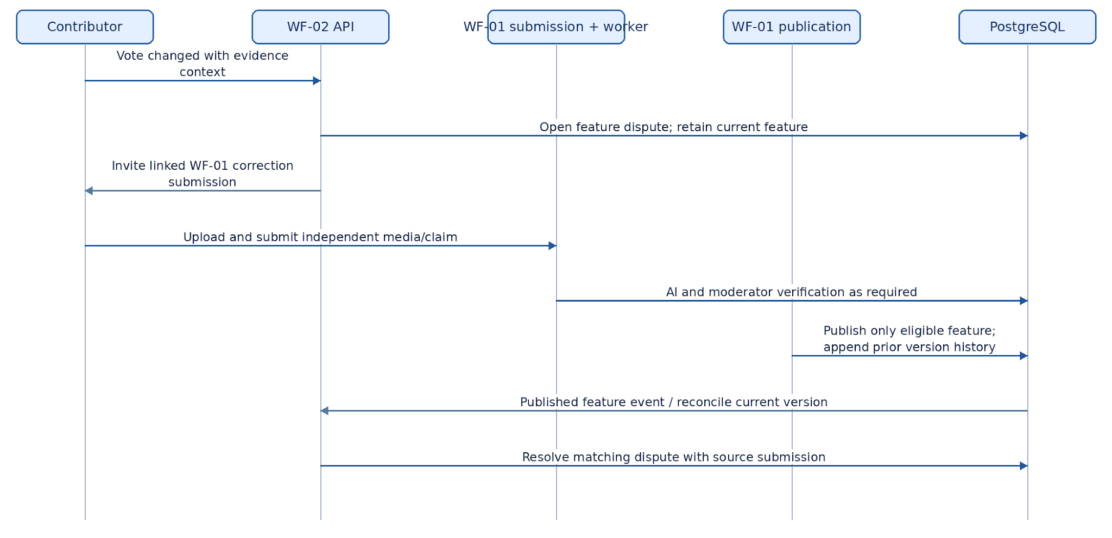
sequenceDiagram
actor U as Contributor
participant W as WF-02 API
participant S as WF-01 submission + worker
participant P as WF-01 publication
participant D as PostgreSQL
U->>W: Vote changed with evidence context
W->>D: Open feature dispute; retain current feature
W-->>U: Invite linked WF-01 correction submission
U->>S: Upload and submit independent media/claim
S->>D: AI and admin verification as required
P->>D: Publish only eligible feature; append prior version history
D-->>W: Published feature event / reconcile current version
W->>D: Resolve matching dispute with source submission

A.7 Domain boundaries and source of truth
Data | Owner | Can WF-02 write it?
Place identity and position | WF-01 / existing Location | No.
Current published feature and full prior versions | WF-01 LocationFeature / LocationFeatureHistory | No; call WF-01 publication through its authorized contract.
Original claim and AI verification | WF-01 Submission, SubmissionClaim, AIAnalysisFeature | No.
Vote, assessment, feature dispute, advisory | WF-02 | Yes, with explicit authorization and audit.
Score, tier, penalty and reward ledger | WF-04 | Read snapshots; emit only vetted idempotent events via WF-04 contract.
Detailed inaccurate-information report | WF-02 Report | Link only; do not duplicate.
WF-01 has FeatureConfidence = .60 × AIConfidence + .40 × CommunityConfidence, calculated at the time a Submission is verified. It currently counts only eligible published submission claims. WF-02's vote score and freshness are separately named; they cannot retroactively edit WF-01 AIAnalysisFeature.FinalConfidence or directly overwrite LocationFeature.Confidence.
Cross-workflow integration gate: To let vetted WF-02 votes participate in a future WF-01 CommunityConfidence calculation, first version and update WF-01 B.11 to read both published claims and eligible vetted votes via one shared evidence reader. Deduplicate contributors across both sources per (LocationId, ScopeId, FeatureType) and keep source IDs, weighting, eligibility and decision-time snapshots. Until that shared contract is implemented and tested, WF-02 votes influence WF-02 dispute/freshness indicators only. No hidden second formula changes WF-01 auto-publish decisions.

A.8 Database architecture

A.8.1 Core persisted entities
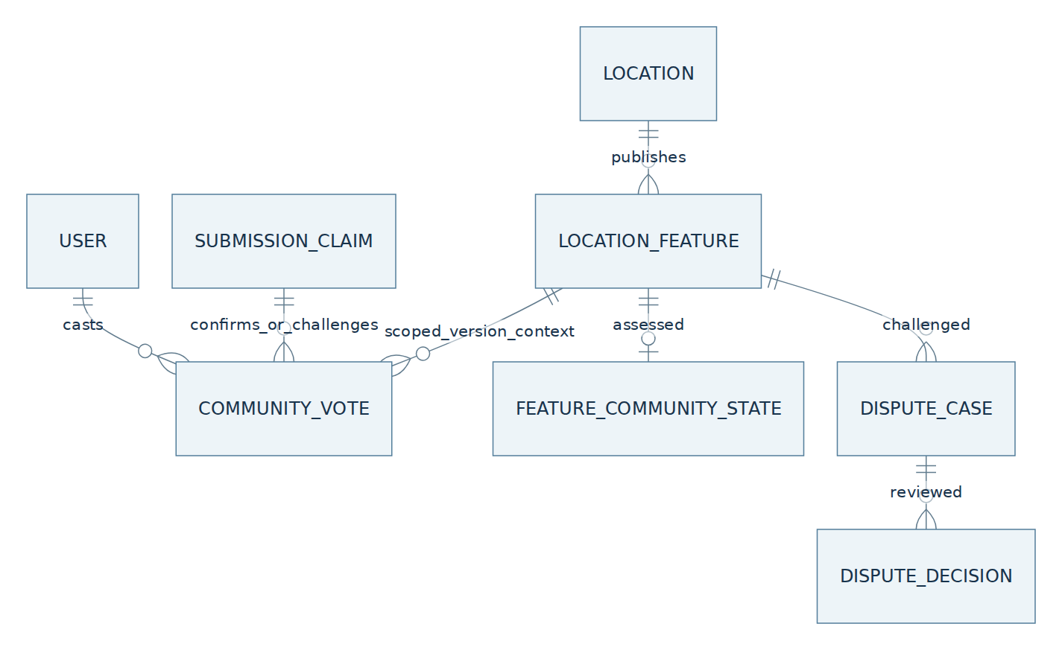
erDiagram
USER ||--o{ COMMUNITY_VOTE : casts
LOCATION ||--o{ LOCATION_FEATURE : publishes
SUBMISSION_CLAIM ||--o{ COMMUNITY_VOTE : confirms_or_challenges
LOCATION_FEATURE ||--o{ COMMUNITY_VOTE : scoped_version_context
LOCATION_FEATURE ||--o| FEATURE_COMMUNITY_STATE : assessed
LOCATION_FEATURE ||--o{ DISPUTE_CASE : challenged
DISPUTE_CASE ||--o{ DISPUTE_DECISION : reviewed

A.8.2 Vote/dispute ERD and WF-01 connections
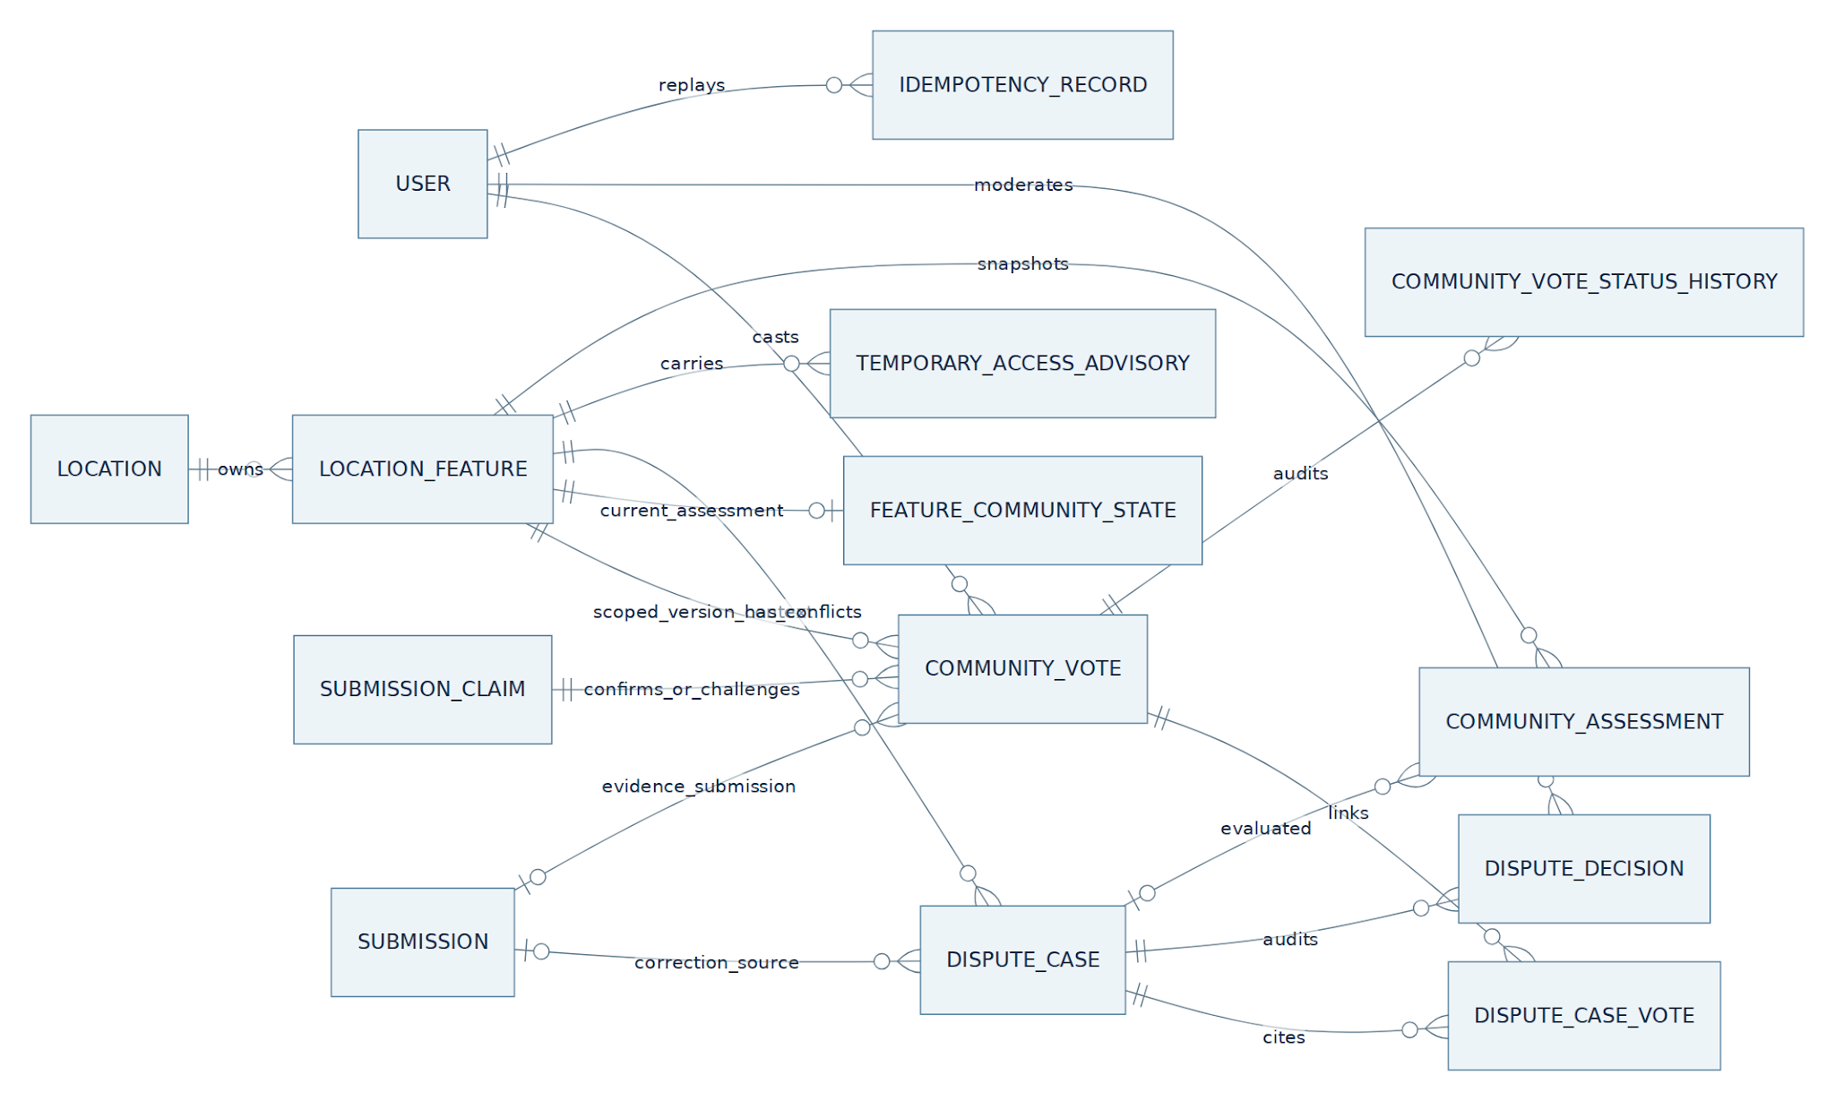
erDiagram
direction LR
USER ||--o{ COMMUNITY_VOTE : casts
LOCATION ||--o{ LOCATION_FEATURE : owns
SUBMISSION_CLAIM ||--o{ COMMUNITY_VOTE : confirms_or_challenges
LOCATION_FEATURE ||--o{ COMMUNITY_VOTE : scoped_version_context
LOCATION_FEATURE ||--o| FEATURE_COMMUNITY_STATE : current_assessment
LOCATION_FEATURE ||--o{ DISPUTE_CASE : has_conflicts
COMMUNITY_VOTE ||--o{ DISPUTE_CASE_VOTE : links
DISPUTE_CASE ||--o{ DISPUTE_CASE_VOTE : cites
DISPUTE_CASE ||--o{ DISPUTE_DECISION : audits
USER ||--o{ DISPUTE_DECISION : moderates
LOCATION_FEATURE ||--o{ TEMPORARY_ACCESS_ADVISORY : carries
SUBMISSION o|--o{ DISPUTE_CASE : correction_source
SUBMISSION o|--o{ COMMUNITY_VOTE : evidence_submission
DISPUTE_CASE o|--o{ COMMUNITY_ASSESSMENT : evaluated
LOCATION_FEATURE ||--o{ COMMUNITY_ASSESSMENT : snapshots
COMMUNITY_VOTE ||--o{ COMMUNITY_VOTE_STATUS_HISTORY : audits
USER ||--o{ IDEMPOTENCY_RECORD : replays
SUBMISSION, USER, LOCATION, LOCATION_FEATURE and IDEMPOTENCY_RECORD are existing entities; reuse rather than duplicate. This view focuses on vote/dispute relationships; WF-02 Report and its audit relationships are shown separately in B.3.8. The ERD expresses logical references. Optional photo/video evidence belongs to a separately authorized linked WF-01 Submission and its existing UploadIntent/SubmissionMedia; a quick vote alone does not attach or consume an upload intent. B.3 specifies the link checks.

A.8.2.1 Vote, author and versioned baseline
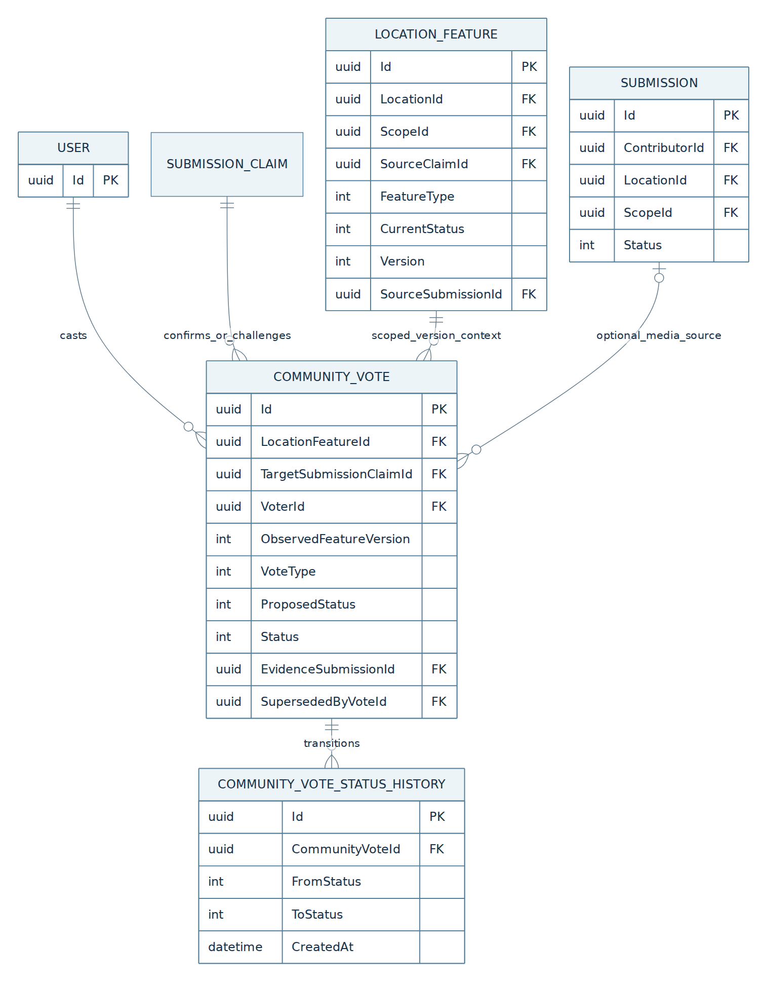
erDiagram
USER ||--o{ COMMUNITY_VOTE : casts
SUBMISSION_CLAIM ||--o{ COMMUNITY_VOTE : confirms_or_challenges
LOCATION_FEATURE ||--o{ COMMUNITY_VOTE : scoped_version_context
COMMUNITY_VOTE ||--o{ COMMUNITY_VOTE_STATUS_HISTORY : transitions
SUBMISSION o|--o{ COMMUNITY_VOTE : optional_media_source

LOCATION_FEATURE {
uuid Id PK
uuid LocationId FK
uuid ScopeId FK
uuid SourceClaimId FK
int FeatureType
int CurrentStatus
int Version
uuid SourceSubmissionId FK
}
COMMUNITY_VOTE {
uuid Id PK
uuid LocationFeatureId FK
uuid TargetSubmissionClaimId FK
uuid VoterId FK
int ObservedFeatureVersion
int VoteType
int ProposedStatus
int Status
uuid EvidenceSubmissionId FK
uuid SupersededByVoteId FK
}
COMMUNITY_VOTE_STATUS_HISTORY {
uuid Id PK
uuid CommunityVoteId FK
int FromStatus
int ToStatus
datetime CreatedAt
}
USER {
uuid Id PK
}
SUBMISSION {
uuid Id PK
uuid ContributorId FK
uuid LocationId FK
uuid ScopeId FK
int Status
}
LOCATION_FEATURE and SUBMISSION are WF-01 records. A vote captures the published Version; the linked Submission is optional and its media belongs to WF-01. The server accepts at most one current effective vote per user, feature and version, while keeping older rows and status history.

A.8.2.2 Assessment, dispute and advisory
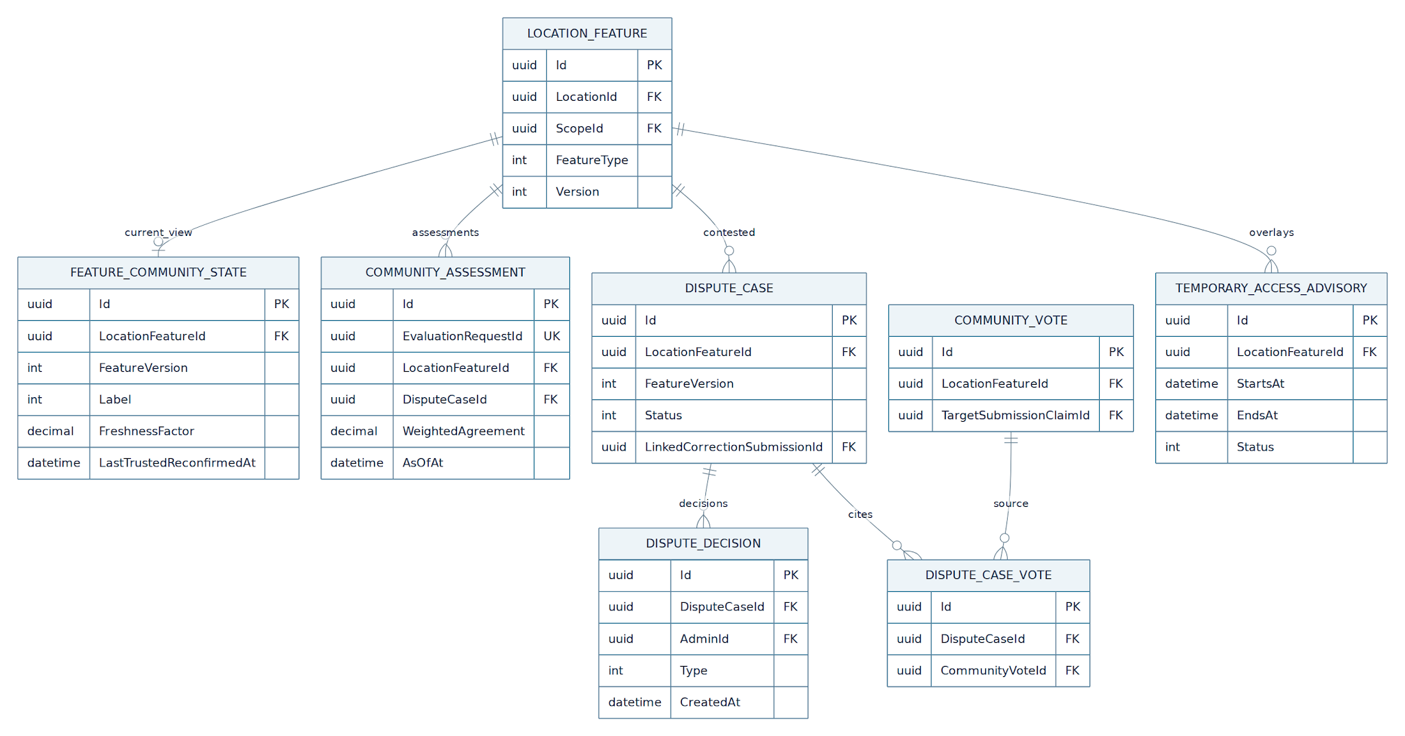
erDiagram
LOCATION_FEATURE ||--o| FEATURE_COMMUNITY_STATE : current_view
LOCATION_FEATURE ||--o{ COMMUNITY_ASSESSMENT : assessments
LOCATION_FEATURE ||--o{ DISPUTE_CASE : contested
DISPUTE_CASE ||--o{ DISPUTE_DECISION : decisions
DISPUTE_CASE ||--o{ DISPUTE_CASE_VOTE : cites
COMMUNITY_VOTE ||--o{ DISPUTE_CASE_VOTE : source
LOCATION_FEATURE ||--o{ TEMPORARY_ACCESS_ADVISORY : overlays

FEATURE_COMMUNITY_STATE {
uuid Id PK
uuid LocationFeatureId FK
int FeatureVersion
int Label
decimal FreshnessFactor
datetime LastTrustedReconfirmedAt
}
COMMUNITY_ASSESSMENT {
uuid Id PK
uuid EvaluationRequestId UK
uuid LocationFeatureId FK
uuid DisputeCaseId FK
decimal WeightedAgreement
datetime AsOfAt
}
DISPUTE_CASE {
uuid Id PK
uuid LocationFeatureId FK
int FeatureVersion
int Status
uuid LinkedCorrectionSubmissionId FK
}
DISPUTE_DECISION {
uuid Id PK
uuid DisputeCaseId FK
uuid AdminId FK
int Type
datetime CreatedAt
}
DISPUTE_CASE_VOTE {
uuid Id PK
uuid DisputeCaseId FK
uuid CommunityVoteId FK
}
TEMPORARY_ACCESS_ADVISORY {
uuid Id PK
uuid LocationFeatureId FK
datetime StartsAt
datetime EndsAt
int Status
}
LOCATION_FEATURE {
uuid Id PK
uuid LocationId FK
uuid ScopeId FK
int FeatureType
int Version
}
COMMUNITY_VOTE {
uuid Id PK
uuid LocationFeatureId FK
uuid TargetSubmissionClaimId FK
}
These diagrams show representative PK/FK/unique identifiers and feature-level ownership. For complete typed columns, partial unique indexes, lifecycle and xmin, use B.3. FreshnessFactor belongs only to the community assessment; a case decision never bypasses WF-01 publication.

A.8.3 Relationship and constraint guide
Relationship | Constraint
Feature → votes | Each vote records the observed published FeatureVersion. A changed version requires a fresh comparison and never silently counts as a vote for the new version.
User + feature + version | Multiple rows may exist for audit; at most one active effective observation counts for that user and version.
Feature → current state | At most one materialized assessment per feature; history in append-only CommunityAssessment.
Feature → disputes | At most one open dispute for a specific (LocationFeatureId, FeatureVersion); closed cases remain readable.
Dispute → decisions | Each decision is append-only; pending follow-up is not a fabricated final verdict.
Media → vote | At most one owner-authorized attachment per upload intent; only private stored keys are persisted.

A.9 Community signal and contributor independence

A.9.1 Meaning of a vote
StillAccurate confirms one published feature value/version. Changed states a proposed Available, Limited or NotAvailable value or gives a concrete change description; Unknown is not a positive vote. Each user can have only one currently effective observation for the same feature version; repeat votes supersede for counting and remain as audit. A person cannot corroborate their own source Submission as an independent observer. Other reports from the same person do not become extra independent votes.

A.9.2 Weighting and review safety
Evaluate per (LocationId, ScopeId, FeatureType, published FeatureVersion and SourceClaimId). An active authenticated baseline account has ReputationScore=50 and passes the reputation gate after ordinary identity, subject, version and abuse checks. WF-04 owns VoteHoldThreshold=50. Below-threshold or unavailable authoritative reputation yields PendingValidation with zero applied weight and distinct reasons; authorized validation or a recovery event reevaluates the vote. Eligible votes use capped nonnegative reputation weight, recency decay and factor=1 while extra tier factors are disabled. Count distinct independent users, excluding the published claim's author. 30 days defines the recent cohort; B.9 defines decay.
Community agreement may flag a case for admin review. It does not represent camera-based evidence, measurements under the Vietnamese technical regulation or permission to auto-publish. The proposed crowd auto-resolution rule (three high-tier voters and at least 90% agreement) is disabled by default pending team/mentor agreement and verified abuse controls.

A.10 Freshness and temporary access

A.10.1 Separate clocks
LocationFeature.VerifiedAt is WF-01's recorded publication/verification time; WF-02 never rewrites it when a user taps “still accurate”. FeatureCommunityState.LastTrustedReconfirmedAt is the latest eligible independent corroboration. A published feature with no corroboration uses the publication time as its freshness origin and is explicitly labelled Uncorroborated. A vote on an older published version cannot reset the new version's clock.

A.10.2 Age and label
Default RecheckAfterDays=90. At age ≤90, status can remain Fresh; after that, NeedsRecheck unless independent newer evidence has passed validation. A gradual, non-authoritative FreshnessFactor = 2^(-max(0, ageDays-90)/180) can sort recheck priorities. Neither the label nor factor changes the physical accessibility state, historic AI score, points or QCVN compliance assertions. It is not FeatureConfidence and is never fed back into itself. Offer a privacy-safe public timeline of approved Location metadata changes and published scoped feature versions, with effective time and permitted evidence preview; Admin retains private GPS, report and moderation history. Use an immutable Location metadata history plus a paginated public DTO, handling merged Locations. Show newest approved public CommunityComments by default; vote/report notes are not public comments. Public comments default to newest approved first (CreatedAt DESC, Id DESC). Their relevance weight decays by age: CommentRecencyWeight = 2^(-ageDays / CommentHalfLifeDays), where ageDays is measured from server-side CreatedAt in UTC and CommentHalfLifeDays is a configurable, versioned policy (initial value 30 days). In the MVP, the first page of the approved comment list supplies a short recent-context preview: highlight at most the three newest approved comments whose read-time weight is at least 0.25 (within 60 days under the initial 30-day half-life). If none qualify, show no recent-context preview; the full newest-first list remains available. There is no separate relevance sort in the MVP. Older approved comments remain accessible through pagination. Comment decay never changes a verified feature, vote consensus, contributor points or the separate feature freshness score.

A.10.3 Temporary closure
A verified short-lived blockage gets a TemporaryAccessAdvisory scoped to the affected feature and time window (default maximum 60 days). Public UI can show “lối vào tạm thời bị chặn đến [date]” beside the published feature. Votes and reports continue to be accepted and logged; the advisory can suppress duplicate dispute escalation for the same known condition but cannot conceal a new distinct safety concern or automatically mark a building permanently inaccessible. When it expires, Hangfire removes its public active flag and evaluates the underlying feature; contradictory observations remain available for review.

A.11 State machines

A.11.1 Vote
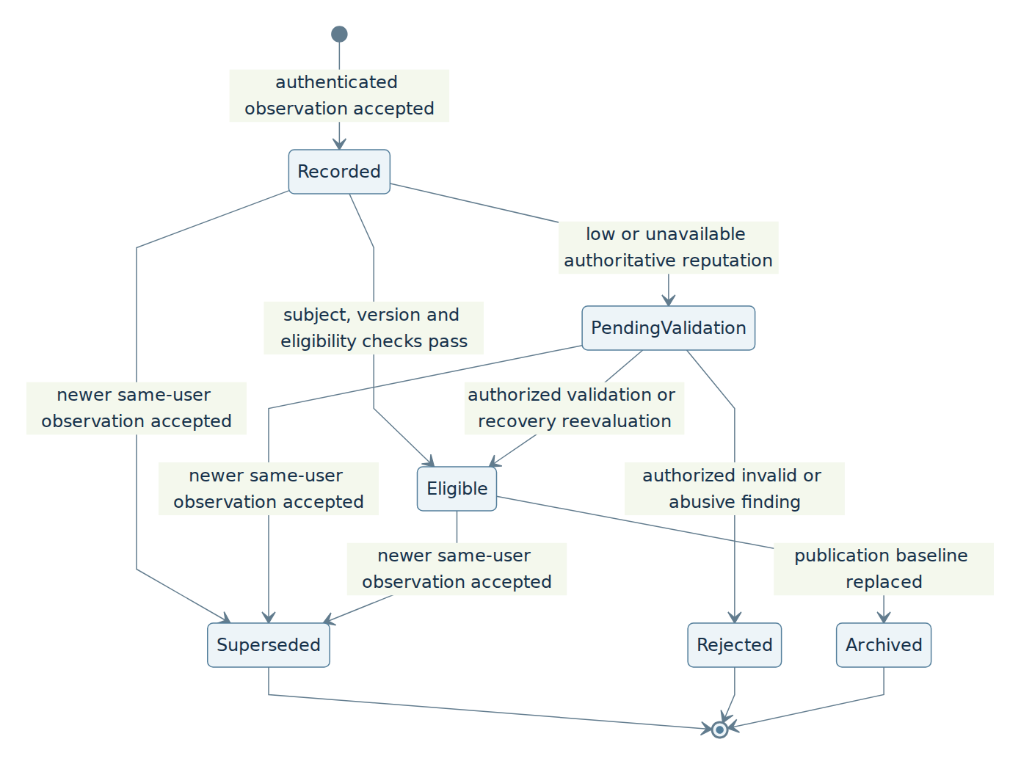
stateDiagram-v2
direction TB
[*] --> Recorded: authenticated observation accepted
Recorded --> PendingValidation: low or unavailable authoritative reputation
Recorded --> Eligible: subject, version and eligibility checks pass
PendingValidation --> Eligible: authorized validation or recovery reevaluation
PendingValidation --> Rejected: authorized invalid or abusive finding
Recorded --> Superseded: newer same-user observation accepted
PendingValidation --> Superseded: newer same-user observation accepted
Eligible --> Superseded: newer same-user observation accepted
Eligible --> Archived: publication baseline replaced
Superseded --> [*]
Rejected --> [*]
Archived --> [*]
Rejected here is a vote review state, not a WF-01 SubmissionStatus. An honest contradictory view does not qualify as abuse merely because an admin retains the old fact.

A.11.2 Feature dispute
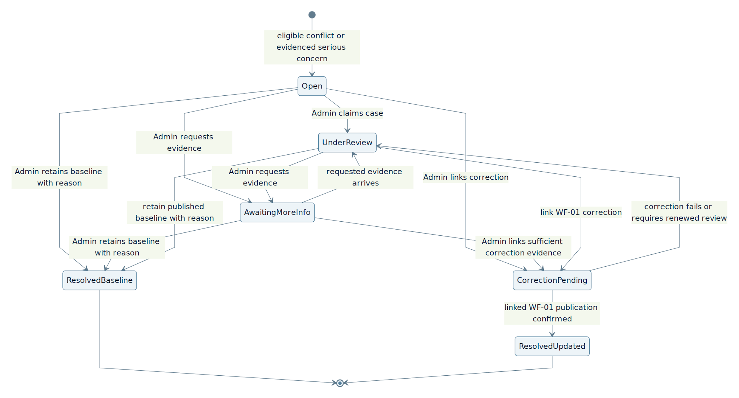
stateDiagram-v2
direction TB
[*] --> Open: eligible conflict or evidenced serious concern
Open --> UnderReview: Admin claims case
Open --> AwaitingMoreInfo: Admin requests evidence
Open --> CorrectionPending: Admin links correction
Open --> ResolvedBaseline: Admin retains baseline with reason
UnderReview --> AwaitingMoreInfo: Admin requests evidence
AwaitingMoreInfo --> UnderReview: requested evidence arrives
AwaitingMoreInfo --> CorrectionPending: Admin links sufficient correction evidence
AwaitingMoreInfo --> ResolvedBaseline: Admin retains baseline with reason
UnderReview --> CorrectionPending: link WF-01 correction
CorrectionPending --> UnderReview: correction fails or requires renewed review
UnderReview --> ResolvedBaseline: retain published baseline with reason
CorrectionPending --> ResolvedUpdated: linked WF-01 publication confirmed
ResolvedBaseline --> [*]
ResolvedUpdated --> [*]
Every transition writes DisputeDecision/audit with reason and actor. Only ResolvedUpdated requires a published WF-01 source and matching Location/FeatureType. A dispute can reopen as a new case after a material new observation or feature version change; closed cases remain immutable.

A.12 Moderation and publication handoff
The admin compares the current published source, its history, vote independence, data age and authorized photos/videos. Actions: (1) retain current value with documented reason; (2) request more evidence, leaving the case open; (3) link a contributor's WF-01 Submission (Flow A) or follow an audited admin correction flow that creates an equivalent WF-01 source; (4) set an evidence-backed, expiring temporary advisory. A changed LocationFeature is written only by WF-01's feature publication service, which appends LocationFeatureHistory, increments version and preserves source IDs. WF-02 consumes the publication event/reconciliation to close its case and archive votes targeting the old version.
The supplied older workflow's “confirmed trolling → −100 points” is a WF-04 policy proposal, not a WF-02 automatic penalty. Only an explicit, reviewable finding of intentionally deceptive conduct may request WF-04 action, after the team agrees on the tier/appeal rules. Mere disagreement, inconclusive evidence or an old fact becoming outdated yields no penalty.

A.13 Cross-workflow behavior
Flow | WF-02 relationship | Required handoff
WF-01 Contribution & AI verification | Publishes the baseline and future correction; stores AI confidence and community snapshot at verification time. | Read published feature/version, link correction Submission, subscribe/reconcile published event; no direct write to truth.
WF-02 detailed Reports | WF-02 owns detailed Reports, their endpoint and moderation/audit states; Reports are distinct from votes. | Link Report to Location/Feature and optional DisputeCase; do not count it as an additional vote.
WF-04 Reputation and rewards | Owns authoritative score, tier and penalty/reward processing. | Read consistent evaluation snapshot; emit idempotent, reviewed actions only under its contract.
Admin Portal — Coverage/export | Can show public-safe freshness/dispute labels. | Export only published truth with separately labelled freshness metadata.

A.13.1 Detailed inaccurate-information reporting
A signed-in User may submit a WF-02 Report when a published place or feature description is wrong, missing or outdated. The report form records a reason and explanation with LocationId, optional FeatureType and observed feature version; it may reference an owned WF-01 evidence Submission. The backend persists Report and status history with an idempotency key. Report is not a CommunityVote and does not count toward weighted agreement, distinct voter thresholds or direct publication. An Admin reviews the report, requests evidence, links an existing feature dispute when appropriate, or rejects it with reason. When a factual correction is needed, create/link a WF-01 Submission or authorized correction; only WF-01 publication updates LocationFeature and its version. WF-02 returns the report status to its owner and exposes moderation actions only to authorized staff. Repeated or abusive reports are rate-limited and reviewed, without automatic reputation penalties. Reports may also identify a wrong address or pin, a scoped feature, an outdated condition or another concrete inaccuracy; they are never limited to image quality. A Location coordinate correction is an Admin-resolved metadata change request with evidence and old/new address/coordinate history, never an automatic majority pin movement. Report creation does not update public truth, and the same author’s separate vote is counted only once as a vote. WrongAddressOrPin reports may include proposed address/coordinate and evidence as untrusted input; only an Admin metadata correction transaction changes Location.Position. Feature reports and votes identify ScopeId where relevant; a scope-specific report does not change another entrance/floor.

A.13.2 Report lifecycle and product outcomes
Submitted: the authenticated contributor receives a reportId and can view the report privately. UnderReview: an authorized admin has taken responsibility. AwaitingMoreInfo: an admin requests a specific missing detail; the report remains visible to its owner and can return to UnderReview when evidence arrives. LinkedToDispute: the report has been associated with an existing feature dispute; it is still a separate report and adds no vote weight. Resolved: the admin records an outcome with a source pointer, such as a retained published fact, an expiring advisory, or a WF-01 correction that has actually been published. Rejected: the report is invalid, duplicated without new information, or outside WF-02 scope; save a reviewable reason. Resolved and Rejected are terminal report states; a later new observation creates a new report rather than rewriting history.

A.13.3 Reporting boundaries and feedback
A report may target an Active Location even when the named feature is missing, because missing information is itself a reportable issue. A vote requires a published concrete feature and version; a report does not. A report about a route/navigation error is outside this place/feature reporting contract and must be handed to a separate supported route only if one exists. If the reporter supplies a photo/video, WF-01 owns media validation and immutable Submission evidence; WF-02 links that authorized submission instead of accepting arbitrary URLs. The public map can show an approved, scoped review/advisory label where policy allows, but report text and reporter identity are never published as trusted feature data. A admin cannot mark a feature changed merely by closing a report.

A.14 Durable jobs, retry and transaction model
Creating a vote stores the vote, effective-vote supersession, idempotency record and Pending evaluation request in one PostgreSQL transaction; commit first, enqueue Hangfire afterward. A recurring Hangfire reconciler recovers missed enqueue and expired leases. The job processes one (LocationFeatureId, FeatureVersion) with lock/concurrency control, writes an immutable assessment snapshot and updates the current state atomically. Freshness scans eligible current features in bounded batches, recompute derived age at a fixed evaluatedAt, and write only changed states. Independent notification outbox delivery occurs after commit. No media service, WF-04 RPC, FCM or AI HTTP call runs inside a database transaction; take authorized snapshots before the short write transaction.

A.15 Security, privacy and observability
Require authentication and anti-spam limits for votes. Authorize media intent ownership, validate bytes and limits through WF-01's storage adapter, redact faces for public previews where supported, and expose only short-lived admin access to originals. Treat device location, EXIF, account identity, score, media key and free-form accusation as private. Keep administrator decisions, evaluated input snapshot, policy version and scheduler run IDs for audit. Metrics: vote accepts/rejects, below-threshold pending count, independent-voter distribution, conflict-to-review time, aged features, publish-linked resolution, duplicate retries and stale leases.

A.16 Representative acceptance outcomes
Case | Expected outcome
First vote on an existing published ramp | One saved observation; no new SubmissionClaim/Submission; public ramp value unchanged.
No published ramp but published elevator exists | Vote on ramp rejected with path into WF-01; do not borrow elevator history.
Same user submits twice for the same feature version | Audit retains both; only newest eligible vote is effective; idempotent replay does not add a second row.
Credible change with a photograph | Feature-specific dispute opens; admin sees authorized evidence; old public value has a review label until WF-01 publishes a change.
Last independent reconfirmation older than 90 days | NeedsRecheck, unchanged published status and unchanged WF-01 FeatureConfidence.
Active temporary advisory expires | Active notice disappears after reconciliation; new observations remain visible to review.
WF-01 publishes a correction concurrently with a vote | Old-version vote archived/re-evaluated; new version never inherits unverified confirmation.
A single very high-tier user votes three times | One independent vote, never reaches a three-person criterion.

A.17 Decisions requiring team/mentor sign-off
Proposal from supplied WF-02 workflow | Baseline here | Decision needed
Default-baseline accounts may vote; below-baseline reputation requires validation | Confirmed: hold only below VoteHoldThreshold or when authoritative eligibility data is unavailable; new accounts at the default baseline pass normal checks. | Approved DefaultReputationScore=50 and VoteHoldThreshold=50. Higher-tier cutoffs, recovery and reviewed misconduct adjustment amounts remain deferred in WF-04.
Tier multipliers including possible ×3 | Do not inherit or multiply again inside WF-01; WF-02 uses a versioned WF-04 factor only if defined. | Decide whether factors apply to voting, displayed community signal and eventual WF-01 integration.
Three high-tier voters and ≥90% agree can auto-resolve | Feature flag disabled; admin is decision-maker. | Calibrate anti-coordination checks, evidence conditions, eligible tiers and post-audit before enabling.
Confirmed intentional false report −100 EXP | No automatic penalty. | WF-04 must define due process, amount, appeal and idempotent event type.
30-day recency, 90-day recheck, 60-day advisory | Configurable defaults; recency window labels recent cohort; 180-day half-life is the weighting formula. | Confirm with usage evidence/mentor; distinguish on-site safety urgency from vote confidence.
Extending WF-01's CommunityConfidence with WF-02 votes | Off until both contracts and tests are versioned. | Approve single evidence reader, independent-voter dedup and historic snapshot rules.

A.18 Design summary
The architecture carries forward community reconfirmation, reputation-aware aggregation, conflict review, detailed inaccurate-information Reports and age-based recheck through separate durable entities. A brief vote is not a submission claim, a community ratio is not an AI or regulatory compliance score, and neither age nor a crowd alone rewrites a published feature. The exact implementation and test gates follow in Part B.

Part B — Detailed normative specification

B.0 Implementation authority

B.0.1 Mandatory invariants
ID | Rule
R-01 | Inspect the existing solution; reuse WF-01's User, Location, LocationFeature, Submission, auth, DB, upload adapter, publication service, outbox and Hangfire infrastructure.
R-02 | A quick vote inserts only WF-02 records. SubmissionClaim requires a WF-01 Submission and is never synthesized from a tap.
R-03 | LocationFeature and LocationFeatureHistory are writable only through the WF-01 publication contract. WF-02 never assigns Published or EXP.
R-04 | One user contributes at most one effective independent vote per feature version; replay is idempotent and previous observations remain auditable.
R-05 | Votes never recalculate a prior AIAnalysisFeature.FinalConfidence; FreshnessFactor, vote ratio and WF-01 FeatureConfidence have distinct fields and units.
R-06 | No reputation, media, FCM, Python or object-storage RPC executes inside a PostgreSQL transaction.
R-07 | Untrusted/pending votes cannot verify community evidence. Test baseline=50, score below 50, missing authoritative snapshot, Admin vote validation and recovery separately. Missing scopeId returns 422 on community/vote routes; opposite floor statuses and claims remain isolated. A stale vote version returns 409; report targets may retain historical context for Admin. Verify targetSubmissionClaimId identifies challenged evidence while linkedSubmissionId identifies a separate correction. Idempotent changed payload always returns IDEMPOTENCY_KEY_REUSED.
R-08 | Resolve to an updated published feature only after a matching WF-01 Submission has actually reached Published.
R-09 | Business thresholds and cron schedules are configuration with startup validation, decision snapshots and policy version; they are not hard-coded.
R-10 | Report creation and moderation belong to WF-02; any reviewed penalty event belongs to WF-04. An unproven discrepancy or ordinary mistake causes no penalty.

B.0.2 Source-to-contract interpretation
The provided WF-02 workflow names Verified, Reinforced, Conflict Reported, Community Under Review and Confidence Decay as a claim lifecycle. They are not inserted into WF-01's SubmissionClaim or SubmissionStatus enums. Here Verified means an existing published WF-01 feature; Reinforced, ConflictReported, NeedsRecheck describe FeatureCommunityState; CommunityUnderReview describes an open DisputeCase. This preserves WF-01's immutable evidence, feature-level truth and state machine.

B.1 Scope and naming
Routes use UUID v4 database IDs. LOC-SGC-0102 and AMV-2026-08942 remain display-only BusinessCode strings and are never parsed as UUID. Timestamps are UTC timestamptz; confidence/ratios/factors are numeric values [0,1]. UI percentages are derived when rendered. featureType uses WF-01's enum and status uses its existing Available, Limited, NotAvailable, Unknown mapping. No place-wide vote combines ramp, elevator and entrance into one yes/no result.

B.1.1 Preconditions
Location.Status=Active; matching LocationFeature is published and concrete (CurrentStatus != Unknown); version is supplied or resolved consistently from current row. A Provisional/unpublished Location or missing feature routes to WF-01. A merged Location must follow the canonical MergedIntoLocationId resolution rules before voting. Users authenticate; a session alone is not evidence of physical presence. Unknown or expired advisory does not disable votes.

B.2 Canonical enums and state transitions
public enum CommunityVoteType { StillAccurate = 1, Changed = 2 }
public enum CommunityVoteStatus { Recorded = 1, PendingValidation = 2, Eligible = 3, Rejected = 4, Superseded = 5, Archived = 6 }
public enum FeatureCommunityLabel { Uncorroborated = 1, Fresh = 2, Reinforced = 3, NeedsRecheck = 4, ConflictReported = 5, CommunityUnderReview = 6 }
public enum DisputeStatus { Open = 1, UnderReview = 2, AwaitingMoreInfo = 3, CorrectionPending = 4, ResolvedBaseline = 5, ResolvedUpdated = 6 }
public enum InaccurateReportStatus { Submitted = 1, UnderReview = 2, AwaitingMoreInfo = 3, LinkedToDispute = 4, Resolved = 5, Rejected = 6 }
public enum InaccurateReportReason { IncorrectFeature = 1, MissingFeature = 2, OutdatedInformation = 3, Other = 4, WrongAddressOrPin = 5 }
public enum DisputeDecisionType { RequestEvidence = 1, RetainBaseline = 2, LinkCorrection = 3, RecordPublication = 4, CreateAdvisory = 5 }
public enum AdvisoryStatus { Scheduled = 1, Active = 2, Expired = 3, Revoked = 4 }
public enum AssessmentJobStatus { Queued = 1, Processing = 2, RetryScheduled = 3, Completed = 4, Failed = 5 }
Stored numeric values are migration-stable. Transitions are only made through the applicable domain service with actor/reason and optimistic concurrency; clients cannot post enums that set review status, eligibility or advisory status. A superseded vote does not alter a closed historic dispute; the current version's assessment is recalculated.

B.3 PostgreSQL schema and relationships
Use the same PostgreSQL DB and EF Core/Npgsql provider as WF-01. Every new primary key is UUID v4. FKs to WF-01 historical source records use restrictive deletion. New date-sensitive indexes use the existing migration convention; do not alter the Location.Position PostGIS schema. Shared tables are extended only if the agreed WF-01 cross-workflow integration gate is approved.

B.3.1 CommunityVote — append-only observation
Column | PostgreSQL type | Null | Meaning
Id | uuid | no | Primary key.
LocationId | uuid | no | Existing canonical Location, FK.
LocationFeatureId | uuid | no | Existing published feature, FK.
TargetSubmissionClaimId | uuid | no | FK to published claim being confirmed/challenged; validate same feature/version.
FeatureType | integer | no | Copy of feature type at observation; immutable audit.
ObservedFeatureVersion | integer | no | WF-01 published version the user saw.
VoterId | uuid | no | Authenticated user, FK.
VoteType | integer | no | StillAccurate or Changed.
ProposedStatus | integer | yes | Required for a concrete Changed vote unless comment explains a temporary situation; never directly published.
Comment | varchar(1500) | yes | Plain text with privacy/content moderation.
EvidenceSubmissionId | uuid | yes | Optional same-place, same-feature WF-01 Submission initiated explicitly by voter; ownership enforced in service.
Status | integer | no | Server-set vote lifecycle.
SupersededByVoteId | uuid | yes | Self-FK to later same-voter observation.
CapturedAt | timestamptz | yes | Untrusted device time retained for audit, bounded for reasonableness.
CreatedAt | timestamptz | no | Server receipt and weight time.
ReviewedById, ReviewedAt, ReviewReason | uuid, timestamptz, text | yes | Validation decision trail; full transitions appended to audit.
Indexes: (LocationFeatureId,ObservedFeatureVersion,CreatedAt DESC), (VoterId,LocationFeatureId,ObservedFeatureVersion,CreatedAt DESC), (EvidenceSubmissionId) filtered non-null. A partial unique index on (VoterId, TargetSubmissionClaimId, ObservedFeatureVersion) WHERE Status IN (Recorded, PendingValidation, Eligible) prevents two simultaneous effective candidates. Insert a replacement by superseding the prior active row inside the same transaction before inserting the new row. Use a row lock keyed by user/feature/version or a bounded unique-conflict retry. Never delete the earlier row to resolve uniqueness.
Vote target constraint: TargetSubmissionClaimId must equal LocationFeature.SourceClaimId for ObservedFeatureVersion at receipt; resolve historical snapshots using LocationFeatureHistory. Reject new votes on stale/unpublished claims; retain self-observations only as auditable zero-independent-weight records. For migration, backfill targets from the recorded feature version before enforcing NOT NULL; unresolved legacy targets must be reviewed before that migration is completed, never inferred from the current version.

B.3.1.1 CommunityVoteStatusHistory — append-only validation audit
Column | PostgreSQL type | Null | Meaning
Id | uuid | no | Primary key.
CommunityVoteId | uuid | no | FK to original observation.
FromStatus | integer | yes | Null only on initial record.
ToStatus | integer | no | Recorded/PendingValidation/Eligible/Rejected/Superseded/Archived.
Actor | varchar(30) | no | User, System or Admin.
ChangedByUserId | uuid | yes | User/admin FK when available.
ReasonCode | varchar(80) | yes | Audit of eligibility or rejection.
CreatedAt | timestamptz | no | Server time.
Index (CommunityVoteId,CreatedAt). A manual change from pending to eligible must be explainable from this table; the vote row retains only its current status.

B.3.2 FeatureCommunityState — current, public-safe read model
Column | PostgreSQL type | Null | Meaning
Id | uuid | no | Primary key.
LocationFeatureId | uuid | no | Unique FK to published feature.
FeatureVersion | integer | no | Snapshot baseline; must equal current version to be displayed without recalculation.
Label | integer | no | Uncorroborated/Fresh/Reinforced/NeedsRecheck/ConflictReported/CommunityUnderReview.
LastTrustedReconfirmedAt | timestamptz | yes | Independent eligible corroboration; cannot precede published baseline.
FreshnessOriginAt | timestamptz | no | LastTrustedReconfirmedAt or version's VerifiedAt.
FreshnessFactor | numeric(5,4) | no | [0,1] auxiliary priority measure.
WeightedAgreement | numeric(5,4) | yes | Ratio of eligible votes agreeing with current baseline; null if no eligible observations.
DistinctEligibleVoters | integer | no | Dedupe count; self-confirmations excluded from independent count.
CurrentDisputeCaseId | uuid | yes | Active dispute; add FK after circular-reference migration or validate relation in service.
PolicyVersion | varchar(40) | no | Evaluation config version.
EvaluatedAt, UpdatedAt | timestamptz | no | Job time and write time.
xmin | PostgreSQL system token | implicit | Optimistic concurrency via Npgsql.
Unique (LocationFeatureId). Index (Label,FreshnessOriginAt) for scans. This table is a projection, not a replacement for LocationFeature.Confidence or the full audit snapshot.

B.3.3 CommunityAssessment — immutable evaluation snapshot
Column | PostgreSQL type | Null | Meaning
Id | uuid | no | UUID key.
EvaluationRequestId | uuid | no | Unique durable evaluation request identity; deduplicates retries.
LocationFeatureId, DisputeCaseId | uuid, uuid | no, yes | Evaluated feature and optional case.
FeatureVersion | integer | no | Baseline version.
AsOfAt | timestamptz | no | Frozen time for deterministic recency/freshness calculation.
AgreeWeight, TotalWeight | numeric(18,6) | no | Bounded, nonnegative effective vote sums.
WeightedAgreement | numeric(5,4) | yes | Null when total is zero.
DistinctEligibleVoters, DistinctHighTierVoters | integer | no | Source-based deduplicated counts.
FreshnessFactor | numeric(5,4) | no | Snapshot, not WF-01 final confidence.
InputsJson | jsonb | no | Authorized internal vote IDs, status, WF-04 score/tier snapshot, weight, timestamps and exclusion reasons.
PolicyVersion, ReasonCode | varchar(40), varchar(80) | no | Reproducibility.
CreatedAt | timestamptz | no | Audit.
Index (LocationFeatureId,FeatureVersion,AsOfAt DESC); unique (EvaluationRequestId) prevents a retry from inserting the same assessment twice. No PII-bearing snapshot is exposed to map users.

B.3.4 DisputeCase, DisputeCaseVote, DisputeDecision
DisputeCase:
Column | PostgreSQL type | Null | Meaning
Id, LocationFeatureId | uuid, uuid | no | Case ID and feature FK.
FeatureVersion, BaselineStatus, Status | integer, integer, integer | no | Version and baseline when opened, current case state.
ReasonCode | varchar(80) | no | Recorded conflict trigger.
OpenedByVoteId | uuid | yes | Initial observation FK.
LinkedCorrectionSubmissionId | uuid | yes | WF-01 evidence/publication source FK.
OpenedAt, UpdatedAt, ResolvedAt | timestamptz, timestamptz, timestamptz | no, no, yes | Lifecycle.
xmin | PostgreSQL system token | implicit | Admin/worker optimistic concurrency.
Partial unique (LocationFeatureId,FeatureVersion) WHERE status is Open/UnderReview/AwaitingMoreInfo/CorrectionPending. Index (Status,OpenedAt,Id) supports the admin queue.
DisputeCaseVote:
Column | PostgreSQL type | Null | Meaning
Id | uuid | no | Primary key.
DisputeCaseId | uuid | no | Case FK.
CommunityVoteId | uuid | no | Original observation FK.
LinkedAt | timestamptz | no | When case adopted this vote.
Unique (DisputeCaseId,CommunityVoteId); this association does not change either vote's value or original server receipt time.
DisputeDecision:
Column | PostgreSQL type | Null | Meaning
Id, DisputeCaseId, AdminId | uuid, uuid, uuid | no | Decision, case and actor FKs.
Type | integer | no | RequestEvidence/RetainBaseline/LinkCorrection/RecordPublication/CreateAdvisory.
Reason | text | no | Nonempty case-specific explanation.
CorrectionSubmissionId, AdvisoryId | uuid, uuid | yes | WF-01 correction FK or WF-02 advisory FK.
CreatedAt | timestamptz | no | Immutable time.
Append-only; update decision requires a new row; admin must have WF-02 permission. CreateAdvisory FK can be bound in a second guarded migration step if both tables are created together.
LinkedCorrectionSubmissionId and CorrectionSubmissionId reference WF-01 Submission, not an invented WF-02 copy. ResolvedUpdated requires the linked Submission to be Published, LocationId and FeatureType matching the case, and LocationFeature.SourceSubmissionId (or its published history event) proving the newly published version came from it. A case cannot resolve by comparing only an AI recommendation or a user's text. Version changes from unrelated authorized publications archive or reopen case after evaluation; no blind close.

B.3.5 TemporaryAccessAdvisory
Column | PostgreSQL type | Null | Meaning
Id, LocationFeatureId | uuid, uuid | no | Advisory and feature.
Status | integer | no | Scheduled, Active, Expired, Revoked.
Reason, EvidenceReference | text, varchar(300) | no, yes | Explain source; never persist a signed URL.
StartsAt, EndsAt | timestamptz | no | EndsAt > StartsAt, duration ≤ configured 60 days by default.
CreatedByAdminId, CreatedAt | uuid, timestamptz | no | Audit.
DisputeCaseId, RevokedAt | uuid, timestamptz | yes | Case link and review action.
Partial unique (LocationFeatureId) WHERE status Active, or transactionally revoke prior advisory before activation. Index (Status,EndsAt) for expiry. Keep expired notices for audit. Do not write an advisory without admin authorization and a concrete feature.

B.3.6 FeatureAssessmentJob and replay
Column | PostgreSQL type | Null | Meaning
Id | uuid | no | Domain job identity; pass this ID to Hangfire.
LocationFeatureId, FeatureVersion | uuid, integer | no | Work unit.
Status, AttemptCount, RequestedRevision | integer, integer, bigint | no | Queued/Processing/RetryScheduled/Completed/Failed, domain retries and monotonic new-vote revision.
NextRetryAt, LockedUntil, LockedByWorkerId | timestamptz, timestamptz, varchar(100) | yes | Lease and recovery.
RequestedAt, CompletedAt, LastErrorCode | timestamptz, timestamptz, varchar(80) | no, yes, yes | Audit.
Unique (LocationFeatureId,FeatureVersion) WHERE Status IN (Queued,Processing,RetryScheduled) coalesces bursts. (Status,NextRetryAt) supports Hangfire reconciliation. On a new vote while job is queued/processing, increment RequestedRevision; worker snapshots it and, if it changed before completion, leaves the job queued for another evaluation. Reuse WF-01 IdempotencyRecord (UserId,Endpoint,Key) for vote POST, adding a nullable WF-02 result reference or saving the exact response JSON through its existing generic fields; do not insert an artificial SubmissionId.

B.3.7 Migration order and deletion policy
- Create new vote, vote status history, state, assessment, dispute, decision, advisory and job tables with FKs to existing entities; set ON DELETE RESTRICT for source/audit FKs. Reuse the WF-01 B.3.17 outbox: nullable SubmissionId and RelatedCaseId, validated reportId in PayloadJson for report-only notifications, and immutable sourceEventId-based deduplication. Enforce the shared canonical payload-source rule from WF-01 B.3.17, including WF4/Portal sources; WF-01 events still require SubmissionId. Backfill sourceEventId before replacing the old dedupe index. Add AccessScope, LocationMetadataHistory, ReportEvidence, CommunityComment and CommunityCommentModerationHistory FKs, checks and indexes before enabling their APIs. Backfill existing reports/comments without fabricating evidence or moderation events; preserve nullable legacy links. Deploy schema first, then dual-compatible readers/writers, then enable routes; rollback the flag rather than delete audit rows. Rename persisted Dispute/Report status label AwaitingEvidence to AwaitingMoreInfo while preserving enum numeric identity; migrate stored string rows and accepted wire aliases explicitly, then emit only AwaitingMoreInfo.
- Add indexes/partial unique guards; backfill FeatureCommunityState from current LocationFeature rows using VerifiedAt, label Uncorroborated, no fabricated votes.
- Enable read APIs, then vote writes, then Hangfire evaluation and freshness schedules; backfill is idempotent and version-aware.
- If a future WF-01 B.11 shared-reader revision is approved, add eligibility/source provenance and versioned migrations separately; do not rewrite older AI verification snapshots.

B.3.8 InaccurateInformationReport and status audit
InaccurateInformationReport: Id UUID v4; LocationId (canonical FK); LocationFeatureId nullable FK with ObservedFeatureVersion snapshot; ScopeId nullable FK to AccessScope; FeatureType nullable; ProposedAddress/ProposedPosition nullable only for WrongAddressOrPin; TargetSubmissionId and TargetSubmissionClaimId nullable FKs to the challenged published source; ReporterId FK; Reason enum; Description; Status; LinkedDisputeCaseId nullable; LinkedSubmissionId nullable FK to reporter-owned correction evidence; Version (concurrency); CreatedAt, UpdatedAt. Idempotency uses the existing IdempotencyRecord contract. ReportStatusHistory: Id; ReportId FK; FromStatus, ToStatus; ActorId; Reason; OccurredAt. Keep report identity and moderation history separate from CommunityVote; no Report row contributes to CommunityAssessment or WF-01 CommunityConfidence. Index (LocationId, Status, CreatedAt) for moderation and (ReporterId, CreatedAt) for own history; the existing IdempotencyRecord unique key scoped by ReporterId, endpoint and Idempotency-Key. Linked evidence must use owned WF-01 media/submission references; do not duplicate raw bytes or write arbitrary external URLs. LocationMetadataHistory is append-only: Id, LocationId, PreviousVersion, NewVersion, old/new name/address/Position, source ReportId, Admin actor, reason, evidence reference and EffectiveAt. A public DTO exposes only approved redacted metadata/feature history. CommunityComment is separate from CommunityVote.Comment: Id, LocationId, optional ScopeId, AuthorId, Body, ModerationStatus, CreatedAt, ApprovedAt, Version; only Approved rows are public. For entrance-anchor updates, LocationMetadataHistory.ChangeType=EntranceAnchor and ScopeId is required; old/new position and Scope.PositionVersion are recorded. A canonical Location pin change instead uses ChangeType=LocationMetadata with ScopeId null and Location.MetadataVersion. Public timeline DTOs distinguish these two changes. CommunityCommentModerationHistory is append-only: Id UUID PK, CommentId FK (RESTRICT), FromStatus, ToStatus, AdminId FK, nonempty Reason, OccurredAt UTC and CommentVersion. Unique(CommentId, CommentVersion) prevents a duplicate moderation edge; the Admin transaction checks expectedVersion, updates CommunityComment.Version and appends one history row atomically. Index(CommentId, OccurredAt, Id) supports audit replay. Only the author may create a bounded comment; public GET returns approved/redacted text and safe age, never vote/report notes. Hide does not erase history. Comment relevance decays in MVP using the versioned CommentHalfLifeDays policy defined in A.10.2 (initial value 30 days), calculated at read time from server-side CreatedAt in UTC. Default public ordering stays newest approved first (CreatedAt DESC, Id DESC); read-time weight qualifies up to three newest approved first-page comments for recent-context emphasis when weight is at least 0.25. No relevance-sort branch exists in the MVP. No batch mutation is needed, older approved comments remain paginated and visible, and comment decay never modifies LocationFeature confidence, votes, contributor points or feature freshness.
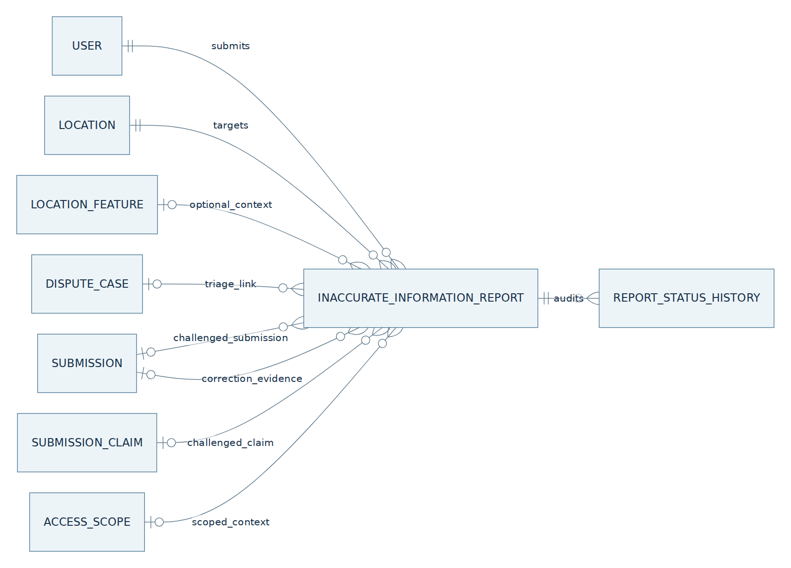
erDiagram
direction LR
USER ||--o{ INACCURATE_INFORMATION_REPORT : submits
LOCATION ||--o{ INACCURATE_INFORMATION_REPORT : targets
LOCATION_FEATURE o|--o{ INACCURATE_INFORMATION_REPORT : optional_context
INACCURATE_INFORMATION_REPORT ||--o{ REPORT_STATUS_HISTORY : audits
DISPUTE_CASE o|--o{ INACCURATE_INFORMATION_REPORT : triage_link
SUBMISSION o|--o{ INACCURATE_INFORMATION_REPORT : challenged_submission
SUBMISSION_CLAIM o|--o{ INACCURATE_INFORMATION_REPORT : challenged_claim
SUBMISSION o|--o{ INACCURATE_INFORMATION_REPORT : correction_evidence
ACCESS_SCOPE o|--o{ INACCURATE_INFORMATION_REPORT : scoped_context

B.4 Configuration and startup validation
Wf02:Recency:RecentWindowDays = 30
Wf02:Recency:HalfLifeDays = 180
Wf02:Freshness:RecheckAfterDays = 90
Wf02:Freshness:FactorHalfLifeAfterRecheckDays = 180
Wf02:Freshness:BatchSize = 500
Wf02:Freshness:Cron = "0 2 * * *" // scheduler local configured timezone; store UTC timestamps
Wf02:Consensus:MinIndependentVotersForReview = 2
Wf02:Consensus:MaxReputationWeight = 100
Wf02:Consensus:CrowdAutoResolveEnabled = false
Wf02:Consensus:CrowdMinHighTierVoters = 3
Wf02:Consensus:CrowdMinAgreement = 0.90
Wf02:Advisory:MaxDurationDays = 60
Wf02:Jobs:MaxAttempts = 3
Wf02:Jobs:LeaseSeconds = 300
Wf02:Jobs:ReconciliationCron = "* * * * *"
Wf02:Jobs:Queue = "wf02-community"
Wf02:Votes:MaxCommentLength = 1500
Wf02:Votes:IdempotencyTtlHours = 24
Use IOptions<Wf02Options> and startup validation for durations/counts, ratios and cron syntax. Consume WF-04's versioned DefaultReputationScore and VoteHoldThreshold; the initial policy sets both equal. Do not apply score <= 0 as a universal hold condition. MinIndependentVotersForReview=2 is a routing heuristic, not a correctness guarantee; concrete safety-relevant evidence may open a case through the configured rule. Missing authoritative eligibility data triggers PendingValidation and recovery, while a confirmed baseline account remains eligible for ordinary checks. Tier factors and crowd auto-resolution remain separately gated; CrowdAutoResolveEnabled=false is mandatory for the initial implementation.

B.5 User and admin HTTP API
All body field names below use JSON camelCase; status names use consistent PascalCase enum serialization or documented snake-case wire mapping in the existing API. Standard error envelope includes code, message, correlationId and validation details, without private metadata. Authorize all writes server-side. Exact backend route prefix can be adjusted to the existing API versioning convention, but document clients must use one canonical contract.

B.5.1 GET /api/v1/locations/{locationId}/features/{featureType}/community
Authenticated read uses the WF-01 map visibility policy. Require scopeId query parameter and resolve exactly (locationId, scopeId, featureType); return 422 for missing/invalid scope, 404 for an unpublished scoped feature. Return its LocationFeatureId, SourceClaimId and published version with the separate community status. Never choose a floor or entrance implicitly.
{
"locationId": "c29efc42-05b9-43d5-bc74-17d616f7eab2",
"scopeId": "<scope-uuid>",
"locationFeatureId": "<published-feature-uuid>",
"sourceClaimId": "<published-source-claim-uuid>",
"featureType": "Ramp",
"publishedStatus": "Available",
"publishedVersion": 2,
"verifiedAt": "2026-06-01T08:00:00Z",
"communityLabel": "NeedsRecheck",
"lastTrustedReconfirmedAt": null,
"recheckRecommended": true,
"activeAdvisory": null,
"publicMessage": "Thông tin ram dốc cần được xác nhận lại tại hiện trường."
}
Do not expose FeatureConfidence as a new value after age decay. Missing community projection may be computed from VerifiedAt on read and reconciled asynchronously, without fabricating independent votes. Unknown feature: 404 FEATURE_NOT_PUBLISHED with WF-01 contribution CTA.

B.5.2 POST /api/v1/locations/{locationId}/features/{featureType}/votes
Headers: Authorization: Bearer, Idempotency-Key required. Request:
{
"scopeId": "<scope-uuid>",
"observedFeatureVersion": 2,
"voteType": "Changed",
"proposedStatus": "Limited",
"comment": "Lối dốc đang bị chắn một phần ở thời điểm ghé thăm.",
"evidenceSubmissionId": null
}
Require scopeId in the body. Resolve LocationFeatureId and current SourceClaimId server-side from (locationId, scopeId, featureType), and reject a stale observedFeatureVersion with 409 rather than retargeting the vote. StillAccurate requires no alternative status; Changed requires a different concrete status or a description of an observed temporary change. A later WF-01 evidence Submission must match location, scope and feature and pass ownership checks. Vote targets the resolved SubmissionClaim; the feature/version records its publication context. Do not accept client weights, tier, timestamps, vote status, storage URLs or mediaIds.
Success 201 Created when saved, regardless of asynchronous aggregation:
{
"voteId": "606427ed-71a6-4ce7-a559-61386388cb44",
"voteStatus": "Recorded",
"evaluationStatus": "Queued",
"featureVersion": 2,
"publishedFeatureChanged": false,
"message": "Đã ghi nhận quan sát. Trạng thái cộng đồng sẽ được cập nhật sau khi đối chiếu."
}
A voter below WF-04's VoteHoldThreshold receives voteStatus=PendingValidation and evaluationStatus=Queued; unavailable authoritative eligibility data uses a separate pending reason and retry. An active new account at DefaultReputationScore is not held merely for being new or for a baseline score of zero. An authorized Admin may validate a held vote after normal subject, identity and evidence checks; the decision does not automatically restore account reputation. Do not expose internal raw weights. The same Idempotency-Key and canonical request hash replays the stored body/status and voteId; changed payload returns 409 IDEMPOTENCY_KEY_REUSED.

B.5.3 POST /api/v1/community-votes/{voteId}/link-submission
Authenticated voter only; header Idempotency-Key. Body {"submissionId":"UUID"}. Validate same contributor, canonical Location, FeatureType, intended claim and non-terminal evidence availability. If a vote already links the same Submission, return previous result; different Submission while an active link exists requires explicit correction policy and cannot silently replace audit. Return 200 with evidenceSubmissionId, link timestamp and evaluationStatus=Queued. This endpoint links, not creates, a WF-01 Submission; the contributor must choose and submit the actual photo/video through WF-01's signed upload and verification pipeline. An unreviewed linked Submission does not make the vote automatically Eligible. Validate ScopeId matches the vote's resolved feature and the linked claim; a different floor/entrance is rejected, even at the same Location.

B.5.4 GET /api/v1/admin/community-disputes
Requires Wf02.Moderate, Admin role and validated Admin Portal session/scope. Query status=open|under_review|awaiting_more_info|correction_pending, page, pageSize, optional Location/Feature filter. Paginated response includes ID, Location public name, FeatureType, published version/value, age, eligible independent voter counts, reason code and openedAt; private observations/media require a separate authorized detail read. GET /api/v1/admin/community-disputes/{caseId} returns case chronology, policy/versioned weight snapshot and authorized evidence references (not public raw URLs). Pagination has deterministic (OpenedAt,Id) order.

B.5.5 PATCH /api/v1/admin/community-disputes/{caseId}
Headers: Bearer admin token, Idempotency-Key and If-Match version/ETag. Examples:
{
"decision": "LinkCorrection",
"reason": "Ảnh hiện trường cho thấy trạng thái ram dốc cần xác minh lại.",
"correctionSubmissionId": "834e25e1-f07c-4070-9135-6e5fdac07ee6"
}
LinkCorrection changes case to CorrectionPending, not public truth. RecordPublication resolves updated only when that submission was published for the same feature. RetainBaseline resolves baseline with reason; RequestEvidence leaves case AwaitingMoreInfo; CreateAdvisory requires startsAt, endsAt and scoped reason within max duration. Return case ID, status, moderatedBy, decidedAt, publishedFeatureChanged, and optional advisory. A stale If-Match or illegal transition returns 409; no silent last-writer-wins decision.

B.5.6 WF-02 detailed report API
POST /api/v1/locations/{locationId}/reports (authenticated, Idempotency-Key) accepts reason enum (IncorrectFeature, MissingFeature, OutdatedInformation, WrongAddressOrPin, Other), description, optional locationFeatureId, scopeId, featureType, observedFeatureVersion, optional targetSubmissionId/targetSubmissionClaimId and separately linkedSubmissionId; WrongAddressOrPin may supply proposedAddress/proposedPosition and evidence as untrusted suggestions. Resolve merged locations; validate the target, text and ownership. Return 201 {reportId, status: Submitted, createdAt}; matching replay returns the same Report and a changed payload with the same key returns 409. Persist Report and status history; the report does not write CommunityVote, affect weightedAgreement or alter LocationFeature. Admin triages Submitted → UnderReview → AwaitingMoreInfo/LinkedToDispute/Resolved/Rejected with actor, reason and audit. A verified issue may link a DisputeCase or WF-01 correction Submission; only WF-01 publishes changed feature truth. GET /api/v1/me/reports lists the contributor's own Reports; GET /api/v1/admin/reports and PATCH /api/v1/admin/reports/{reportId} require admin rights. Optional evidence media uses the authorized WF-01 upload/link contract, never arbitrary public URLs. Rate-limit duplicates without discarding the audit record; report content is not public accessibility truth. An Admin-approved pin/address correction commits Location and LocationMetadataHistory with expectedVersion in one transaction, returns MetadataCorrected and preserves old capture snapshots.

B.6 Ordered vote processing
- Authenticate and authorize; rate-limit repeated votes and reject malformed location/feature UUIDs.
- Canonicalize merged Location and load its current published LocationFeature, version and status; enforce the client-observed version with 409 FEATURE_VERSION_CHANGED and return current safe feature summary.
- Validate VoteType, proposed state, text length/content, and optional linked Submission subject and ownership. Never trust client reputation or timestamps.
- Find existing (UserId,endpoint,Idempotency-Key) record and compare hash of canonical body before trying to supersede an older vote.
- Resolve WF-04 score/tier snapshot outside the write transaction (or use an already consistent local authoritative projection). If unavailable, set PendingValidation and enqueue reevaluation.
- Begin short DB transaction; recheck feature version and lock per voter/feature/version; supersede previous active effective vote; append new vote and status audit; create or coalesce FeatureAssessmentJob; store idempotent response; commit.
- Best-effort enqueue Hangfire by domain job ID, return 201. Hangfire reconciler recovers a committed job if enqueue fails. Never wait for Python AI or community recomputation in the mobile POST.

B.7 Evidence and media route
A quick vote is intentionally lightweight and has no raw upload fields. A detailed Report is a separate WF-02 record and never becomes a counted vote. The original source's optional evidence_media means open WF-01 contribution with evidence, using POST /api/v1/media/upload-intents, direct private signed PUT and POST /api/v1/submissions, then link the resulting UUID to the vote/case. WF-01 revalidates actual JPEG/PNG/video bytes, GPS/EXIF, ownership, quality and privacy, and Hangfire calls the Python service. WF-02 moderation can view the linked Submission's original evidence only under authorization. Link creation does not copy media to a public bucket, bypass AI or presume its final outcome. If product later requires an upload inside the quick vote form, that is an explicit new upload-intent ownership contract plus migrations, not mediaUrls guessed by the frontend.

B.8 Vote eligibility and independence

B.8.1 Effective observation set
For current feature version v, take the latest non-superseded, non-rejected vote per VoterId targeting its published SourceClaimId, where ObservedFeatureVersion=v. Archived votes never count for v+1. PendingValidation has applied weight zero; Recorded awaits eligibility processing and does not increase public confirmation until validated. Eligible needs successful identity, subject, current-version and policy checks. The baseline source contributor's own quick vote is not an independent confirmation. If a voter also owns a WF-01 published claim for this feature, the later shared-reader extension deduplicates across both sources; no double vote. All lookups and deduplication remain within (LocationId, ScopeId, FeatureType); never pool observations across floors/entrances.

B.8.2 Detecting conflict
Treat only StillAccurate as agreement when its observation was valid and eligibility is confirmed. A Changed vote with an alternative concrete status, or a described temporary blockage even if the published feature state stays the same, is contradictory for triage. Unknown is not positive agreement. A single credible material/safety-relevant contradiction may open an Open case; otherwise the default review heuristic requests two independent eligible voters before opening. Untrusted votes are stored but do not count toward the threshold. If existing active advisory already names the same condition, link observation to its case or context rather than opening duplicate identical cases, while still accepting distinct new reports.

B.8.3 Reputation and tier snapshot
Use WF-04's authoritative evaluation-time score, baseline=50, VoteHoldThreshold=50 and policy version, never spendable points or prospective awards. Score<50 or missing authoritative data yields PendingValidation with distinct reasons and zero applied weight. Baseline 50 passes this gate after ordinary checks. Authorized Admin validation accepts only that vote; account recovery is separately audited. For Eligible votes use min(max(score,1),MaxReputationWeight) and factor=1 while extra tier factors remain disabled. Record score, threshold, eligibility, source claim/version and policy snapshot. Do not alter WF-01 claim weights or completed snapshots.

B.9 Recency and weighting
At frozen asOfAt, for each eligible effective independent voter i:
ageDays_i = max(0, (asOfAt - CommunityVote.CreatedAt_i).TotalDays)
recencyWeight_i = 2 ^ (-ageDays_i / HalfLifeDays)
effectiveWeight_i = clamp(Wf04ReputationScore_i, 1, MaxReputationWeight)
× Wf04Wf02TierFactor_i × recencyWeight_i
weightedAgree = sum(effectiveWeight_i where vote_i agrees with published status)
weightedTotal = sum(effectiveWeight_i for all eligible concrete observations)
weightedAgreement = weightedAgree / weightedTotal, if weightedTotal > 0
If total is zero, weightedAgreement=null, hasIndependentCommunityEvidence=false; never display 100% agreement from zero votes. Count each user once, including in DistinctHighTierVoters. Round displayed percentages to one decimal; persist exact numeric snapshots with a deterministic evaluation timestamp. RecentWindowDays=30 is a label/priority window for the newest cohort, not an extra multiplier silently applied on top of the half-life. Historical WF-01 published claims use their own frozen 180-day consensus logic; WF-02's weightedAgreement is a separate value until the B.11 integration gate is accepted.

B.9.1 Example
At the evaluation time, three eligible independent voters with effective weights 85, 20, 5 record two agreements and one contradiction: agreement = (85+20)/(85+20+5)=0.9545. The result is community agreement about the currently published value, not AI confidence, compliance with the Vietnamese technical regulation or final permission to publish. One user's three observations still count once, even if their score is high.

B.10 Freshness algorithm and presentation
freshnessOriginAt = LastTrustedReconfirmedAt ?? CurrentPublishedFeature.VerifiedAt
ageDays = max(0, (asOfAt - freshnessOriginAt).TotalDays)
isStale = ageDays > RecheckAfterDays
FreshnessFactor = 2 ^ (-max(0, ageDays - RecheckAfterDays)
/ FactorHalfLifeAfterRecheckDays)
LastTrustedReconfirmedAt advances only for an independent, eligible, same-version StillAccurate corroboration without active contradictory evidence; a self-confirmation or PendingValidation vote never resets it. A linked WF-01 re-publication starts a new version with new VerifiedAt; previous reconfirmations cannot be copied to it. The factor remains 1 until the 90-day recheck date, then decreases gradually, clamped to [0,1]. Set NeedsRecheck when stale and no higher-priority active dispute/advisory; materialized label precedence: CommunityUnderReview > ConflictReported > NeedsRecheck > Reinforced > Fresh > Uncorroborated. An active advisory is a separate overlay and can coexist with a case label; it never converts a published Available feature into NotAvailable.
The UI should say “thông tin cần xác nhận lại” rather than “địa điểm không còn tiếp cận được”. Do not store FreshnessFactor in WF-01 LocationFeature.Confidence, or turn a time-based warning into a claim that an item fails Vietnamese technical regulation QCVN 10:2024/BXD.

B.11 WF-01 shared community-evidence integration gate
Current WF-01 B.11 accepts only explicitly eligible SubmissionClaim rows from Published Submissions. Initial WF-02 implementation does not change its CommunityConfidence nor AutoVerified threshold. An opt-in future revision must specify:
- A shared ICommunityEvidenceReader with source union PublishedSubmissionClaim and EligibleCommunityVote, excluding current submission and its author when assessing their new claim.
- Same LocationId, FeatureType, concrete value and correct published version/time alignment; a temporary blockage without stable proposed state is not a permanent claim.
- One latest eligible evidence item per contributor across both sources, with source ID and reason for choice, preserving claim recency and WF-04 score snapshot.
- Exact approved factor policy; no unintended double application of a WF-04 3× tier multiplier to WF-01's published-claim weights.
- Matched per-feature value agreement, ContributorFactor and FeatureConfidence=.60×AIConfidence+.40×CommunityConfidence; no retroactive change to a completed AI result.
- Backfill/recompute strategy, config version, migration, monitoring and tests for old/new snapshot coexistence.
Until every item is implemented, the developer must not feed WF-02 vote totals into WF-01 auto-publication. This is an integration dependency, not an undocumented shortcut.

B.12 Dispute policy and review

B.12.1 Opening and coalescing
An eligible contradiction creates a ConflictReported assessment. If the configured independent-voter threshold or the explicit serious-evidence override is met, create or reuse the one active DisputeCase for (LocationFeatureId,FeatureVersion). The override requires an auditable reason, valid evidence link or verified admin flag; mere text containing alarming words is not enough. Attach each relevant vote via DisputeCaseVote and retain its original value. A concurrent pair of votes racing to open a case is handled by the partial unique index; the loser reloads and links to the winner.

B.12.2 Decisions
Decision | Permitted starting status | Durable action | Public feature value
RequestEvidence | Open / UnderReview / AwaitingMoreInfo | New DisputeDecision, status AwaitingMoreInfo; send notification through outbox if product policy requires. | Unchanged; show under review if material conflict.
RetainBaseline | Open / UnderReview / AwaitingMoreInfo | New decision with reason; status ResolvedBaseline; do not erase votes. | Unchanged.
LinkCorrection | Open / UnderReview / AwaitingMoreInfo | Validate WF-01 Submission; store link and status CorrectionPending. | Unchanged pending publication.
RecordPublication | CorrectionPending | Check same-feature published WF-01 source and new version; status ResolvedUpdated; archive old-version vote eligibility. | Updated by WF-01 publication transaction, not this decision.
CreateAdvisory | Open / UnderReview / AwaitingMoreInfo | Admin-approved time-bounded advisory with reason and dates; case may remain open. | Unchanged; public advisory overlay.
RetainBaseline is a finding that the evidence does not support changing current publication; it is not a finding of intentional lying. Do not emit a negative WF-04 event without its independent reviewed misconduct procedure. Admin concurrent decisions compare xmin/ETag and return 409 when stale.

B.12.3 Crowd auto-resolution is gated
Source BR-06 proposes ≥3 high-tier independent voters with ≥90% weighted agreement. This version persists those parameters for review and computes audit candidates, but CrowdAutoResolveEnabled=false. Even an enabled future implementation must reject self corroboration, same-contributor repeats, coordinated evidence from duplicate accounts, pending votes, stale baseline versions and conditions requiring a physical measurement. An auto-resolution may close an already-public baseline dispute only under an explicitly approved policy; it cannot publish a different feature value without WF-01.

B.13 Temporary advisory lifecycle
The admin checks evidence and sets StartsAt<EndsAt≤StartsAt+MaxDurationDays. Scheduled notice activates by Hangfire at StartsAt; active notice expires by Hangfire at EndsAt, using idempotent UTC comparisons. Optional deliberate Revoked requires a reason and admin identity. Read path also checks StartsAt<=now<EndsAt so a delayed job cannot show an expired notice. An advisory only communicates a time-limited observed obstruction; it does not suspend receiving new community observations, hide the permanent feature version or automatically discard an open case. At expiry, enqueue assessment and put unresolved meaningful conflicts back into the review queue.

B.14 Background jobs and reliability

B.14.1 Vote evaluation job
The vote transaction inserts/coalesces FeatureAssessmentJob(Queued). After commit schedule Wf02Evaluate(featureJobId) in persistent Hangfire queue wf02-community; use Hangfire PostgreSQL storage already configured for WF-01. The handler claims the domain job with DB row lock and lease, reads current feature/version and effective votes, fetches/validates WF-04 scores via a bounded adapter, computes a deterministic result at frozen asOfAt, then writes CommunityAssessment, FeatureCommunityState and optional case link under optimistic concurrency. If feature version changed, mark old assessment historical and enqueue the current version; never apply an old-version snapshot to the new public feature.

B.14.2 Recurring scans and missed enqueue
Register Hangfire recurring Wf02FreshnessScan on a configured daily schedule and Wf02ReconcileJobs initially once per minute. Scan current published features by indexed pagination with a stable cutoff, at most BatchSize rows per transaction. Candidate selection includes approaching/past recheck age, active advisory start/expiry, changed feature version and stale evaluation job leases. Reconciliation re-enqueues Queued, due RetryScheduled and expired Processing jobs; it does not create duplicates through partial unique constraints. Multiple servers must coordinate by DB locking and a cluster-wide Python/CPU budget when a linked WF-01 submission needs inference; the WF-02 evaluator itself never calls Python.

B.14.3 Retry, failure and observability
Use domain retries (default three) with configurable backoff and error categories: WF-04 unavailable, DB concurrency, malformed linked data and unexpected runtime failure. Set Hangfire AutomaticRetry(Attempts=0) for this domain handler so domain retry and Hangfire retry cannot multiply. On process crash, lease expiry allows reconciliation. If retries exhaust, mark domain job Failed, preserve last known public truth, surface evaluation error to operations and allow admin/replay recovery. Do not silently call the result Reinforced. Record job ID, feature/version, policy version, duration, eligible vote count and reason codes in structured logs; redact private comments and raw scores in ordinary application logs.

B.15 Transaction and concurrency matrix
Transaction | Atomic database writes | Outside transaction
New vote | Supersede prior active candidate; insert vote; status audit; coalesced assessment job; replay response record. | Auth provider check, optional WF-04 score fetch, Hangfire enqueue after commit.
Evaluation | Immutable assessment snapshot; current state version/label; case create-or-link; job completion; notification outbox where needed. | Any WF-04 adapter read before write; FCM delivery after commit.
Admin decision | Append decision; guarded case status; optional advisory; audit/outbox. | Media retrieval, evidence preview and WF-01 submission request before/after DB transaction.
WF-01 correction publication | WF-01 atomically updates LocationFeature/history/status/EXP once. | WF-02 consumes committed publication event or reconciliation; never shares a cross-service transaction.
Advisory start/expiry | Guard status/time and update/requeue assessment. | FCM after commit.
xmin protects materialized state and dispute cases. Job completion checks feature version and latest queued revision under the same transaction. Stale workers must not close a newer case. Serializable transaction is not globally required if row locks, unique constraints and bounded retries enforce these invariants. PostgreSQL and Hangfire persistence are separate commits even if they share the server; the domain job plus reconciler bridges the gap.

B.16 Error, exception and user response matrix
Code | Scenario | HTTP / background outcome | User-facing guidance
AUTH_REQUIRED | User not logged in. | 401; no vote. | Sign in to submit an observation.
LOCATION_NOT_ACTIVE | Place is Provisional or missing. | 404/409 according to existing route policy. | Start or check a WF-01 contribution.
FEATURE_NOT_PUBLISHED | Selected feature has no current published value. | 404; no vote. | Submit new feature evidence through WF-01.
FEATURE_VERSION_CHANGED | Mobile view referenced previous version. | 409 with safe current summary. | Review latest information before voting.
INVALID_OBSERVATION | Changed vote lacks concrete status or useful description. | 422 with field errors. | Provide a specific observation.
DUPLICATE_REQUEST | Same Idempotency-Key and payload. | Replay original 201/200. | No duplicated vote or points.
IDEMPOTENCY_KEY_REUSED | Same key, different payload. | 409. | Retry with a new key.
PENDING_VALIDATION | Score below VoteHoldThreshold, authoritative eligibility data unavailable, or evidence subject needs review. | 201 recorded, applied weight zero. | Observation saved; awaiting review.
WF04_UNAVAILABLE | Reputation reader temporarily unreachable. | Save observation pending, evaluate later; no fabricated weight. | Observation saved; checking status later.
EVIDENCE_LINK_INVALID | Linked submission belongs to another user/place/feature. | 403/422; do not reveal its existence to unauthorized actor. | Select your own relevant submission.
CASE_CONFLICT | Another admin decided or version changed. | 409; reload detail. | Review current case before resubmitting.
EVIDENCE_INSUFFICIENT | Admin cannot establish a new fact. | Retain open AwaitingMoreInfo. | More information may be requested; no penalty.
TEMP_ADVISORY_EXPIRED | Advisory deadline passed. | Expiry job runs/reconciles. | Remove active notice; feature may still need review.
EVALUATION_FAILED | Domain job exhausts retries. | Failed job and operations alert; no truth change. | Display last known published value with pending community assessment.
The original source's below-default reputation EX-01, no-claim EX-02, insufficient-evidence EX-03, false-report EX-04, no-decay EX-05, crowd EX-06 and temporary-closure EX-07 correspond to the specific rows/policies above. EX-04 never deducts points simply because a claim is not confirmed; WF-04 adjudication is separate.

B.17 Security and privacy
Authorize signed-in reads against existing Location visibility; writes also require a valid user session. Wf02.Moderate, the Admin role and a validated Admin Portal session/scope all guard queue/detail/decision endpoints; an Admin mobile session cannot exercise them. Both User and Admin accounts may perform ordinary mobile User actions under the same ownership rules, including while the same Admin has a separate portal session. An Admin cannot decide a report or dispute involving their own data: compare the portal-authenticated Admin ID with Report.ReporterId; the ContributorId of the challenged published TargetSubmission or current baseline source Submission; the ContributorId of any linked correction Submission; and the CommunityVote.VoterId of every vote linked through DisputeCaseVote.CommunityVoteId, including OpenedByVoteId. For a report linked to a dispute, apply the same case check. Another uninvolved Admin must review it. Resolve canonical source ownership and make this guard part of the decision transaction so a concurrent link or source-version change cannot bypass it. A one-Admin self-originated case remains in the applicable review state until a different Admin can decide; independent WF-01 AutoVerified remains governed by its own gates. Reuse WF-01 A.2.3's shared User.Role and portal authorization contract; do not add a second role mapping. Hide private comments, voter IDs, tier, score, device position, evidence keys and any closed moderation accusations from public APIs. Use WF-01 owned signed uploads only for linked Submission evidence, size/type/byte validation and short-lived admin read capabilities. Record reason and actor for manual eligibility and advisory changes. Rate-limit per user/location/feature with configuration to reduce spam; user identity and stable feature/version dedupe prevent simple repeat voting. A third-party Google Places listing is not a verified accessibility source. Public labels are descriptive and do not claim a feature is compliant with the Vietnamese technical regulation from an image or from crowd counts.

B.18 Notifications and UX text
Reuse WF-01 B.3.17 NotificationOutbox and FCM delivery. Existing dispute/advisory event types are DisputeOpened, EvidenceRequested, DisputeResolvedBaseline, DisputeResolvedUpdated, AdvisoryStarted and AdvisoryExpired. RelatedCaseId is the nullable DisputeCase FK; SubmissionId is required only when the event has a submission source. A report-only evidence request/final decision carries its real reportId in PayloadJson without inventing a case or submission. Supply and validate sourceType/sourceId/sourceEventId under the shared WF-01 B.3.17 allowlist; reportId refers to the Report, while sourceEventId refers to its committed history. Do not impose a submission/case requirement on other supported workflow events. Every event carries the immutable sourceEventId; uniqueness by recipient/type/sourceEventId prevents retry duplicates while allowing later legitimate decisions. Commit outbox work with its source history/outcome, dispatch after commit, and send private outcomes only to involved users. Suggested messages:
Situation | Message
Recorded corroboration | “Cảm ơn bạn đã xác nhận thông tin tại địa điểm này.”
Change observation queued | “Đã ghi nhận thay đổi; dữ liệu hiện tại đang được đối chiếu.”
Needs recheck | “Thông tin về hạng mục này cần được xác nhận lại tại hiện trường.”
Under review | “Hạng mục đang có thông tin khác nhau và đang được kiểm duyệt.”
WF-01 correction published | “Thông tin về hạng mục đã được cập nhật và xuất bản.”
Avoid promising EXP on an unreviewed quick vote and avoid “địa điểm đạt Vietnamese Technical Regulation” claims. Notification failure cannot roll back a confirmed case transition or WF-01 publication.

B.19 Representative integration test scenarios
Test | Setup / action | Mandatory assertion
New place lacks published feature | Location Provisional or concrete feature absent | No WF-02 vote/case; appropriate WF-01 path.
Cross-feature isolation | Same Location, published Ramp and Elevator | Vote Ramp updates only Ramp state; Elevator history/confidence intact.
One user repeats vote | Two different Idempotency-Keys, same user/feature/version | Two audit rows, one effective vote, previous superseded.
Same request replay | Same key/body twice | Identical saved response and vote ID; only one new row.
Reused key, changed body | Change proposed status with same key | 409; no new write.
Two users race to open case | Concurrent contradictions for one version | One active case, both vote links, no lost update.
Zero eligible votes | Only below-threshold pending observations | WeightedAgreement null; no false 100% consensus; public feature unchanged.
Reputation update later | Snapshot created then WF-04 score changes | Old assessment immutable; later evaluation has explicit new score/version.
Rep score dominates | One user has maximum rep, others independent | Voter count reflects independent users; no three-voter auto-resolve.
Old-version vote arrives | WF-01 published v3, mobile saw v2 | 409; cannot reconfirm v3 implicitly.
Linked evidence misownership | Submission owned by another contributor | 403; no link, no leaked media.
Freshness boundary | asOfAt at day 90, then >90 | Fresh at boundary, NeedsRecheck afterwards; WF-01 final confidence unchanged.
Self corroboration | Source contributor taps StillAccurate | Auditable observation; never increments independent trusted corroboration.
Under-review contradictory evidence | Admin sees valid opposing votes | Feature remains published with review label until WF-01 publication.
Two admin decisions race | Both same ETag | One wins, one gets 409; two opposite outcomes not committed.
Invalid resolution | Linked WF-01 Submission AI recommendation but not Published | Disallow ResolvedUpdated; no feature rewrite.
Publication and pending vote race | v2 vote evaluation overlaps v3 publication | No v2 freshness carried onto v3; old job cannot overwrite current state.
Advisory expires while worker down | Read after end time then reconciliation | Expired notice not shown; eventual job makes durable state consistent.
Hangfire enqueue failure | Domain job committed, enqueue fails | API returns saved response; recurring reconciler schedules job once.
Penalty suggestion | Honest incorrect report or evidence unclear | No automatic −100 EXP or negative WF-04 event.
Run PostgreSQL integration tests for partial indexes, FK restrictions, xmin and worker leases. Unit-test deterministic weighting at fixed asOfAt; API tests cover auth and no private-field leakage. Keep migration/backfill test for existing WF-01 LocationFeature rows without WF-02 votes.

B.20 API ownership and acceptance traceability
Requirement from supplied workflow | Owning section | Acceptance proof
Append-only community observations | B.3.1, B.6, B.8 | Supersession/replay tests B.19.
Reputation-weighted consensus | B.8–B.9 | Frozen score snapshot, bounded weights, distinct voter tests.
Recent 30-day view | B.4, B.9 | Recency label separated from half-life weighting.
90-day recheck | A.10, B.10, B.14 | Boundary and expired-worker tests.
Conflict and admin ruling | A.11–A.12, B.12, B.5.4–B.5.5 | Single active case, ETag and publication-gate tests.
Detailed report | A.13.1, B.3.8, B.5.6 | Report 201/replay/409, owner-only history, admin transitions, independent vote count and optional WF-01 correction; no direct publication.
High-tier crowd rule | A.17, B.12.3 | Disabled flag and policy-change gate.
Temporary blockage | A.10.3, B.13 | Expiry and continued-vote tests.
False/troll report penalty | A.12, A.17, B.16 | No automatic charge; WF-04 owns reviewed decision.

B.21 Deployment and rollout checklist
- Apply additive migrations with new constraints before enabling writes; create Report/ReportStatusHistory and their FKs/indexes without replacing WF-01 tables; seed current feature read models as Uncorroborated using publication time.
- Wire the shared LocationFeature read service, existing identity/auth, WF-01 submission/link and WF-04 reputation adapters; verify private media access with the existing storage adapter.
- Deploy API read routes; then vote and Report write routes with moderation authorization and shared idempotency; enable the durable vote evaluation job and Hangfire recurring freshness/reconciliation, metrics and operator replay. Run Report transition/replay tests before exposing the Report action in WF-03.
- Keep crowd auto-resolution, negative reputation events and WF-01 vote-based CommunityConfidence extension off until those contracts are separately signed off and tested.
- Validate backups/migrations, concurrency, unauthorized access, partial unique constraints and outbox delivery; audit that no vote updates WF-01 LocationFeature directly.

B.22 Detailed WF-02 Report implementation contract
This section expands B.3.8 and B.5.6. The existing CommunityVote, DisputeCase, LocationFeature and WF-01 publication contracts remain authoritative. A Report is a separately auditable complaint; no Report status, count or attachment is a consensus vote.

B.22.1 Entities, keys and relational constraints
InaccurateInformationReport columns: Id UUID v4 PK; LocationId UUID FK to the canonical existing Location; LocationFeatureId nullable FK and ObservedFeatureVersion identify the feature version being reported; TargetSubmissionId and TargetSubmissionClaimId nullable FKs identify the challenged published source; ReporterId UUID FK to existing User; ScopeId nullable FK to AccessScope of the same Location; ProposedAddress and ProposedPosition nullable only for WrongAddressOrPin; FeatureType nullable using WF-01's canonical feature enum; ObservedFeatureVersion nullable integer; Reason required enum IncorrectFeature, MissingFeature, OutdatedInformation, WrongAddressOrPin or Other; Description required bounded text; Status required enum Submitted, UnderReview, AwaitingMoreInfo, LinkedToDispute, Resolved or Rejected; LinkedDisputeCaseId nullable FK; LinkedSubmissionId nullable FK; Version integer concurrency token initialized to 1; CreatedAt and UpdatedAt UTC. Keep resolution reason/outcome as private moderation metadata, never as a public feature value. ReportStatusHistory: Id UUID v4 PK; ReportId FK; FromStatus nullable; ToStatus required; ActorId FK; Reason/Outcome text where applicable; OccurredAt UTC. A submitted report and its first history row are inserted in the same transaction. Existing LocationFeature and Submission rows are referenced, not copied. LocationMetadataHistory stores immutable old/new Location metadata snapshots and source/version. A correction locks the Location, checks expectedVersion, commits new values and history atomically; rejected requests never change the pin. ReportEvidence is append-only: Id UUID v4 PK, ReportId FK (RESTRICT), AddedByReporterId FK, Description bounded nullable, OwnedMediaId nullable FK to an original privately owned media item (Description or OwnedMediaId required), CreatedAt UTC, SourceVersion, IdempotencyKey and RequestHash. Enforce reporter = Report.ReporterId and the media owner/location binding in the transaction; no arbitrary URL or duplicate bytes. Unique(ReportId, AddedByReporterId, IdempotencyKey) and Index(ReportId, CreatedAt, Id) support replay and audit. The shared IdempotencyRecord (user, endpoint, key) stores the exact response and canonical body hash; same key/body replays without a new evidence row or history edge, changed body returns 409. Lock Report and check expectedVersion before append; evidence, status transition, version increment, history and outbox commit atomically. Each item belongs to the report owner and canonical Location; evidence remains private to its owner and authorized Admin. Do not edit the original Report description or count a supplement as a vote. A successful supplement in AwaitingMoreInfo atomically appends evidence, history and version, returns to UnderReview and notifies Admin; other states return 409.

B.22.2 Indexes, versioning and retention
Create an index on (LocationId, Status, CreatedAt DESC) for the admin queue and (ReporterId, CreatedAt DESC, Id DESC) for owner history; an optional filtered (LocationId, FeatureType, Status) index can support active-case triage after query plans justify it. Use the existing IdempotencyRecord contract keyed by user, endpoint and Idempotency-Key, with request hash and stored response; do not create a second uncoordinated idempotency table. Use Report.Version or an equivalent PostgreSQL concurrency token on every admin transition. Never hard-delete report/status history while an audit or linked dispute must be retained. Define retention and private-media expiry using the project's existing privacy policy; this section does not invent a public retention period.

B.22.3 POST request and response contract
POST /api/v1/locations/{locationId}/reports requires Bearer and Idempotency-Key. IncorrectFeature example: {"reason":"IncorrectFeature","scopeId":"<scope-uuid>","featureType":"Ramp","locationFeatureId":"<feature-uuid>","observedFeatureVersion":3,"targetSubmissionId":"<published-source-submission-uuid>","targetSubmissionClaimId":"<published-source-claim-uuid>","description":"Ramp information appears outdated","linkedSubmissionId":null}. Server validates all target IDs against the scoped published version. TargetSubmissionId/TargetSubmissionClaimId identify reported source evidence; LinkedSubmissionId is optional separately owned correction evidence, never a substitute target. MissingFeature may name the scope and absent feature with null published target/version. Place-level WrongAddressOrPin uses Location as target: {"reason":"WrongAddressOrPin","description":"Entrance pin is on adjacent building","proposedAddress":"<address>","proposedPosition":{"latitude":10.77,"longitude":106.70},"linkedSubmissionId":null}. Proposed values require Admin approval before Location changes. Derive ReporterId from the token. First success returns 201 with reportId/status/locationId/createdAt; identical replay returns the stored response and changed payload returns 409 IDEMPOTENCY_KEY_REUSED.

B.22.4 Read and moderation API contract
GET /api/v1/me/reports?pageSize&cursor returns only the authenticated reporter's reportId, safe location name, optional featureType, status, createdAt, last public-safe update and nextCursor; never include other reporters or private review notes. GET /api/v1/admin/reports?status&locationId&cursor requires Admin role, validated Admin Portal session/scope and Wf02.Moderate, returns a bounded queue with author reference, target/version, reason and authorized evidence references. PATCH /api/v1/admin/reports/{reportId} requires a typed decision, reason and expectedVersion: {"decision":"RequestEvidence","note":"Provide a current entrance photo","expectedVersion":2}. Response includes reportId, status, version and updatedAt; stale expectedVersion returns 409 REPORT_VERSION_CHANGED with a safe current summary. Unsupported transitions return 409 INVALID_REPORT_TRANSITION; malformed input returns 422. The server records admin identity from auth, not request data, and applies B.22.7's conflict guard to the reporter, challenged source contributor, linked correction contributor and linked dispute voters before any decision. GET /api/v1/locations/{locationId}/timeline?pageSize&cursor returns approved redacted LocationMetadataHistory and scoped published LocationFeatureHistory in effective-time order, resolving merges with a stable cursor. GET /api/v1/locations/{locationId}/comments?pageSize&cursor returns Approved CommunityComments newest first; POST /api/v1/locations/{locationId}/comments creates PendingReview content for its author. Admin comment approval/hide requires reason and history. No public route exposes vote comments or raw reports. Admin metadata contract: PATCH /api/v1/admin/locations/{locationId}/metadata accepts proposedAddress/position, sourceReportId, expectedMetadataVersion and reason. It validates the report/canonical Location and neighboring identity, locks Location, updates address/position and MetadataVersion, writes before/after LocationMetadataHistory and resolves the source report with MetadataCorrected in one transaction. On stale version return 409 with no partial update. Entrance-anchor correction delegates to WF-01's authorized AccessScope position service; the report decision links its resulting history version. POST /api/v1/me/reports/{reportId}/evidence requires the authenticated report owner, Idempotency-Key and expectedVersion; body has bounded description and/or owned staged mediaIds (no arbitrary URL). Only AwaitingMoreInfo accepts it; exact replay returns the same evidence result, changed-key payload or stale version returns 409, foreign report returns 403/404. Response includes reportId, evidenceId, status: UnderReview, version and action timestamp. GET /api/v1/me/reports/{reportId} includes the Admin's public-safe requested detail and the owner's supplements. POST /api/v1/admin/locations/{locationId}/comments/{commentId}/moderation approves or hides a pending/approved public comment with expectedVersion and reason; audit actor/time/old/new state. Public comment GET defaults to newest-first by server-side CreatedAt then Id, with a stable cursor; approved comments also have read-time CommentRecencyWeight under the versioned 30-day initial half-life. The response marks an approved comment isRecentContext=true when its read-time weight is at least 0.25; the client highlights at most the first three such comments on the first page as a recent-context preview. Otherwise it shows no preview. There is no relevance-sort parameter in the MVP; older approved comments remain visible.

B.22.5 Validation matrix and ownership rules
Validate UUIDs, authentication, active/canonical Location, supported reason, feature enum, bounded nonempty description, observed feature version when supplied, linked Submission ownership and same canonical Location. A missing feature must not be rejected solely because no LocationFeature exists. An observed version mismatch may be accepted as a historical report with a stale-baseline flag for admin review; it must never be counted as a current-version vote. Reject foreign linked Submission IDs with 403/404 according to the existing non-disclosure policy. Apply user/Location rate limits and duplicate hints; a similar report from another person is not silently discarded or counted as corroboration. No client ReputationScore, moderation state, public media URL or award amount is trusted. Validate ScopeId belongs to canonical Location and matches referenced feature/version; WrongAddressOrPin proposed coordinates are finite, in range and retained as untrusted request data. Approved metadata correction uses a Location version guard and append-only before/after history; do not count coordinate reports as votes.

B.22.6 Creation transaction and idempotency
Perform authentication and cheap request validation first. Resolve merged Location identity and authorized linked Submission outside any long transaction. In one short PostgreSQL transaction: check IdempotencyRecord and hash; lock/recheck the canonical Location and linked subject as needed; insert Report at Submitted with Version=1; insert first ReportStatusHistory; store replayable 201 response and an optional notification outbox entry; commit. Return the response after commit. Any notification or external media lookup runs outside the transaction. If the process fails before commit, nothing is visible; if it fails after commit but before responding, replay retrieves the same report. Concurrent identical keys yield at most one Report through a unique idempotency constraint and conflict recovery.

B.22.7 State transition guards and admin actions
Allowed report transitions: Submitted→UnderReview/Rejected; UnderReview→AwaitingMoreInfo/LinkedToDispute/Resolved/Rejected; AwaitingMoreInfo→UnderReview/Rejected; LinkedToDispute→UnderReview/Resolved. Resolved and Rejected are terminal for that Report. Each transition requires actor authorization, expectedVersion, reason and one append-only history row in the same transaction as the version increment. An Admin decision is forbidden when the authenticated Admin ID matches the Report.ReporterId, the contributor of the challenged TargetSubmission/current published baseline source, the contributor of a linked correction Submission, or any linked CommunityVote.VoterId reached through DisputeCaseVote.CommunityVoteId (including the originating vote); a report linked to a dispute inherits those case conflicts. Resolve these identities against the canonical published source and locked case/version in the decision transaction. Another uninvolved Admin must decide; a rejected self-review attempt writes no transition or history row. A one-Admin case needing manual review remains pending without a self-approval exception. Linking a DisputeCase requires the same canonical Location and compatible feature/version context; link reuse does not create another case or a vote. Marking Resolved with outcome CorrectionPublished requires an existing, actually Published WF-01 Submission or publication/version reference; a pending correction can be linked but does not meet that outcome. A review/advisory outcome requires the relevant WF-02 advisory record and expiry policy. No admin transition writes LocationFeature directly. Resolved outcome MetadataCorrected requires the same transaction to commit an approved versioned Location metadata update and immutable history row. Admin reviews target identity, evidence and neighboring-place ambiguity; community votes inform but never directly move the pin. For scoped feature cases, Report.ScopeId must match linked claim, feature version and dispute. The AwaitingMoreInfo→UnderReview edge is initiated only by an owner supplement accepted under the report's current expectedVersion (or an explicit audited Admin reopening with existing evidence); its reason links ReportEvidenceId. RequestEvidence must specify the missing detail in the owner-safe response. A notification failure cannot undo the evidence/history transaction.

B.22.8 WF-01, vote and dispute integration
An optional linked WF-01 Submission must pass owner or admin authorization and point to the same canonical Location. WF-01 remains responsible for photo/video validation, AI verification, correction submission state and feature publication. WF-02 stores only its linked ID and safe derived context. A report can be linked to a DisputeCase for triage; it is not inserted into DisputeCaseVote and does not increase DistinctContributorCount or WeightedAgreement. If a separate CommunityVote is submitted by the same user, it has its own ID, idempotency key, eligibility and one-person rule. On WF-01 publication, reconcile linked report/case against the new feature version and require an auditable report outcome; do not automatically declare every related report true or award points. WF-04 receives only separately approved, reviewable events.

B.22.9 Notifications, visibility and privacy
Notify the reporter after a committed request for evidence or final decision using WF-01 B.3.17 outbox/FCM. Set PayloadJson.sourceType=InaccurateInformationReport, sourceId=Report.Id, reportId=Report.Id and sourceEventId=the committed ReportStatusHistory.Id; no linked Submission or DisputeCase is required for a standalone report. Validate the source and owner before committing. Delivery retry must not duplicate ReportStatusHistory. Show the reporter a safe status and action required, but hide private admin deliberation, another user's report and raw GPS/media metadata. Admin evidence access uses authorized short-lived private media links and existing privacy/blur rules. Logs include correlation ID, reportId, actorId, transition and error category, but not full description, sensitive media URL or provider token. WF-03 search may offer an explicit Report action; it never submits one during search or publishes report text as accessibility truth.

B.22.10 Failure, race and recovery outcomes
Case R-01 duplicate identical POST: replay 201 body, one Report and one first history row. R-02 same key changed payload: 409, no second report. R-03 target merged concurrently: retry canonical resolution or return 409 with safe replacement identity; never attach to two Locations. R-04 feature version changes after report submission: retain the report and observed version for historical review; do not reclassify it as a new vote. R-05 two admins update from Version=2: exactly one commits; the other receives 409 and reloads. R-06 evidence Submission rejected/cancelled: unlink unusable evidence only through an audited admin transition; keep the report. R-07 FCM delivery or dispatcher/Hangfire scheduling fails after commit: report/history and its durable outbox row remain committed; reconciliation retries delivery. A required outbox DB insert belongs to the source transaction, so its DB failure cannot leave a source falsely committed without the required notification record. R-08 WF-01 correction fails or is pending: retain the report in review/linked state; never claim CorrectionPublished. R-09 rate limit: 429 with retry guidance and no partially persisted report.

B.22.11 Integration tests and release gates
Test report of an existing feature and of a missing feature; place-level report; merged Location resolution; owner-only list versus admin queue; valid and foreign Submission linkage; stale observed version; same-key replay and changed-key conflict; concurrent report creation; concurrent admin decisions; self-review rejection for an Admin's own report, challenged published Submission, any linked dispute vote (including a non-originating vote) and linked correction, a second uninvolved Admin's valid decision, and one-Admin pending behavior; verify a concurrent source/case link cannot bypass the guard; all allowed and forbidden transitions; dispute coalescing; a report plus vote by the same user counted only once as a vote; no Report affecting WF-01 CommunityConfidence; pending versus Published correction outcome; outbox outage; audit/PII/media-link exposure. Database assertions inspect ReportStatusHistory, Version, IdempotencyRecord and unchanged LocationFeature/CommunityAssessment. Done means the API, schema, authorization, race handling and business outcomes above are observable and reproducible; proposed tier multipliers, auto-resolve and penalty policies remain gated under A.17. Add wrong-address/pin report and concurrent Admin corrections (one version wins), unchanged prior capture snapshots, scope mismatch rejection, public timeline redaction/pagination/merged Location, newest approved comments, private vote-comment isolation and recent-context emphasis that never changes LocationFeature. Test an owner supplement with media and text, stale version, identical idempotent replay, changed payload conflict, foreign owner, wrong state, concurrent Admin decision, malformed/foreign media and outbox outage. Verify one ReportEvidence row, one state-history edge and no CommunityVote/LocationFeature mutation. Test Admin comment approval/hide with version and audit; default public newest-first stable pagination, private notes excluded, and read-time comment decay at day 0, 30 and 60 (weights 1, 0.5 and 0.25 under the initial 30-day half-life). Verify the 0.25 recent-context boundary, at most three preview comments, no preview when all approved comments are older, older comments remain reachable, no relevance-sort parameter, and no LocationFeature or vote mutation. Verify a standalone report with no Submission/DisputeCase can notify its owner using reportId plus its history sourceEventId. Replay creates one outbox event; a later distinct evidence request creates another. Reject missing/mismatched source context. Check dispute transitions from every permitted starting status and replacement of a PendingValidation vote by a newer same-user observation.
Outbox assertions: PayloadJson.reportId/sourceId equal Report.Id and sourceEventId equals that report's committed ReportStatusHistory.Id, not the report ID copied into every field. Replayed decisions emit one logical notification; another audited decision gets its own history source.

B.23 Definition of Done
WF-02 is complete when authenticated users can submit idempotent feature-specific votes and separate detailed Reports; admins can audit/version report decisions and feature disputes, link only real WF-01 corrections, and never count Reports as votes. Hangfire reliably maintains separate freshness/community read models, temporary advisories expire safely, and all history remains auditable without changing WF-01 confidence or published truth on a quick vote or Report. The SQL schema, DTOs, authorization, privacy, migration and test scenarios in B.3–B.22 are required gates; the Report API and state transitions in B.22 are included. The policy decisions in A.17 remain visibly open until the team approves them; implementation must not silently infer approval.

WF-03 — Personalized Accessibility Search and Surrounding Exploration

Part A — Technical / Design Specification

A.1 Purpose, scope and interpretation

A.1.1 Purpose
Help a User find places, inspect published accessibility features and approved public evidence, and obtain a need-specific summary when scoped evidence supports it. The User may search by name/address, use Find near me, or select an area/pin. Opening a result never creates or changes a Location, Submission, claim, vote or reward.

A.1.2 Scope and workflow ownership
WF-03 owns accessibility discovery through POST /api/v1/locations/discover/search and local place suggestions through GET /api/v1/locations/search?source=accessmap. Only AccessMap identities and current published scoped features appear in WF3 results; third-party place candidates are not mixed into these results. WF-01 owns separate evidence contribution and may use an external provider for place selection. WF-02 owns votes, inaccuracy reports, disputes and freshness. The main audience is wheelchair users and people with mobility limitations; elderly people and stroller users may select the same concrete feature criteria. Mobility presets are wheelchair, limited_mobility, elderly, stroller and none. A result supports destination choice; it does not provide indoor/turn-by-turn navigation or guarantee a usable route.

A.1.3 Boundaries
WF-01 owns canonical Location identity, deduplication, immutable evidence, publication and LocationFeature truth. WF-02 owns votes/reports, disputes and freshness. WF-03 reads their published/public-safe outputs and evaluates explicit current search conditions. A contribution, vote or report starts only after a separate User action. External geocoding may resolve a User-selected center; an external place listing is never a WF3 destination result or accessibility source.

A.2 Actors and responsibilities
User: searches by text, current position, selected address/area or a manually placed pin; selects current mobility conditions; inspects published facts; and may explicitly open WF1 contribution or WF2 vote/report. All search, discovery and place-detail actions require a signed-in account; a mobile Admin account uses these ordinary User functions under the same rules. A User may opt in to saved needs and favorites; the current filters work without a saved profile. Admin maintains versioned mappings/defaults for supported features and handles authorized review only in a portal-scoped Admin session; Admin cannot invent unsupported feature types through free-form tags. ASP.NET Core validates inputs, queries PostGIS and applies deterministic matching rules. A geocoding provider may resolve a chosen address outside the DB transaction. Python analyzes contribution evidence in WF1 only and is not called for search matching. WF-01 A.2.3 owns the shared User.Role and portal authorization contract.

A.3 Architecture and data flow

A.3.1 Logical architecture
React Native → ASP.NET Core search/discovery services → PostgreSQL/PostGIS Location, current scoped LocationFeature and WF2 public-safe state. WF3 text suggestions explicitly request source=accessmap, which skips external place fallback. Optional address geocoding only establishes a center after the User selects an unambiguous address; manual pin placement requires no geocoder. A versioned .NET rule policy matches published features. Evidence previews reuse approved public media derivatives through short-lived permitted links; raw storage keys and private originals are never returned.

A.3.2 Search-time policy
MatchingPolicy v1 is a deterministic, versioned backend rule policy over published scoped features and the User's visible required/preferred conditions. There is no remote AI matcher or alternate matching adapter in this release. Unavailable required data yields InsufficientData; if the local matching component fails while published details remain available, return the checklist with label=null and degraded=true. Do not turn a failure into an accessibility verdict. A label describes the selected conditions and evidence time, not whole-place regulatory compliance.

A.4 Preconditions, product actions and outcomes

A.4.1 Preconditions and successful outcome
Text search requires q (a place name/address) and can run without GPS; it is not silently restricted to 2,000 m. Find near me requires a valid center and starts with a configurable 2,000 m radius. Searching around a manually selected area/pin uses the area/radius explicitly shown and confirmed by the User. Coordinates are optional for text search and can bias distance ranking without imposing an unstated radius. Results are bounded and paginated; discovery starts at pageSize=20 with the configured maximum enforced. Search and discovery require an authenticated User and accept current filters. Saved preferences and favorites remain owner-only; the absence of a saved profile never blocks a signed-in User's search.

A.4.2 Product action mapping
The following product actions map to backend behavior; identifiers of actual Figma screens are intentionally not assumed.

Product wording | Backend action
Search near me or enter an area | Resolve a User-selected center from device position, an unambiguous address/area or a manual map pin. Find near me starts at 2,000 m; text search has no implicit 2 km cutoff. Query only local AccessMap records and paginate.
Choose accessibility needs | Apply visible required/preferred criteria, optionally prefilled from an authenticated User's consented defaults. A signed-in User may supply current criteria directly without saving a profile. No required criteria means a general published checklist, not an inferred compatibility label.
Open an accessibility result | Show current published scoped facts, verified time, WF2 freshness/review warnings and approved public evidence previews. Never expose unreviewed claims or private originals.
Explore surrounding context | Return sourced, dated observations or published derivatives when available; omit uncollected width, obstacles, transit or parking data.
Contribute or reconfirm | Offer Contribute accessibility information when data is missing; open the existing WF1 form with place identity/name/address/pin, selected scope and missing feature types. Search filters are inspection prompts, not confirmed claims. Registered User may separately open WF2 vote/report.

A.4.3 Business rules and validation outcomes
Distinguish invalid input, missing published evidence and unavailable support services. No missing evidence or service failure can establish Inaccessible. Feature type is the supported category, filter is the User's requested condition, and SubmissionClaim is a separate evidence-backed assertion confirmed in WF1.

Case | Result | User action / note
Neither text query nor usable search center | 400; prompt for text, an address/area or a pin. | Type a place name/address, use current position, or select a pin. Denied GPS alone does not block text search.
No saved profile and no explicit required conditions | General published checklist; label=null. | May select a profile for personalized matching.
Known place has no published relevant evidence | insufficient_data; never infer inaccessible. | Show missing criteria and Contribute accessibility information. Preserve the selected place/scope when opening WF1.
Requested supported feature has no published evidence | InsufficientData for the dependent condition. | Name the missing feature and relevant scope. Invalid feature names are rejected, not silently replaced.
Local matching evaluation fails | Published checklist, label=null and degraded=true, if published reads still work. | Retry matching; do not fabricate a label. A failed data read returns its typed service error.
No AccessMap place matches | 200 with empty local results; no external candidate inserted. | Offer WF1 contribution, preserving entered name/address/pin. External identity lookup is confined to that separate contribution flow.

A.5 Search identity and spatial resolution

A.5.1 Local lookup and contribution handoff
WF3 calls GET /api/v1/locations/search with source=accessmap. The shared backend applies local name/address matching and must skip IPlaceProvider fallback for that request, including when no local result exists. This source selector is a query behavior, not an authorization boundary. WF1 can retain its existing local-plus-provider place-selection behavior when the selector is omitted. Suggestion GET returns identities and safe hasAccessibilityData, never compatibility labels. POST /api/v1/locations/discover/search evaluates only Active local destinations using current published scoped features. Public visibility rules still apply to every identity; Provisional may only be an allowed identity suggestion, with no trusted label, and never a discovery recommendation. Hidden places are never exposed by an ordinary signed-in search; Merged identities resolve to the canonical target.
When a known place lacks evidence or the local search is empty, show Contribute accessibility information. Reuse the existing WF1 entry form rather than requiring a new submission screen. Pass canonical LocationId when known; otherwise carry the entered name, address and selected pin. Pass scope and the feature types needing inspection as draft context. Required/preferred search filters, travelingAlone and requested floor never become evidence or accepted accessibility claims. WF1 independently resolves identity, deduplicates, captures evidence and requires explicit claim confirmation/Submit. The User is already signed in when choosing contribution; retain the bounded draft context while opening WF1. Navigation alone creates no Location or Submission.
Map layers remain bounded by viewport/bbox and zoom, with clustering, pagination and explicit enabled layers. PostGIS stores/queries the spatial records; the selected map SDK renders them. Only approved published features/entrances/advisories and permitted sourced context are displayed; never load all places or raw media.

A.5.2 GPS and manual address
q is the search string for a place name or address, not a coordinate. The User may choose current position, select an unambiguous address/area result, or tap/drag a map pin; the UI extracts latitude/longitude so the User never needs to type them. A pin selected as search center is not evidence of a visit and does not update Location.Position. Validate finite latitude in [-90,90], longitude in [-180,180] and a complete pair when supplied. With q and no explicitly selected radius, search local text matches without an implicit 2 km restriction; optional coordinates only bias proximity. With no q, coordinates define nearby search and an omitted radius uses the 2,000 m Find near me default. Discovery sends the selected center and explicit area radius. A typed address is not silently geocoded to an ambiguous location; ask the User to choose or place a pin. GPS denial leaves text and manual-center search available.

A.6 Published features, matching and labels

A.6.1 Data authority
Read current published LocationFeature and source/version within (LocationId, ScopeId, FeatureType), never a pending/rejected raw claim. Location.Status already distinguishes Provisional, Active, Merged and Hidden; do not add another visibility column for the same purpose. Discovery uses Active local destinations; an allowed Provisional identity suggestion has hasAccessibilityData=false and label=null, while Hidden is excluded and Merged resolves to canonical identity. Public visibility does not determine whether a place exists for deduplication: WF1's server-side identity check must search eligible canonical/provisional duplicate candidates even when they are absent from the public result. Reuse a confirmed Provisional match; an overlapping Hidden place requires authorized review rather than a duplicate or automatic unhide. Do not disclose hidden/private metadata in that response. WF2 may attach a freshness warning, dispute or time-bounded advisory, but only WF1 publication changes the feature value.

A.6.2 Profile-to-feature mapping
Supported feature types reuse WF1 AccessibilityFeatureType: Ramp, Elevator, AccessibleRestroom, AccessibleParking, WideEntrance, TactileGuidance and StepFreeAccess. A feature type is a category, a required/preferred filter expresses desired status, and a SubmissionClaim is an independently confirmed assertion with evidence. User cannot add free-form feature types. Adding a supported type requires the team's scope/evidence decision and a developer change to the canonical enum, validation, collection UI and matching policy; it is not a new arbitrary Admin-created tag. Admin maintains versioned mappings/defaults only within the implemented catalogue. The UI offers implemented catalogue values and editable defaults for the selected mobility preset; it does not invent feature support from an image or demographic assumption. Image-based suggestions belong to WF1 pre-scan and remain advisory.
Editable presets: wheelchair requires StepFreeAccess and WideEntrance, preferring Ramp/Elevator/AccessibleRestroom/AccessibleParking; limited_mobility requires StepFreeAccess, preferring Ramp/Elevator/AccessibleParking; elderly has no required default and prefers StepFreeAccess/Ramp/Elevator/AccessibleParking; stroller requires StepFreeAccess and WideEntrance, preferring Ramp/Elevator; none has no defaults. TactileGuidance stays a canonical explicit feature filter without adding another profile. User sees and can change every required/preferred criterion. Apply AND to required conditions in a coherent entrance/floor scope; preferred criteria affect ranking only. Missing, stale, disputed or unmeasured required evidence yields InsufficientData. A companion toggle is request context, not proof of assistance on site. Age/gender can describe personal circumstances, but the current matching contract assigns neither a demographic weight nor an automatic accessibility verdict; the User confirms concrete functional needs. The elderly preset is a convenience label, not an inferred age. Display settings are independent of matching.

A.6.3 Label precedence
Evaluate coherent entrance/floor contexts against the User's explicit required conditions; never join unrelated entrances or infer floor coverage. With no required conditions/profile, return the published checklist with label=null. Per context, missing, Unknown, stale, disputed or unmeasured required evidence remains unresolved; a current affirmative failure rules out that context. Prefer a complete verified independent context. If no complete independent context exists and a potentially usable context is unresolved or depends on unrepresented assistance, return InsufficientData. Use Inaccessible only when current evidence affirmatively rules out every relevant documented context. Preferred conditions affect ranking only. AssistedAccess requires travelingAlone=false plus a complete, current, approved same-scope representation of both the limitation and a usable assistance option that satisfies all required conditions. LocationFeature supplies current SourceClaimId/SourceSubmissionId and scope/version; the referenced published claim and approved evidence establish provenance only. Neither Limited, an Admin approval alone, a free-text note, an image, nor a companion toggle encodes a machine-readable assistance option. The current WF1 claim/feature contract has no approved typed assistance representation. Therefore this baseline retains AssistedAccess in the label vocabulary but does not emit it; use InsufficientData with the published checklist/evidence when suitability depends on unrepresented assistance. A complete independently usable context still yields IndependentAccess; current evidence affirmatively ruling out every relevant context still yields Inaccessible. Do not parse comments or run AI on evidence during search. Do not add an assistance field, feature, entity or workflow as part of this clarification. Return reasons, scope and source versions without a safety or whole-place compliance guarantee.

A.6.4 Confidence and regulatory claims
The WF-01 FeatureConfidence concerns publication of an individual feature. It is not automatically a probability that a person can independently enter a whole place. If a result exposes matchingConfidence, define and calibrate it separately with policy version, evidence coverage, freshness and disagreement; otherwise return null and do not fabricate results[].confidence_score. The source's 90 cm door width and ramp slope examples require a clause mapping, measured values with units, evidence provenance and review before claiming criterion compliance. The source's QCVN 10:2014/BXD reference is superseded here by the project's QCVN 10:2024/BXD reference; do not make an unverified hard-coded 90 cm product gate.

A.7 Surrounding-area context and media
Evidence thumbnails are approved public preview images derived from media supporting published accessibility information. They are not private originals, raw object keys or unreviewed uploads. Reuse the existing WF1 media/storage pipeline; do not require a new LocationVisualCache table. A thumbnail link may be renewed after expiry only after rechecking that its source remains public and permitted. Public previews retain safe source/observation time while excluding private capture/device GPS.
SurroundingObservation remains optional sourced context with source, captured time, permission and expiry; return an empty observations list when no supported source exists. Cache expiry does not make an old physical observation current. If a source changes, use a newly accepted observation/version and update the projection through its existing authorized path; do not overwrite verified accessibility facts from an external context feed. See B.1 for request timeout, link renewal and cache invalidation rules.

A.8 API and response contract

A.8.1 Endpoints and ownership
An authenticated User calls GET /api/v1/locations/search?source=accessmap for local identity suggestions, POST /api/v1/locations/discover/search for explicit current-condition matching, and bounded map/detail/surroundings reads. Suggestion GET accepts q or a coordinate pair and returns no compatibility label; discovery uses only current published local scoped evidence. source=accessmap suppresses external place queries/results in this shared route. Provider geocoding, when needed, only resolves a chosen search center; it does not add destinations. A read/navigate action never creates Location, claim, vote or report.
Saved needs and favorites require authenticated ownership: GET/PUT/DELETE /api/v1/me/accessibility-preference and GET/PUT/DELETE favorites routes. Derive UserId from the session. Preference GET returns 200 with defaults/version/consentedAt or 404 unset; PUT validates canonical profile/features, consent and expectedVersion, returning 409 stale or 422 invalid; DELETE clears idempotently. Favorites GET is paginated; PUT/DELETE by canonical locationId are idempotent, apply the existing limit and return only owner data. Unauthenticated requests return 401 on search, discovery, details and private routes; authenticated requests to another User's private resources remain forbidden. A signed-in User may visibly prefill defaults, but the server evaluates only the explicit discovery request and never silently merges saved fields.

Endpoint | Caller | Result / ownership
GET /api/v1/locations/search | Authenticated User | Local name/address/nearby identity suggestions with source=accessmap; no external fallback and no compatibility labels. Public visibility applies independently of published accessibility-data availability.
POST /api/v1/locations/discover/search | Authenticated User | Bounded, explicit mobility filters on published scoped features; a signed-in account is required, but a saved profile is optional. A User may set per-request travelingAlone and floor; /me preferences and favorites remain owner-only.
GET /api/v1/locations/{id}/surroundings | Authenticated User | Public-safe sourced observations and approved public evidence derivatives for an eligible place; empty observations when unsupported. Renew expired links only after current access checks.
PUT /api/v1/me/accessibility-preference | Authenticated User | Authenticated owner only; opt-in saved mobility profile and canonical required/preferred criteria with consent/version. Current center, companion/floor and demographic attributes are not added to this record.
WF-01 submit / WF-02 vote or report | Explicit separate user action | Delegated to existing workflow endpoints; no implicit mutation from search.

A.8.2 User-facing result fields
Suggestion DTO: source=accessmap, local locationId, name/address, public place coordinate and hasAccessibilityData; no externalPlaceId or compatibility label in WF3 responses. Discovery DTO: locationId, label/reasons, per-condition scoped evidence/version/verified time, verified entrance/floor limits, WF2 safe freshness/advisory flags, matchingPolicyVersion, approved public evidence thumbnail and nextCursor. Map DTOs expose bounded approved marker/cluster IDs, source/version and safe counts. A thumbnail is a permitted public derivative, not an authorization bypass to a private original. Never return private user/device GPS, account identity, report notes, storage keys or provider secrets.

A.8.3 Failure and fallback semantics
400 when suggestion search has neither q nor a complete coordinate pair, or malformed coordinates; 422 for invalid radius, source selector or unsupported/duplicate discovery criteria. Text search without GPS is valid. Return 200 with empty local results when no place matches; known places with insufficient relevant published evidence remain explicitly InsufficientData, not Inaccessible. A local matching failure can degrade to a published checklist with label=null only when the published data read succeeded; a failed data read returns a typed service error. Geocoder failure retains available local text results and offers manual pin selection; it never triggers external destination fallback. Never silently choose an ambiguous center.

A.9 User sequence
1. User opens search. User may opt in to load editable saved defaults or select current filters directly. Favorites and local recent places are shortcuts, not evidence. 2. User types q (name/address), chooses Find near me, selects an address/area or places a pin. Text search has no implicit 2 km cutoff; Find near me starts at 2,000 m and shows the radius. 3. GET /locations/search?source=accessmap returns bounded local suggestions. User edits required/preferred features, companion toggle and optional floor; POST /locations/discover/search evaluates the explicit conditions against Active local scoped evidence. 4. Results show reasons, freshness, approved previews and access limits. Required missing evidence is InsufficientData. 5. The map requests only enabled approved layers in the viewport. 6. When information is missing, User may choose Contribute accessibility information. Keep the selected/entered name, address, pin, canonical ID if known, scope and feature inspection prompts; The User is already signed in before opening WF1. Do not pre-confirm claims from search filters. WF1 revalidates/deduplicates and requires evidence/confirmation. WF2 vote/report remains a separate explicit action.

A.10 Exceptions
No q/center: prompt for text, address/area or manual pin. No saved profile: use explicit current criteria or show the general checklist. Missing published criteria: identify the missing feature/scope, show InsufficientData and offer WF1 contribution. An invalid catalogue value returns typed validation, rather than substituting another need. Local matching failure degrades only to an available published checklist. Geocoding/provider failure means that address-resolution call failed or timed out; retain local text results/selected pin and offer retry or manual selection, without adding external destinations.
Stale/disputed data is owned by WF2. Its freshness reader/jobs flag NeedsRecheck; Users may submit eligible confirmations or reports, and Admin reviews disputes/evidence/advisories. An evidence-backed factual correction goes through WF1 publication to create a new feature version. WF3 reads the public-safe state, displays the warning and withholds a strong compatibility conclusion if a required feature is affected; search never resolves a dispute or overwrites published truth.

A.11 Privacy, accessibility and reliability
Process the chosen center and current criteria for the request; do not persist raw queries, GPS trails or inferred visit habits as a server-side search history. Redact these inputs from logs/analytics. Saved needs and favorites are optional, private, owner-controlled and deletable; they are explicit records, not inferred behavior. Recent places stay on the device, at most 20 canonical references, clearable and expiring after 30 days; no server synchronization or route history.
Matching uses User-confirmed functional needs and current conditions. The current policy defines no age/gender scoring coefficients or demographic-based verdict. It does not infer those attributes from behavior or require demographic UI classifications. Changing this later would require an explicit versioned data/matching contract; this revision adds no demographic fields. Keep labels explanatory, controls readable and usable, and do not rely on color alone. Larger text/contrast settings do not affect ranking. Bound geocoding timeouts, explicit search areas, page sizes and map viewport loads. Cache only permitted public/versioned data and invalidate it after publication or relevant WF2 state changes.

A.12 Acceptance outcomes
User can search by q or manual pin without GPS. Find near me starts at 2,000 m; text matches outside 2 km are not silently excluded. WF3 returns only AccessMap candidates and published scoped facts, with no external place fallback. Search and discovery require authentication; unauthenticated requests receive 401. A signed-in User can use current criteria without a saved profile. Unsupported catalogue values fail validation; missing current evidence yields InsufficientData. Backend rules perform matching without Python/remote inference. A contribution CTA preserves draft identity/scope but never promotes filters to claims. WF2 warnings remain visible until its review/correction path resolves them; search cannot change public facts. Approved thumbnails refresh permission on link renewal and projections honor source versions. Recent places obey 20-item/30-day/Clear rules. Unknown measurements do not establish regulatory compliance.

A.13 Decisions requiring team confirmation
MatchingPolicy v1, explicit required/preferred filters, request-only companion/floor context, authenticated discovery and opt-in saved defaults are the approved baseline in B.2/B.4. Missing scoped evidence yields InsufficientData. Future profile categories, unsupported metrics or inferred habits remain excluded until separately approved.

Decision to confirm | Current safe baseline
WF-02 report ownership | Confirmed: WF-02 owns detailed inaccurate-information Reports; WF-03 may link to its report form but does not implement the report endpoint.
Profile set and feature mapping | Approved v1 uses canonical published feature types and the explicit preset mappings in B.2. Unsupported or missing required evidence yields InsufficientData; no implicit thresholds.
Matcher technology | Deterministic versioned backend rules only. No remote matcher or AI adapter is included in the WF3 release.
Matching confidence | Nullable until independently defined and calibrated; do not relabel WF-01 FeatureConfidence.
Surroundings cache and UI codes | Reuse approved public media derivatives. Optional sourced surroundings remain empty if not implemented; cache refresh/link renewal follow B.1 without adding LocationVisualCache.
Authenticated search and privacy | Only signed-in Users can search/discover with explicit current filters. Owners may opt in to saved needs/favorites with version/deletion checks. Recent places remain local, max 20, expire after 30 days and have Clear. No raw server search/query/GPS trail or habit-learning feature is introduced.

Part B — Implementation Specification

B.0 Implementation authority
Part B defines the WF3 contract using WF1 published data and WF2 public-safe freshness/review state. The approved release uses deterministic backend matching, the supported mobility catalogue and explicit current-request filters. A.13 records remaining configuration/deferred items, not permission to enable unsupported mechanisms. Search and navigation do not create or mutate trusted accessibility facts.

B.1 Core entities and read models
Reuse existing Location, AccessScope, current LocationFeature/history, approved SubmissionMedia derivatives and WF2 FeatureCommunityState/TemporaryAccessAdvisory. No new User/Location or required LocationVisualCache table is introduced. Current search requests are transient; server-side query/GPS trails and habit learning are outside this release.

B.1.1 Saved needs, favorites and local recent places
AccessibilityPreference is one optional private row per UserId: supported mobility profile, defaultRequiredFeatures/defaultPreferredFeatures, consent timestamp, UpdatedAt and Version. Validate canonical featureType/desiredStatus pairs, no duplicates, and explicit required/preferred lists. GET/PUT/DELETE enforce session ownership, consent and optimistic version. Do not persist the current center, companion toggle or requested floor in this row; this release adds no age/gender matching fields. A single search can override defaults visibly without rewriting them.
FavoriteLocation stores UserId, canonical Active LocationId and CreatedAt with unique(UserId,LocationId), configurable maximum 100 and owner-only deletion. CreatedAt is the first successful save time, supports newest-saved ordering and stable pagination (CreatedAt DESC, LocationId DESC), and is not a visit time. Idempotent repeated PUT does not move CreatedAt. Resolve merged IDs on write; hide inactive/unapproved favorites on public-detail reads while allowing removal.
Recent places are device-local, deduplicated canonical references, most recently opened first; keep at most 20 and expire an entry 30 days after its latest open. Clear removes the local list. Retain only the reference and local recency metadata needed for this shortcut; no server sync, raw search query or GPS trail.

B.1.2 Public media, optional observations and cache renewal
Reuse approved public evidence derivatives. A request timeout is a failed call, not media expiry; return the defined error/fallback and allow retry. A signed preview-link expiry is an access-capability expiry: recheck publication/permission and issue a fresh link to the still-approved derivative. Do not change source observation time or accessibility confidence when renewing the link.
No LocationVisualCache table is required. If a public projection is cached, bind it to current scoped LocationFeature version, relevant WF2 assessment/advisory state and policy version. Publication or WF2 state changes invalidate/rebuild affected projections through existing signals or a read-time version check. An expired/mismatched cache entry is recomputed on demand from authorized current sources, not silently extended. If refresh fails, omit/mark the optional context unavailable; it cannot support a positive label.
Optional SurroundingObservation carries LocationId, source, captured time, geometry/media reference, permission and expiry under its existing source contract. Expiry makes the observation stale; only newly accepted source evidence can make it current. A context-source change updates the projection after its authorized ingestion/review, never overwrites WF1 verified feature truth. Return an empty observations list if the optional source is not implemented.

B.1.3 Enum catalogue and wire values
Mobility profile values: none, wheelchair, limited_mobility, elderly, stroller. These are editable filter presets, not separate User roles.
Matching label values: IndependentAccess, AssistedAccess, Inaccessible, InsufficientData; label=null when no personalized conclusion is requested or matching is degraded. AssistedAccess is retained but not emitted by this baseline because the existing contract lacks typed verified-assistance data; follow A.6.3. Lowercase explanatory wording is not another stored enum.
Reuse WF1 AccessibilityFeatureType: Ramp, Elevator, AccessibleRestroom, AccessibleParking, WideEntrance, TactileGuidance, StepFreeAccess.
Reuse WF1 FeatureClaimStatus: Unknown, Available, Limited, NotAvailable. Unknown never means a negative observation.
Reuse WF1 LocationStatus: Provisional, Active, Merged, Hidden; AccessScope.Kind: BuildingGeneral, Entrance, Floor, Unit; CoverageStatus: Known, Unknown. Reuse existing scope position states rather than define a second enum.
Reuse WF2 FeatureCommunityLabel: Uncorroborated, Fresh, Reinforced, NeedsRecheck, ConflictReported, CommunityUnderReview, plus existing advisory status. WF3 reads these flags; it does not own their transitions. Do not redeclare shared enum numeric IDs or accept arbitrary feature names.

B.2 Profile matching contract
Discovery evaluates current published LocationFeature versions and evidence per canonical Location/Scope/FeatureType, with WF2 safe freshness/advisory state and a matchingPolicyVersion. Request criteria are explicit requiredFeatures/preferredFeatures, current travelingAlone and requestedFloor plus a selected area. A saved preference may prefill the UI only after opt-in; it does not silently alter the backend request. A signed-in User may supply current criteria without a saved profile.
MatchingPolicy v1 implements A.6.3 with the existing catalogue. Required conditions use AND within one coherent context. A current NotAvailable condition rules out that context; an otherwise potentially usable context with missing/Unknown/stale/disputed evidence or unmeasured limits remains unresolved. Limited alone proves neither independent use nor assistance. Prefer a complete independent context; otherwise return InsufficientData when an alternative is unresolved or depends on assistance not represented by the existing contract. Return Inaccessible only when current evidence rules out every relevant documented context. AssistedAccess remains a vocabulary value but is not emitted in this baseline; no typed assistance predicate exists in the current data contract. Never infer it from travelingAlone=false, Limited, text, media or Admin approval alone. Output scoped reasons, evidence/source versions and the approved checklist. Matching reads existing data and never creates a claim, assistance record or publication.
Age/gender have no assigned fields, coefficients or demographic verdict in the current contract. User-confirmed functional conditions govern this release; display settings, favorites, local recency and visit frequency do not serve as accessibility evidence or inferred requirements.

B.3 Validation and service boundaries
Validate q or a complete coordinate pair, source=accessmap when called from WF3, explicit area/radius where relevant, canonical filters and bounded page/row counts. Reject unsupported source/filter values with typed validation. source=accessmap must bypass external place lookup, including on an empty local page; it does not bypass visibility. Geocode only a selected address when needed and outside any DB transaction; a selected pin supplies its coordinates directly. Use deterministic local backend rules for matching. Python remains in WF1 evidence processing, with no remote matching request or private-profile/media transfer from WF3. If a local policy error occurs, degrade only to available published data, never a fabricated label.

B.4 Search query and sorting
Suggestion GET: with q, match normalized local place name/address; do not apply a 2 km filter unless the User explicitly selected a radius. Optional coordinates supply proximity bias after textual relevance. Without q, require a coordinate pair and use ST_DWithin on geography with the explicit radius or the 2,000 m Find near me default. Use the GiST index; paginate bounded local candidates and fetch published scoped summaries in one bounded batch. Text results sort by match relevance DESC, optional distance ASC, LocationId ASC; coordinate-only nearby results sort by distance ASC then LocationId ASC. Bind the cursor to that exact sort plus q/coordinates/radius/source and page-size policy; a changed query cannot reuse an old cursor. source=accessmap suppresses provider fallback; Provisional may only appear as a permitted identity with no accessibility label. No suggestion computes compatibility.
Discovery POST accepts {area:{lat,lng,radiusMeters},requiredFeatures:[{featureType,desiredStatus}],preferredFeatures:[{featureType,desiredStatus}],travelingAlone,requestedFloor,pageSize,cursor}. The client sends the visible explicit area/radius: Find near me starts at 2,000 m; manual-area/pin search uses the User-confirmed extent. Validate finite coordinates, positive configured-bounded radius and supported nonduplicate criteria. pageSize initially defaults to 20 and is capped by server configuration. Evaluate only Active local candidates with current published scoped evidence. Order by required-condition coverage, preferred matches DESC, distance ASC, trusted evidence freshness DESC, LocationId ASC. This is suitability ranking, not a promise that distance is always the first criterion. Return reasons and nextCursor without external candidates.
Authenticated search/discovery cursors are opaque integrity-protected continuation tokens binding normalized q/area/filter hash, source, sort position, policy version and data cutoff. Changing criteria requires a new search; a search cursor requires an authenticated session and is bound to its UserId; another User cannot replay it. Favorites cursors additionally bind the authenticated UserId; another user's token cannot reveal or paginate private favorites. Validate tokens and never treat them as authorization credentials. No persistent server-side raw search trail is required.
Private preference/favorite APIs retain their existing ownership, consent, optimistic version and idempotency contracts. The client may load consented defaults, display/edit them and send the resulting explicit criteria. Empty discovery input is never secretly merged with saved private fields. Favorite and local-recent shortcuts navigate to places; they do not assign compatibility labels.

B.5 Endpoint examples
Text example: GET /api/v1/locations/search?source=accessmap&q=Saigon%20Centre&limit=20. This has no implicit 2 km cutoff. Optional lat/lng may bias ranking without silently restricting text matches. Nearby example: GET /api/v1/locations/search?source=accessmap&lat=10.773820&lng=106.701140&radiusMeters=2000&limit=20. The UI identifies this as Find near me and displays its radius. A suggestion contains {"locationId":"<UUID>","source":"accessmap","name":"Saigon Centre","hasAccessibilityData":true,"label":null}, with a bounded nextCursor when another page exists. No externalPlaceId or provider destination is returned.
Discovery example: POST /api/v1/locations/discover/search with {"area":{"lat":10.77382,"lng":106.70114,"radiusMeters":2000},"requiredFeatures":[{"featureType":"StepFreeAccess","desiredStatus":"Available"},{"featureType":"Elevator","desiredStatus":"Available"}],"preferredFeatures":[{"featureType":"AccessibleParking","desiredStatus":"Available"}],"travelingAlone":true,"requestedFloor":2,"pageSize":20}. This radius was explicitly selected for the nearby search. Return locationId, label, perConditionReasons, matchedScopeIds, verified access limits, publishedFeatureVersions, freshness and nextCursor. Missing evidence is InsufficientData, not Inaccessible.
GET /api/v1/map/features?bbox=minLng,minLat,maxLng,maxLat&zoom&layers=places,entrances,advisories returns only bounded approved markers/clusters with source/version and safe counts. GET /api/v1/locations/{id}/surroundings returns approved optional observations/previews or an empty list if no source is implemented. An expired thumbnail link is renewed only after current publication/access checks.

B.6 Business rules and configuration
FindNearMeDefaultRadiusMeters=2000 is the initial nearby-search setting, not a global text-search limit. Text q is unrestricted by that default; any radius filter must be explicit. Manual-area/pin discovery sends its confirmed area/radius. Bound positive radius, pageSize and rows with validated server configuration; discovery initially uses 20 results/page. Match supported canonical features under versioned mappings; adding a type requires the team/developer catalogue change described in A.6.2, not arbitrary Admin tag creation. Keep criterion-specific regulation evidence separate from whole-place suitability. Required feature conditions use AND and compatible scopes; assistance requires evidence, not just a companion toggle. Public map layers remain approved places/features, entrances/floor limits and authorized advisories; sourced surroundings stay disabled/empty until their source, timestamp, permission and update path exist. PostGIS performs bounded queries; the map SDK renders the enabled viewport layers.

Rule | MVP decision / configuration
BR-01 Area input | Text q or a complete selected center; Find near me defaults to 2,000 m only. Manual pin/address area is explicit; text search has no implicit 2 km cutoff.
BR-02 Door width | No automatic 90 cm compliance gate without measured evidence, units and criterion mapping.
BR-03 Regulation reference | Use QCVN 10:2024/BXD for implemented criterion evidence only; do not declare whole-place compliance.
BR-04 Assisted access | Requires a typed verified assistance option, not Limited or a companion toggle. Baseline lacks that representation: return InsufficientData when assistance is needed; do not emit AssistedAccess.
BR-05 Default profile | none → general feature checklist with no personalized label.
BR-06–08 Need-specific tags | Canonical enum and editable mappings; invalid type→422, supported type lacking published evidence→InsufficientData. No free-form tag creation.
BR-09 Authenticated search/discover | Search and discovery use explicit request filters and bounded results. All place-search, discovery, map and detail routes require a signed-in User; unauthenticated requests receive 401.

B.7 Failure matrix
EX-01 no q or usable center→400 with text/address/pin prompt; GPS denial alone is not an error. EX-02 no saved profile→current explicit criteria or general list. EX-03 known place lacks published criteria→InsufficientData with WF1 contribution CTA. EX-04 local matching component failure→published checklist/null label/degraded only if its data read succeeded; otherwise typed service error. EX-05 missing supported mapped evidence→InsufficientData; invalid catalogue value→422. EX-06 selected-address geocoder failure→retain local text results/existing pin and offer retry/manual selection, never external destination fallback. EX-07 stale/disputed required evidence→warning and withheld strong conclusion, resolved through WF2/WF1 ownership.

Code | Situation | Outcome
EX-01 | No valid area input | 400 with text query, address/area or manual-pin choice; incomplete/malformed coordinates are invalid.
EX-02 | Profile unset | 200 with explicit current criteria, or a general published list when none were selected.
EX-03 | No published feature evidence | 200 insufficient_data; contribution path.
EX-04 | Local matching component fails | Published checklist/null label/degraded only if data read succeeded; otherwise typed service failure.
EX-05 | Supported selected feature lacks mapped evidence | 200 insufficient_data for that profile.
EX-06 | External geocoder unavailable | Retain local text results/selected center; offer retry or manual pin. No external destination fallback.
EX-07 | Stale, disputed or unknown critical feature | Show warning; withhold strong positive or negative label.

B.8 Security and observability
Authenticated search/discovery enforces Location visibility, input limits and rate limits; source=accessmap never bypasses permissions. Private preference/favorite actions derive UserId from auth and check ownership, consent, versions and deletion. Approved public thumbnail access rechecks publication/permission on renewal; public DTOs never leak private originals, user/device GPS or storage keys. Provider failure means a concrete map/geocoding call failed or timed out; distinguish it from an empty AccessMap result, invalid input and local rule failure. Log safe operational counts, latency, policy version, cache refresh outcomes and missing-evidence reasons with raw q/address/GPS/preferences redacted. Do not create server-side search/visit trails. Public cursors bind query/filter state; private favorites cursors bind the owner as well. No demographic score or behavior-based recommender is introduced; matching uses the explicit functional conditions.

B.9 Integration tests and done criteria
Verify text-only search without GPS, manual pin extraction, complete-coordinate validation and Find near me's 2,000 m default. A text match outside 2 km remains searchable unless an explicit radius was chosen. Assert bounded paging/stable ordering and that source=accessmap invokes no external place fallback even when local results are empty; external geocoding only resolves a chosen center. Unauthenticated search/discovery requests receive 401; a signed-in User can search with current criteria and no saved profile.
Test deterministic rule matching with AND-required conditions, preferred ranking, Unknown versus NotAvailable, coherent entrance/floor scope, stale/disputed required evidence, per-request companion toggle and insufficient floor data. No Python/remote matcher is invoked. No User-confirmed filter silently becomes a claim or a saved preference write. A local rule failure returns a published checklist only when that read succeeded; data errors are not accessibility labels. WF3 never creates Location/claim/vote/report/reward by reading results. Test q plus coordinates uses relevance before distance, while coordinate-only nearby uses distance; reject a cursor from different criteria. Test a failing context plus an unresolved alternative => InsufficientData, all relevant contexts affirmatively unusable => Inaccessible, a complete independent context plus an unknown alternative => IndependentAccess, and no verified assistance option => no AssistedAccess even when travelingAlone=false. Assert that Limited plus travelingAlone=false, an approved source claim, an Admin note or an image alone never produces AssistedAccess. The baseline emits no AssistedAccess without typed supported assistance data and performs no text/image inference during search; return InsufficientData for assistance-dependent uncertainty. A complete independent alternative remains IndependentAccess and all affirmatively unusable relevant contexts remain Inaccessible.
Test Contribute accessibility information for a known place with missing evidence and for an empty local result: retain identity/name/address/pin/scope/missing-feature prompts, open WF1 in the same signed-in session with bounded draft context, and require evidence and explicit confirmation. WF1 deduplicates Provisional/Hidden overlaps without public leakage or automatic unhide. WF2 review/correction owns stale/dispute resolution; WF3 only exposes safe warnings.
Approved public evidence thumbnails must originate from permitted published media. Expired link→recheck and renew capability; revoked/unpublished media→no renewal. Cache/source version mismatch or expiry→refresh from current approved data; failed optional refresh→omit/mark unavailable, never renew stale facts. Optional surroundings may legitimately return an empty list. A geocoder/map provider failure is a failed external support call, not proof of inaccessible conditions.
Test opt-in preference CRUD, missing/saved state, duplicate/unsupported criteria, stale expectedVersion, visible default prefill and request-only overrides. Test favorite ownership/idempotency/deletion, unchanged first-save CreatedAt, stable paging, merged/inactive targets and 100-item limit. Favorites cursors cannot cross owners; authenticated search cursors bind to UserId and reject changed filter/policy bindings or another User's replay. Local recent places deduplicate, cap at 20, expire 30 days after latest open and Clear locally without server sync. Verify raw q/GPS/visit trails are not retained by the search service; current-request processing and explicit saved needs/favorites remain allowed. The current DTO/policy has no demographic scoring input; labels use declared functional conditions, not an inferred age, gender or visit habit.

B.10 Diagram sources
Each rendered figure matches its editable Mermaid source. These views use the revised local-only WF3 contract; WF1 retains its separately scoped external contribution lookup.

B.10.1 Architecture
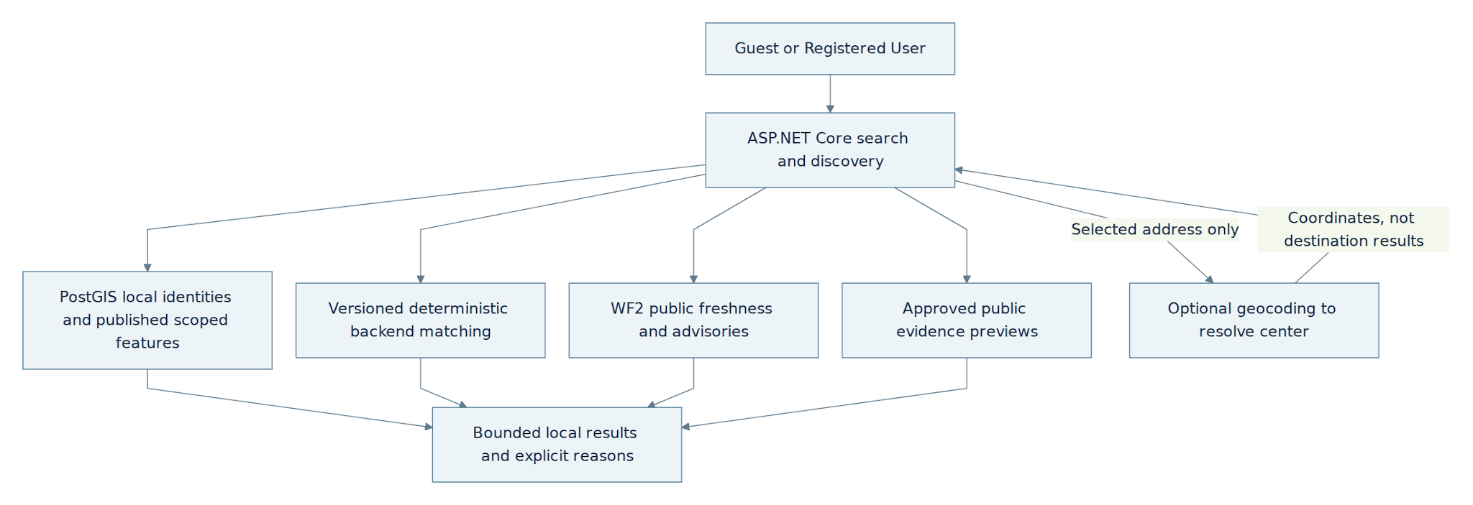
flowchart TB
User["Authenticated User"] --> API["ASP.NET Core search and discovery"]
API --> Local["PostGIS local identities and published scoped features"]
API --> Rules["Versioned deterministic backend matching"]
API --> State["WF2 public freshness and advisories"]
API --> Media["Approved public evidence previews"]
API -->|"Selected address only"| Geo["Optional geocoding to resolve center"]
Geo -->|"Coordinates, not destination results"| API
Local --> Result["Bounded local results and explicit reasons"]
Rules --> Result
State --> Result
Media --> Result

B.10.2 Search, discovery and contribution handoff
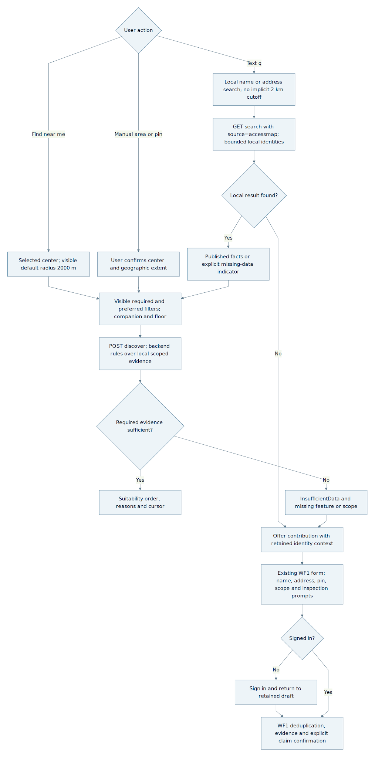
flowchart TB
Start{"User action"}
Start -->|"Text q"| Text["Local name or address search; no implicit 2 km cutoff"]
Start -->|"Find near me"| Near["Selected center; visible default radius 2000 m"]
Start -->|"Manual area or pin"| Pin["User confirms center and geographic extent"]
Text --> Local["GET search with source=accessmap; bounded local identities"]
Near --> Criteria["Visible required and preferred filters; companion and floor"]
Pin --> Criteria
Local --> Found{"Local result found?"}
Found -->|"Yes"| Details["Published facts or explicit missing-data indicator"]
Found -->|"No"| Offer["Offer contribution with retained identity context"]
Details --> Criteria
Criteria --> Match["POST discover; backend rules over local scoped evidence"]
Match --> Evidence{"Required evidence sufficient?"}
Evidence -->|"Yes"| Ranked["Suitability order, reasons and cursor"]
Evidence -->|"No"| Missing["InsufficientData and missing feature or scope"]
Missing --> Offer
Offer --> Draft["Existing WF1 form; name, address, pin, scope and inspection prompts"]
Draft --> Auth{"Signed in?"}
Auth -->|"No"| Login["Sign in and return to retained draft"]
Login --> WF1["WF1 deduplication, evidence and explicit claim confirmation"]
Auth -->|"Yes"| WF1

B.10.3 Data relationships
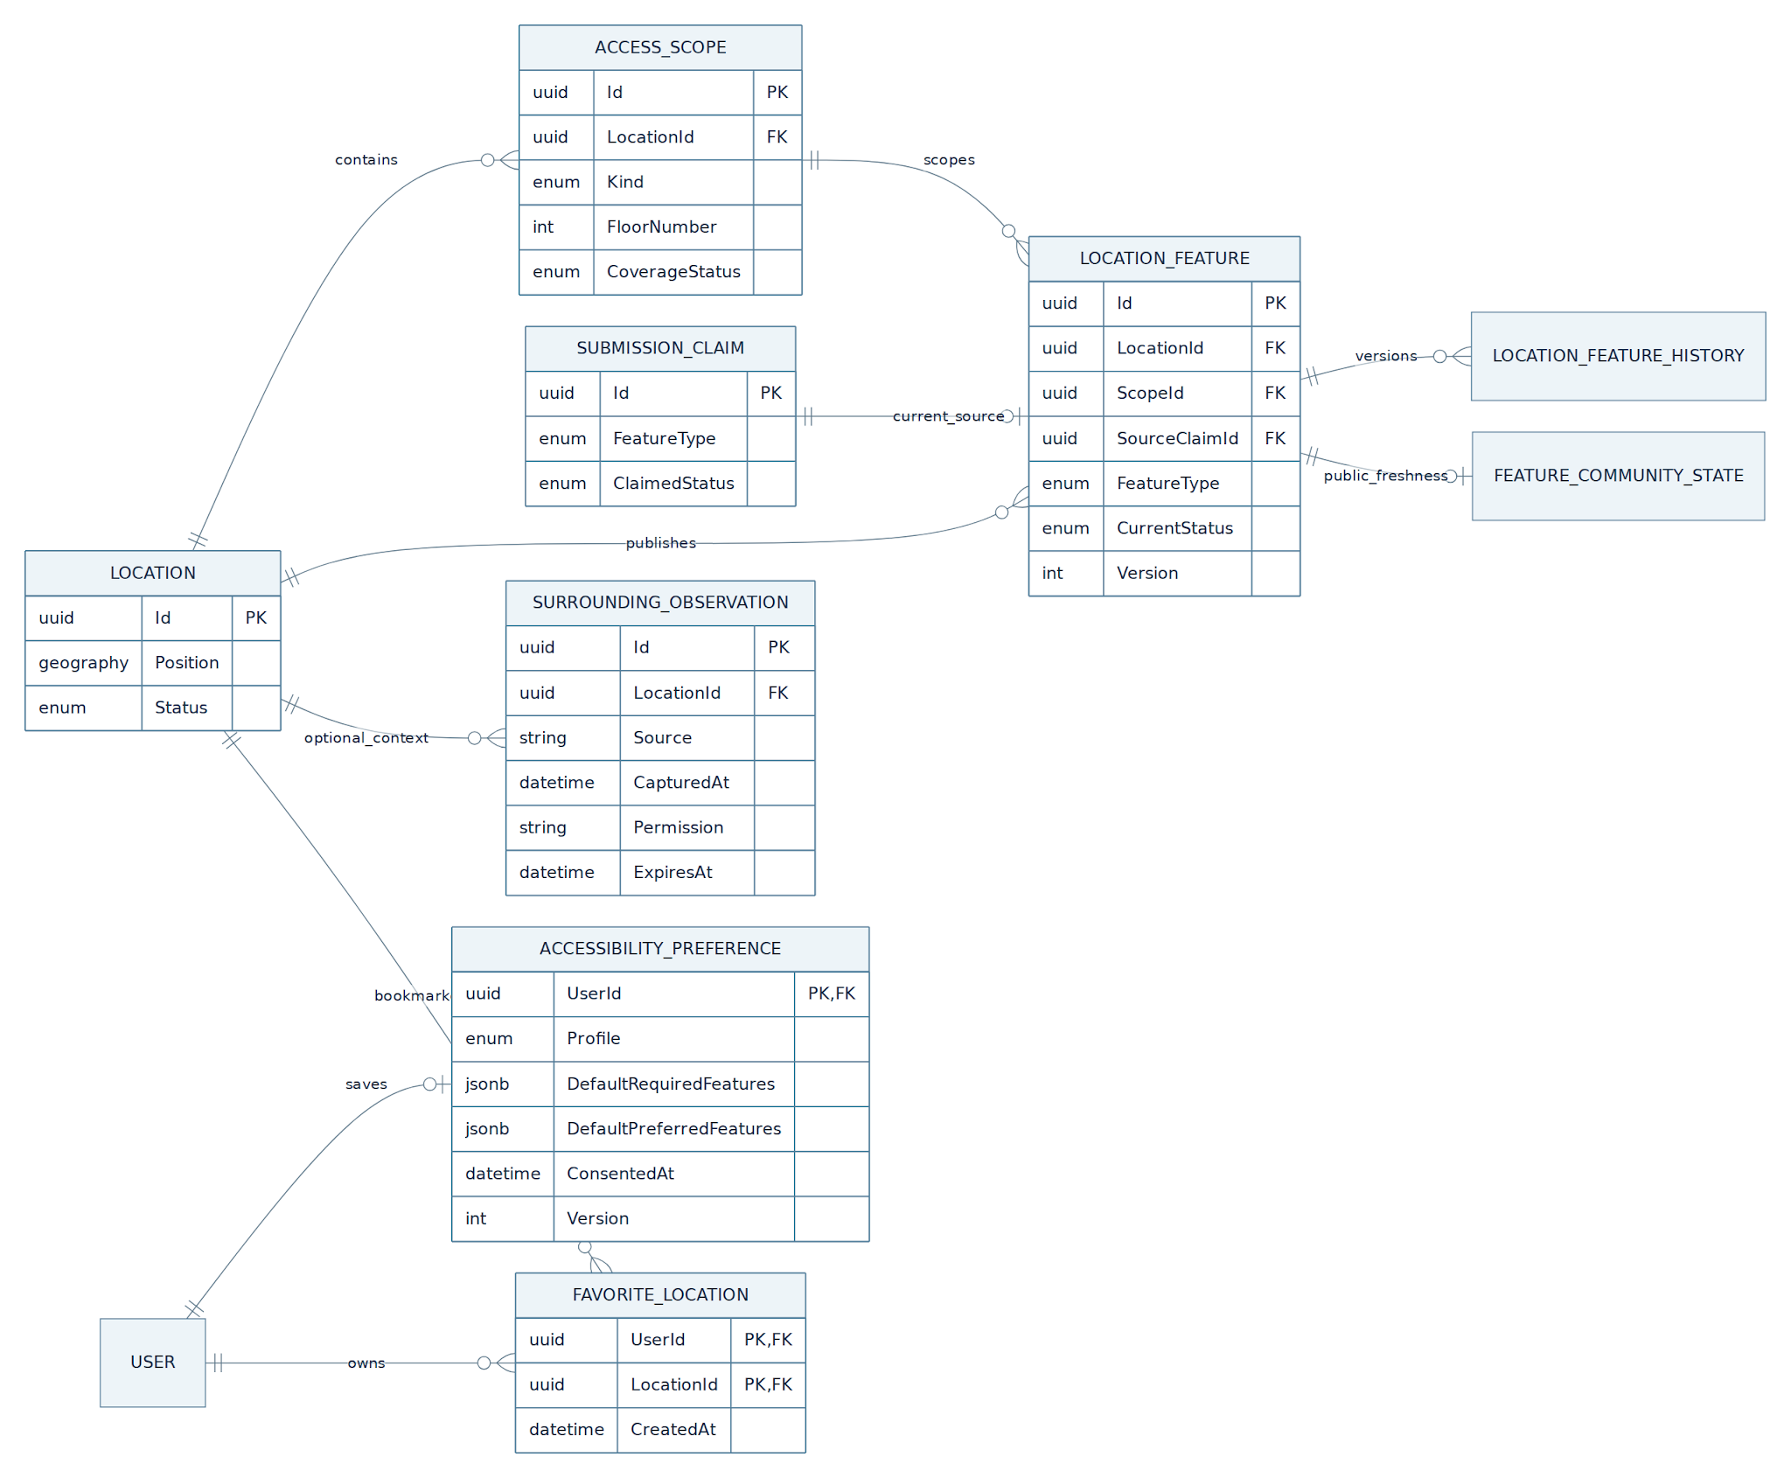
erDiagram
direction LR
LOCATION ||--o{ ACCESS_SCOPE : contains
LOCATION ||--o{ LOCATION_FEATURE : publishes
ACCESS_SCOPE ||--o{ LOCATION_FEATURE : scopes
SUBMISSION_CLAIM ||--o| LOCATION_FEATURE : current_source
LOCATION_FEATURE ||--o{ LOCATION_FEATURE_HISTORY : versions
LOCATION_FEATURE ||--o| FEATURE_COMMUNITY_STATE : public_freshness
LOCATION ||--o{ SURROUNDING_OBSERVATION : optional_context
USER ||--o| ACCESSIBILITY_PREFERENCE : saves
USER ||--o{ FAVORITE_LOCATION : owns
LOCATION ||--o{ FAVORITE_LOCATION : bookmarked
LOCATION {
uuid Id PK
geography Position
enum Status
}
ACCESS_SCOPE {
uuid Id PK
uuid LocationId FK
enum Kind
int FloorNumber
enum CoverageStatus
}
LOCATION_FEATURE {
uuid Id PK
uuid LocationId FK
uuid ScopeId FK
uuid SourceClaimId FK
enum FeatureType
enum CurrentStatus
int Version
}
SUBMISSION_CLAIM {
uuid Id PK
enum FeatureType
enum ClaimedStatus
}
ACCESSIBILITY_PREFERENCE {
uuid UserId PK,FK
enum Profile
jsonb DefaultRequiredFeatures
jsonb DefaultPreferredFeatures
datetime ConsentedAt
int Version
}
FAVORITE_LOCATION {
uuid UserId PK,FK
uuid LocationId PK,FK
datetime CreatedAt
}
SURROUNDING_OBSERVATION {
uuid Id PK
uuid LocationId FK
string Source
datetime CapturedAt
string Permission
datetime ExpiresAt
}

WF-04 — Reputation Leaderboard and Optional Partner Vouchers

Part A — Technical / Design Specification

A.1 Purpose, scope and product meaning

A.1.1 Purpose
Maintain an authoritative reputation snapshot and display a contributor leaderboard whose size grows from Top 10 to Top 50 by qualified-contributor count, with an exact-rank badge for each displayed position, based on trustworthy published contributions. Partner-voucher redemption is optional and separately gated. The source proposes penalties and privilege changes; those are reviewed policies, not an automatic override of WF-01 publication or WF-02 evidence checks.

A.1.2 Cross-workflow ownership
WF-01 decides which Submission and feature publish, then commits one durable +50 EXP new-place or +20 EXP existing-place ReputationEvent. WF-04 consumes that event idempotently and owns the reputation score, leaderboard and balance views. WF-02 owns votes, disputes and inaccuracy reports. Submitting or resolving a report does not itself earn points; WF-02 vote/report rewards remain disabled until eligible outcomes, unique event sources, amounts and anti-repeat rules are approved. WF-03 search reads published truth and does not generate points.

A.1.3 Definitions
Each eligible WF-01 publication source feeds +5/+2 non-spendable trust toward ReputationScore and the leaderboard's lifetime net trust total. ReputationScore is bounded 0–100 for reliability decisions; the leaderboard uses the unbounded sum of eligible trust deltas so active contributors do not all tie at 100. Neither is a raw like, vote or upload count. Existing +50/+20 spendable PointLots support optional issuer-gated vouchers; spending cannot reduce trust, rank or historical verification snapshots. Both awards use source uniqueness and the approved 30-day scope/feature anti-repeat guard. Reviewed adjustments append compensating entries; only authorized trust adjustments change the ranking total.

A.2 Actors and trust boundaries
User sees the count-scaled leaderboard (initially Top 10) and their own rank label and reputation; public entries use the User's existing self-chosen display name. An Admin signed in on mobile has the same ordinary User view and contribution rights, without mobile management actions. If vouchers are enabled, the User may also view eligible partner offers and request redemption. Admin reviews suspected misconduct or corrective adjustments with reason and audit, and manages approved catalog inventory only when vouchers are enabled. These admin actions require the Admin role, a validated portal-scoped session and the relevant action policy; an Admin mobile session alone cannot call the management APIs. Partner Business supplies approved voucher inventory through a separately defined partnership process; no direct partner API is assumed. ASP.NET Core owns ledger and redemption state; PostgreSQL is the system of record. Hangfire can apply delayed holds and deliver notifications after commits. Reuse WF-01 A.2.3's shared User.Role and portal authorization contract.

A.3 Logical architecture
WF-01 publication → immutable ReputationEvent → WF-04 eligibility, ledger and account snapshot → count-scaled reputation leaderboard view. A separately authorized Admin trust adjustment → ManualAdjustmentAudit → trust-only ledger entry; WF-02 vote/report reward events are disabled. Contributor mobile and ReactJS Admin Portal call ASP.NET Core endpoints. When voucher capability is enabled, catalog stock and private code inventory use approved storage; public catalog responses never expose unused codes. Optional redemption is an atomic database transaction with unique source/idempotency guards. Notifications use the existing outbox after commit.

A.4 Preconditions, actions and outcomes

A.4.1 Preconditions
The leaderboard requires an authenticated active account and reads only committed trust entries; rank has no effect on verification or reward eligibility. Optional redemption requires an authenticated active account, an approved unexpired stocked offer, enough released spendable points and no effective Active redemption restriction. UnderReview only records investigation and cannot block spending; an Active restriction needs an evidence-backed Admin decision, recorded reason, applicable scope, expiry/review deadline and review path. An AI warning, abnormal earning rate or unconfirmed report cannot activate it. Enforce at most one successful voucher issuance per user in the preceding rolling 30×24 hours; failure and idempotent replay do not consume another slot. Score-affecting events need a unique authorized source and allowed type.

A.4.2 Product action mapping
Product actions are mapped below without assuming screen IDs from Figma.

Product wording | Backend action
See reputation and leaderboard | Read own score, tier, lifetime net trust total, personal rank label and derived rank badge; show the public count-scaled leaderboard (initially Top 10) with the User's self-chosen display name, exact rank and badge, without private ledger history. Spendable balances remain available in the optional voucher area.
Receive publication reward | Apply an eligible WF-01 source once: +50/+20 spendable points and +5/+2 trust; enforce the 30-day anti-repeat guard, then notify.
Browse optional partner vouchers | List approved available offers without unused codes or private inventory.
Redeem an optional voucher | Validate own spendable balance and offer, atomically allocate one code and debit points, return owner-only receipt.
Request review of a restriction or missing reward | Show source and status; reconcile a genuinely missed eligible event idempotently or release an authorized restriction. Admin trust adjustments require separate audit and never grant arbitrary spendable points.

A.4.3 Business rules and validation outcomes
Only eligible published WF-01 outcomes receive configured spendable/trust credit after WF-04 checks. A source event is not guaranteed credit. Pending/failed contributions and unreviewed votes/reports create no vested award. Show Pending until the eligibility transaction completes, HeldForReview under an evidenced review, Credited after ledger/lot commit, or Cancelled with an ineligibility reason. From WF-01 publication, the initial operational target is uncomplicated credit within 15 minutes, with an alert after 60 minutes unresolved; this is monitored, not a guarantee measured from Submit. Admin review initially targets three business days and records a case-specific deadline. Notify privately of suspected patterns as 'under review', never as confirmed misconduct.

Situation / check | Durable result | Contributor / admin action
Published new Location / enrichment | One +50 / +20 EXP event; no credit before publication. | See earned points and separate hold status.
Rejected, cancelled or pending contribution | No vested award. | Wait or submit corrected evidence under WF-01.
Held points or reviewed restriction | Account/event remains auditable; spendable excludes held points. | View status and review path; admin decides release.
Insufficient points or sold-out offer | No redemption, debit or stock change. | Select another offer or retry later.
Duplicate redemption request | Replay the same redemption; no second code. | Show original receipt.
Suspected misconduct or manual adjustment | Review case and explicit event only after authorized decision. | No automatic permanent ban from a raw count.

A.5 Reward and tier lifecycle

A.5.1 Crediting
WF-01 commits one durable source ReputationEvent with publication. WF-04 applies eligible credit once, updates the score snapshot and leaderboard total, and queues tier notifications. A submission cannot use its pending award to verify itself. WF-02 vote/report rewards remain disabled without approved eligibility, amount and event type. The initial leaderboard displays Top 10 by lifetime net eligible trust: +5 new location, +2 enrichment and signed authorized trust adjustments; it does not count raw likes, uploads, reports, voucher balance or redemption. Ties use distinct credited locations, then the earlier TrustNetReachedAt (when the current total was most recently established), then stable UserId. Users see their own rank privately: exact #1–#500, `500+` for #501–#1,000, `1000+` from #1,001 onward, or `Unranked` without a qualifying contribution. Public entries show the User's existing self-chosen display name; there is no separate leaderboard alias or hide preference. For each rank from 1 through LeaderboardDisplayLimit, derive a distinct display badge labeled “Top {rank}” (for example Top 4 and Top 5 are different badges); a rank outside the limit has no rank badge. The badge updates when rank or display limit changes, is not a permanent award, and grants no points, prizes, trust boost or moderation privileges. The backend derives LeaderboardDisplayLimit from N, the count of active Users with at least one credited WF-01 publication source and a positive LifetimeTrustNet (exclude the default 50 score and sources that never reached Credited, including ineligible Cancelled events). Formula: min(50, max(10, 10×floor(N/100))). Thus N<200 displays up to Top 10; 200–299 Top 20; 300–399 Top 30; 400–499 Top 40; N≥500 Top 50. This is an automatic display rule with a maximum of 50, not an Admin choice or award. With fewer than ten qualified Users, return the actual Users only, without empty positions or artificial ranks. The UI reads displayLimit and badge labels from the API rather than hardcoding variants.

A.5.2 Score and tier
DefaultReputationScore=50; VoteHoldThreshold=50. ReputationScore=clamp(50 + 5×N_new + 2×N_enrichment − P_reviewed, 0, 100). Count only distinct credited WF-01 NewLocationPublished and ExistingLocationEnriched source events, once each. A published correction uses ExistingLocationEnriched, never a second correction/report/vote award. Apply the existing rolling 30-day anti-repeat guard per (UserId, LocationId, ScopeId, FeatureType) to both reputation and spendable awards; new media alone does not reset eligibility. One enrichment Submission earns at most +20 spendable points and +2 reputation if at least one published feature is eligible; an ineligible repeated feature earns neither. New-location publication uses the existing unique per-Location award (+50 spendable, +5 reputation). Baseline newcomers pass the reputation gate; below 50 requires WF-02 per-vote validation. P_reviewed includes only authorized, appealable manual adjustments; automatic penalty amounts, extra tier factors and tier cutoffs remain disabled/deferred. Never decay ReputationScore or deduct voucher costs. One eligible new place and one distinct enrichment yield 57, unchanged by redemption. Persist policy version and immutable decision-time snapshots. Ordinary errors, AI failures and disagreement are not automatic penalties; tiers never waive publication gates.
For this formula, P_reviewed is the negative of the net authorized ManualAdjustmentAudit.Amount sum (trust units), including its audited compensating reversals; the final score remains clamped to 0–100. Manual trust adjustment creates no spendable-point delta and never replays publication awards. LeaderboardTrustNet is the lifetime sum of actually credited publication trust deltas and authorized reviewed trust adjustments in ReputationLedgerEntry (excluding the default 50); rank by this unbounded total. Voucher redemption does not reduce rank. Rebuild the derived total from the immutable ledger and update it with the score snapshot after each committed trust entry. FeatureType in the anti-repeat key is WF-01's canonical accessibility feature enum for the same LocationId and ScopeId, not a free-form tag. WF-01 may publish a genuine update at any time; the same user's repeat feature inside the rolling 30-day reward window earns no new credit, while a later new source is evaluated normally after that window. New media alone never resets it.

A.5.3 Point hold and release
No default time hold applies after an eligible publication award. AvailableAt is the credit time unless an existing, evidenced review restriction applies; retain HoldReason, SourceEventId and lot status. A reviewed temporary restriction needs an expiry or authorized resolution. Held points remain visible/auditable but unspendable. When voucher redemption is enabled, permit at most one successful issuance per user in any rolling 30-day window; failed attempts and idempotent replays do not consume another slot. Canonical lot states are Held/Available/Spent under B.1; partially spent released lots remain Available. A review case in UnderReview alone is not an active restriction. An anomaly creates UnderReview and a neutral notice without holding points. Only a reviewed Active decision can hold lots. On expiry or authorized release, reconcile every applicable case so points do not remain Held indefinitely; an unresolved case reaching its review deadline is escalated to Admin, not silently extended.

A.6 Optional voucher redemption
Voucher redemption is an optional gated capability; the leaderboard remains available without an issuer. It is enabled only for an approved real issuer, stocked unique codes, published terms/expiry and a support owner. The contributor first previews point cost, expiry and terms, then explicitly confirms a versioned offer. The backend uses authenticated UserId and Idempotency-Key, checks eligibility, stock and spendable points, and atomically reserves one code, debits eligible PointLots and creates an Issued UserVoucherRedemption. Failed validation/transaction changes neither stock nor points; replay returns the same receipt. Return the code only to its owner. MVP can reliably show Issued and Expired based on code issuance and known expiry. Used and Cancelled, and any refund, remain disabled until the issuer supplies verifiable use and revocation signals. A future cancellation window shorter than seven days and before expiry additionally requires proof the code is unused, revocation first and exactly-once compensating points; without these do not promise returns.

A.7 Misconduct and adjustments
An Admin may investigate intentional deception, collusion or reward farming. Submission rate limits, idempotency, feature/location deduplication and the 30-day credit guard address different spam paths; suppressing repeat credit must not suppress a legitimate WF-01 update. Warning or UnderReview alone does not restrict actions. In the enabled baseline, only an evidence-backed Admin decision may activate a bounded redemption/point restriction with actor, reason, scope, expiry/review deadline and user appeal. Trust deductions use ManualAdjustmentAudit and compensating entries; disagreement, poor photos, AI error or raw rejection count alone never prove misconduct. A lower score affects WF-02 validation, not published truth. A proposed warning → bounded contribution/vote restriction → soft lock of contribution/vote actions remains disabled pending approved violation criteria, action scopes, deadlines, appeals and release; signed-in search stays available. The legacy −100 EXP and three-strike automatic ban remain disabled. If points were already spent on an Issued voucher, retain the debit and receipt; do not create a negative balance, automatic refund or code revocation without issuer proof and a separately approved spendable reversal contract. Reviewed trust/restriction measures remain available.

A.8 Notification and user visibility
Show up to LeaderboardDisplayLimit self-chosen display names, exact ranks, rank badges and lifetime net trust totals, and show each User their own score, personal rank label, derived badge, tier and calculation policy version. Keep earned, held, spendable and spent amounts separate in the optional voucher area. A redemption response shows redemption ID, reward ID, charged points, current spendable balance and securely scoped code only for the owner. Notifications for published reward, hold, tier change, reviewed restriction and redemption use an outbox; delivery failures do not roll back the ledger or redemption. Notify a suspected case privately as under review with source/status and review route. A confirmed decision gives the safe recorded reason and appeal path. For apparently missing credit, show the source event and Pending/HeldForReview/Credited/Cancelled result; publication alone is not a guarantee.
Use the same WF-01 B.3.17 outbox. Reward/tier notification sourceType=ReputationLedgerEntry and sourceId/sourceEventId=the committed ledger Id; redemption uses UserVoucherRedemption.Id; reviewed hold/restriction uses AccountRestrictionReviewCase.Id; manual trust adjustment uses ManualAdjustmentAudit.Id. Pair each with its real once-per-source EventType. Retain source identity on retries; do not create a fake Submission/DisputeCase. Recipient is the affected account owner, and outbox work commits with the existing ledger/redemption/review transaction. Private voucher codes remain in the owner-authorized receipt, not notification payloads.

A.9 End-to-end sequences
Reputation: WF-01 publishes → commits source event → WF-04 idempotently applies ledger entry → recalculates trust snapshot → refreshes the count-scaled leaderboard → queues notification. Optional redemption: user selects offer → API validates user/stock/balance → short serializable transaction reserves one code and debits points → commits redemption/audit → returns owner-only result. Investigation: anomaly flagged → admin reviews case → optional bounded hold → explicit decision or release; no automatic permanent ban on signal alone.

A.10 Error and fallback cases
Insufficient spendable points: reject without charge. Sold-out/expired offer: reject and refresh catalog. Duplicate request: replay original result. Changed payload with same key: conflict. Hold/restriction: explain status and review path without exposing private investigative details. Catalog or notification service unavailable: do not manufacture stock or code; preserve committed redemption and retry delivery. Manual admin adjustment without source case: reject until reason and authorization are recorded.

A.11 Privacy and accountability
Do not expose another person's score history, contact details, partner codes or investigation notes. The leaderboard shows only the User's self-chosen display name, exact public rank, derived rank badge and lifetime net trust total; private rank labels remain visible only to their owners. Do not publish tier or misconduct status alongside rank. The Admin role manages stock and account adjustments; log every action and code reveal, and protect code inventory at rest. Account action and appeal policy must be visible to affected users in plain language; no inferred misconduct from AI or vote disagreement.

A.12 Acceptance outcomes
For eligible source fixtures after WF4 checks, first moderated new-location publication credits +50 spendable/+5 trust and enrichment credits +20/+2; an ineligible repeat or rejected/cancelled submission credits zero. A worker retry awards no second points. Spending a voucher does not rewrite a prior WF-01 community weight snapshot. Concurrent requests for the final code produce at most one redemption. A pending hold cannot be spent. Failed notification does not reverse credit. Low or high tier alone cannot auto-publish a contribution. Unreviewed contradictory vote produces no penalty.

A.13 Decisions requiring team sign-off
A.5.2 and B.2 define the approved baseline: only two WF-01 publication event types, separate trust/spendable values and anti-repeat guard. The lifetime trust leaderboard and one badge per exact displayed rank (Top 1 through Top {LeaderboardDisplayLimit}) are the recognition feature. The backend derives the limit from qualified-contributor count: under 200→10, 200→20, 300→30, 400→40, 500 or more→50; a rank such as #37 has its own “Top 37” label when the limit includes it. Each User has at most one current rank badge; it changes with rank or limit and grants no points, physical reward or privilege. No historical badge is retained solely for once holding a rank. Ordinary awards have no default hold. Optional voucher redemption requires an approved issuer, inventory, terms and support, then permits one successful issuance per rolling 30 days. WF-02 report/vote rewards, retroactive clawback of spent voucher points, Used/Cancelled/refunds, automatic penalties, tier auto-publication and graduated contribution/vote soft locks remain disabled. The proposed soft lock needs approved confirmed-violation criteria, action scope, duration/review deadline, notice, appeal and release before implementation; the legacy −100/three-strike automatic rule is not a baseline. Higher tiers and reviewed adjustment amounts remain open policy decisions.

Decision requiring sign-off | MVP-safe baseline
EXP versus ReputationScore | Separate accounting; voucher spending must not silently change historic credibility.
Tier thresholds and privileges | Approved baseline=50 and VoteHoldThreshold=50; below-baseline votes require validation. Higher-tier boundaries and recovery adjustments remain deferred; no publication bypass.
Vote reward and eligibility | No WF-02 report or vote EXP in the baseline; future credit requires a confirmed valuable outcome, unique source event, award amount and anti-repeat policy.
Penalty and ban | Automatic −100 and three-strike ban remain disabled. Proposed graduated contribution/vote restriction needs confirmed evidence, typed action scope, bounded duration, appeal and release.
Voucher hold and limits | No default three-day hold; only reviewed restrictions. If enabled, redemption is capped at one successful issuance per rolling 30 days.
Partner fulfillment | Only approved issuer-backed offers; unique private code inventory and issue contract. Refund/use status is disabled until verifiable issuer integration.

Part B — Implementation Specification

B.0 Implementation authority
Part B is a proposed build contract consistent with the existing WF-01/WF-02 owners. Values from the source that conflict with publication or review gates remain disabled proposals, not implied application behavior.

B.1 Entities and ERD interpretation
Reuse WF-01 ReputationEvent and existing User/auth entities, with UUID v4 keys, UTC timestamptz, required fields unless nullable and ON DELETE RESTRICT for source/audit FKs. Preserve existing enum identities. PolicyVersion identifies the approved rules applied to a particular decision: source eligibility, award amounts/units, 30-day guard, score thresholds and enabled redemption/restriction gates. Keep the source event's identity/status and decision time; persist the evaluated PolicyVersion in ReputationLedgerEntry and ReputationAccountSnapshot, linked back to the event by SourceEventId. A later version applies prospectively; it never rewrites a completed credit, historic verification snapshot or issued voucher. Retain older versions for audit and deterministic replay; missing or unsupported version blocks credit/redeem pending correction.
ReputationLedgerEntry: Id PK; UserId uuid FK; SourceType text; SourceId uuid for the authorized publication/manual-adjustment source; SourceEventId uuid nullable FK to ReputationEvent (required for publication, null for reviewed manual adjustments); Amount integer for the effective spendable delta; EffectiveReputationDelta integer for the separate signed trust delta; PolicyVersion text; RecordedAt and AppliedAt timestamps. UNIQUE (SourceType,SourceId) and partial UNIQUE (SourceEventId) WHERE SourceEventId IS NOT NULL. Source ownership/type is validated. Entries are immutable; reviewed corrections append compensating entries linked to their audit source.
Unit mapping: publication entries carry eligible +50/+20 spendable in Amount and +5/+2 trust in EffectiveReputationDelta. For the existing manual reputation-adjustment endpoint, Amount=0 and EffectiveReputationDelta=ManualAdjustmentAudit.Amount. Audit Amount and ledger Amount are different named fields with different units; neither is implicitly copied into both balances.
ReputationAccountSnapshot: UserId uuid PK/FK; Score numeric bounded 0–100; LifetimeTrustNet signed integer (sum of committed EffectiveReputationDelta, excluding the default 50); DistinctCreditedLocationCount integer >=0; TrustNetReachedAt timestamptz nullable; Tier text from existing policy; PolicyVersion text. DistinctCreditedLocationCount counts distinct canonical LocationIds with at least one WF-01 publication source that actually reached Credited; repeated credits for one Location count once. Pending, HeldForReview and ineligible Cancelled events never enter the count. Once a source was Credited, a later generic ManualAdjustmentAudit trust deduction or compensating restoration does not erase that historical contribution or change this count; no source-specific publication reversal is enabled in the current contract. When two Locations are merged, resolve each credited ReputationEvent.LocationId to its current canonical LocationId and recompute this distinct count for affected Users. The authorized merge transaction serializes with affected account credit updates, locks the affected snapshots and persists the recomputed counts with the merge; two previously counted places that now resolve to one count once. Keep credited events and ledger immutable; do not change LifetimeTrustNet, Score, spendable points or TrustNetReachedAt merely because Location identity merged. Invalidate the bounded leaderboard cache after commit. A concurrent credit/merge must retry on conflict and produce the same canonical distinct count without a new entity. TrustNetReachedAt is the application time of the latest committed nonzero trust delta that established the current LifetimeTrustNet, including a reviewed adjustment; idempotent replay does not move it. Use null only when no trust delta has been applied. Update these ranking fields, Score and LifetimeTrustNet atomically with eligible publication credit or a trust-only adjustment. Rebuild deterministically from immutable source/ledger entries ordered by application time then entry Id, never from spendable balance. Missing snapshots recover LifetimeTrustNet from applied trust entries, Score=clamp(50+LifetimeTrustNet,0,100), the distinct count from publication sources that reached Credited after resolving their LocationIds through the current merge chain, and TrustNetReachedAt from that ordered trust history. The leaderboard reads this derived snapshot; no new ranking/reward table is required.
PointLot: Id PK; UserId uuid FK; SourceEventId uuid FK; EarnedPoints integer>0; SpentPoints integer with 0<=SpentPoints<=EarnedPoints; Status uses canonical values Held, Available, Spent; EarnedAt and AvailableAt timestamptz; HoldReason text nullable. UNIQUE (SourceEventId) for publication awards. Available means released with EarnedPoints-SpentPoints>0; partial consumption stays Available. Held means the positive remaining amount is unspendable under an evidenced Active restriction; require HoldReason and its existing review/audit source. Spent means SpentPoints=EarnedPoints and contributes zero. Create Available on ordinary eligible credit, or Held only under an existing authorized restriction; no default hold. Available→Held requires a reviewed restriction, Held→Available requires its expiry/authorized release and no other active applicable hold, Available→Spent occurs atomically with the debit exhausting the lot. Spent is terminal in this release: no refund or lot-expiry lifecycle is added. AvailableAt remains NOT NULL and records the earliest eligibility time, defaulting to credit time; releasing an initially Held lot records the actual release time. While Status=Held, its timestamp never grants permission to spend. Lot owner must match source owner; status and remaining amount are checked transactionally.
VoucherOffer: Id PK; PointCost integer>0; Terms text; OfferVersion integer>0; ExpiresAt timestamptz; Status uses Active, Inactive, Expired. Inactive is not redeemable, including unapproved/disabled offers. Only an authorized Admin may activate an approved issuer-backed offer with valid terms/expiry and supported stock; Active is necessary but does not replace the account, stock and point gates. Admin disabling yields Inactive; elapsed ExpiresAt yields Expired and blocks redemption even before a reconciliation job updates the label. No offer approval bypass or new fulfillment workflow is added.
VoucherInventoryCode: Id PK; OfferId uuid FK; PrivateCode protected text; Status uses Available or Issued. Available means not allocated to a redemption; Issued means allocated exactly once to a committed UserVoucherRedemption. Available→Issued, receipt creation and lot debits commit atomically; failure leaves Available and creates no receipt/debit. Database locks provide temporary reservation; do not persist an extra Reserved state or leave a code stranded by an aborted request. Issued is not proof of external use and never automatically returns to Available. Prevent duplicate issuer codes in approved inventory. Never expose unused raw codes publicly; offer expiry/disablement blocks their issuance without inventing code refund/revocation.
UserVoucherRedemption: Id PK; UserId/OfferId/InventoryCodeId uuid FKs; Status Issued/Expired only; OfferVersion integer>0; IdempotencyKey and RequestHash text; IssuedAt and ExpiresAt timestamps with IssuedAt<ExpiresAt; IssuerReference text nullable and IssuerStatusCheckedAt timestamp nullable, unused without a verified issuer contract. UNIQUE (UserId,IdempotencyKey), UNIQUE (InventoryCodeId). Code must belong to OfferId; retain confirmed terms/version and receipt. Enforce one successful issuance per user per rolling 30 days under the account lock, not merely an index.
RedemptionDebit: Id PK; RedemptionId and PointLotId uuid FKs; Amount integer>0; UNIQUE (RedemptionId,PointLotId). Each lot belongs to the redemption owner. SUM(debits) equals the confirmed receipt cost and lot SpentPoints agrees with committed debits; lock/check these cross-row invariants in the issuance transaction. Failed issuance creates no debit.
AccountRestrictionReviewCase is the existing AccountRestriction/ReviewCase concept: Id PK; UserId uuid FK; Reason text; Status uses UnderReview, Active, Resolved, Expired; ExpiresAt timestamptz nullable as allowed by the reviewed policy. UnderReview records investigation only and does not itself block spending or prove misconduct. Authorized evidence-backed activation moves UnderReview→Active with reason, actor, existing audit source and bounded deadline. An authorized no-restriction outcome moves UnderReview→Resolved. Active→Resolved is an audited release/decision; UnderReview/Active→Expired follows the recorded deadline. Spending checks effective Active status and the deadline on read, so a delayed job cannot extend a restriction. Releasing one case does not release another still-active applicable hold. Resolved/Expired have no active restriction effect; preserve history and prior decisions. No automatic score penalty, permanent ban or additional case entity is introduced. Only an effective Active case based on an authorized decision and unexpired deadline blocks applicable redemption. UnderReview cannot make PointLots Held. A future contribution/vote soft lock needs a typed action-scope contract in existing authorization/review before enabling; free-form Reason cannot serve as a permission state.
ManualAdjustmentAudit: Id PK; UserId and ActorId uuid FKs to User; Reason and SourceReference text; Amount signed integer measured only in reputation/trust units for the existing POST /api/v1/admin/reputation-adjustments endpoint; RecordedAt timestamptz. Amount<0 is an authorized trust deduction; Amount>0 is an authorized compensating restoration/reversal of a referenced prior adjustment, not a new contribution award. ActorId must pass current Admin/action permission, the approved reviewed-adjustment policy and source validation; ActorId=UserId is forbidden, so another Admin reviews and applies an adjustment to an Admin's own account. Zero/unsupported units are rejected. Commit this audit and one immutable ledger entry together: SourceType=ManualAdjustmentAudit, SourceId=audit.Id, SourceEventId=null, EffectiveReputationDelta=audit.Amount, ledger Amount=0 spendable points. Never copy audit.Amount into both ledger deltas. No PointLot or RedemptionDebit is created by this trust adjustment; SpendablePoints, voucher balance and historical verification snapshots remain unchanged. SourceReference retains the reviewed case/prior-adjustment reference under existing audit rules. Use the existing IdempotencyRecord: same authenticated Admin/endpoint/key and payload replays the same audit/result; a changed payload conflicts. Amount/appeal permissions remain policy-gated; this clarification does not enable automatic penalties, arbitrary recovery awards, manual spendable credit or refunds.
Apply eligibility, ledger/lot creation and snapshot update in one short account-scoped transaction. Lock/serialize UserId before the rolling 30-day feature guard so concurrent distinct events cannot both pass it. Mark ReputationEvent Credited only after eligible credit commits; mark an ineligible repeat Cancelled with an eligibility reason and no credit/lot. Pending/HeldForReview are unresolved. Rollback leaves the source retryable with no partial award. Deferred tier multipliers, Used/Cancelled voucher states and refunds stay disabled.

B.2 Event and balance contract
DefaultReputationScore=50; VoteHoldThreshold=50. ReputationScore=clamp(50 + 5×N_new + 2×N_enrichment − P_reviewed, 0, 100). Count only distinct credited WF-01 NewLocationPublished and ExistingLocationEnriched source events, once each. A published correction uses ExistingLocationEnriched, never a second correction/report/vote award. Apply the existing rolling 30-day anti-repeat guard per (UserId, LocationId, ScopeId, FeatureType) to both reputation and spendable awards; new media alone does not reset eligibility. One enrichment Submission earns at most +20 spendable points and +2 reputation if at least one published feature is eligible; an ineligible repeated feature earns neither. New-location publication uses the existing unique per-Location award (+50 spendable, +5 reputation). Baseline newcomers pass the reputation gate; below 50 requires WF-02 per-vote validation. P_reviewed includes only authorized, appealable manual adjustments; automatic penalty amounts, extra tier factors and tier cutoffs remain disabled/deferred. Never decay ReputationScore or deduct voucher costs. One eligible new place and one distinct enrichment yield 57, unchanged by redemption. Apply each source event atomically to the appropriate ledger/point lot and account snapshot, with existing unique source-event guards and notification outbox. SpendablePoints equals released earned lots less redemption debits and authorized point reversals; held lots are excluded. LifetimeTrustNet=sum(EffectiveReputationDelta) over committed trust ledger entries for the User, without the default 50 or the 0–100 clamp. Recalculate the derived snapshot atomically with trust entries; rank from LifetimeTrustNet, not from spendable points or bounded Score. Record effective trust delta, source/policy and applied-at in the existing ledger. Rebuild snapshots from immutable entries and detect drift; a policy change never rewrites completed WF-01/02 decision-time snapshots. WF-01 records every actual publication source once; eligibility is evaluated here. ReputationEvent.Points is nominal; the committed ledger/lot and event outcome determine actual credit. Expose no positive PointsAwarded before that commit. WF-01 can publish a new correction of a current feature within 30 days; WF-04 records but Cancels an ineligible repeated award, without rolling back published truth. After the same-user/location/scope/FeatureType window ends, a genuinely new published source is evaluated again. New media, wording or idempotency key never resets eligibility. Baseline WF-02 reports and votes earn no credit.
For this formula, P_reviewed is the negative of the net authorized ManualAdjustmentAudit.Amount sum (trust units), including its audited compensating reversals; the final score remains clamped to 0–100. Manual trust adjustment creates no spendable-point delta and never replays publication awards.

B.3 Leaderboard and optional redemption API
GET /api/v1/leaderboard returns up to LeaderboardDisplayLimit qualified Users by LifetimeTrustNet with exact rank, derived rankBadge (Top{rank}), displayName from the existing User profile, total and displayLimit. LeaderboardDisplayLimit is calculated server-side from the current qualified-contributor count N using min(50, max(10, 10×floor(N/100))). N includes active Users with at least one credited WF-01 publication and positive LifetimeTrustNet, exclude baseline-only accounts. Read at most the first 1,000 qualified Users in ranking order from committed snapshots. Let N1000 be the number of rows returned; derive displayLimit=min(50,max(10,10×floor(N1000/100))). Because the limit never exceeds 50 once N≥500, a capped count of 1,000 produces the same display limit as the full contributor count. Return displayLimit in the response. A short-lived cache of this bounded ranking may be invalidated/refreshed on eligible credit, reviewed trust reversal and account-status change; do not query the full immutable ledger per view. The client cannot override the derived limit; changing 10→20→30→40→50 requires no Admin action or new API shape. Order by ReputationAccountSnapshot.LifetimeTrustNet DESC, DistinctCreditedLocationCount DESC, TrustNetReachedAt ASC NULLS LAST, then UserId ASC. These are committed snapshot fields, not per-request scans of publication or ledger history. Derive the private rank label from the first 1,000 qualified Users in the same deterministic order: positions 1–500 return exact `#{rank}`; 501–1,000 return `500+`; a qualified User absent from those 1,000 returns `1000+`; a User without a qualifying source returns `Unranked`. `500+` means rank >500 and `1000+` means rank >1,000. Never return an exact rank above 500 to the client. Select public ranked positions 1 through LeaderboardDisplayLimit from this bounded list. If fewer Users qualify, return the actual count only. Reuse the bounded ordered list for both the public board and the private Me label; do not scan the full ledger or persist ranks per User. A matching PostgreSQL B-tree ordering index on snapshot ranking keys should be evaluated with EXPLAIN ANALYZE when the qualified population grows; LIMIT alone does not guarantee an efficient sort without a suitable plan. Reuse the existing self-chosen User display name; do not add leaderboard-specific alias, hide-preference or reward entities. GET /api/v1/me/reputation returns own score/tier, LifetimeTrustNet, rankLabel (`#1`–`#500`, `500+`, `1000+` or `Unranked`), derived rankBadge only within LeaderboardDisplayLimit, earned/held/spendable counts and policy version. The User's private rank remains visible to that User even when it is outside the public display limit. GET /api/v1/vouchers, when enabled, returns approved non-restricted active offers and stock availability without raw codes. POST /api/v1/vouchers/{voucherId}/preview returns point cost, expiry, terms and offerVersion without a debit. POST /api/v1/vouchers/{voucherId}/redeem requires Authorization and Idempotency-Key, takes confirmed offerVersion, obtains UserId from token, returns 201 with redemptionId, pointsDeducted, spendablePoints and owner-only voucherCode. GET /api/v1/me/redemptions lists own history. Admin endpoints manage offers, inventory and reviewed adjustments under separate policy permissions. If VoucherRedemptionEnabled=false, catalog redemption is unavailable with an explicit not_enabled response; points, reputation and recognition remain usable. No MVP refund/Used/Cancelled endpoint is exposed. The product may show a missing-credit review route using the existing authorized support/Admin review process and source event ID; no direct spendable-credit endpoint or new report reward is implied.

Endpoint | Caller | Contract
GET /api/v1/leaderboard | Authenticated User | Server-derived Top 10–50 qualified Users; exact rank, displayName from the existing User profile, rankBadge, LifetimeTrustNet and displayLimit.
GET /api/v1/me/reputation | Authenticated User | Own ledger-backed score, lifetime net trust, private rankLabel, tier and earned/held/spendable balances.
GET /api/v1/vouchers | Authenticated User | Available only when VoucherRedemptionEnabled; approved active offers only, never raw unused codes.
POST /api/v1/vouchers/{id}/redeem | Authenticated User | Available only when VoucherRedemptionEnabled; Auth + Idempotency-Key, one atomic debit and code allocation.
GET /api/v1/me/redemptions | Authenticated User | Owner-only receipts and issued codes under access controls.
POST /api/v1/admin/vouchers | Admin role + validated Admin Portal session/scope + action policy | When voucher capability is enabled, manage approved offers and stock with audit.
POST /api/v1/admin/reputation-adjustments | Admin role + validated Admin Portal session/scope + action policy | Trust-only reviewed adjustment: audit Amount maps to EffectiveReputationDelta; ledger spendable Amount=0. Require authorized source, reason and idempotent audit.

B.4 Validation and concurrency
Validate UUID, account status, offer availability, expiry, eligibility, stock, held/spendable points, rolling 30-day issuance limit and replay hash. Lock the account balance and stock/code row in a stable order inside a short PostgreSQL transaction; debit only released lots and reserve one code atomically. On a unique conflict, reload the committed result and replay if the hash matches; otherwise 409. If the transaction aborts, neither code nor points changes. Do not call partner/notification services inside the transaction. Verify offerVersion against the confirmed preview and reject a changed price/terms with 409 requiring renewed confirmation. Expiry reconciliation changes Issued→Expired when the known expiry passes; it does not assert external use. A future issuer callback must be authenticated/idempotent before adding Used/Cancelled.

B.5 Configuration and policy gates
Approved initial policy: DefaultReputationScore=50, VoteHoldThreshold=50, trust bounded 0–100, LifetimeTrustNet unbounded, and a lifetime leaderboard with server-derived LeaderboardDisplayLimit=min(50,max(10,10×floor(N/100))) where N counts active Users with credited WF-01 publication and positive LifetimeTrustNet. Under 200 eligible Users the cap stays 10; at 200/300/400 it becomes 20/30/40; at 500 and above it stays 50. Accounts with only the default score do not qualify. New-location publication adds +5 trust/+50 spendable; enrichment adds +2/+20, subject to the rolling 30-day same-user/location/scope/FeatureType anti-repeat guard. Public display uses the existing self-chosen User display name; there is no leaderboard alias or hide preference. Derive rankBadge=Top{rank} when 1≤rank≤LeaderboardDisplayLimit, otherwise none. Independently derive personal rankLabel as exact #rank through 500, `500+` through 1,000, and `1000+` thereafter; no badge follows from a rank bucket. Do not store a permanent badge or grant prize, credit or verification advantage. An automatic display-limit change does not recalculate reputation or change the underlying rank; it only changes which ranks and badges are publicly visible. The server derives the limit from N; no Admin setting or per-user override is required. FeatureType uses WF-01's enum; corrections are enrichment, not a third reward. Recover missing snapshots; UnderReview alone cannot hold spendable points. Ordinary credit has no default time hold. Monitor uncomplicated credit within 15 minutes of publication, alert after 60 minutes unresolved and target Admin review within three business days plus a case deadline; these are initial operating targets, not guaranteed submission-to-award times. With VoucherRedemptionEnabled=true, enforce one successful issuance in rolling 30×24 hours, issuer/stock/terms gates and atomic account locking. TierAutoPublishEnabled=false, ExtraTierVoteFactorEnabled=false, AutomaticPermanentBanEnabled=false, AutoMisconductPenaltyEnabled=false. WF-02 reward, progressive contribution/vote lock, retrospective voucher clawback, higher tiers and new reward types stay disabled pending policy approval; Used/Cancelled/refund require verifiable issuer signals.

Rule | Source proposal | Safe release gate
BR-01 tiers | DefaultReputationScore=50; VoteHoldThreshold=50. Higher-tier thresholds remain deferred. | Versioned and approved; default-baseline newcomers pass the reputation gate, below-baseline votes require validation; no publication bypass.
BR-02 vote weight | High tier 3× | Disabled until WF-02 factor policy and abuse tests approved.
BR-03 auto publish | High tier unlock | Disabled; WF-01 validation and cold-start remain authoritative.
BR-04/05 penalties | Legacy −100 / three strikes; disabled | No count-triggered penalty. A future graduated action-scoped soft lock requires confirmed evidence, duration, appeal, release and authorization rules; current trust-only adjustments remain gated.
BR-06 voucher cost | Per offer | Validate approved, stocked eligible offer.
BR-07 collusion | 24h/3 reciprocal interactions | UnderReview is notice only; an Active bounded hold requires an explicit Admin decision and review path.
BR-08 point hold | No default time hold | Only evidenced, reviewed restrictions hold spendable points; otherwise available at credit.
BR-09 rolling 30-day issuance limit | 1 successful issuance / rolling 30 days | Under account lock count Issued receipts in the preceding rolling 30×24 hours only when enabled; replay/failure does not consume a slot.

B.6 Background work and audit
Hangfire claims pending source events, reconciles reviewed Held lots after all applicable Active restrictions end, and retries outbox delivery. A durable source/lot survives enqueue failure; a reconciler picks it up. Monitor the initial 15-minute uncomplicated credit target, alert after 60 minutes unresolved and route cases by recorded review deadline; timers do not establish misconduct. Credits, debits and restrictions retain actor, reason, source and timestamps. Adjustments are compensating entries. Held→Available requires expiry/authorized release and no other applicable Active hold; there is no default maturity delay or external partner distribution contract.

B.7 Error matrix
EX-01 insufficient spendable points: reject without debit. EX-02 expired/sold-out offer: 409/410, no debit; popup explains and refreshes alternatives. If a still-valid offer's terms/price/version changed, return 409, show the new preview and require explicit reconfirmation, without automatic redeem retry. EX-03 suspected violation: UnderReview notice only, Active reviewed restriction after decision. EX-04 adjustment: auth/reason/audit. EX-05 suspected collusion: review first, explicit Active hold only. EX-06 abnormal earning: review notice/deadline, no automatic redemption hold. Duplicate replay, stock conflict and code delivery retry retain existing rules.

Code | Situation | Result
EX-01 | Insufficient spendable points | Reject without debit or stock change.
EX-02 | Offer expired / out of stock | Reject with no debit/code. Popup explains expiry or sold-out status and refreshes alternatives; a valid offer whose version changed requires a fresh preview and explicit confirmation.
EX-03 | Suspected repeated misconduct | Reviewed account restriction only; no automatic permanent ban.
EX-04 | Manual adjustment | Require actor, permission, reason and source case.
EX-05 | Possible collusion | Temporary reviewable hold with deadline.
EX-06 | Abnormal point accumulation | Open UnderReview with private notice, audit and deadline; only an authorized Active restriction changes redeemability.
EX-07 | Duplicate or concurrent redemption | Replay identical key; prevent double debit and code issue.

B.8 Test scenarios and Definition of Done
Test exactly-once source application, baseline 50, eligible new-place +5 and distinct enrichment +2→57, LifetimeTrustNet=7, with +50/+20 separate spendable lots. Test ranking and all ordered tie breakers using the committed snapshot fields, atomic distinct-location count and reached-time updates, idempotent replay, deterministic rebuild, an ineligible Cancelled source that never enters the count, a repeat credited source at the same Location that does not increment the count, a merge of two credited Locations for one User that changes the distinct count from two to one without changing trust, spendable points or reached time, a concurrent merge/credit with deterministic retry and cache invalidation, and a generic trust deduction/restoration that changes total/time but not historical location count; reject ActorId=UserId for manual adjustment and allow another Admin's audited adjustment. Test self-chosen display name in public results, private rankLabel at #500/#501/#1,000/#1,001 and Unranked, no exact rank over #500 in the response, bounded Top 1,000 lookup and reuse for displayLimit and Me; exact badge values at ranks 1/2/3/4/5/10 and the 10→11 boundary, then contributor-count transitions N=199→200, 299→300, 399→400 and 499→500, plus N<10 and N>500, ledger rebuild, authorized trust reversal and no rank change on voucher redemption. All qualified Users within LeaderboardDisplayLimit appear publicly with their rank badge. Public results must not reveal account contact details, private history or investigations. Same source replay and repeat of the same user/location/scope/feature inside 30 days add neither trust nor points, even with new media; one multi-claim enrichment earns at most one award. A correction uses enrichment only. At the rolling-window boundary reevaluate eligibility; publication and expiry alone do not bypass it. Redemption leaves trust at 57. No default three-day hold; reviewed restrictions prevent spending. If issuer-gated redemption is enabled, simultaneous requests enforce one successful issuance per rolling 30 days atomically; replay/failure does not consume another slot. Verify final-code concurrency, changed-offer 409, private code access, Issued→Expired, no Used from code reveal, no refund endpoint, outbox retry and immutable decision-time snapshots. Reviewed adjustment/recovery remains authorized and audited. Assert Pending/HeldForReview => PointsAwarded=null, ineligible Cancelled => 0 with no ledger/lot credit, and Credited => the committed spendable amount. Race two distinct publication events for the same user/scope/feature inside the guard window: only the eligible event credits. Check source uniqueness, lot-owner/code-offer consistency, debit sum and snapshot rebuild. Validate canonical states in B.1: partial debit leaves Available; full debit yields Spent; Held cannot be debited; releasing one hold cannot bypass another Active case. UnderReview alone does not block spending; expired restrictions stop blocking even if a job is delayed. Available→Issued code allocation is atomic with the receipt/debit; no persisted Reserved state or Issued→Available reset. Expired/inactive offers cannot issue codes. UserVoucherRedemption still supports only Issued→Expired. Confirm report/vote alone earns no points; a genuine WF-01 feature update inside the same user's 30-day guard changes truth while reward is Cancelled, then a source after the boundary is reevaluated. UnderReview and notification do not affect redeemability; Active requires Admin evidence/deadline, and expiry/release reconciles held lots. Test missing-credit review by source/guard/ledger and idempotent replay without manual duplicate spendable credit. An Issued voucher remains historical after later misconduct, with no negative balance/refund/code reuse. Validate PolicyVersion replay, rolling 30×24-hour issuance boundary and expired/sold-out versus changed-version popups.
Shared outbox tests cover source/recipient validation for ledger, redemption and restriction notifications without SubmissionId/RelatedCaseId; retry yields one logical event. Manual-adjustment fixture: the approved audit's signed trust amount equals EffectiveReputationDelta, ledger Amount=0, no PointLot/debit/spendable change, no historical snapshot rewrite; same-key replay applies once and mismatched source/unit is rejected. An authorized compensating reversal references the prior audit and restores trust only under the existing policy.

B.9 Diagram sources
Editable Mermaid sources below define the current WF-04 behavior; rendered figures should be refreshed from these sources when exported.

B.9.1 Reputation and optional redemption architecture
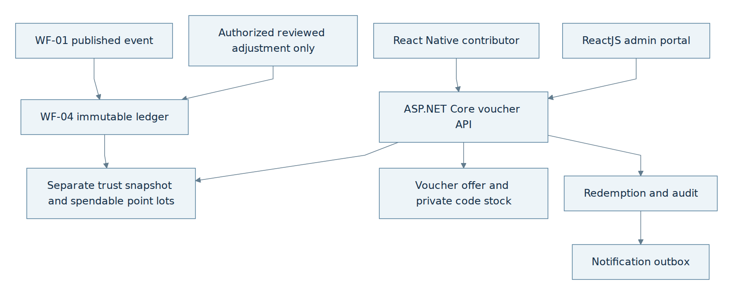
flowchart TB
W1["WF-01 published event"] --> Ledger["WF-04 immutable ledger"]
W2["Authorized reviewed adjustment only"] --> Ledger
Ledger --> Balance["Trust snapshot and spendable point lots"]
Balance --> Rank["Configured exact rank badge"]
App["React Native User"] --> API["ASP.NET Core reputation API"]
Admin["ReactJS admin portal"] --> API
API --> Balance
API --> Rank
API --> Stock["Optional voucher stock"]
API --> Redeem["Redemption and audit"]
Redeem --> Outbox["Notification outbox"]

B.9.2 Reputation and optional redemption decisions
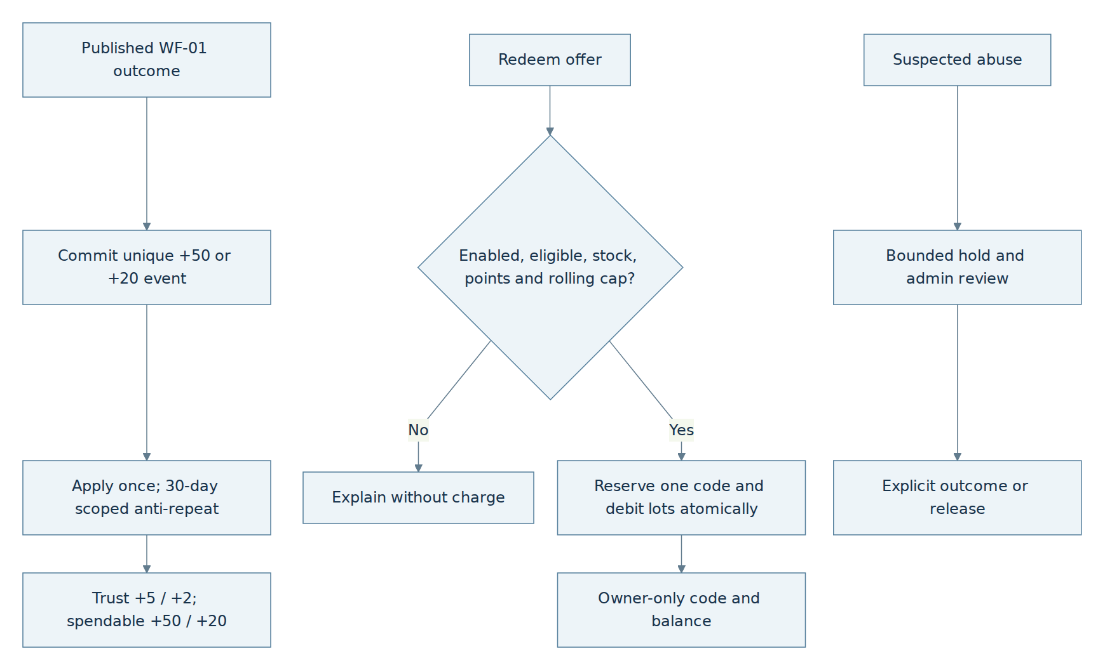
flowchart TB
Pub["Published WF-01 outcome"] --> Event["Commit unique +50 or +20 event"]
Event --> Apply["Apply once; 30-day scoped anti-repeat"]
Apply --> Lots["Trust +5 / +2; spendable +50 / +20"]
Lots --> Board["Update trust; display exact rank badge"]
Request["Optional voucher redemption"] --> Check{"Enabled, eligible, stock, points and rolling cap?"}
Check -->|No| Explain["Explain without charge"]
Check -->|Yes| Tx["Reserve one code and debit lots atomically"]
Tx --> Result["Owner-only code and balance"]
Flag["Suspected abuse"] --> Review["Bounded hold and admin review"]
Review --> Decide["Explicit outcome or release"]

B.9.3 Data relationships
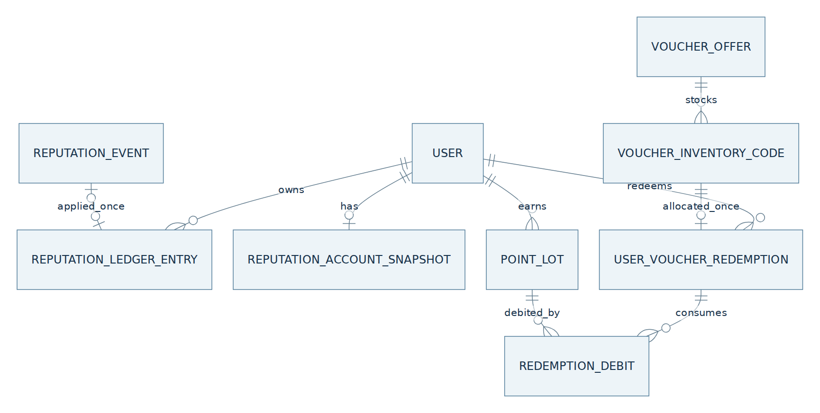
erDiagram
USER ||--o{ REPUTATION_LEDGER_ENTRY : owns
REPUTATION_EVENT o|--o| REPUTATION_LEDGER_ENTRY : applied_once
USER ||--o| REPUTATION_ACCOUNT_SNAPSHOT : has
USER ||--o{ POINT_LOT : earns
VOUCHER_OFFER ||--o{ VOUCHER_INVENTORY_CODE : stocks
USER ||--o{ USER_VOUCHER_REDEMPTION : redeems
VOUCHER_INVENTORY_CODE ||--o| USER_VOUCHER_REDEMPTION : allocated_once
USER_VOUCHER_REDEMPTION ||--o{ REDEMPTION_DEBIT : consumes
POINT_LOT ||--o{ REDEMPTION_DEBIT : debited_by

Admin Portal — Coverage Analytics and Manual Report Export

Part A — Technical / Design Specification

A.1 Purpose, scope and definitions

A.1.1 Business goal
Turn published AccessMap accessibility data into clearly defined coverage statistics by administrative area and time period. An Admin can review and export CSV, PDF or GeoJSON for potential collaboration. Local authorities and advocacy organizations receive any file manually outside the platform; The Admin Portal does not email or provide a partner API.

A.1.2 What coverage means
Coverage describes the observed AccessMap dataset, not the real-world share of all accessible places. Distinguish count of published Locations, count with at least one current published LocationFeature, per-feature presence/limitation, evidence quality and data gaps. Make the eligible population, geography, time window, feature statuses, source freshness and denominator explicit in every chart and export. Do not label an unobserved area inaccessible.

A.1.3 Source of truth
WF-01 Location and current published LocationFeature/Version are authoritative for location and feature values. WF-02 provides non-authoritative freshness/advisory/dispute context; WF-03 search results and Google Places discovery are not a source of published accessibility truth. WF-04 contributor scores are not a location-quality substitute. The Admin Portal reads these projections and never changes their states.

A.2 Actors and system boundaries
Only an Admin account signed in through the ReactJS Admin Portal may request management actions; an ordinary User cannot enter this portal. A mobile Admin login permits ordinary User actions but is not a portal-scoped management session. The same Admin may keep mobile and portal sessions active concurrently; each uses a distinct server-validated session identifier (or existing auth token family) and its own permissions. Reuse the existing auth session/revocation mechanism to reject a signed-out session's outstanding tokens without ending the other session. Global account revocation rejects both; removal of Admin access immediately rejects portal management even if an old portal token remains unexpired. The backend checks current role, portal context, action policy and revocation on each management request, without trusting a client session label or stale role claim. The backend validates the authoritative Admin role, the portal-scoped session/token and Coverage.Read/Generate/Export permission on every relevant API; a UI route, Origin header or caller-provided role is not proof of portal authorization. Admin selects scope, requests aggregation and previews the stored results before choosing a file format. The ASP.NET Core Analytics Service validates parameters and uses a durable Hangfire job to aggregate a consistent PostGIS snapshot. PostgreSQL stores report parameters, metrics and preview data. After review, Admin selects CSV, PDF or GeoJSON and requests export; a separate Hangfire render job creates the private artifact from that same stored snapshot. A ready export supplies an authorized download path. External sharing remains manual. Reuse the existing User.Role and auth infrastructure described in WF-01 A.2.3; no portal-specific User or UserRole table is added.

A.3 Logical architecture
ReactJS Admin Portal → ASP.NET Core report API → CoverageReportRequest and durable aggregation job. Hangfire reads a consistent snapshot, runs region density, feature-ratio and confidence-summary branches, stores merged metrics/warnings and exposes Generated preview data. No file format is required at this stage. After preview and review, Admin selects a format and calls Export. The API commits CoverageExportRequest plus durable render work and returns 202 Accepted. Hangfire renders from the reviewed stored snapshot, stores the private artifact, records successful export audit and marks the export Ready. Download access is authorized and audited before an expiring link is returned.

A.4 Preconditions, actions and outcomes

A.4.1 Preconditions
An authenticated Admin with Coverage.Read/Generate/Export rights supplies a valid supported region, time window and feature filters. No output format is selected for initial aggregation. Geometry and period limits are checked before work starts. Insufficient published data still produces a preview with warnings and explicit denominators. Export later requires a reviewed snapshot, supported selected format and purpose; snapshot data must still be retained.

A.4.2 Product action mapping
The Admin portal exposes generate, review and export as distinct actions. External sharing remains an accountable manual step outside the system.

Product wording | Backend action
Generate coverage report | Validate region, period and filters; commit durable report request/job and return 202.
Preview statistics and warnings | Read same-snapshot metrics, denominators and explicit insufficient-data flags.
Review or regenerate | Review the stored preview; changing scope creates a new report. After approval, select the desired output format.
Export CSV, PDF or GeoJSON | Select format after preview; return 202 with exportId, render asynchronously from the same snapshot, and allow download only when Ready.
Record manual partner sharing | Optionally log admin-reported handoff; platform does not send the file externally.

A.4.3 Business rules and validation outcomes
Validate input before expensive PostGIS aggregation. Density, feature proportions and confidence summary use one consistent retained snapshot. Low sample warns without blocking a valid export. Required-branch error records retry/failure on CoverageJob and prevents Generated/review/export until recovery; never substitute zero or publish an incomplete report.

Situation / check | Result | Admin action
Invalid region or time window | 400/422 before PostGIS job. | Correct parameters.
No or small published sample | Generate with insufficient-data warning; undefined ratios null. | Review caveat and export if useful.
Density / feature / confidence branches | Compute independently and merge only same-snapshot results. | Inspect source and denominators.
Branch timeout | Retry the aggregation job; persist terminal job failure and block Generated/review/export. Never fake zero metrics. | Retry or narrow scope.
Export request | 202 Accepted with exportId/status; Ready exposes the authorized download path after successful render and audit. | Download and share manually if approved.
External collaboration | No direct partner API/email; optional manual-share record. | Deliver through an external organizational process.

A.5 Report lifecycle
Report lifecycle: Requested → Aggregating → Generated → Reviewed → Exported → Archived, with optional SharedRecorded after Exported. Generated means stored metrics, warnings and preview are ready; no downloadable file is required. Reviewed records the Admin and snapshot approval. Format selection happens after preview. Each CoverageExportRequest has its own Queued → Rendering → Ready or Failed lifecycle with bounded retries. A successful artifact plus export audit permits Ready and the report's first Exported transition. Rendering failure leaves the reviewed report and any earlier ready exports intact. SharedRecorded is an Admin-entered manual handoff, never inferred from a link or download. Changed scope creates a new report; another format creates a new export request against the same snapshot.

A.6 Coverage calculations

A.6.1 Region and time semantics
Use the configured versioned administrative boundary and PostGIS geography(Point,4326) for one canonical eligible Location. On a shared boundary assign it once with the deterministic canonical RegionId rule. As-of mode selects the latest eligible publication effective at the requested cutoff. Period mode uses [from,to) and counts the latest qualifying scoped publication per unit within that window; it is activity in the period, not total as-of stock. Include exact cutoff/window, boundary version and timezone in metadata. Deduplicate merged Locations; never count historical versions as extra current places. Snapshot and branch populations follow A.6.2/B.4.

A.6.2 Independent aggregate branches
Density counts DISTINCT canonical eligible published LocationId and divides only by a known region-area denominator. Feature distribution counts current units at (LocationId, ScopeId, FeatureType), grouped by canonical feature/status; its eligible denominator uses that same scoped-feature grain and requested snapshot/filter. Missing observations are disclosed separately, not treated as negative or counted as a fabricated feature. Confidence summarizes current trusted scoped-feature confidence with sample/missing counts. Never aggregate conflicting floors into a whole-place accessibility guarantee. Run all three branches independently and merge only the same retained snapshot.

A.6.3 Missing data and caveats
If no eligible published location exists, return zero observed locations and insufficient_data; ratios whose denominator is zero are null, not 0%. When a minimum sample threshold is missed, keep the report/export but display a warning on preview and within each file. Distinguish Unknown, no feature observation, stale or disputed evidence, and genuine negative published feature status. A map heat layer visualizes AccessMap observation density, not universal accessibility.

A.7 Report contents and formats
Every format includes reportId, generated time, geographic boundary label/version, time semantics, filters, population/denominator definitions, snapshot cutoff, metric definitions, sample sizes, missing-data warnings and provenance. CSV contains aggregate region/feature rows with protected spreadsheet-safe cell encoding. PDF contains the same summary, tables, legends and a clearly labelled coverage map when geometry permits. GeoJSON contains only approved aggregate region features with safe properties; do not include contributor GPS, raw media, individual identity or private moderation notes.

A.8 Admin review, export and sharing
Preview displays the stored metrics, warnings, excluded population and generation outcome. Admin reviews this snapshot, then selects CSV/PDF/GeoJSON and purpose and presses Export. The API returns 202 with exportId and Queued; the portal polls export status. The worker renders only the stored approved aggregates and required boundary snapshot, never reruns live Location queries during export. Once Ready, an authorized audited download returns an expiring link. Retries reuse the same request/artifact identity. Another format can be requested against the same snapshot; new scope or fresher map data requires a new reportId. Manual sharing is recorded separately. Admin also receives prioritized WF-01 cases, WF-02 reports and coordinate correction requests. High contributor reputation may alter queue order and evidence presentation, never the authorized decision or safety gate. Admin can inspect private Location metadata history and scoped feature versions; signed-in Users see only approved redacted history. Aggregate feedback by district, place type, feature and time to identify data quality and coverage work without equating report volume to proven barriers or inferring floors from GPS. Public map layers use bounded client queries and are separate from Admin coverage heat layers; exports retain provenance, window, sample threshold and privacy review. The Admin worklist reuses WF-01 submission review and WF-02 report/dispute APIs; it does not create a second moderation truth store. Priority for trusted contributors affects queue ordering only, with the same evidence checks and auditable Admin action. WrongAddressOrPin cases use WF-02's versioned metadata correction and AccessScope entrance anchor approval. A separate quality-insights view distinguishes raw report counts from Admin-confirmed corrected locations/features and groups approved signals by district, place type, scoped feature and period.

A.9 Exception paths
Invalid region/time/filter: 400/422 before aggregation job creation. No data: Generated preview with insufficient_data and null ratios. Aggregate failures follow bounded retry on CoverageJob and block Generated/review/export; Incomplete reports are disabled. Export from an unreviewed report or unavailable retained snapshot: 409, no render job. Unsupported format: 422. A render/storage failure retries the export job, then marks that export Failed while preserving preview and earlier exports. Unauthorized preview/export/download: 403. Expired links can be reissued only for a retained Ready artifact with audit. Oversized scope requires narrowing or bounded partitioning.

A.10 Security and privacy
Use least-privilege admin scopes, rate limits and job quotas. Apply small-cell suppression or coarser region granularity for sensitive aggregates where policy requires, while explaining suppressed values. Enforce private storage, encrypted transport, file retention and signed-link expiry. Record generation and every export; avoid raw contributor/device GPS, identity, precise photo metadata, personal scores and object-storage secrets in reports. Review output before external manual sharing. Quality insights use aggregate-only read permission and an explicit minimum sample/small-cell policy; private per-report evidence is available only through its authorized case view. Public map layer payloads come from WF-03 bounded viewport APIs, not this Admin analytics endpoint.

A.11 Acceptance outcomes
A valid generation request yields a durable aggregation job and reproducible stored snapshot/preview without selecting a format or creating an artifact. Zero denominator is null with warning; low-data reports remain exportable after review. Export selects format after preview, returns 202, and creates one durable request per idempotency key. Rendering uses the reviewed snapshot even if live map data changes; no link is issued before Ready. Export audit precedes link delivery. Failed rendering preserves preview and permits another format request. Only an authorized Admin can access reports; no automatic partner API or email is invoked.

A.12 Reporting definitions and configuration
Use these reporting definitions consistently with A.6 and Part B. The existing regional density, scoped-feature proportions and confidence summary are the only metric branches. Required-branch aggregation failure blocks Generated/review/export; Incomplete output is disabled. Operational bounds, retention and privacy settings are explicit versioned deployment configuration, not new business features. Reject unconfigured reporting safely rather than assuming unlimited scope or bypassing suppression.

Reporting item | Required behavior
Region boundaries | Use the configured administrative boundary version; assign a boundary-edge point once using the deterministic canonical RegionId rule.
Report time mode | As-of: latest eligible publication effective at cutoff. Period: publications effective within [from,to), latest qualifying scoped version per unit; do not mix period activity with total stock.
Minimum sample and suppression | Low sample warns without blocking. Sensitive cells below the configured minimum suppress exact values/counts consistently in preview and every export.
Confidence metric | Eligible current published scoped-feature confidence on 0–1 scale, with sample/missing counts and disclosed stale/disputed exclusions.
Partial failure policy | Aggregation failure remains on the job; report cannot become Generated. Incomplete output is disabled.
Retention and manual sharing | Private retained snapshots/artifacts, audited links and explicit configured expiry; manual sharing only, without partner integration.

Part B — Implementation Specification

B.0 Implementation authority
Part B specifies the existing Analytics Service contract. It adds no external partner integration and never modifies WF-01/WF-02 source truth. A.6/A.12 define metric meaning; B.7 defines required deployment configuration and validation before operational reporting.

B.1 Data model and ERD
Complete the existing report/export entities as follows; no new analytics subsystem. Id fields use UUID v4, timestamps use timestamptz UTC, strings use text and JSON collections use jsonb. Fields are NOT NULL unless nullable is stated. Source/audit FKs restrict destructive deletion; retain existing xmin concurrency.
CoverageReportRequest: Id uuid PK; RequestedBy uuid FK to authorized User; CreatedAt timestamp; RegionId/BoundaryVersion text; From/To nullable timestamps according to TimeMode; TimeMode enum; FeatureFilter jsonb; Status using existing report lifecycle; PolicyVersion/ParametersHash text; SnapshotAt timestamp fixed on the consistent aggregation snapshot; retained boundary/preview inputs jsonb; Purpose text. SnapshotAt/preview inputs may be null only before they exist; Generated requires all mandatory snapshot/preview data. Obtain RequestedBy from auth. Canonical TimeMode wire names are AsOf and Period, retaining the existing cutoff versus [from,to) semantics in A.6/A.12. Canonical report Status values are Requested, Aggregating, Generated, Reviewed, Exported, SharedRecorded, Archived; transitions remain B.2. Do not invent Failed/Incomplete as report states. Approval storage: use the existing RetainedPreviewInputs jsonb, with immutable snapshot/boundary/preview data and a separate approval member {reviewedBy, reviewedAt, snapshotAt, parametersHash, policyVersion}. Before review, approval is absent. On Generated→Reviewed, set reviewedBy from the authorized authenticated Admin and reviewedAt from server UTC; copy the exact stored SnapshotAt, ParametersHash and PolicyVersion. Persist approval and status atomically under xmin. Approval metadata is excluded from aggregation inputs/hashes and does not mutate the retained preview or snapshot identity. Never accept client-supplied reviewer/time or silently replace an approval; replay against the same approved snapshot returns the existing result, while stale or mismatching identity returns 409. Export authorization requires this approval to match the retained snapshot in Reviewed, Exported or SharedRecorded; a changed scope requires a new report.
CoverageReportMetric: ReportId uuid FK; RegionId and MetricKey text; composite PK (ReportId,RegionId,MetricKey). MetricKey identifies the existing branch and feature/status grouping, preventing group overwrite. Numerator numeric>=0; Denominator numeric nullable and >=0 when present; SampleSize integer>=0; ValueNullable numeric nullable; WarningFlags jsonb; BranchStatus existing enum. Zero/missing denominator yields null ratio. BranchVersion in B.4 is the report's frozen metric PolicyVersion, not an additional column/entity. Upsert only the same report/snapshot/policy; incomplete branches cannot produce Generated. Canonical BranchStatus values are Pending, Succeeded, Failed: Pending is unfinished work, Succeeded means the branch result for the retained snapshot/policy is committed, Failed means unavailable due to recorded branch failure. Zero eligible data is Succeeded with warnings/null ratios, not Failed. Generated requires every mandatory branch Succeeded; failed branches never yield an incomplete public report. These labels normalize existing branch outcomes, not additional aggregation features.
CoverageExportRequest: Id uuid PK; ReportId uuid FK; RequestedBy uuid FK to authorized User; Format enum CSV/PDF/GeoJSON; Purpose/IdempotencyKey/RequestHash text; SnapshotAt timestamp and PolicyVersion text copied from reviewed report; Status Queued/Rendering/Ready/Failed; CreatedAt timestamp; CompletedAt timestamp nullable; FailureCode text nullable. UNIQUE (RequestedBy,ReportId,IdempotencyKey); changed payload conflicts. Ready/Failed require CompletedAt; Ready requires committed artifact/audit. Failure preserves the approved report.
CoverageArtifact: Id uuid PK; ReportId uuid FK; ExportRequestId uuid UNIQUE FK; Format enum; PrivateObjectKey/Sha256 text; Size bigint>=0; CreatedAt/RetentionUntil timestamps with RetentionUntil>CreatedAt. Report/format must match its export request. Keep objects private/immutable and retain source snapshot for the supported export period.
CoverageExportAudit: ExportRequestId uuid PK/FK for one successful render; ReportId/ArtifactId/AdminId uuid FKs; ExportedAt timestamp; Purpose/FileHash text. Values must match the Ready artifact/request; generation does not prove external sharing.
DownloadAccessAudit: ArtifactId/AdminId uuid FKs; AccessedAt timestamp; composite key (ArtifactId,AdminId,AccessedAt) for append-only access records. Check current authorization, Ready status and retention before issuing a link; repeated access remains auditable.
CoverageJob: Id uuid PK; Kind Aggregate/Render; ReportId uuid FK; ExportRequestId uuid nullable FK; Status reuses WF-01 AIProcessingJobStatus names and numeric identities: Queued=0, Processing=1, RetryScheduled=2, Succeeded=3, Failed=4, Cancelled=5. This Portal release uses Queued→Processing, Processing→RetryScheduled for a retryable failure, RetryScheduled→Processing when due, and Processing→Succeeded or Failed. Failed is terminal after a nonretryable failure or exhausted configured retries; no infinite retry. Cancelled remains a shared enum member but is not an enabled Portal transition or a new cancellation endpoint. AttemptCount integer>=0; LockedUntil/NextRetryAt timestamptz nullable; FailureCode text nullable. CHECK Aggregate=>ExportRequestId IS NULL and Render=>ExportRequestId IS NOT NULL; a render export belongs to ReportId. Processing requires a live lease; RetryScheduled requires NextRetryAt; terminal states clear the lease and retry time. Only one nonterminal job per aggregation report/render export via existing active-status uniqueness and lease rules. A recovered expired Processing lease resumes the same logical job under bounded retry; it does not create a second export. Aggregate Succeeded requires all mandatory branches/preview committed and report Generated; Render Succeeded requires Ready artifact/audit committed. Aggregate failure leaves the report ungenerated; render failure preserves its reviewed snapshot/earlier artifacts. Remote I/O remains outside DB transactions.

B.2 States and transition guards
Requested→Aggregating when the durable aggregate job is claimed; Aggregating→Generated only after required branches, warnings and retained preview are persisted. Generated→Reviewed records authorized approval of the exact snapshot. After preview, an export request moves Queued→Rendering→Ready or Failed. Ready commits the artifact and CoverageExportAudit; the first Ready export moves the report Reviewed→Exported. A failed export preserves the approved report and earlier artifacts. Exported→SharedRecorded is a manual handoff; Exported/SharedRecorded→Archived follows retention. Use existing xmin optimistic concurrency plus snapshot identity on report/export writes. Persist approval actor/time/snapshot identity in CoverageReportRequest.RetainedPreviewInputs.approval as defined in B.1, atomically with Reviewed. CoverageExportAudit records successful renders and DownloadAccessAudit records link/access activity; neither substitutes for snapshot approval. Reuse these existing structures; no transition-history table is introduced. Aggregation failure is recorded on the existing CoverageJob with failure/retry metadata, keeps the report ungenerated and blocks approval/export until successful retry. Incomplete reports are disabled pending an explicit partial-data policy.

B.3 Admin API
POST /api/v1/admin/coverage-reports accepts region, timeMode, from/to, featureTypes and purpose with Idempotency-Key; no formats field is required or consumed for rendering at this stage. Return 202 with reportId and Requested. GET /api/v1/admin/coverage-reports/{id} returns status, stored metrics, warnings and preview. POST /{id}/review records approval of that snapshot. After preview/review, POST /{id}/exports accepts {format, purpose} with its own Idempotency-Key; commit CoverageExportRequest and render job, return 202 {reportId, exportId, status: Queued, statusUrl}. GET /{id}/exports/{exportId} returns Queued/Rendering/Ready/Failed with a safe failureCode; only Ready returns artifactId and the authorized download endpoint. GET /{id}/downloads/{artifactId} checks Admin role, validated Admin Portal session/scope, action rights and report/export ownership, report/export readiness and retention, audits access and issues an expiring link. Same export key/payload replays the original 202/exportId; a changed format or purpose with that key returns 409. Optional POST /{id}/manual-share-record records a handoff without sending a file. GET /api/v1/admin/quality-insights?regionId&from&to&placeType&featureType returns bounded report counts by status/reason, confirmed metadata corrections, published scoped feature changes and missing-data counts with denominators, source/version and suppression flags. It never labels report volume as proven accessibility barriers. Worklist cards link to the existing WF-01 Admin endpoints, WF-02 reports/disputes and approved entrance metadata action rather than duplicating their transitions.

Endpoint | Caller | Result
POST /api/v1/admin/coverage-reports | Admin | 202 Requested with reportId; validate scope and idempotency; format is selected later.
GET /api/v1/admin/coverage-reports/{id} | Admin | State, preview, warnings, metrics and snapshot definition.
POST /api/v1/admin/coverage-reports/{id}/review | Admin | Audited review and optional decision note.
POST /api/v1/admin/coverage-reports/{id}/exports | Admin | 202 Queued with exportId and statusUrl. GET /{id}/exports/{exportId} polls rendering; Ready returns the authorized artifact download path.
GET /api/v1/admin/coverage-reports/{id}/downloads/{artifactId} | Admin | For a retained Ready export only: audit access and issue/renew an authorized download link.
POST /api/v1/admin/coverage-reports/{id}/manual-share-record | Admin | Optional metadata-only record; sends no file.

B.4 Validation and PostGIS aggregation
Reject invalid geometry, out-of-range time/radius, unsupported feature types and excessive complexity before enqueue. Query active/published canonical Locations using indexed spatial predicates, version-aware feature joins and partitioned result sets. Execute three logically separate branches with shared SnapshotAt and region version; persist each metric idempotently by (ReportId, RegionId, MetricKey) under the report's frozen PolicyVersion (the BranchVersion); retries cannot mix policies. Enforce query timeout and quota; a single giant SQL query is not required. Implement the three branches against one PostgreSQL REPEATABLE READ snapshot in a bounded aggregation transaction, or materialize a versioned eligible-row snapshot first and run all branches from it. A shared timestamp string alone does not guarantee the same rows when WF-01 publishes concurrently. Persist a SnapshotToken/data cutoff, boundary version, branch input counts and metric policy version; on retry either reuse the materialized snapshot or restart all branches, never merge partial results from different snapshots. Keep remote services and rendering outside the transaction.

B.5 Rendering and object storage
Create no file during preview aggregation. The separate render worker loads the approved stored metrics, warning flags and retained boundary/format inputs using CoverageExportRequest.ReportId and frozen snapshot identity. Never query live Location rows again during export. Use safe CSV encoding, bounded PDF maps and aggregate GeoJSON. Store the immutable artifact privately under a deterministic ExportRequestId-based key with SHA-256; retries verify an existing artifact before reuse. Keep storage I/O outside DB transactions and reconcile orphan objects. A new format creates a new export request referencing the same snapshot; retain the source snapshot for the supported export period.

B.6 Durable jobs and consistency
Generation transaction: commit CoverageReportRequest plus Aggregate domain job, return 202; after commit schedule Hangfire with reconciliation for missed enqueue. Aggregation persists one consistent metric/preview snapshot and marks Generated. Export transaction, after snapshot review and format selection: validate request/idempotency and commit CoverageExportRequest plus Render domain job, return 202. The render worker claims a lease, changes Queued to Rendering, renders outside the transaction and writes private bytes; then atomically commits the matching artifact metadata, successful export audit, Ready status, report Exported transition where needed and the shared WF-01 B.3.17 notification outbox. Set sourceType=CoverageExportRequest, sourceId=export.Id and sourceEventId=CoverageExportAudit.ExportRequestId (the same export UUID) for the existing ExportReady outcome; RecipientUserId is the authorized requesting Admin. The canonical export and its matching Ready artifact/audit must exist; no SubmissionId or RelatedCaseId is required. This adds no separate notification pipeline. Retry never reaggregates live data or duplicates an artifact/audit. On exhaustion set export Failed and preserve the reviewed report. Download audit is committed before any signed capability is returned.

B.7 Business rules and configuration
Required versioned configuration: MaxArea (positive square kilometres), MaxTimeRange (positive duration), MaxRows (positive row count), MinSampleForHeadline (positive integer), SuppressSmallCells (explicit privacy policy), JobTimeout (positive duration), Concurrency (positive bounded job count), ExportLinkTTL (positive duration), RetentionDays (positive integer). Validate at startup and before report work; no implicit unlimited/zero fallback. Deployment supplies tested values for the supported region/capacity. Missing/invalid settings leave coverage generation/export disabled with an explicit configuration error, without disabling other workflows. Link TTL cannot exceed remaining artifact retention; accepted jobs enforce area/time/row/timeout limits. Low sample warns rather than failing valid scope. For sensitive cells below the configured threshold, suppress exact numerator, denominator, sample count and derived value consistently; another format/total must not leak them. Policy version and snapshot travel with every artifact. Confidence uses 0–1; density is distinct eligible canonical places per square kilometre; feature proportions use the same (LocationId,ScopeId,FeatureType) population. Zero denominator yields null, not 0%. No branch declares universal/regulatory compliance.

Rule | Default behavior | Constraint
Validate scope | Before heavy PostGIS processing. | Bound region/time/complexity and authorize admin.
Density branch | Count unique canonical published places. | State denominator and area version.
Feature ratio branch | Count current published features by type/status. | No raw pending claims or old version double counts.
Confidence branch | Summarize trusted feature scores with n/missing. | Not a whole-place QCVN compliance score.
Insufficient data | Warn, keep export possible. | Zero denominator → null ratio, never 0%.
Export audit | Record every export and file hash. | Commit before link, authorized private download.

B.8 Failure matrix
EX-01 invalid params →400/422, no job. EX-02 zero eligible data →Generated with warning and null ratios. EX-03 branch timeout/failure →bounded job retry; on exhaustion retain failure metadata, keep report ungenerated and block review/export; no Incomplete output. EX-04 render/storage error →bounded export retry, then export Failed while approved preview/earlier Ready files remain. EX-05 unauthorized →403 and audit. EX-06 expired link →new logged short-lived link if authorized. EX-07 oversized scope →422 requesting narrower scope. EX-08 sensitive small cell →existing suppression/coarsening policy and warning.

Code | Situation | Result
EX-01 | Invalid region/time/filter | 400/422; no report job.
EX-02 | No eligible published data | Generated with warning and null ratios.
EX-03 | Query/branch timeout | Bounded aggregation-job retry; terminal failure blocks report generation/export.
EX-04 | Render/storage failure | Retry export idempotently; terminal Failed preserves preview and earlier Ready artifacts.
EX-05 | Unauthorized generation or download | 403; audit.
EX-06 | Expired signed link | Reissue on authorized request; log access.
EX-07 | Oversized scope | 422; require narrower range or region.
EX-08 | Sensitive small count | Suppress/coarsen by approved privacy policy.

B.9 Test scenarios and Definition of Done
Test boundary/time semantics, merged-place dedup, current feature versions, zero denominator, warnings and branch reconciliation. Verify generation without formats produces preview without an artifact; selecting a format after review returns 202/exportId; polls expose Queued/Rendering/Ready/Failed; map updates between preview and export cannot alter exported figures; another format uses the same snapshot; key/payload replay returns the same export and changed payload returns 409; no link before Ready; render failure preserves preview; checksum, CSV safety, aggregate GeoJSON privacy, retention, signed-link expiry and audit ordering remain enforced. Done means the preview and every exported format match the approved snapshot, and no system-to-partner transfer occurs. Test simultaneous Admin mobile and portal sessions, sign-out of one session with outstanding-token rejection and continued use of the other, global revocation of both, and immediate portal denial after removal of Admin access despite an unexpired token. Test worklist ordering without a tier-based decision bypass, wrong-pin approval with immutable before/after history, quality-insights separation of Submitted reports from confirmed corrections, scope/floor grouping, small-cell suppression, stable bounded pagination and no private evidence in aggregate/map responses. Add a concurrent WF-01 publication during aggregation: the three metric branches must reflect either the same before state or the same after state, never a mixture. Retry after one branch failure must preserve the chosen snapshot identity or start a new complete aggregation; preview and all export formats must retain identical counts and source versions. Verify missing/invalid required configuration disables only reporting work; zero-denominator/null and sensitive-cell suppression match preview/CSV/PDF/GeoJSON. Check metric composite-key idempotency, single successful export audit, matching report/export/artifact references, and link TTL bounded by remaining retention. Verify approval and Reviewed commit atomically, the authenticated reviewer/time and exact snapshot identity are retained in the existing JSON, approval retries cannot replace that evidence, and missing/mismatching approval blocks export. Verify canonical job state/lease/retry guards in B.1, shared enum identity with WF-01, no Portal Cancelled transition, and no report Failed/Incomplete state. Empty-data branches succeed with warnings; required-branch failure blocks generation. Job success must agree transactionally with Generated or Ready, according to job kind.
Assert ExportReady outbox accepts its validated CoverageExportRequest source with null SubmissionId/RelatedCaseId and notifies only its authorized requester. Repeated render completion reuses export identity/EventType and creates no duplicate notification; a foreign/missing/mismatched export source is rejected.

B.10 Diagram sources
Rendered figures sit directly above the editable Mermaid diagrams.

B.10.1 Analytics architecture
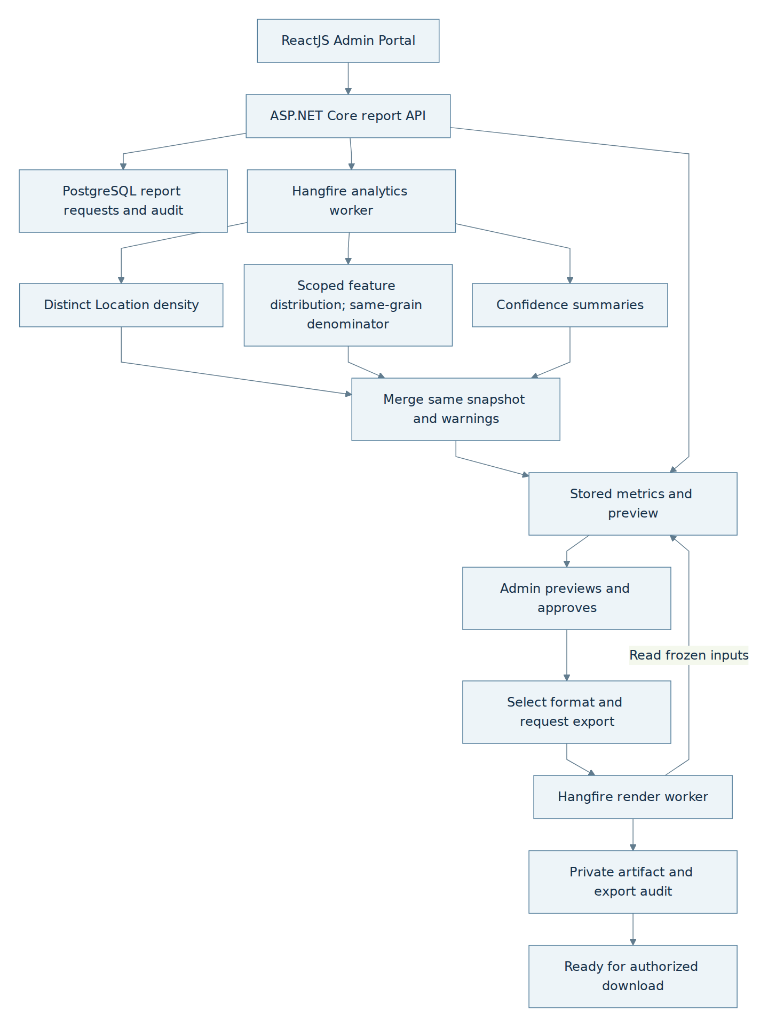
flowchart TB
Admin["ReactJS Admin Portal"] --> API["ASP.NET Core report API"]
API --> DB["PostgreSQL report requests and audit"]
API --> Job["Hangfire analytics worker"]
Job --> Geo["Distinct Location density"]
Job --> Feature["Scoped feature distribution; same-grain denominator"]
Job --> Score["Confidence summaries"]
Geo --> Merge["Merge same snapshot and warnings"]
Feature --> Merge
Score --> Merge
Merge --> Snapshot["Stored metrics and preview"]
Snapshot --> Review["Admin previews and approves"]
Review --> Choice["Select format and request export"]
Choice --> Render["Hangfire render worker"]
Render --> Object["Private artifact and export audit"]
API --> Snapshot
Render -->|Read frozen inputs| Snapshot
Object --> Ready["Ready for authorized download"]

B.10.2 Generation and export decisions
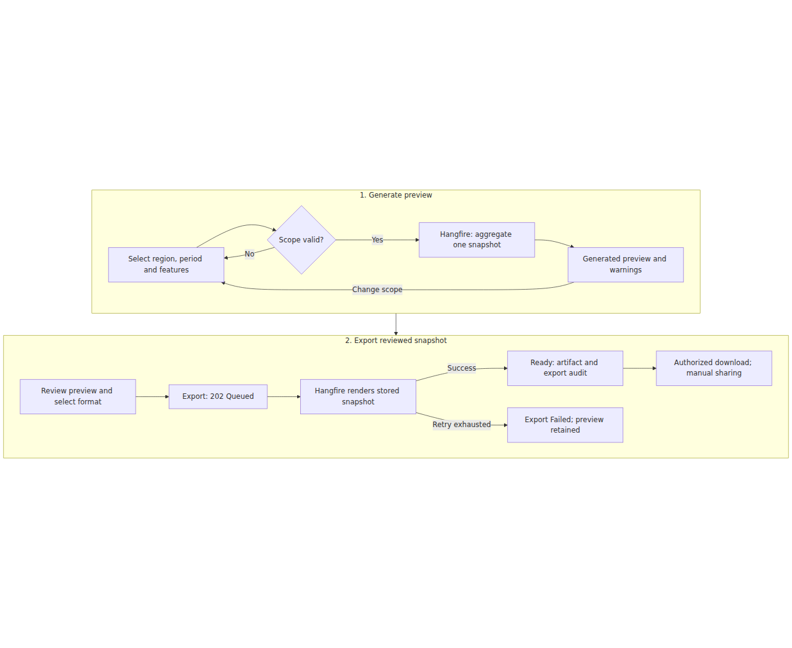
flowchart TB
subgraph Generate["1. Generate preview"]
direction LR
Scope["Select region, period and features"] --> Valid{"Scope valid?"}
Valid -->|No| Scope
Valid -->|Yes| Aggregate["Hangfire: aggregate one snapshot"]
Aggregate --> Preview["Generated preview and warnings"]
Preview -->|Change scope| Scope
end
subgraph Export["2. Export reviewed snapshot"]
direction LR
Choose["Review preview and select format"] --> Queue["Export: 202 Queued"]
Queue --> Render["Hangfire renders stored snapshot"]
Render -->|Success| Ready["Ready: artifact and export audit"]
Render -->|Retry exhausted| Failed["Export Failed; preview retained"]
Ready --> Download["Authorized download; manual sharing"]
end
Generate --> Export

B.10.3 Report and audit relationships
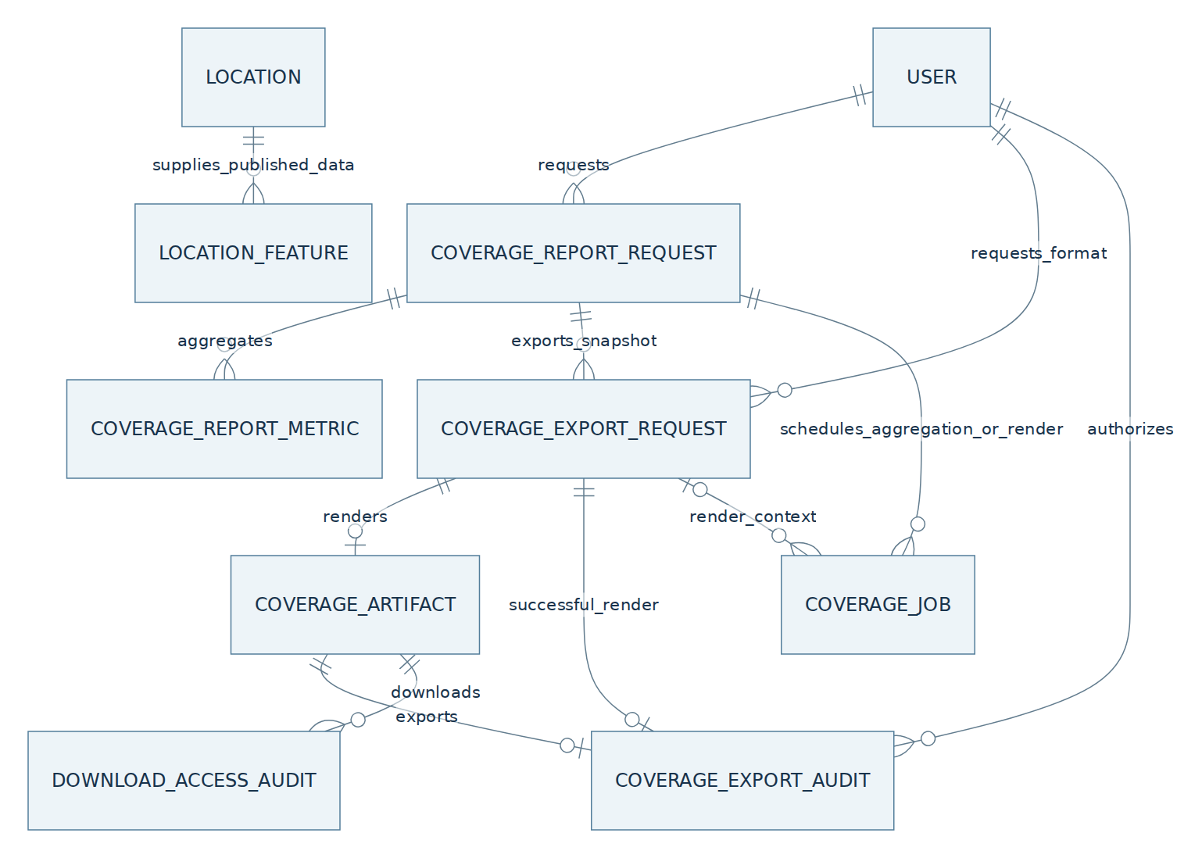
erDiagram
USER ||--o{ COVERAGE_REPORT_REQUEST : requests
COVERAGE_REPORT_REQUEST ||--o{ COVERAGE_REPORT_METRIC : aggregates
COVERAGE_REPORT_REQUEST ||--o{ COVERAGE_EXPORT_REQUEST : exports_snapshot
USER ||--o{ COVERAGE_EXPORT_REQUEST : requests_format
COVERAGE_EXPORT_REQUEST ||--o| COVERAGE_ARTIFACT : renders
COVERAGE_EXPORT_REQUEST ||--o| COVERAGE_EXPORT_AUDIT : successful_render
COVERAGE_ARTIFACT ||--o| COVERAGE_EXPORT_AUDIT : exports
COVERAGE_ARTIFACT ||--o{ DOWNLOAD_ACCESS_AUDIT : downloads
COVERAGE_REPORT_REQUEST ||--o{ COVERAGE_JOB : schedules_aggregation_or_render
COVERAGE_EXPORT_REQUEST o|--o{ COVERAGE_JOB : render_context
LOCATION ||--o{ LOCATION_FEATURE : supplies_published_data
USER ||--o{ COVERAGE_EXPORT_AUDIT : authorizes

AccessMap VN — System Diagrams
Editable visual diagrams (16 pages): diagrams.net file. The code beneath each figure remains the textual source.

1. Context diagram

1.1 Full-system context and external interfaces
The black box includes mobile/web, backend/auth, owned AI Media Analysis Service, workers and database. Independent map/place, storage and delivery providers are external interfaces. Delivery providers represent business push notifications and the approved Email/Sms registration OTP channels. OTP uses the auth sender/challenge before account creation; it is not queued in the domain FCM outbox. An unauthenticated person may register with one selected OTP channel and then sign in; place search and viewing require an authenticated session. Voucher inventory remains Admin-entered under its existing issuer gate, and file sharing remains manual. No new actor, diagram or partner integration is introduced.
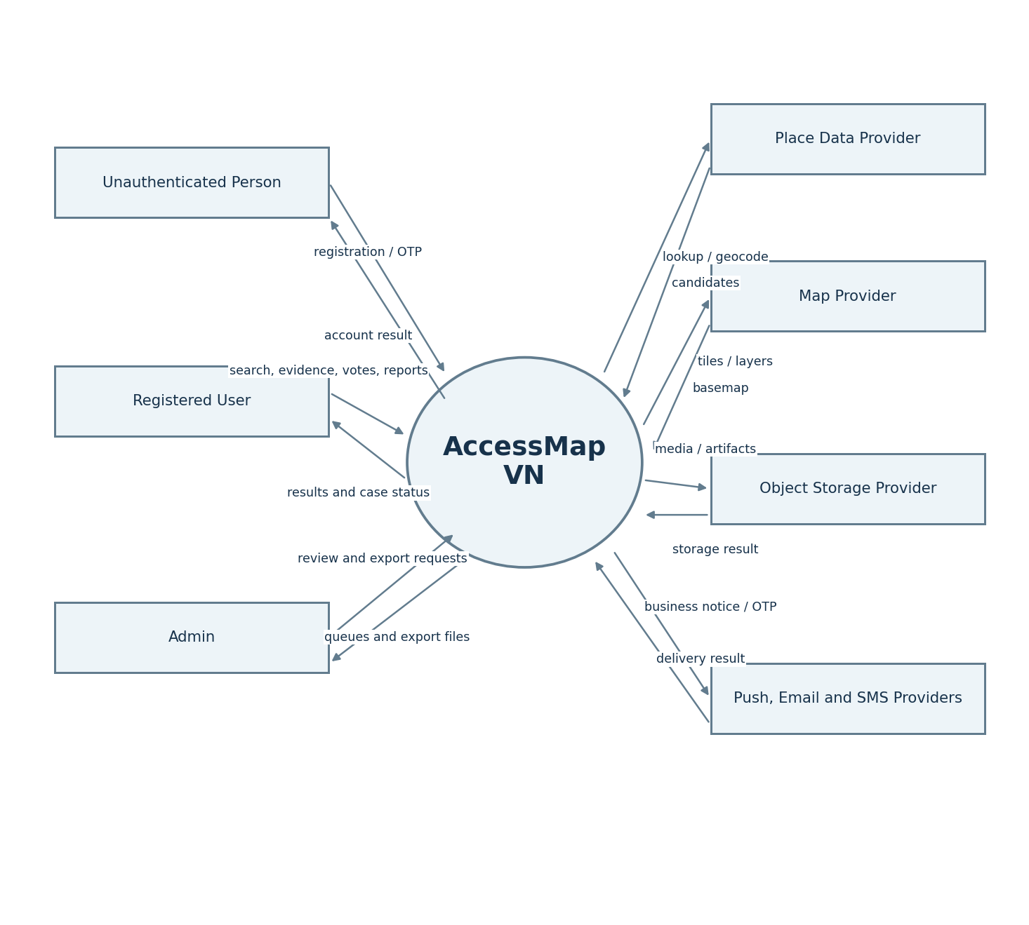
Figure — 1.1 Full-system context and external interfaces.
Editable Mermaid source
flowchart LR
Unauthenticated["Unauthenticated Person"] -->|"Registration and selected-channel OTP"| AM(("AccessMap VN"))
AM -->|"Registration and sign-in outcome"| Unauthenticated
User["Registered User"] -->|"Search criteria, needs, contributions, votes, reports and reward requests"| AM
AM -->|"Place results, case status, reputation and reward receipts"| User
Admin["Admin"] -->|"Review decisions, metadata corrections and coverage requests"| AM
AM -->|"Review queues, retained previews and export files"| Admin
AM -->|"Place lookup and geocoding requests"| Places["Place Data Provider"]
Places -->|"Candidate identities, addresses and coordinates"| AM
AM -->|"Map tile and enabled-layer requests"| Map["Map Provider"]
Map -->|"Basemap tiles and permitted provider context"| AM
AM -->|"Private media and artifact storage operations"| Store["Object Storage Provider"]
Store -->|"Stored objects and operation results"| AM
AM -->|"Business notifications and registration OTP"| Notify["Push, Email and SMS Providers"]
Notify -->|"Delivery acceptance or failure"| AM

2. Use case diagrams
These are three views of the same AccessMap boundary. An unauthenticated person can register and sign in; the signed-in User uses place information and performs contribution/community actions. Admin can use ordinary User actions in a mobile session, while portal management requires a separate portal session and explicit permission. Associations denote participation, not flow order. Shared registration requires unique canonical email and phone and one successful OTP through the User-selected Email or Sms channel under WF-01 A.2.3/B.4.7. Confirm only that channel, not both; ordinary login does not require another OTP. Reuse the existing User/auth model and ownership checks; Guest place access is not enabled by these diagrams.

2.1 Account entry and signed-in place capabilities
Unauthenticated people can register with the selected Email or Sms OTP channel and sign in. After signing in, a User can search, use explicit current-request discovery filters, explore enabled map layers, inspect published evidence and read approved history/comments. Saved preferences and favorites also require authentication. The optional Guest proposal does not change this baseline.
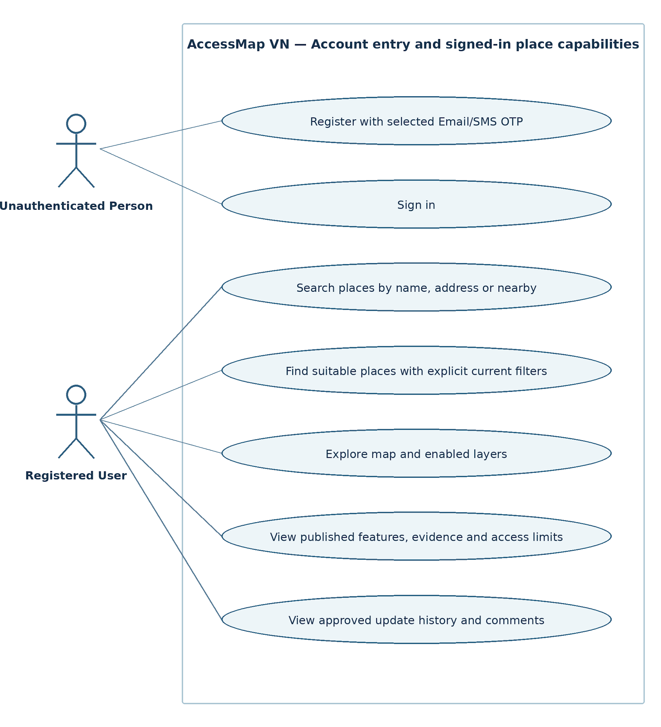
Figure — 2.1 Account entry and signed-in place capabilities.
Editable UML source (PlantUML); edit shapes in diagrams.net file
@startuml
left to right direction
actor "Unauthenticated Person" as Visitor
actor "Registered User" as User
rectangle "AccessMap VN" {
usecase "Register with selected Email/SMS OTP" as Register
usecase "Sign in" as SignIn
usecase "Search places by name, address or nearby" as Search
usecase "Find suitable places with explicit current filters" as Discover
usecase "Explore map and enabled layers" as Map
usecase "View published features, evidence and access limits" as Details
usecase "View approved update history and comments" as History
}
Visitor -- Register
Visitor -- SignIn
User -- Search
User -- Discover
User -- Map
User -- Details
User -- History
@enduml

2.2 Registered User capabilities
One signed-in User manages saved needs/favorites, contributes and updates evidence, supplies corrections, votes on a published claim, reports inaccuracies, comments, views reputation/points and sees the leaderboard and private own rank. Pre-scan review and claim confirmation are included in a contribution; no AIAnalysis or durable job is created by pre-scan. Voucher redemption is shown only under its existing issuer/enablement gate.
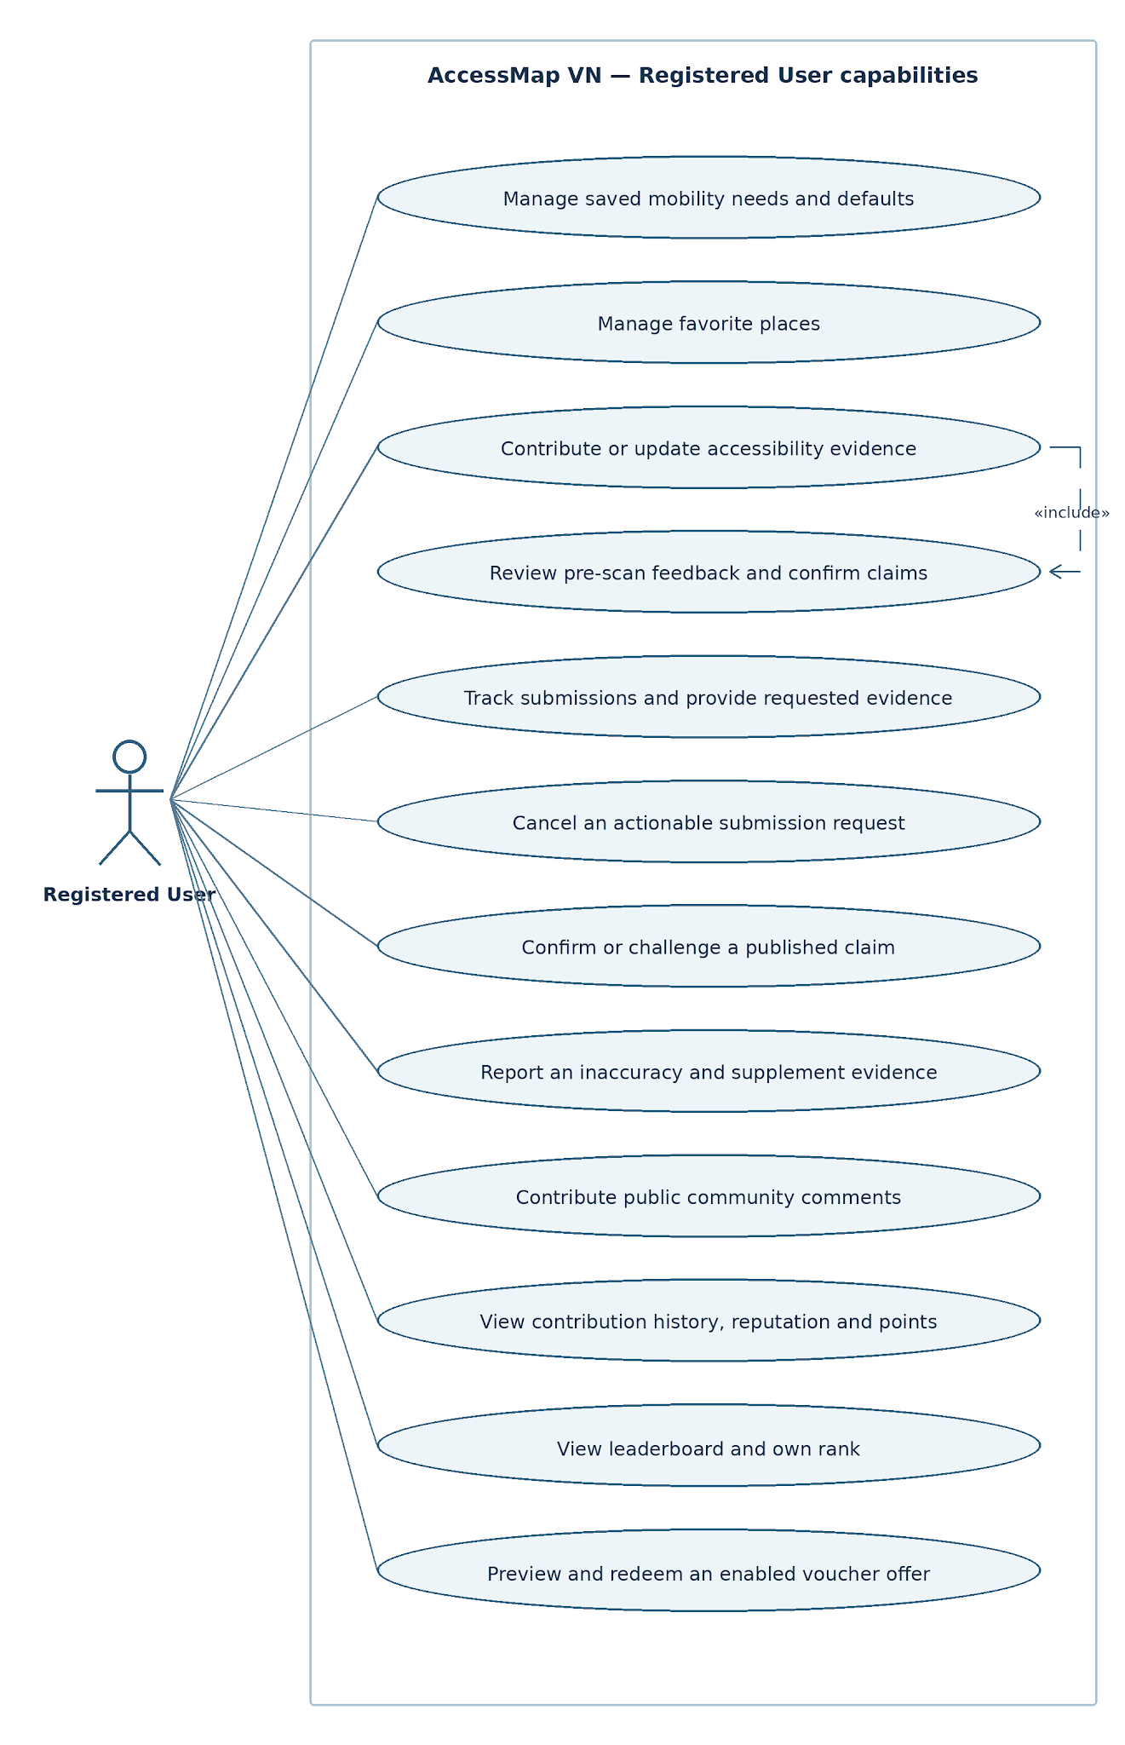
Figure — 2.2 Registered User capabilities.
Editable UML source (PlantUML); edit shapes in diagrams.net file
@startuml
left to right direction
actor "Registered User" as User
rectangle "AccessMap VN" {
usecase "Manage saved mobility needs and defaults" as Needs
usecase "Manage favorite places" as Favorites
usecase "Contribute or update accessibility evidence" as Submit
usecase "Review pre-scan feedback and confirm claims" as PreScan
usecase "Track submissions and provide requested evidence" as Track
usecase "Cancel an actionable submission request" as Cancel
usecase "Confirm or challenge a published claim" as Vote
usecase "Report an inaccuracy and supplement evidence" as Report
usecase "Contribute public community comments" as Comment
usecase "View contribution history, reputation and points" as Points
usecase "View leaderboard and own rank" as Board
usecase "Preview and redeem an enabled voucher offer" as Redeem
}
User -- Needs
User -- Favorites
User -- Submit
User -- Track
User -- Cancel
User -- Vote
User -- Report
User -- Comment
User -- Points
User -- Board
User -- Redeem
Submit ..> PreScan : <<include>>
@enduml

2.3 Admin Portal capabilities
Admin handles contribution and community review, temporary advisories, metadata corrections, comment moderation, approved reward administration, audited restrictions/adjustments and coverage preview/review/export. Requesting more evidence is an optional extension while reviewing a contribution. Report approval is a prerequisite for export; it is not a use-case dependency.
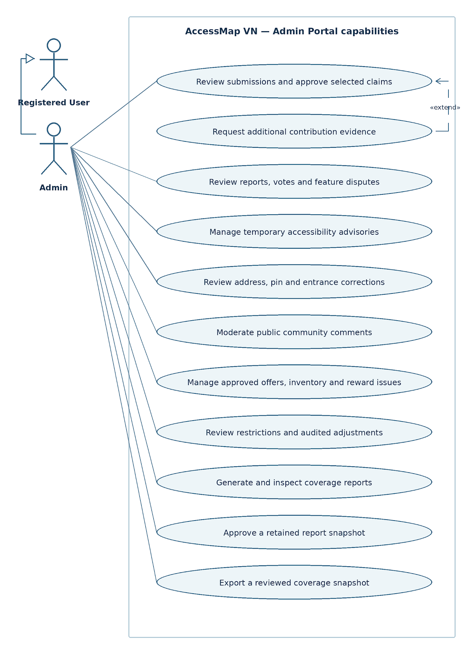
Figure — 2.3 Admin Portal capabilities.
Editable UML source (PlantUML); edit shapes in diagrams.net file
@startuml
left to right direction
actor "Registered User" as User
actor "Admin" as Admin
Admin --|> User
rectangle "AccessMap VN - Admin Portal" {
usecase "Review submissions and approve selected claims" as Submission
usecase "Request additional contribution evidence" as Info
usecase "Review reports, votes and feature disputes" as Dispute
usecase "Manage temporary accessibility advisories" as Advisory
usecase "Review address, pin and entrance corrections" as Metadata
usecase "Moderate public community comments" as Comments
usecase "Manage approved offers, inventory and reward issues" as Reward
usecase "Review restrictions and audited adjustments" as Accounts
usecase "Generate and inspect coverage reports" as Coverage
usecase "Approve a retained report snapshot" as Approve
usecase "Export a reviewed coverage snapshot" as Export
}
Admin -- Submission
Admin -- Dispute
Admin -- Advisory
Admin -- Metadata
Admin -- Comments
Admin -- Reward
Admin -- Accounts
Admin -- Coverage
Admin -- Approve
Admin -- Export
Info ..> Submission : <<extend>>
@enduml

3. Conceptual entity diagrams
These views explain the relationships most frequently questioned in review. They do not define different databases or replace the connected system ERDs in sections 5 and 6.

3.1 Claim comparison and AI evidence lineage
AIAnalysis is an immutable post-submit full-scan attempt; one Submission can retain multiple attempts. AIAnalysisFeature.ComparedSubmissionClaimId optionally identifies the exact claim being compared. AIAnalysisEvidence belongs to one analysis, optionally identifies a feature result, and optionally cites a source SubmissionMedia item from the same Submission. Consequently the media can support multiple full-scan attempts through evidence rows; a forced Media–AIAnalysis 1:1 relation would lose retry/history. Pre-scan assessments remain on UploadIntent/SubmissionMedia and are not another AIAnalysis type. Python supplies observations/evidence; backend compares the claim, calculates confidence and routes.
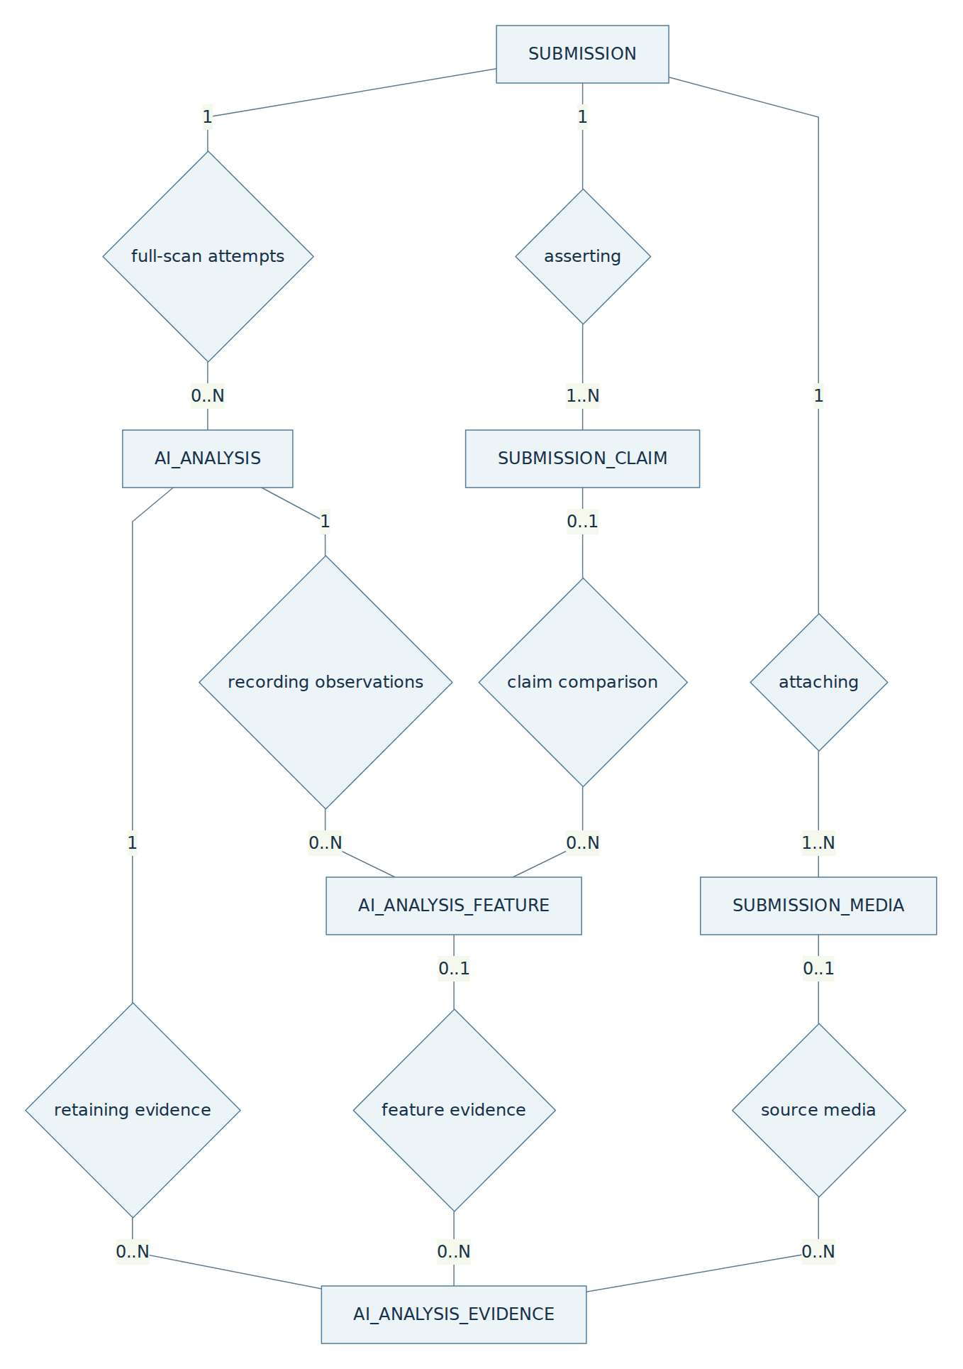
Figure — 3.1 Claim comparison and AI evidence lineage.
Editable Mermaid source
flowchart TB
S["SUBMISSION"] -- "1" --- Has{"asserting"}
Has -- "1..N" --- C["SUBMISSION_CLAIM"]
S -- "1" --- Attach{"attaching"}
Attach -- "1..N" --- M["SUBMISSION_MEDIA"]
S -- "1" --- Scan{"full-scan attempts"}
Scan -- "0..N" --- A["AI_ANALYSIS"]
A -- "1" --- Obs{"recording observations"}
Obs -- "0..N" --- AF["AI_ANALYSIS_FEATURE"]
C -- "0..1" --- Compare{"claim comparison"}
Compare -- "0..N" --- AF
A -- "1" --- Cite{"retaining evidence"}
Cite -- "0..N" --- E["AI_ANALYSIS_EVIDENCE"]
AF -- "0..1" --- Detail{"feature evidence"}
Detail -- "0..N" --- E
M -- "0..1" --- Source{"source media"}
Source -- "0..N" --- E

3.2 Claim-based votes, report targets and point ownership
CommunityVote.TargetSubmissionClaimId is the published claim being confirmed or challenged. LocationFeatureId/ObservedFeatureVersion retain its public snapshot, not a second voting subject. Report.TargetSubmissionId/TargetSubmissionClaimId identify challenged evidence; LinkedSubmissionId is separate correction evidence supplied by the reporter. LocationId remains required context for missing-feature and wrong-address/pin reports that may have no target claim. PointLot is owned by User and sourced by an approved ReputationEvent; it stores spendable rewards, not trust.
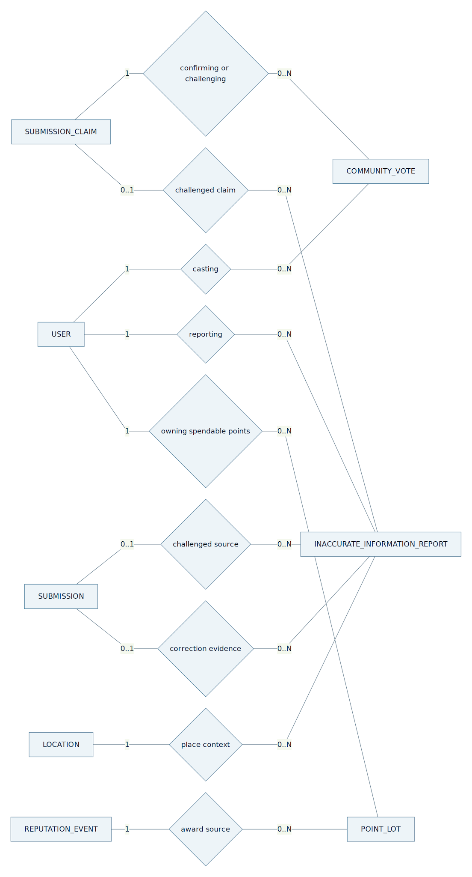
Figure — 3.2 Claim-based votes, report targets and point ownership.
Editable Mermaid source
flowchart LR
U["USER"] -- "1" --- Own{"casting"}
Own -- "0..N" --- V["COMMUNITY_VOTE"]
C["SUBMISSION_CLAIM"] -- "1" --- Confirm{"confirming or challenging"}
Confirm -- "0..N" --- V
U -- "1" --- File{"reporting"}
File -- "0..N" --- R["INACCURATE_INFORMATION_REPORT"]
S["SUBMISSION"] -- "0..1" --- Target{"challenged source"}
Target -- "0..N" --- R
C -- "0..1" --- ClaimTarget{"challenged claim"}
ClaimTarget -- "0..N" --- R
S -- "0..1" --- Correction{"correction evidence"}
Correction -- "0..N" --- R
L["LOCATION"] -- "1" --- Place{"place context"}
Place -- "0..N" --- R
U -- "1" --- Earn{"owning spendable points"}
Earn -- "0..N" --- P["POINT_LOT"]
RE["REPUTATION_EVENT"] -- "1" --- Award{"award source"}
Award -- "0..N" --- P

4. State diagrams
Each diagram models one existing business object. State labels match its owning workflow; no global status enum combines submissions, reports, jobs and vouchers. WF3 search/discovery has transient requests, so it has no persisted SearchRequest lifecycle. New evidence creates a new Submission attempt rather than mutating its predecessor. Unshown transitions are forbidden; terminal states are immutable.

4.1 Submission lifecycle — WF1
The backend state service alone changes SubmissionStatus with append-only history. AutoVerified is a backend result after combined scoring and hard-rule checks, followed by a guarded publication transaction. AwaitingMoreInfo covers actionable evidence gaps; usable risky evidence goes to Admin. Resubmission is a new child object, not a state transition of its parent.
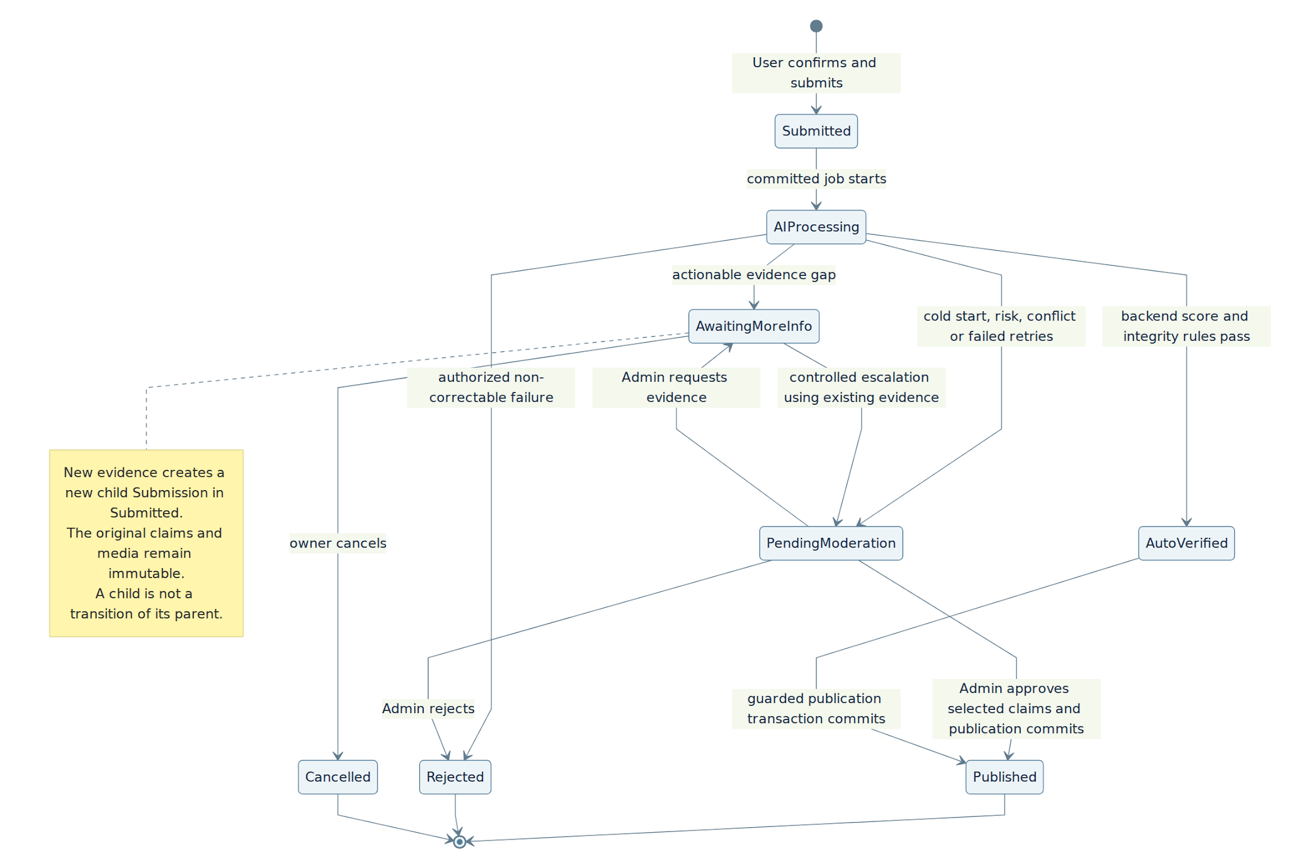
Figure — 4.1 Submission lifecycle — WF1.
Editable Mermaid source
stateDiagram-v2
direction TB
[*] --> Submitted: User confirms and submits
Submitted --> AIProcessing: committed job starts
AIProcessing --> AwaitingMoreInfo: actionable evidence gap
AIProcessing --> PendingModeration: cold start, risk, conflict or failed retries
AIProcessing --> AutoVerified: backend score and integrity rules pass
AIProcessing --> Rejected: authorized non-correctable failure
PendingModeration --> AwaitingMoreInfo: Admin requests evidence
AwaitingMoreInfo --> PendingModeration: controlled escalation using existing evidence
AwaitingMoreInfo --> Cancelled: owner cancels
PendingModeration --> Published: Admin approves selected claims and publication commits
PendingModeration --> Rejected: Admin rejects
AutoVerified --> Published: guarded publication transaction commits
Published --> [*]
Rejected --> [*]
Cancelled --> [*]
note right of AwaitingMoreInfo
New evidence creates a new child Submission in Submitted.
The original claims and media remain immutable.
A child is not a transition of its parent.
end note

4.2 AIProcessingJob lifecycle — WF1
Queued/Processing/RetryScheduled/Succeeded/Failed/Cancelled are the existing job enum. MaxRetries=3 means one initial execution plus three retries. A stale or ineligible worker is fenced from completion. Cancellation here is worker/job coordination when its Submission no longer permits processing, not permission for a User to cancel any Submission state. Pre-scan creates no such job.
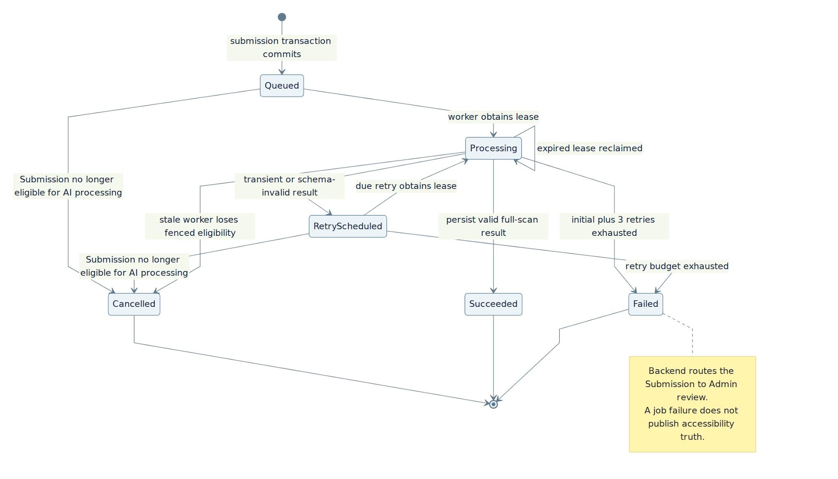
Figure — 4.2 AIProcessingJob lifecycle — WF1.
Editable Mermaid source
stateDiagram-v2
direction TB
[*] --> Queued: submission transaction commits
Queued --> Processing: worker obtains lease
Processing --> Succeeded: persist valid full-scan result
Processing --> RetryScheduled: transient or schema-invalid result
RetryScheduled --> Processing: due retry obtains lease
Processing --> Processing: expired lease reclaimed
Processing --> Failed: initial plus 3 retries exhausted
RetryScheduled --> Failed: retry budget exhausted
Queued --> Cancelled: Submission no longer eligible for AI processing
RetryScheduled --> Cancelled: Submission no longer eligible for AI processing
Processing --> Cancelled: stale worker loses fenced eligibility
Cancelled --> [*]
Succeeded --> [*]
Failed --> [*]
note right of Failed
Backend routes the Submission to Admin review.
A job failure does not publish accessibility truth.
end note

4.3 CommunityVote lifecycle — WF2
A stored observation does not automatically count. Eligibility checks subject/claim/version, independence and authoritative reputation. PendingValidation has zero applied weight until authorized validation/recovery. A newer observation supersedes the earlier effective candidate under the existing uniqueness guard; old published-version votes are archived.
Figure — 4.3 CommunityVote lifecycle — WF2.
Editable Mermaid source
stateDiagram-v2
direction TB
[*] --> Recorded: authenticated observation accepted
Recorded --> PendingValidation: low or unavailable authoritative reputation
Recorded --> Eligible: subject, version and eligibility checks pass
PendingValidation --> Eligible: authorized validation or recovery reevaluation
PendingValidation --> Rejected: authorized invalid or abusive finding
Recorded --> Superseded: newer same-user observation accepted
PendingValidation --> Superseded: newer same-user observation accepted
Eligible --> Superseded: newer same-user observation accepted
Eligible --> Archived: publication baseline replaced
Superseded --> [*]
Rejected --> [*]
Archived --> [*]

4.4 Feature dispute lifecycle — WF2
Admin decisions follow WF2 B.12.2. RequestEvidence, RetainBaseline and LinkCorrection are allowed from Open, UnderReview or AwaitingMoreInfo as specified there. Only confirmation of a linked Published WF1 correction permits ResolvedUpdated. A closed case remains immutable; a later material observation may create a separate case. Temporary advisories do not directly replace published truth.
Figure — 4.4 Feature dispute lifecycle — WF2.
Editable Mermaid source
stateDiagram-v2
direction TB
[*] --> Open: eligible conflict or evidenced serious concern
Open --> UnderReview: Admin claims case
Open --> AwaitingMoreInfo: Admin requests evidence
Open --> CorrectionPending: Admin links correction
Open --> ResolvedBaseline: Admin retains baseline with reason
UnderReview --> AwaitingMoreInfo: Admin requests evidence
AwaitingMoreInfo --> UnderReview: requested evidence arrives
AwaitingMoreInfo --> CorrectionPending: Admin links sufficient correction evidence
AwaitingMoreInfo --> ResolvedBaseline: Admin retains baseline with reason
UnderReview --> CorrectionPending: link WF-01 correction
CorrectionPending --> UnderReview: correction fails or requires renewed review
UnderReview --> ResolvedBaseline: retain published baseline with reason
CorrectionPending --> ResolvedUpdated: linked WF-01 publication confirmed
ResolvedBaseline --> [*]
ResolvedUpdated --> [*]

4.5 Inaccuracy report lifecycle — WF2
Transitions match the report contract, including owner supplements from AwaitingMoreInfo back to UnderReview. Every transition checks authorization, expectedVersion, compatible location/scope/targets and appends report history. Resolved requires a supported outcome; a pending correction alone is not CorrectionPublished.
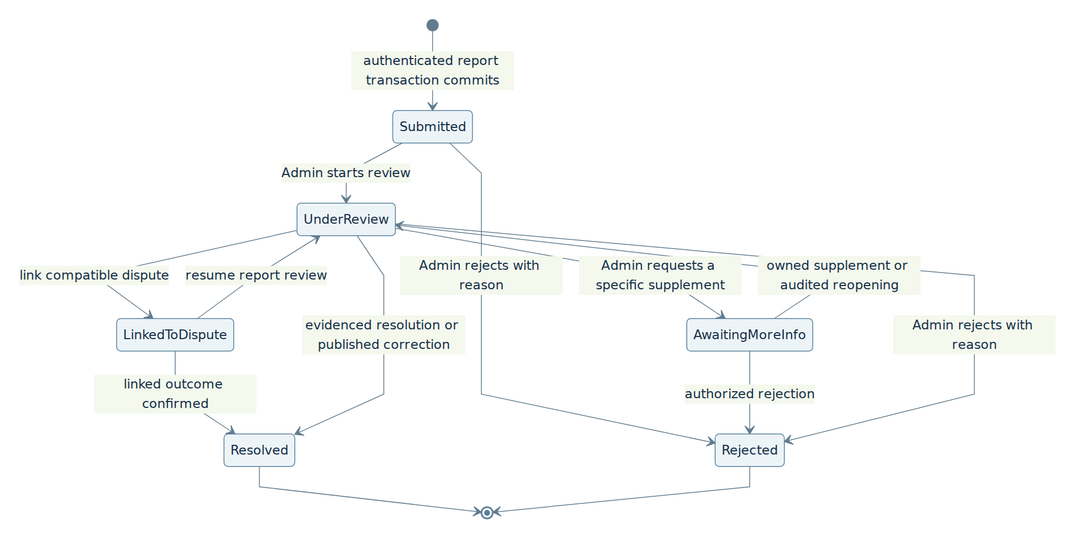
Figure — 4.5 Inaccuracy report lifecycle — WF2.
Editable Mermaid source
stateDiagram-v2
direction TB
[*] --> Submitted: authenticated report transaction commits
Submitted --> UnderReview: Admin starts review
Submitted --> Rejected: Admin rejects with reason
UnderReview --> AwaitingMoreInfo: Admin requests a specific supplement
AwaitingMoreInfo --> UnderReview: owned supplement or audited reopening
AwaitingMoreInfo --> Rejected: authorized rejection
UnderReview --> LinkedToDispute: link compatible dispute
LinkedToDispute --> UnderReview: resume report review
LinkedToDispute --> Resolved: linked outcome confirmed
UnderReview --> Resolved: evidenced resolution or published correction
UnderReview --> Rejected: Admin rejects with reason
Resolved --> [*]
Rejected --> [*]

4.6 Issued voucher lifecycle — WF4
The existing gated release supports Issued and Expired only. Issuance requires explicit confirmation plus atomic stock reservation and debit of eligible spendable lots. Failed validation produces no issued voucher/debit. Used, Cancelled and refunds remain disabled until externally verifiable use/revocation exists; this diagram does not enable them.
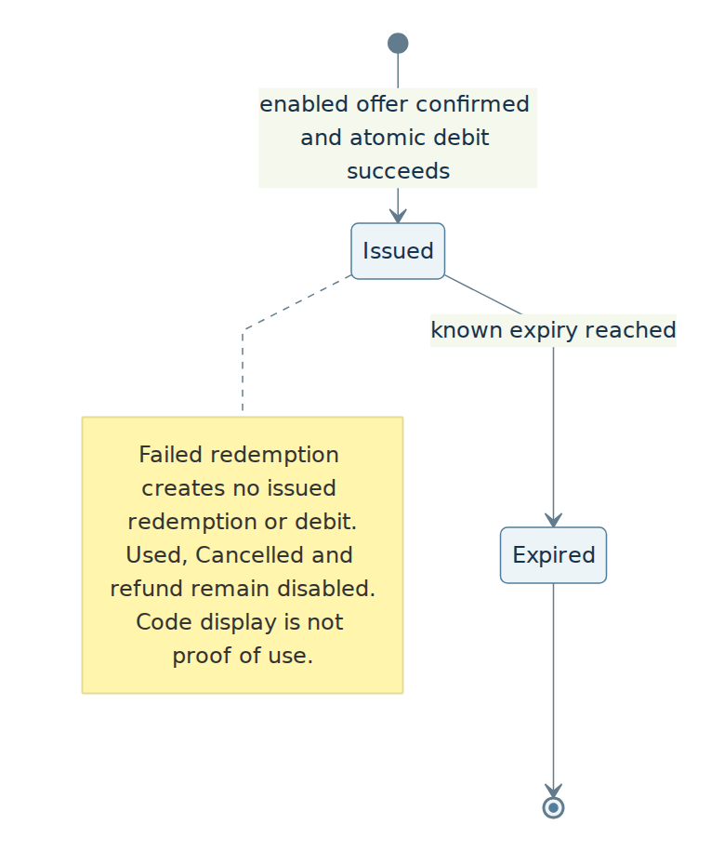
Figure — 4.6 Issued voucher lifecycle — WF4.
Editable Mermaid source
stateDiagram-v2
direction TB
[*] --> Issued: enabled offer confirmed and atomic debit succeeds
Issued --> Expired: known expiry reached
Expired --> [*]
note right of Issued
Failed redemption creates no issued redemption or debit.
Used, Cancelled and refund remain disabled.
Code display is not proof of use.
end note

4.7 Coverage report lifecycle — Admin Portal
The report aggregates one retained snapshot, then Admin reviews it. The first successful export marks Exported. SharedRecorded is an explicit manual handoff. Aggregation failure stays on CoverageJob and blocks generation/review/export; no invented Failed or Incomplete report state is introduced.
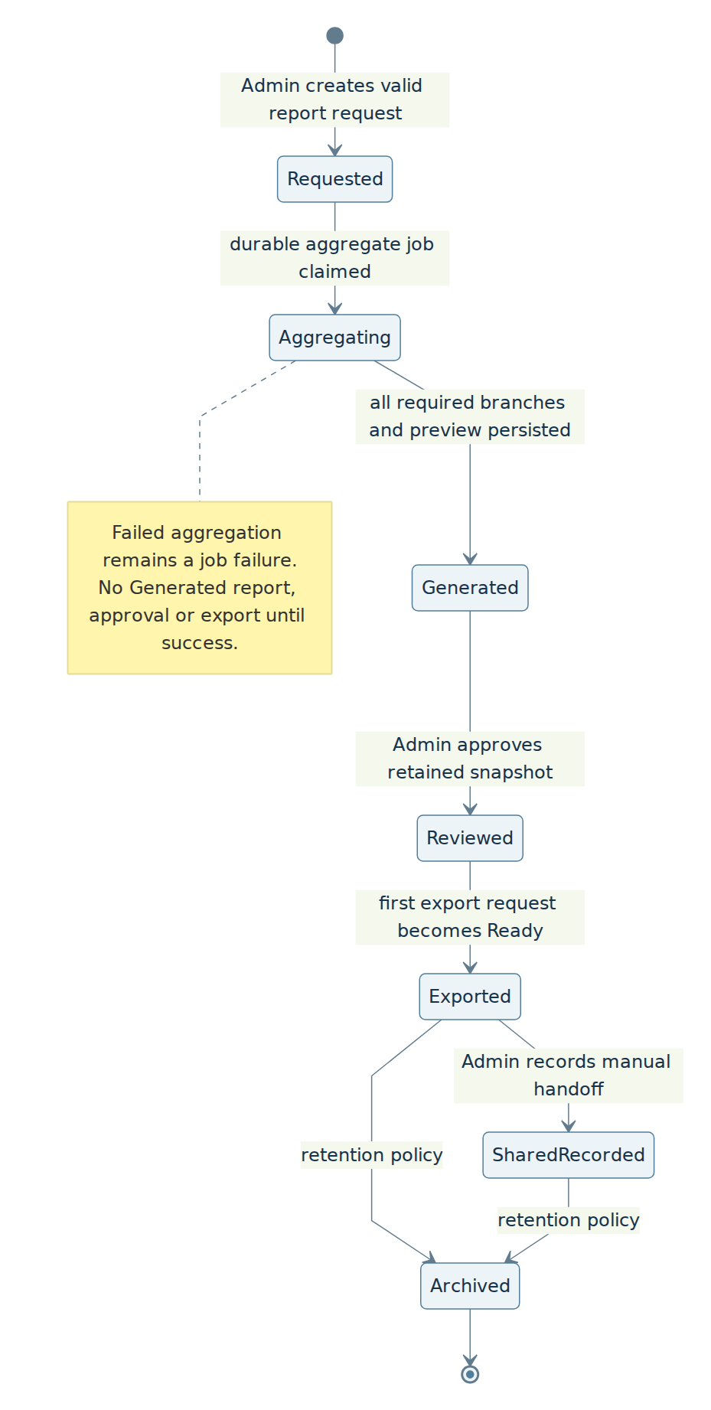
Figure — 4.7 Coverage report lifecycle — Admin Portal.
Editable Mermaid source
stateDiagram-v2
direction TB
[*] --> Requested: Admin creates valid report request
Requested --> Aggregating: durable aggregate job claimed
Aggregating --> Generated: all required branches and preview persisted
Generated --> Reviewed: Admin approves retained snapshot
Reviewed --> Exported: first export request becomes Ready
Exported --> SharedRecorded: Admin records manual handoff
Exported --> Archived: retention policy
SharedRecorded --> Archived: retention policy
Archived --> [*]
note right of Aggregating
Failed aggregation remains a job failure.
No Generated report, approval or export until success.
end note

4.8 Coverage export lifecycle — Admin Portal
Each requested file format has its own export request and retained report snapshot. Rendering is bounded/retryable. Ready commits its artifact and successful export audit. Terminal export failure preserves the approved report and all earlier successful artifacts.
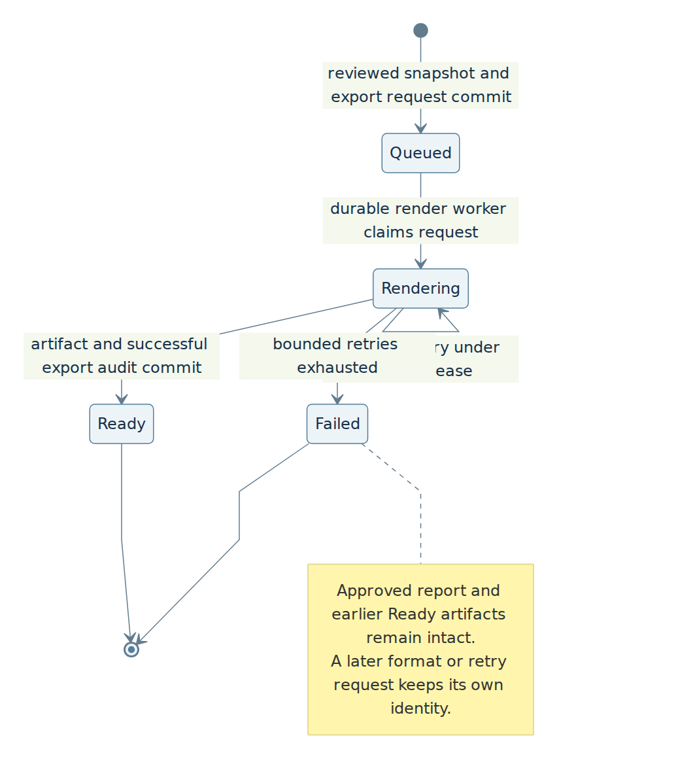
Figure — 4.8 Coverage export lifecycle — Admin Portal.
Editable Mermaid source
stateDiagram-v2
direction TB
[*] --> Queued: reviewed snapshot and export request commit
Queued --> Rendering: durable render worker claims request
Rendering --> Rendering: bounded retry under current lease
Rendering --> Ready: artifact and successful export audit commit
Rendering --> Failed: bounded retries exhausted
Ready --> [*]
Failed --> [*]
note right of Failed
Approved report and earlier Ready artifacts remain intact.
A later format or retry request keeps its own identity.
end note

5. Main ERD — names-only system view

5.1 One connected database — entity names and relationships
This overview contains the same 55 entities as the attribute view in section 6. It covers existing authentication, all four workflows and the Admin Portal in one connected model, not a separate database per workflow. Boxes intentionally omit attributes in this view. The existing USER/auth record has one authoritative Role (User or Admin); no custom ROLE or USER_ROLE table is required for these two account roles. SURROUNDING_OBSERVATION is the already-described optional sourced context, not a new requirement; proposed LocationVisualCache and device-local RecentPlace are not added as server tables.
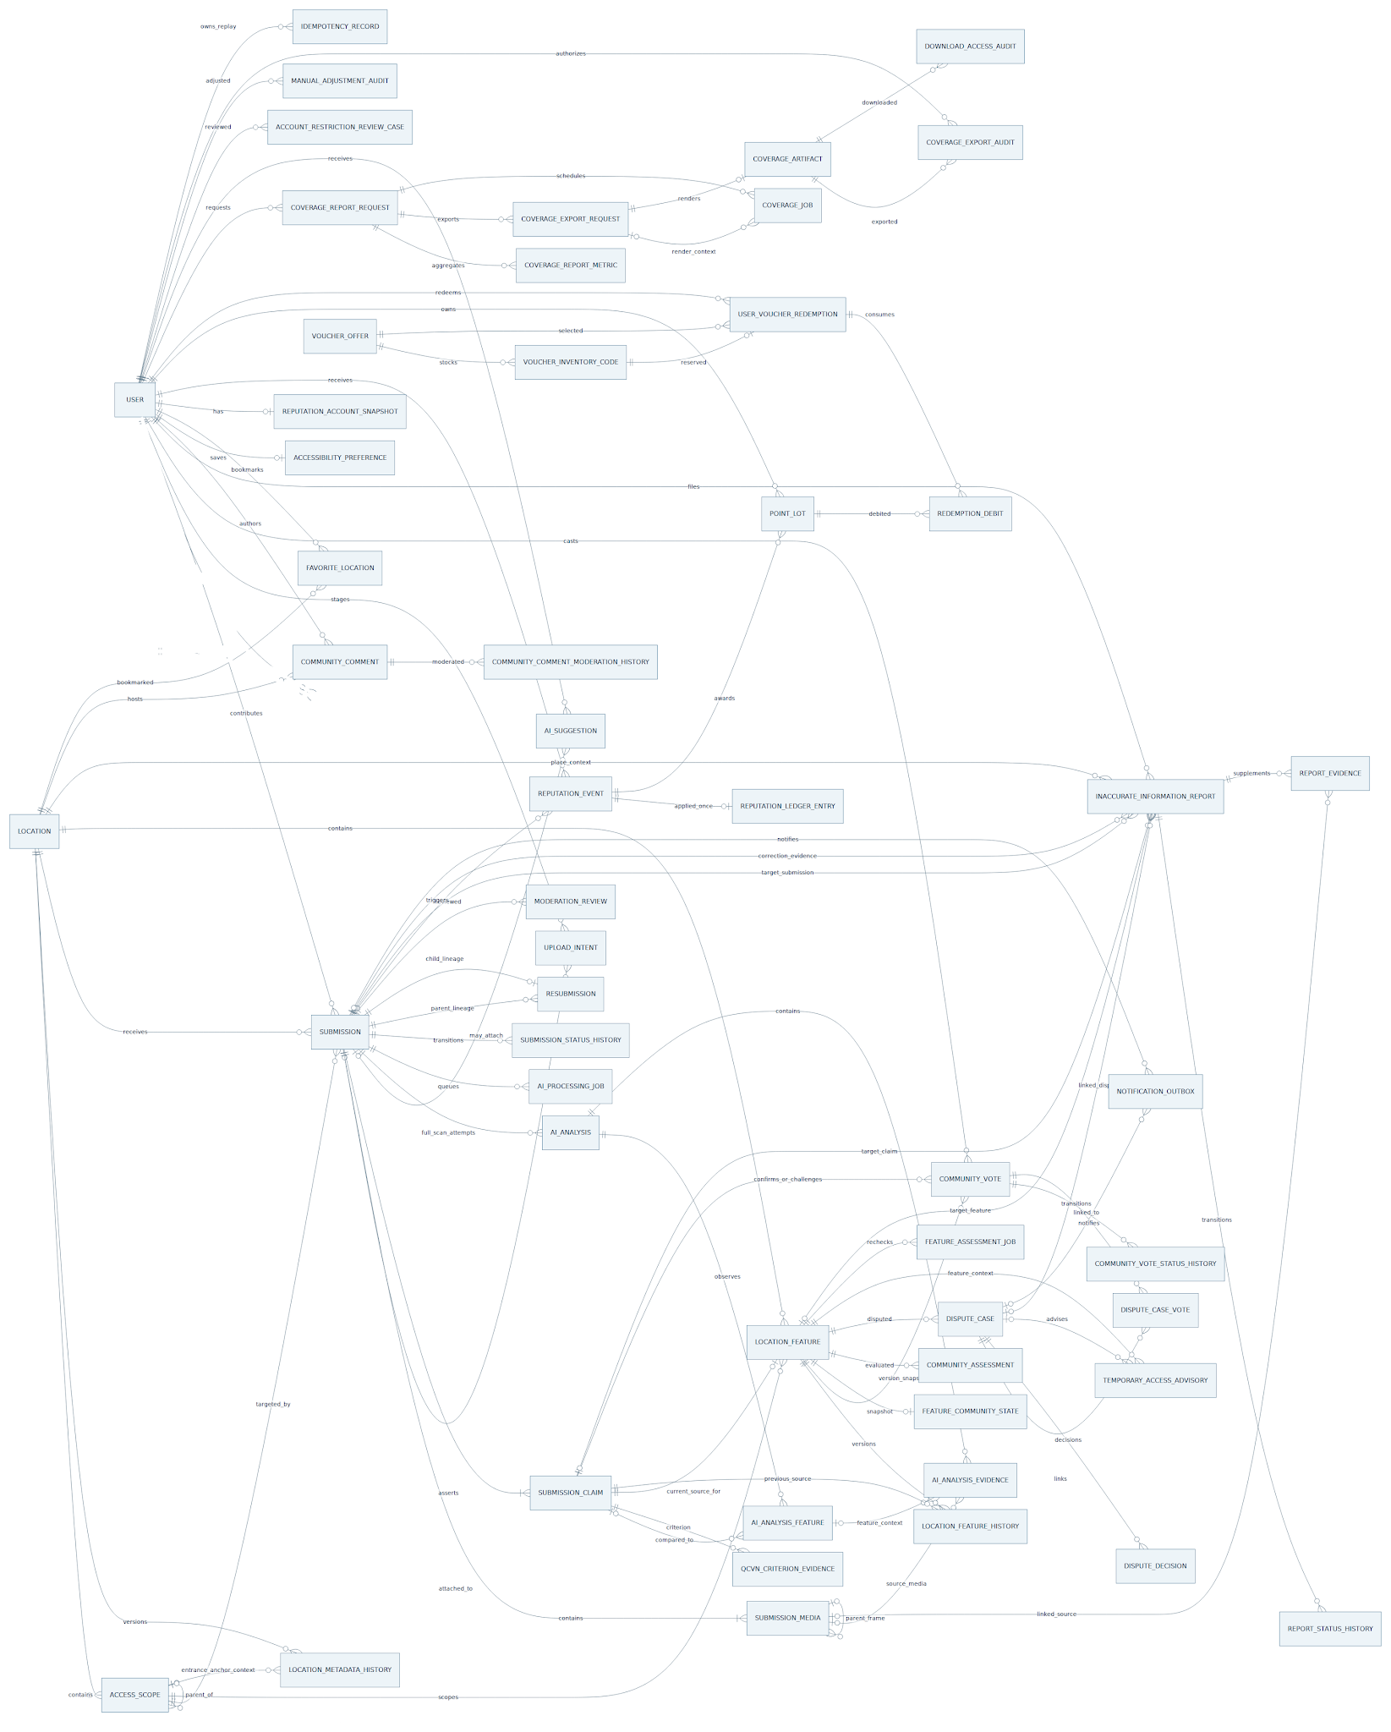
Figure — 5.1 One connected database — entity names and relationships.
Editable Mermaid source
erDiagram
direction LR
LOCATION o|--o{ LOCATION : MergedIntoLocationId
SUBMISSION o|--o{ LOCATION : OriginatingSubmissionId
USER ||--o{ SUBMISSION : ContributorId
LOCATION ||--o{ SUBMISSION : LocationId
SUBMISSION o|--o{ SUBMISSION : PreviousSubmissionId
SUBMISSION o|--o{ SUBMISSION : RootSubmissionId
ACCESS_SCOPE ||--o{ SUBMISSION : ScopeId
SUBMISSION ||--|{ SUBMISSION_MEDIA : SubmissionId
UPLOAD_INTENT o|--o| SUBMISSION_MEDIA : UploadIntentId
SUBMISSION_MEDIA o|--o{ SUBMISSION_MEDIA : ParentMediaId
USER ||--o{ UPLOAD_INTENT : ContributorId
SUBMISSION o|--o{ UPLOAD_INTENT : SubmissionId
SUBMISSION ||--|{ SUBMISSION_CLAIM : SubmissionId
SUBMISSION o|--o{ AI_SUGGESTION : SubmissionId
USER ||--o{ AI_SUGGESTION : ContributorId
SUBMISSION ||--o{ AI_ANALYSIS : SubmissionId
AI_ANALYSIS ||--o{ AI_ANALYSIS_FEATURE : AIAnalysisId
SUBMISSION_CLAIM o|--o{ AI_ANALYSIS_FEATURE : ComparedSubmissionClaimId
AI_ANALYSIS ||--o{ AI_ANALYSIS_EVIDENCE : AIAnalysisId
AI_ANALYSIS_FEATURE o|--o{ AI_ANALYSIS_EVIDENCE : AIAnalysisFeatureId
SUBMISSION_MEDIA o|--o{ AI_ANALYSIS_EVIDENCE : MediaId
SUBMISSION ||--o{ QCVN_CRITERION_EVIDENCE : SubmissionId
USER o|--o{ QCVN_CRITERION_EVIDENCE : AssessedBy
SUBMISSION ||--o{ AI_PROCESSING_JOB : SubmissionId
SUBMISSION ||--o{ SUBMISSION_STATUS_HISTORY : SubmissionId
USER o|--o{ SUBMISSION_STATUS_HISTORY : ChangedByUserId
SUBMISSION ||--o| RESUBMISSION : PreviousSubmissionId
SUBMISSION ||--o| RESUBMISSION : NewSubmissionId
USER o|--o{ RESUBMISSION : RequestedByUserId
SUBMISSION ||--o{ MODERATION_REVIEW : SubmissionId
USER ||--o{ MODERATION_REVIEW : AdminId
USER ||--o{ REPUTATION_EVENT : UserId
SUBMISSION ||--o| REPUTATION_EVENT : SubmissionId
LOCATION ||--o{ REPUTATION_EVENT : LocationId
LOCATION ||--o{ LOCATION_FEATURE : LocationId
SUBMISSION ||--o{ LOCATION_FEATURE : SourceSubmissionId
SUBMISSION_CLAIM ||--o| LOCATION_FEATURE : SourceClaimId
ACCESS_SCOPE ||--o{ LOCATION_FEATURE : ScopeId
LOCATION_FEATURE ||--o{ LOCATION_FEATURE_HISTORY : LocationFeatureId
LOCATION ||--o{ LOCATION_FEATURE_HISTORY : LocationId
SUBMISSION ||--o{ LOCATION_FEATURE_HISTORY : PreviousSourceSubmissionId
SUBMISSION_CLAIM ||--o{ LOCATION_FEATURE_HISTORY : PreviousSourceClaimId
ACCESS_SCOPE ||--o{ LOCATION_FEATURE_HISTORY : ScopeId
USER ||--o{ IDEMPOTENCY_RECORD : UserId
SUBMISSION o|--o{ IDEMPOTENCY_RECORD : SubmissionId
SUBMISSION o|--o{ NOTIFICATION_OUTBOX : SubmissionId
DISPUTE_CASE o|--o{ NOTIFICATION_OUTBOX : RelatedCaseId
USER ||--o{ NOTIFICATION_OUTBOX : RecipientUserId
LOCATION ||--o{ COMMUNITY_VOTE : LocationId
LOCATION_FEATURE ||--o{ COMMUNITY_VOTE : observed_publication_context
SUBMISSION_CLAIM ||--o{ COMMUNITY_VOTE : confirms_or_challenges
USER ||--o{ COMMUNITY_VOTE : VoterId
SUBMISSION o|--o{ COMMUNITY_VOTE : EvidenceSubmissionId
COMMUNITY_VOTE o|--o{ COMMUNITY_VOTE : SupersededByVoteId
USER o|--o{ COMMUNITY_VOTE : ReviewedById
COMMUNITY_VOTE ||--o{ COMMUNITY_VOTE_STATUS_HISTORY : CommunityVoteId
USER o|--o{ COMMUNITY_VOTE_STATUS_HISTORY : ChangedByUserId
LOCATION_FEATURE ||--o| FEATURE_COMMUNITY_STATE : LocationFeatureId
DISPUTE_CASE o|--o| FEATURE_COMMUNITY_STATE : CurrentDisputeCaseId
LOCATION_FEATURE ||--o{ COMMUNITY_ASSESSMENT : LocationFeatureId
DISPUTE_CASE o|--o{ COMMUNITY_ASSESSMENT : DisputeCaseId
LOCATION_FEATURE ||--o{ DISPUTE_CASE : LocationFeatureId
COMMUNITY_VOTE o|--o{ DISPUTE_CASE : OpenedByVoteId
SUBMISSION o|--o{ DISPUTE_CASE : LinkedCorrectionSubmissionId
DISPUTE_CASE ||--o{ DISPUTE_CASE_VOTE : DisputeCaseId
COMMUNITY_VOTE ||--o{ DISPUTE_CASE_VOTE : CommunityVoteId
DISPUTE_CASE ||--o{ DISPUTE_DECISION : DisputeCaseId
USER ||--o{ DISPUTE_DECISION : AdminId
SUBMISSION o|--o{ DISPUTE_DECISION : CorrectionSubmissionId
TEMPORARY_ACCESS_ADVISORY o|--o{ DISPUTE_DECISION : AdvisoryId
LOCATION_FEATURE ||--o{ TEMPORARY_ACCESS_ADVISORY : LocationFeatureId
USER ||--o{ TEMPORARY_ACCESS_ADVISORY : CreatedByAdminId
DISPUTE_CASE o|--o{ TEMPORARY_ACCESS_ADVISORY : DisputeCaseId
LOCATION_FEATURE ||--o{ FEATURE_ASSESSMENT_JOB : LocationFeatureId
LOCATION ||--o{ ACCESS_SCOPE : LocationId
ACCESS_SCOPE o|--o{ ACCESS_SCOPE : ParentScopeId
LOCATION ||--o{ INACCURATE_INFORMATION_REPORT : LocationId
ACCESS_SCOPE o|--o{ INACCURATE_INFORMATION_REPORT : ScopeId
LOCATION_FEATURE o|--o{ INACCURATE_INFORMATION_REPORT : LocationFeatureId
SUBMISSION o|--o{ INACCURATE_INFORMATION_REPORT : TargetSubmissionId
SUBMISSION_CLAIM o|--o{ INACCURATE_INFORMATION_REPORT : TargetSubmissionClaimId
USER ||--o{ INACCURATE_INFORMATION_REPORT : ReporterId
DISPUTE_CASE o|--o{ INACCURATE_INFORMATION_REPORT : LinkedDisputeCaseId
SUBMISSION o|--o{ INACCURATE_INFORMATION_REPORT : LinkedSubmissionId
INACCURATE_INFORMATION_REPORT ||--o{ REPORT_STATUS_HISTORY : ReportId
USER ||--o{ REPORT_STATUS_HISTORY : ActorId
INACCURATE_INFORMATION_REPORT ||--o{ REPORT_EVIDENCE : ReportId
USER ||--o{ REPORT_EVIDENCE : AddedByReporterId
SUBMISSION_MEDIA o|--o{ REPORT_EVIDENCE : OwnedMediaId
LOCATION ||--o{ LOCATION_METADATA_HISTORY : LocationId
ACCESS_SCOPE o|--o{ LOCATION_METADATA_HISTORY : ScopeId
INACCURATE_INFORMATION_REPORT o|--o{ LOCATION_METADATA_HISTORY : ReportId
USER ||--o{ LOCATION_METADATA_HISTORY : AdminId
LOCATION ||--o{ COMMUNITY_COMMENT : LocationId
ACCESS_SCOPE o|--o{ COMMUNITY_COMMENT : ScopeId
USER ||--o{ COMMUNITY_COMMENT : AuthorId
COMMUNITY_COMMENT ||--o{ COMMUNITY_COMMENT_MODERATION_HISTORY : CommentId
USER ||--o{ COMMUNITY_COMMENT_MODERATION_HISTORY : AdminId
USER ||--o| ACCESSIBILITY_PREFERENCE : UserId
USER ||--o{ FAVORITE_LOCATION : UserId
LOCATION ||--o{ FAVORITE_LOCATION : LocationId
LOCATION ||--o{ SURROUNDING_OBSERVATION : LocationId
SUBMISSION_MEDIA o|--o{ SURROUNDING_OBSERVATION : MediaId
USER ||--o{ REPUTATION_LEDGER_ENTRY : UserId
REPUTATION_EVENT o|--o| REPUTATION_LEDGER_ENTRY : SourceEventId
USER ||--o| REPUTATION_ACCOUNT_SNAPSHOT : UserId
USER ||--o{ POINT_LOT : UserId
REPUTATION_EVENT ||--o| POINT_LOT : SourceEventId
VOUCHER_OFFER ||--o{ VOUCHER_INVENTORY_CODE : OfferId
USER ||--o{ USER_VOUCHER_REDEMPTION : UserId
VOUCHER_OFFER ||--o{ USER_VOUCHER_REDEMPTION : OfferId
VOUCHER_INVENTORY_CODE ||--o| USER_VOUCHER_REDEMPTION : InventoryCodeId
USER_VOUCHER_REDEMPTION ||--o{ REDEMPTION_DEBIT : RedemptionId
POINT_LOT ||--o{ REDEMPTION_DEBIT : PointLotId
USER ||--o{ ACCOUNT_RESTRICTION_REVIEW_CASE : UserId
USER ||--o{ MANUAL_ADJUSTMENT_AUDIT : UserId
USER ||--o{ MANUAL_ADJUSTMENT_AUDIT : ActorId
USER ||--o{ COVERAGE_REPORT_REQUEST : RequestedBy
COVERAGE_REPORT_REQUEST ||--o{ COVERAGE_REPORT_METRIC : ReportId
COVERAGE_REPORT_REQUEST ||--o{ COVERAGE_EXPORT_REQUEST : ReportId
USER ||--o{ COVERAGE_EXPORT_REQUEST : RequestedBy
COVERAGE_REPORT_REQUEST ||--o{ COVERAGE_ARTIFACT : ReportId
COVERAGE_EXPORT_REQUEST ||--o| COVERAGE_ARTIFACT : ExportRequestId
COVERAGE_EXPORT_REQUEST ||--o| COVERAGE_EXPORT_AUDIT : ExportRequestId
COVERAGE_REPORT_REQUEST ||--o{ COVERAGE_EXPORT_AUDIT : ReportId
COVERAGE_ARTIFACT ||--o{ COVERAGE_EXPORT_AUDIT : ArtifactId
USER ||--o{ COVERAGE_EXPORT_AUDIT : AdminId
COVERAGE_ARTIFACT ||--o{ DOWNLOAD_ACCESS_AUDIT : ArtifactId
USER ||--o{ DOWNLOAD_ACCESS_AUDIT : AdminId
COVERAGE_REPORT_REQUEST ||--o{ COVERAGE_JOB : ReportId
COVERAGE_EXPORT_REQUEST o|--o{ COVERAGE_JOB : ExportRequestId

Vote target: COMMUNITY_VOTE.TargetSubmissionClaimId is a required FK to the published SubmissionClaim; its LocationFeatureId and ObservedFeatureVersion only identify the observed publication context. Claim–current-feature cardinality is one claim to zero/one current feature, and exactly one current source claim per feature. Other claims can support/challenge that scoped feature through historical consensus and votes; no arbitrary ClaimFeatureLink M:N is introduced.
Report target: LocationId supplies required place context. Optional TargetSubmissionId and TargetSubmissionClaimId identify challenged publication evidence; LinkedSubmissionId independently identifies correction evidence. Feature/version and all supplied references must agree on Location and ScopeId. A place-only report has no fabricated claim target.
Reward ownership: ReputationEvent records one publication source, not an unconditional credit. WF-04 applies eligible events once to separate trust and spendable balances under its anti-repeat guard. User owns PointLots and ReputationAccountSnapshot. PointLot.SourceEventId is unique for publication awards; RedemptionDebit consumes eligible lots through UserVoucherRedemption. ReputationAccountSnapshot is a rebuildable trust/tier projection, not a spendable balance. Redemption never reduces trust.

6. Full logical ERD — attributes and keys

6.1 One connected database — documented attributes and keys
This is the same connected 55-entity model, expanded with documented attributes, PK/FK markings and nullable indicators. Field widths, exact PostgreSQL types, constraints and migrations remain owned by the existing workflow schema tables and schema-extension prose. For entities currently specified in prose rather than a physical schema table, the figure uses their documented logical data items; it does not silently approve new physical columns. Reuse the existing User/auth implementation with one authoritative Role. The full canvas is large: use the editable Mermaid below for close inspection; the embedded figure is a whole-system overview.
Figure — 6.1 One connected database — documented attributes and keys.
Editable Mermaid source
erDiagram
direction LR
LOCATION o|--o{ LOCATION : MergedIntoLocationId
SUBMISSION o|--o{ LOCATION : OriginatingSubmissionId
USER ||--o{ SUBMISSION : ContributorId
LOCATION ||--o{ SUBMISSION : LocationId
SUBMISSION o|--o{ SUBMISSION : PreviousSubmissionId
SUBMISSION o|--o{ SUBMISSION : RootSubmissionId
ACCESS_SCOPE ||--o{ SUBMISSION : ScopeId
SUBMISSION ||--|{ SUBMISSION_MEDIA : SubmissionId
UPLOAD_INTENT o|--o| SUBMISSION_MEDIA : UploadIntentId
SUBMISSION_MEDIA o|--o{ SUBMISSION_MEDIA : ParentMediaId
USER ||--o{ UPLOAD_INTENT : ContributorId
SUBMISSION o|--o{ UPLOAD_INTENT : SubmissionId
SUBMISSION ||--|{ SUBMISSION_CLAIM : SubmissionId
SUBMISSION o|--o{ AI_SUGGESTION : SubmissionId
USER ||--o{ AI_SUGGESTION : ContributorId
SUBMISSION ||--o{ AI_ANALYSIS : SubmissionId
AI_ANALYSIS ||--o{ AI_ANALYSIS_FEATURE : AIAnalysisId
SUBMISSION_CLAIM o|--o{ AI_ANALYSIS_FEATURE : ComparedSubmissionClaimId
AI_ANALYSIS ||--o{ AI_ANALYSIS_EVIDENCE : AIAnalysisId
AI_ANALYSIS_FEATURE o|--o{ AI_ANALYSIS_EVIDENCE : AIAnalysisFeatureId
SUBMISSION_MEDIA o|--o{ AI_ANALYSIS_EVIDENCE : MediaId
SUBMISSION ||--o{ QCVN_CRITERION_EVIDENCE : SubmissionId
USER o|--o{ QCVN_CRITERION_EVIDENCE : AssessedBy
SUBMISSION ||--o{ AI_PROCESSING_JOB : SubmissionId
SUBMISSION ||--o{ SUBMISSION_STATUS_HISTORY : SubmissionId
USER o|--o{ SUBMISSION_STATUS_HISTORY : ChangedByUserId
SUBMISSION ||--o| RESUBMISSION : PreviousSubmissionId
SUBMISSION ||--o| RESUBMISSION : NewSubmissionId
USER o|--o{ RESUBMISSION : RequestedByUserId
SUBMISSION ||--o{ MODERATION_REVIEW : SubmissionId
USER ||--o{ MODERATION_REVIEW : AdminId
USER ||--o{ REPUTATION_EVENT : UserId
SUBMISSION ||--o| REPUTATION_EVENT : SubmissionId
LOCATION ||--o{ REPUTATION_EVENT : LocationId
LOCATION ||--o{ LOCATION_FEATURE : LocationId
SUBMISSION ||--o{ LOCATION_FEATURE : SourceSubmissionId
SUBMISSION_CLAIM ||--o| LOCATION_FEATURE : SourceClaimId
ACCESS_SCOPE ||--o{ LOCATION_FEATURE : ScopeId
LOCATION_FEATURE ||--o{ LOCATION_FEATURE_HISTORY : LocationFeatureId
LOCATION ||--o{ LOCATION_FEATURE_HISTORY : LocationId
SUBMISSION ||--o{ LOCATION_FEATURE_HISTORY : PreviousSourceSubmissionId
SUBMISSION_CLAIM ||--o{ LOCATION_FEATURE_HISTORY : PreviousSourceClaimId
ACCESS_SCOPE ||--o{ LOCATION_FEATURE_HISTORY : ScopeId
USER ||--o{ IDEMPOTENCY_RECORD : UserId
SUBMISSION o|--o{ IDEMPOTENCY_RECORD : SubmissionId
SUBMISSION o|--o{ NOTIFICATION_OUTBOX : SubmissionId
DISPUTE_CASE o|--o{ NOTIFICATION_OUTBOX : RelatedCaseId
USER ||--o{ NOTIFICATION_OUTBOX : RecipientUserId
LOCATION ||--o{ COMMUNITY_VOTE : LocationId
LOCATION_FEATURE ||--o{ COMMUNITY_VOTE : observed_publication_context
SUBMISSION_CLAIM ||--o{ COMMUNITY_VOTE : confirms_or_challenges
USER ||--o{ COMMUNITY_VOTE : VoterId
SUBMISSION o|--o{ COMMUNITY_VOTE : EvidenceSubmissionId
COMMUNITY_VOTE o|--o{ COMMUNITY_VOTE : SupersededByVoteId
USER o|--o{ COMMUNITY_VOTE : ReviewedById
COMMUNITY_VOTE ||--o{ COMMUNITY_VOTE_STATUS_HISTORY : CommunityVoteId
USER o|--o{ COMMUNITY_VOTE_STATUS_HISTORY : ChangedByUserId
LOCATION_FEATURE ||--o| FEATURE_COMMUNITY_STATE : LocationFeatureId
DISPUTE_CASE o|--o| FEATURE_COMMUNITY_STATE : CurrentDisputeCaseId
LOCATION_FEATURE ||--o{ COMMUNITY_ASSESSMENT : LocationFeatureId
DISPUTE_CASE o|--o{ COMMUNITY_ASSESSMENT : DisputeCaseId
LOCATION_FEATURE ||--o{ DISPUTE_CASE : LocationFeatureId
COMMUNITY_VOTE o|--o{ DISPUTE_CASE : OpenedByVoteId
SUBMISSION o|--o{ DISPUTE_CASE : LinkedCorrectionSubmissionId
DISPUTE_CASE ||--o{ DISPUTE_CASE_VOTE : DisputeCaseId
COMMUNITY_VOTE ||--o{ DISPUTE_CASE_VOTE : CommunityVoteId
DISPUTE_CASE ||--o{ DISPUTE_DECISION : DisputeCaseId
USER ||--o{ DISPUTE_DECISION : AdminId
SUBMISSION o|--o{ DISPUTE_DECISION : CorrectionSubmissionId
TEMPORARY_ACCESS_ADVISORY o|--o{ DISPUTE_DECISION : AdvisoryId
LOCATION_FEATURE ||--o{ TEMPORARY_ACCESS_ADVISORY : LocationFeatureId
USER ||--o{ TEMPORARY_ACCESS_ADVISORY : CreatedByAdminId
DISPUTE_CASE o|--o{ TEMPORARY_ACCESS_ADVISORY : DisputeCaseId
LOCATION_FEATURE ||--o{ FEATURE_ASSESSMENT_JOB : LocationFeatureId
LOCATION ||--o{ ACCESS_SCOPE : LocationId
ACCESS_SCOPE o|--o{ ACCESS_SCOPE : ParentScopeId
LOCATION ||--o{ INACCURATE_INFORMATION_REPORT : LocationId
ACCESS_SCOPE o|--o{ INACCURATE_INFORMATION_REPORT : ScopeId
LOCATION_FEATURE o|--o{ INACCURATE_INFORMATION_REPORT : LocationFeatureId
SUBMISSION o|--o{ INACCURATE_INFORMATION_REPORT : TargetSubmissionId
SUBMISSION_CLAIM o|--o{ INACCURATE_INFORMATION_REPORT : TargetSubmissionClaimId
USER ||--o{ INACCURATE_INFORMATION_REPORT : ReporterId
DISPUTE_CASE o|--o{ INACCURATE_INFORMATION_REPORT : LinkedDisputeCaseId
SUBMISSION o|--o{ INACCURATE_INFORMATION_REPORT : LinkedSubmissionId
INACCURATE_INFORMATION_REPORT ||--o{ REPORT_STATUS_HISTORY : ReportId
USER ||--o{ REPORT_STATUS_HISTORY : ActorId
INACCURATE_INFORMATION_REPORT ||--o{ REPORT_EVIDENCE : ReportId
USER ||--o{ REPORT_EVIDENCE : AddedByReporterId
SUBMISSION_MEDIA o|--o{ REPORT_EVIDENCE : OwnedMediaId
LOCATION ||--o{ LOCATION_METADATA_HISTORY : LocationId
ACCESS_SCOPE o|--o{ LOCATION_METADATA_HISTORY : ScopeId
INACCURATE_INFORMATION_REPORT o|--o{ LOCATION_METADATA_HISTORY : ReportId
USER ||--o{ LOCATION_METADATA_HISTORY : AdminId
LOCATION ||--o{ COMMUNITY_COMMENT : LocationId
ACCESS_SCOPE o|--o{ COMMUNITY_COMMENT : ScopeId
USER ||--o{ COMMUNITY_COMMENT : AuthorId
COMMUNITY_COMMENT ||--o{ COMMUNITY_COMMENT_MODERATION_HISTORY : CommentId
USER ||--o{ COMMUNITY_COMMENT_MODERATION_HISTORY : AdminId
USER ||--o| ACCESSIBILITY_PREFERENCE : UserId
USER ||--o{ FAVORITE_LOCATION : UserId
LOCATION ||--o{ FAVORITE_LOCATION : LocationId
LOCATION ||--o{ SURROUNDING_OBSERVATION : LocationId
SUBMISSION_MEDIA o|--o{ SURROUNDING_OBSERVATION : MediaId
USER ||--o{ REPUTATION_LEDGER_ENTRY : UserId
REPUTATION_EVENT o|--o| REPUTATION_LEDGER_ENTRY : SourceEventId
USER ||--o| REPUTATION_ACCOUNT_SNAPSHOT : UserId
USER ||--o{ POINT_LOT : UserId
REPUTATION_EVENT ||--o| POINT_LOT : SourceEventId
VOUCHER_OFFER ||--o{ VOUCHER_INVENTORY_CODE : OfferId
USER ||--o{ USER_VOUCHER_REDEMPTION : UserId
VOUCHER_OFFER ||--o{ USER_VOUCHER_REDEMPTION : OfferId
VOUCHER_INVENTORY_CODE ||--o| USER_VOUCHER_REDEMPTION : InventoryCodeId
USER_VOUCHER_REDEMPTION ||--o{ REDEMPTION_DEBIT : RedemptionId
POINT_LOT ||--o{ REDEMPTION_DEBIT : PointLotId
USER ||--o{ ACCOUNT_RESTRICTION_REVIEW_CASE : UserId
USER ||--o{ MANUAL_ADJUSTMENT_AUDIT : UserId
USER ||--o{ MANUAL_ADJUSTMENT_AUDIT : ActorId
USER ||--o{ COVERAGE_REPORT_REQUEST : RequestedBy
COVERAGE_REPORT_REQUEST ||--o{ COVERAGE_REPORT_METRIC : ReportId
COVERAGE_REPORT_REQUEST ||--o{ COVERAGE_EXPORT_REQUEST : ReportId
USER ||--o{ COVERAGE_EXPORT_REQUEST : RequestedBy
COVERAGE_REPORT_REQUEST ||--o{ COVERAGE_ARTIFACT : ReportId
COVERAGE_EXPORT_REQUEST ||--o| COVERAGE_ARTIFACT : ExportRequestId
COVERAGE_EXPORT_REQUEST ||--o| COVERAGE_EXPORT_AUDIT : ExportRequestId
COVERAGE_REPORT_REQUEST ||--o{ COVERAGE_EXPORT_AUDIT : ReportId
COVERAGE_ARTIFACT ||--o{ COVERAGE_EXPORT_AUDIT : ArtifactId
USER ||--o{ COVERAGE_EXPORT_AUDIT : AdminId
COVERAGE_ARTIFACT ||--o{ DOWNLOAD_ACCESS_AUDIT : ArtifactId
USER ||--o{ DOWNLOAD_ACCESS_AUDIT : AdminId
COVERAGE_REPORT_REQUEST ||--o{ COVERAGE_JOB : ReportId
COVERAGE_EXPORT_REQUEST o|--o{ COVERAGE_JOB : ExportRequestId
ACCESSIBILITY_PREFERENCE {
uuid UserId PK,FK
enum Profile
jsonb DefaultRequiredFeatures
jsonb DefaultPreferredFeatures
timestamptz ConsentedAt
timestamptz UpdatedAt
int Version
}
ACCESS_SCOPE {
uuid Id PK
uuid LocationId FK
uuid ParentScopeId FK "nullable"
enum Kind
string Label
int FloorNumber "nullable"
geography Position "nullable"
enum PositionStatus
int PositionVersion
enum CoverageStatus
timestamptz CreatedAt
timestamptz UpdatedAt
}
ACCOUNT_RESTRICTION_REVIEW_CASE {
uuid Id PK
uuid UserId FK
string Reason
enum Status
timestamptz ExpiresAt "nullable"
}
AI_ANALYSIS {
uuid Id PK
uuid SubmissionId FK
int Status
numeric OverallConfidence "nullable"
string ModelVersion "nullable"
string ProviderName "nullable"
jsonb RawResultJson "nullable"
timestamptz StartedAt
timestamptz CompletedAt "nullable"
string ErrorCode "nullable"
text ErrorMessage "nullable"
int AttemptNumber
jsonb FullScanAuthenticity "nullable"
}
AI_ANALYSIS_EVIDENCE {
uuid Id PK
uuid AIAnalysisId FK
uuid AIAnalysisFeatureId FK "nullable"
int FeatureType "nullable"
string EvidenceType
text Description
uuid MediaId FK "nullable"
timestamptz CreatedAt
}
AI_ANALYSIS_FEATURE {
uuid Id PK
uuid AIAnalysisId FK
uuid ComparedSubmissionClaimId FK "nullable"
int FeatureType
int Result
numeric ModelConfidence
numeric CvScore "nullable"
numeric NlpScore "nullable"
numeric AiConfidence
numeric ConsensusRatio
numeric CommunityConfidence
boolean HasCommunityEvidence
numeric ContributorFactor
int DistinctContributorCount
numeric WeightedAgree
numeric WeightedTotal
jsonb CommunityInputSnapshot "nullable"
numeric FinalConfidence
text Explanation "nullable"
timestamptz CreatedAt
}
AI_PROCESSING_JOB {
uuid Id PK
uuid SubmissionId FK
int Status
int AttemptCount
timestamptz NextRetryAt "nullable"
timestamptz LockedUntil "nullable"
string LockedByWorkerId "nullable"
string ErrorCategory "nullable"
text ErrorMessage "nullable"
timestamptz CreatedAt
timestamptz StartedAt "nullable"
timestamptz CompletedAt "nullable"
}
AI_SUGGESTION {
uuid Id PK
uuid SubmissionId FK "nullable"
uuid ContributorId FK
uuid CorrelationId
int FeatureType
int SuggestedState
numeric Confidence
string Reason "nullable"
string ModelVersion "nullable"
timestamptz CreatedAt
}
COMMUNITY_ASSESSMENT {
uuid Id PK
uuid EvaluationRequestId
uuid LocationFeatureId FK
uuid DisputeCaseId FK "nullable"
int FeatureVersion
timestamptz AsOfAt
numeric AgreeWeight
numeric TotalWeight
numeric WeightedAgreement "nullable"
int DistinctEligibleVoters
int DistinctHighTierVoters
numeric FreshnessFactor
jsonb InputsJson
string PolicyVersion
string ReasonCode
timestamptz CreatedAt
}
COMMUNITY_COMMENT {
uuid Id PK
uuid LocationId FK
uuid ScopeId FK "nullable"
uuid AuthorId FK
string Body
enum ModerationStatus
timestamptz CreatedAt
timestamptz ApprovedAt "nullable"
int Version
}
COMMUNITY_COMMENT_MODERATION_HISTORY {
uuid Id PK
uuid CommentId FK
enum FromStatus
enum ToStatus
uuid AdminId FK
string Reason
timestamptz OccurredAt
int CommentVersion
}
COMMUNITY_VOTE {
uuid Id PK
uuid LocationId FK
uuid LocationFeatureId FK
uuid TargetSubmissionClaimId FK
int FeatureType
int ObservedFeatureVersion
uuid VoterId FK
int VoteType
int ProposedStatus "nullable"
string Comment "nullable"
uuid EvidenceSubmissionId FK "nullable"
int Status
uuid SupersededByVoteId FK "nullable"
timestamptz CapturedAt "nullable"
timestamptz CreatedAt
uuid ReviewedById FK "nullable"
timestamptz ReviewedAt "nullable"
text ReviewReason "nullable"
}
COMMUNITY_VOTE_STATUS_HISTORY {
uuid Id PK
uuid CommunityVoteId FK
int FromStatus "nullable"
int ToStatus
string Actor
uuid ChangedByUserId FK "nullable"
string ReasonCode "nullable"
timestamptz CreatedAt
}
COVERAGE_ARTIFACT {
uuid Id PK
uuid ReportId FK
uuid ExportRequestId FK
enum Format
string PrivateObjectKey
string Sha256
int Size
timestamptz CreatedAt
timestamptz RetentionUntil
}
COVERAGE_EXPORT_AUDIT {
uuid ExportRequestId PK,FK
uuid ReportId FK
uuid ArtifactId FK
uuid AdminId FK
timestamptz ExportedAt
string Purpose
string FileHash
}
COVERAGE_EXPORT_REQUEST {
uuid Id PK
uuid ReportId FK
uuid RequestedBy FK
enum Format
string Purpose
string IdempotencyKey
string RequestHash
timestamptz SnapshotAt
string PolicyVersion
enum Status
timestamptz CreatedAt
timestamptz CompletedAt "nullable"
string FailureCode "nullable"
token xmin
}
COVERAGE_JOB {
uuid Id PK
enum Kind
uuid ReportId FK
uuid ExportRequestId FK "nullable"
enum Status
int AttemptCount
timestamptz LockedUntil "nullable"
timestamptz NextRetryAt "nullable"
string FailureCode "nullable"
}
COVERAGE_REPORT_METRIC {
uuid ReportId PK,FK
string RegionId PK
string MetricKey PK
numeric Numerator
numeric Denominator "nullable"
int SampleSize
numeric ValueNullable "nullable"
jsonb WarningFlags
enum BranchStatus
}
COVERAGE_REPORT_REQUEST {
uuid Id PK
uuid RequestedBy FK
timestamptz CreatedAt
string RegionId
string BoundaryVersion
timestamptz From "nullable"
timestamptz To "nullable"
enum TimeMode
jsonb FeatureFilter
enum Status
string PolicyVersion
string ParametersHash
timestamptz SnapshotAt "nullable until snapshot"
jsonb RetainedPreviewInputs "nullable until preview"
string Purpose
token xmin
}
DISPUTE_CASE {
uuid Id PK
uuid LocationFeatureId FK
int FeatureVersion
int BaselineStatus
int Status
string ReasonCode
uuid OpenedByVoteId FK "nullable"
uuid LinkedCorrectionSubmissionId FK "nullable"
timestamptz OpenedAt
timestamptz UpdatedAt
timestamptz ResolvedAt "nullable"
token xmin
}
DISPUTE_CASE_VOTE {
uuid Id PK
uuid DisputeCaseId FK
uuid CommunityVoteId FK
timestamptz LinkedAt
}
DISPUTE_DECISION {
uuid Id PK
uuid DisputeCaseId FK
uuid AdminId FK
int Type
text Reason
uuid CorrectionSubmissionId FK "nullable"
uuid AdvisoryId FK "nullable"
timestamptz CreatedAt
}
DOWNLOAD_ACCESS_AUDIT {
uuid ArtifactId PK,FK
uuid AdminId PK,FK
timestamptz AccessedAt PK
}
FAVORITE_LOCATION {
uuid UserId PK,FK
uuid LocationId PK,FK
timestamptz CreatedAt
}
FEATURE_ASSESSMENT_JOB {
uuid Id PK
uuid LocationFeatureId FK
int FeatureVersion
int Status
int AttemptCount
int RequestedRevision
timestamptz NextRetryAt "nullable"
timestamptz LockedUntil "nullable"
string LockedByWorkerId "nullable"
timestamptz RequestedAt
timestamptz CompletedAt "nullable"
string LastErrorCode "nullable"
}
FEATURE_COMMUNITY_STATE {
uuid Id PK
uuid LocationFeatureId FK
int FeatureVersion
int Label
timestamptz LastTrustedReconfirmedAt "nullable"
timestamptz FreshnessOriginAt
numeric FreshnessFactor
numeric WeightedAgreement "nullable"
int DistinctEligibleVoters
uuid CurrentDisputeCaseId FK "nullable"
string PolicyVersion
timestamptz EvaluatedAt
timestamptz UpdatedAt
token xmin
}
IDEMPOTENCY_RECORD {
uuid Id PK
uuid UserId FK
string Endpoint
string Key
string RequestHash
int ResponseStatusCode
jsonb ResponseBodyJson
uuid SubmissionId FK "nullable"
timestamptz CreatedAt
timestamptz ExpiresAt
}
INACCURATE_INFORMATION_REPORT {
uuid Id PK
uuid LocationId FK
uuid ScopeId FK "nullable"
uuid LocationFeatureId FK "nullable"
int ObservedFeatureVersion "nullable"
enum FeatureType "nullable"
uuid TargetSubmissionId FK "nullable"
uuid TargetSubmissionClaimId FK "nullable"
uuid ReporterId FK
enum Reason
string Description
enum Status
uuid LinkedDisputeCaseId FK "nullable"
uuid LinkedSubmissionId FK "nullable"
string ProposedAddress "nullable"
geography ProposedPosition "nullable"
int Version
timestamptz CreatedAt
timestamptz UpdatedAt
}
LOCATION {
string ExternalPlaceId "nullable"
string BusinessCode
string ExternalPlaceProvider "nullable"
timestamptz ExternalPlaceFetchedAt "nullable"
string NormalizedName "nullable"
string NormalizedAddress "nullable"
geography Position
int Origin
int Status
uuid MergedIntoLocationId FK "nullable"
uuid OriginatingSubmissionId FK "nullable"
uuid Id PK
string Name
string Address
int MetadataVersion
}
LOCATION_FEATURE {
uuid Id PK
uuid LocationId FK
int FeatureType
int CurrentStatus
numeric Confidence
uuid SourceSubmissionId FK
uuid SourceClaimId FK
int Version
timestamptz VerifiedAt
timestamptz UpdatedAt
uuid ScopeId FK
}
LOCATION_FEATURE_HISTORY {
uuid Id PK
uuid LocationFeatureId FK
uuid LocationId FK
int FeatureType
int PreviousStatus
numeric PreviousConfidence
uuid PreviousSourceSubmissionId FK
uuid PreviousSourceClaimId FK
int PreviousVersion
timestamptz PreviousVerifiedAt
timestamptz ReplacedAt
uuid ScopeId FK
}
LOCATION_METADATA_HISTORY {
uuid Id PK
uuid LocationId FK
uuid ScopeId FK "nullable"
enum ChangeType
int PreviousVersion
int NewVersion
jsonb OldValues
jsonb NewValues
uuid ReportId FK "nullable"
uuid AdminId FK
string Reason
string EvidenceReference "nullable"
timestamptz EffectiveAt
}
MANUAL_ADJUSTMENT_AUDIT {
uuid Id PK
uuid UserId FK
uuid ActorId FK
string Reason
string SourceReference
int Amount
timestamptz RecordedAt
}
MODERATION_REVIEW {
uuid Id PK
uuid SubmissionId FK
uuid AdminId FK
int Decision
text Reason "nullable"
jsonb ApprovedClaimIds "nullable"
timestamptz CreatedAt
}
NOTIFICATION_OUTBOX {
uuid Id PK
uuid SubmissionId FK "nullable"
uuid RelatedCaseId FK "nullable"
uuid RecipientUserId FK
string EventType
jsonb PayloadJson
int Status
int AttemptCount
timestamptz NextAttemptAt "nullable"
timestamptz LockedUntil "nullable"
string LockedByWorkerId "nullable"
string LastError "nullable"
timestamptz CreatedAt
timestamptz SentAt "nullable"
}
POINT_LOT {
uuid Id PK
uuid UserId FK
uuid SourceEventId FK
int EarnedPoints
int SpentPoints
enum Status
timestamptz EarnedAt
timestamptz AvailableAt
string HoldReason "nullable"
}
QCVN_CRITERION_EVIDENCE {
uuid Id PK
uuid SubmissionId FK
int FeatureType
string StandardVersion
string CriterionReference
jsonb RequiredEvidenceJson
jsonb ObservedEvidenceJson "nullable"
string Outcome
uuid AssessedBy FK "nullable"
timestamptz AssessedAt
}
REDEMPTION_DEBIT {
uuid Id PK
uuid RedemptionId FK
uuid PointLotId FK
int Amount
}
REPORT_EVIDENCE {
uuid Id PK
uuid ReportId FK
uuid AddedByReporterId FK
string Description "nullable"
uuid OwnedMediaId FK "nullable"
timestamptz CreatedAt
int SourceVersion
string IdempotencyKey
string RequestHash
}
REPORT_STATUS_HISTORY {
uuid Id PK
uuid ReportId FK
enum FromStatus "nullable"
enum ToStatus
uuid ActorId FK
string Reason "nullable"
timestamptz OccurredAt
}
REPUTATION_ACCOUNT_SNAPSHOT {
uuid UserId PK,FK
numeric Score
int LifetimeTrustNet
int DistinctCreditedLocationCount
timestamptz TrustNetReachedAt "nullable"
string Tier
string PolicyVersion
}
REPUTATION_EVENT {
uuid Id PK
uuid UserId FK
uuid SubmissionId FK
uuid LocationId FK
int Type
int Points
int Status
string Reason "nullable"
timestamptz CreatedAt
timestamptz CreditedAt "nullable"
}
REPUTATION_LEDGER_ENTRY {
uuid Id PK
uuid UserId FK
string SourceType
uuid SourceId
uuid SourceEventId FK "nullable"
int Amount
int EffectiveReputationDelta
string PolicyVersion
timestamptz RecordedAt
timestamptz AppliedAt
}
RESUBMISSION {
uuid Id PK
uuid PreviousSubmissionId FK
uuid NewSubmissionId FK
int AttemptNumber
text RequestedReason
uuid RequestedByUserId FK "nullable"
text ContributorNote "nullable"
timestamptz CreatedAt
}
SUBMISSION {
uuid Id PK
string BusinessCode
int FlowType
uuid ContributorId FK
uuid LocationId FK
int Status
text TextDescription "nullable"
float DeviceLatitude "nullable"
float DeviceLongitude "nullable"
float MediaGpsLatitude "nullable"
float MediaGpsLongitude "nullable"
float GpsDistanceMeters "nullable"
numeric AiConfidence "nullable"
uuid PreviousSubmissionId FK "nullable"
uuid RootSubmissionId FK "nullable"
int AttemptNumber
timestamptz CreatedAt
timestamptz UpdatedAt
timestamptz PublishedAt "nullable"
timestamptz RejectedAt "nullable"
text RejectionReason "nullable"
uuid ScopeId FK
}
SUBMISSION_CLAIM {
uuid Id PK
uuid SubmissionId FK
int FeatureType
int ClaimedStatus
text Description "nullable"
numeric MeasurementValue "nullable"
string MeasurementUnit "nullable"
boolean IsEligibleForPublication
int VerificationResult "nullable"
numeric Confidence "nullable"
timestamptz CreatedAt
}
SUBMISSION_MEDIA {
uuid Id PK
uuid SubmissionId FK
uuid UploadIntentId FK "nullable"
uuid ParentMediaId FK "nullable"
int MediaType
string StorageKey
string FileName
string ContentType
int FileSizeBytes
int Width "nullable"
int Height "nullable"
float DurationSeconds "nullable"
float FrameTimestampSeconds "nullable"
float Latitude "nullable"
float Longitude "nullable"
timestamptz CapturedAt "nullable"
numeric BlurScore "nullable"
boolean PassedQualityCheck
string MediaHash
timestamptz CreatedAt
jsonb PreScanAuthenticity "nullable"
jsonb CaptureMetadata "nullable"
jsonb CaptureGpsAssessment "nullable"
enum ExifGpsParseStatus
float ExifGpsDistanceMeters "nullable"
}
SUBMISSION_STATUS_HISTORY {
uuid Id PK
uuid SubmissionId FK
int FromStatus "nullable"
int ToStatus
uuid ChangedByUserId FK "nullable"
string Actor
string ReasonCode "nullable"
text Reason "nullable"
timestamptz CreatedAt
}
SURROUNDING_OBSERVATION {
uuid Id PK
uuid LocationId FK
string Source
timestamptz CapturedAt
geography Geometry "nullable"
uuid MediaId FK "nullable"
string Permission
timestamptz ExpiresAt
}
TEMPORARY_ACCESS_ADVISORY {
uuid Id PK
uuid LocationFeatureId FK
int Status
text Reason
string EvidenceReference "nullable"
timestamptz StartsAt
timestamptz EndsAt
uuid CreatedByAdminId FK
timestamptz CreatedAt
uuid DisputeCaseId FK "nullable"
timestamptz RevokedAt "nullable"
}
UPLOAD_INTENT {
uuid Id PK
uuid ContributorId FK
string StagingStorageKey
string FinalStorageKey "nullable"
int MediaType
string DeclaredContentType
int DeclaredSizeBytes
int ActualSizeBytes "nullable"
string MediaHash "nullable"
string Status
uuid SubmissionId FK "nullable"
timestamptz ExpiresAt
timestamptz CreatedAt
jsonb PreScanAuthenticity "nullable"
jsonb CaptureMetadata
}
USER {
uuid Id PK
string Role
string Email UK
string PhoneNumber UK
boolean EmailConfirmed
boolean PhoneNumberConfirmed
}
USER_VOUCHER_REDEMPTION {
uuid Id PK
uuid UserId FK
uuid OfferId FK
uuid InventoryCodeId FK
enum Status
int OfferVersion
string IdempotencyKey
string RequestHash
timestamptz IssuedAt
timestamptz ExpiresAt
string IssuerReference "nullable"
timestamptz IssuerStatusCheckedAt "nullable"
}
VOUCHER_INVENTORY_CODE {
uuid Id PK
uuid OfferId FK
string PrivateCode
enum Status
}
VOUCHER_OFFER {
uuid Id PK
int PointCost
string Terms
int OfferVersion
timestamptz ExpiresAt
enum Status
}

Schema alignment: QCVNCriterionEvidence retains SubmissionId plus FeatureType. ReputationEvent.SubmissionId is publication-required/unique; WF4 decides actual credit. Claim/media lineage remains AIAnalysisFeature.ComparedSubmissionClaimId and AIAnalysisEvidence.MediaId. NotificationOutbox keeps nullable SubmissionId/RelatedCaseId FKs; its existing PayloadJson carries the shared allowlisted sourceType/sourceId/sourceEventId for real submission, report/dispute/advisory, reward/restriction/redemption and export sources. JSON references are validated by their writer and are not new FK edges/columns. reportId=Report.Id, sourceEventId=ReportStatusHistory.Id for report decisions. Auth Email/PhoneNumber uniqueness is on canonical comparisons, reusing existing auth normalization/confirmation fields; OTP confirms only the selected channel. User.Role is the one authoritative User/Admin role under WF1 A.2.3. ReputationAccountSnapshot includes LifetimeTrustNet, DistinctCreditedLocationCount and TrustNetReachedAt for the WF4 ranking rules. ManualAdjustmentAudit.Amount is signed trust, mapping to ledger EffectiveReputationDelta with ledger spendable Amount=0. The same 55 entities and existing workflow contracts remain; these clarifications do not create new entities.
Authorization reminder: an AdminId/ActorId FK points to User identity; it does not itself grant a permission. Every moderation, metadata, reward and export write rechecks current role, action permission, ownership/context and concurrency server-side, then retains actor/time/reason. No client-supplied role or reputation value can authorize the operation.

Ý | Đề xuất
Điểm cho report/vote | Để deferred. Chỉ nên bật khi xác định được report/vote nào thực sự có giá trị và cách chống lấy điểm bằng spam.
Khóa mềm theo số lần vi phạm | Chưa nên triển khai kiểu “3 lần là khóa”. Một report sai, ảnh kém hoặc AI đánh giá sai chưa đủ chứng minh gian lận. Baseline đã có giới hạn tần suất, chống lặp, Admin review và hạn chế đổi thưởng có thời hạn sau quyết định được ghi nhận. Nếu sau này cần khóa quyền đóng góp/vote, phải chốt bằng chứng, thời hạn, người duyệt và cách khiếu nại/mở lại. Đây là đề xuất của mình từ quy tắc hiện tại và hướng chống lạm dụng theo nhiều lớp của OWASP. (OWASP Cheat Sheet Series)
Guest | Giữ ở mục optional riêng để bàn với mentor. Baseline hiện vẫn yêu cầu đăng nhập.
Voucher mở rộng | Giữ optional trong WF4; leaderboard và trust là phần chính. Không cần chốt hoàn trả, xác nhận đã sử dụng hay tích hợp đối tác lúc này.

